SETTLEMENTS MONITORING ON SOIL IMPROVEMENT BY PRELOADS IN THE RECLAMATION AREA FOR A NEW PORT AT COSTA RICA CARIBBEAN SEA

**by**

*Esteban Mayorga Marín1 and Luis Millán Solórzano*2

**ABSTRACT**

Geotechnical monitoring is used more and more in engineering works. Successful monitoring requires, on one side, to understand which are the limit states conditions and principal variables to be measured, as well as instrumentation, data and comprehensive processing techniques to analyze and transform sensed data into diagnostics for decision-making.

The aim of this paper is present the settlements analysis based on geotechnical monitoring instrumentation for the preloads during construction of the reclamation for the new Container Terminal, in execution at Moin, Costa Rica.

The current phase of the project, comprises the construction of a 600 meters wharf, the dredging of 10 million cubic meters in the waterways and the reclamation of a 30 hectares island required for the operations areas, including storage yards, buildings and other facilities and utilities. Due to fat clay layer on the soil profile up to 45 m depth, if no geotechnical improvement was done, high settlements on surface could be expected.

Prefabricated vertical drains (PVDs) were installed all over the reclamation, which was then preloaded with several surcharges using the same dredged material. This was done to produce most of the expected total settlement, before the construction of the yard and structures, reducing settlements during the operation phase, maintaining them within tolerable service limits for the foundations. The preloads are sand fills of approximately 10 m high, which was calculated originally on the expected service loads during operations, but incremented to that height to accelerate treatment time.

The instrumentation used on site were surcharge plates and piezometers, placed on the initial filling of the land reclamation area at the work fill level of the port, and prior to the preload to measure the consolidation of the deeper clayey soils. For settlement control, the project was divided into 18 work areas, which were preloaded in a sequence using the same material, but moved from one area to another. In consequence, the treatment time at each area was critical for the overall construction schedule of the project.

Settlement auscultation plates were placed on the initial filling of the port area without preloads, to then survey elevations in the same plate to obtain the settlements produced by the preloads. The information was taken in weekly measurements. The measured settlements were used as a basis for model calibrations and predictions.

So, the main objectives of the settlement data analysis were: 1) to verify the settlements monitored on the settlement plates and 2) to predict the remaining holding times necessary to achieve the target consolidation. Based on the information from the contractor, the designer and inspector of the project decides when was adequate to withdraw the surcharges at each area, for efficiency of the soil improvement and release of the areas for other activities on the construction schedule.

_______________________

1 Consorcio BICA-Millán Ingeniería, M.Sc. Structural & Geotechnical Engineering, esteban.mayorga.marin@gmail.com

2 Consorcio BICA-Millán Ingeniería, M.Sc./MPE Cand., luis@millaning.com

Consolidation was reviewed through the Observational Procedure of Settlement Prediction, Asaoka (1978), which is a method based on the settlement measurements, to calculate future settlement.

As part of the geotechnical verifications, a computational analysis of settlements for the final scenario was performed in a critical area of the project, simulating the scenario after the construction of the project, and compared with analytical method of Asaoka. This was a 3D model based on finite differences. The model includes stratigraphy and parameters for each layer, taken from the soil investigations, and representative boundary conditions.

Also, CPT tests were executed before and after, to verify measures not only the consolidation degree of the soils, but also the resistance parameters for slope stability in the slope embankment below the pier. This analysis will not be discussed in this paper.

The analysis evaluated if the required performance settlement would be achieved from the method, according with the technical project specifications. The relation between instrumentation and diagnostics is described as consecutive processes that are intrinsically related for effectiveness. According to that it´s shown for this authors is necessary to keep the instrumentation points (plates points and survey points) permanently to verify the predictions during the operation phase and not just in the construction stages.

1. **DESCRIPTIONS**

For this project was performed several geotechnical investigations, the general stratigraphic profile that is recognized in the field of wharf is as follows: a) silty sand unit with a lower level of -17 to -22 m NMB, b) alternating layers of sand and clay with a lower level of -38 to -40 m in the first half of the wharf, which begins to intercalate a clay layer having a lower level of -38 to -42 m NMB, c) mudstone unit with upper elevations of -38 to -42 m, where the first 1-4 m thick are smooth.

The process of soil improvements includes Deep Soil Mixing (DSM), stone columns and (Vertical drains) PVDs, this last one was made in an area of 36 hectares, to a maximum length of 47 m, from the level +2 m to elevation -45 m. The spacing between the drains is 1.75-2.00 m in a triangular configuration.

Also, it was necessary to use preloads to consolidate the clayey soils at the bottom of the reclamation area. The material used was mainly to sand dredging, placed in two ways:

1. Hydraulically (direct output of discharge tube), in areas surrounded by previously constructed levees of the same material, for the first treatment areas.
2. Through earthmoving machinery, i.e. excavators and trucks mobilizing the material from one area to another for most of the areas. This method was used mainly when the treatment is completed in one area and was required release the same.
3. **INSTRUMENTATION AND DATA ADQUISITION SPECIFICATIONS**

**2.1 Settlement plates**

To track preloads two monitoring were made for settlements: a) an analysis of sampled data of 86 settlement plates around the reclamation and b) soil resistance by testing piezocone (CPT) results. This paper deals with the first revision.

The scheme of the settlement plates is shown in Figure 1. The settlement plates were installed when filling in the reclamation area was above sea level, about +2 m from low water level (LWL). The measurements include georeferenced position, and the upper topographic level and of the general ground level around the control points.

Finally, all data was analyzed and interpreted using analytical methods like Asaoka’s method and computational models, based on that, was established if the residual settlement required by design has been reached, and the release of the area is authorized. This implies the unloading of the preload, operation that at this time had been already been carried out in all the areas of improvement.

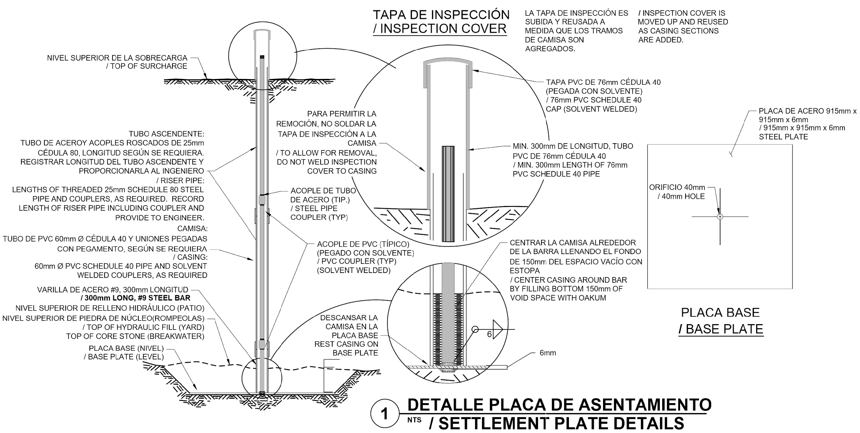

**Figure 1: Instrumentation scheme of settlement plates**

**2.2 Settlements measurements specifications**

The settlements thresholds stablished in the technical specifications of the project for the acceptance of preloads through the criterion of settlements for the yard area are:

1. the maximum total settlement two years after the completion of the work must be limited to 10 centimeters and
2. 30 centimeters before 20 years.

The procedure is to install the settlements plates and do an initial survey of on the initial filling without preload. When the preload is placed, measuring of the produced settlements are initiated. The instrumentation was placed from the start of monitoring in yard areas prefilled 1-6, 9-19 according to the numbering previously established (see *Figure 2*).

Measurements were made usually on weekly basis, i.e. sampling every 7 days, which is the minimum frequency recommended by the Asaoka’s method. There were some weeks without measurement, principally because the measuring points were not accessible. This could be for several reasons, being the principal that there is not access, for example if the hydraulic fill is nor stable or for bad weather. In such cases, before applying the Asaoka’s method, data should be normalized, which means interpolation of the measurements so that the data is presented as settlement value every 7 days.

1. **ANALYSIS AND PROGNOSIS OF SOIL SETTLEMENTS**

**3.1 Settlement analysis by Asaoka’s method**

It was performed several analytical calculations based on data acquired from settlement plates of the yard area. For this, as explained sampling rate of seven days is required for applying the Asaoka’s method for predicting the future settlements. Therefore, in some cases, measurements were interpolated between them to have a consistent methodology. The procedure is well known by the engineering community and it's explained widely by Asaoka (1978).

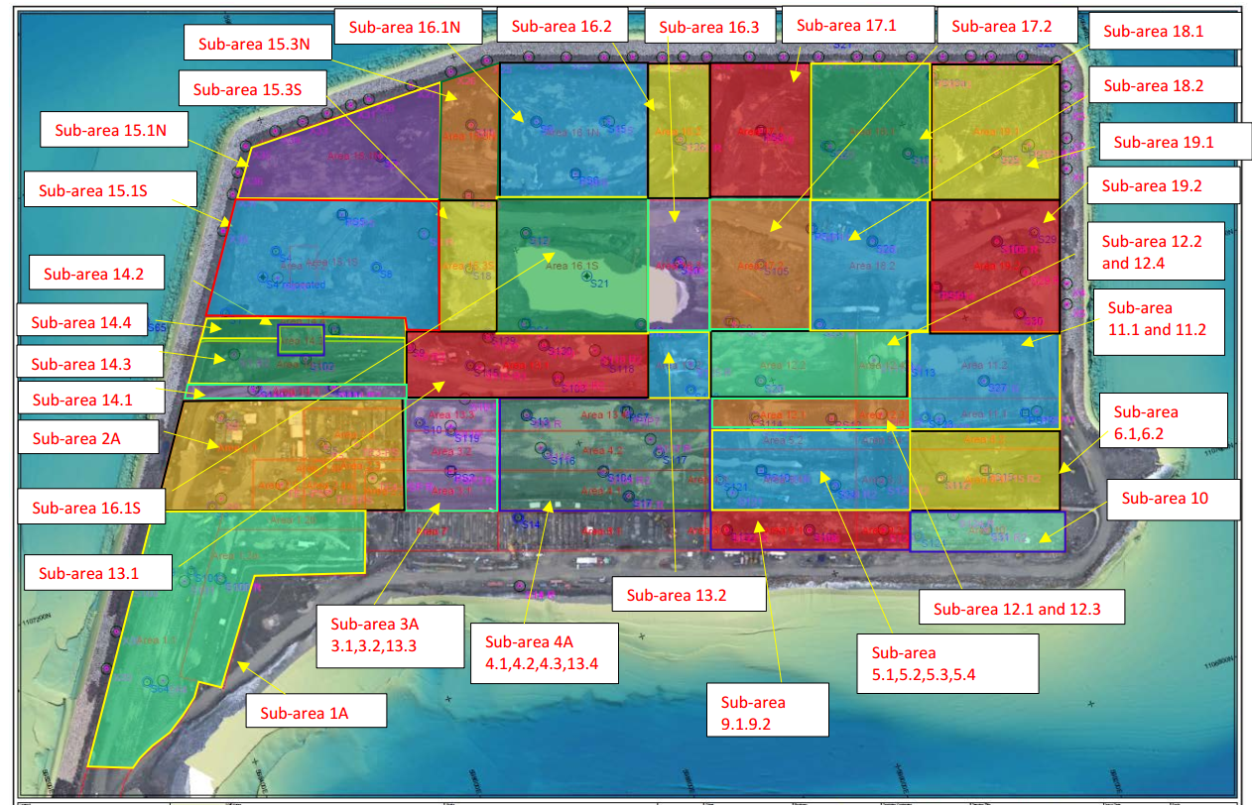

**Figure 2: Sub areas preloads. Source: project specifications.**

Based on the analysis, the following observations was reached:

1. The maximum settlement criteria or thresholds requested in the technical specifications of the project were met for the soils corresponding to the settlement plates located in the control areas 1-6, 9-19.
2. In areas 17-19 the service settlement was reached prematurely, as a consolidation process took place over time thanks to the initial 2 and 4 m preload columns for a long term, while the other areas were treated.
3. There are other specific cases that required other analyzes, derived from the analysis of future settlements that are not considered in this article as,
   1. The treatment of the strip of the temporary breakwater for the construction of the patio included through the areas 13, 15- 17 and
   2. The boundaries between the areas 6 of the yard and 10 of the wharf where the slope between the wharf and the yard is formed, which depends on the resistance to soil cutting and seismic analysis.

**3.3 Computational settlement analysis for the final construction stage of areas 6 and 10**

As part of the geotechnical validations it was carried out a computational analysis of settlements for the final stage of the project, after construction of the project, so that was validated the analytical calculus memory realized with the Asaoka’s method.

The mathematical model that the software use is based on the finite differences method. The model includes all border conditions, such as stratigraphy and the different parameters of the different soil strata.

The parameters in the case of clays depend on the consolidation. When dealing with granular soils (gravel, sands) the elastic modulus of the soil is used, as the main parameter for the soil modeling. Also, this model is integral, since included improvements with DSM, stone columns, the steel piles, a concrete slab over the piles and finally a service load of 5 ton/m2. In Figure 3 it´s shown a prognosis of a maximum settlement of 6.2 cm in 20 years, which is within the required specifications.

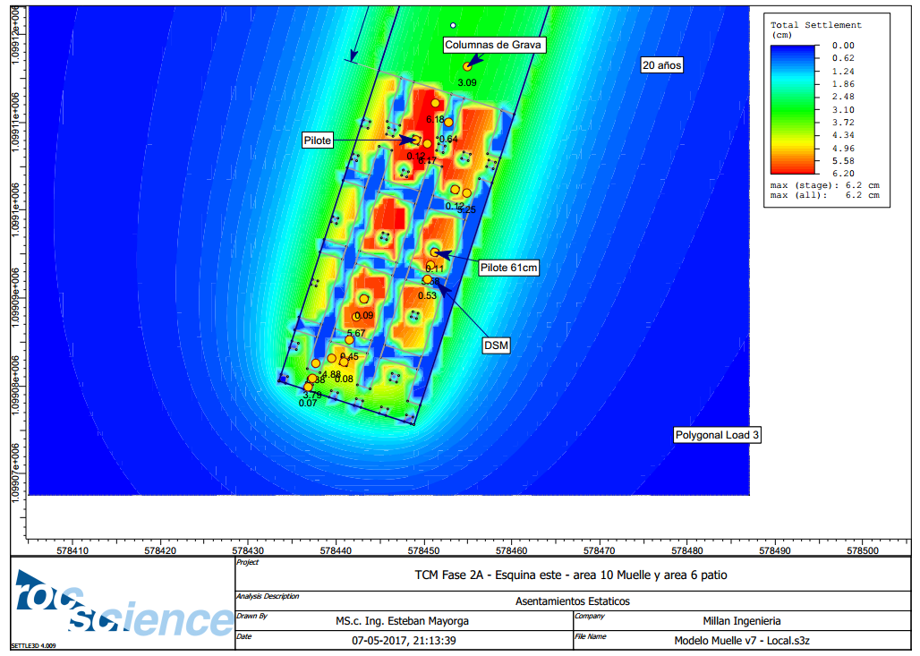

**Figure 3: Computational model results for settlements predictions to 20 years in areas 6 (yard) and 10 (wharf).**

In Figures 4-6, the results obtained in the model are shown graphically. The settlements by consolidation reveal that there, is very little permeability of clays, which makes the settlements reflected in the surface are considerably smaller than the settlements produced by the service load (5 ton/m2). This is, the graphs show a rapid consolidation in the time (50 months approx.) due mainly to the elastic modules of the improvements (DSM, etc.).

The above validates the analytical model of Asaoka used so far for the analysis of the soil settlements, since it meets with the maximum thresholds of the settlements on the wharf and in the yard.

20

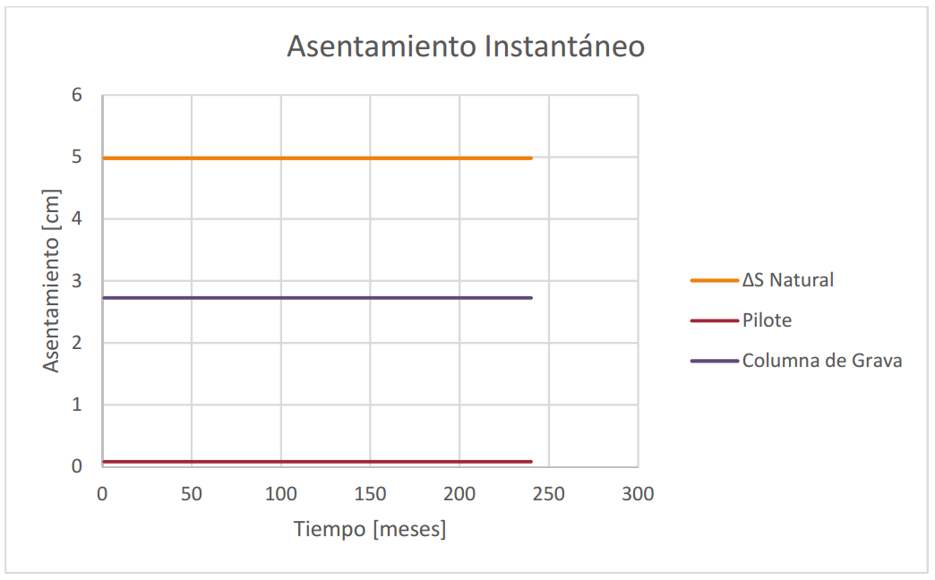

**Figure 4 Instantaneous settlements due to service loading in areas 6 and 10.**

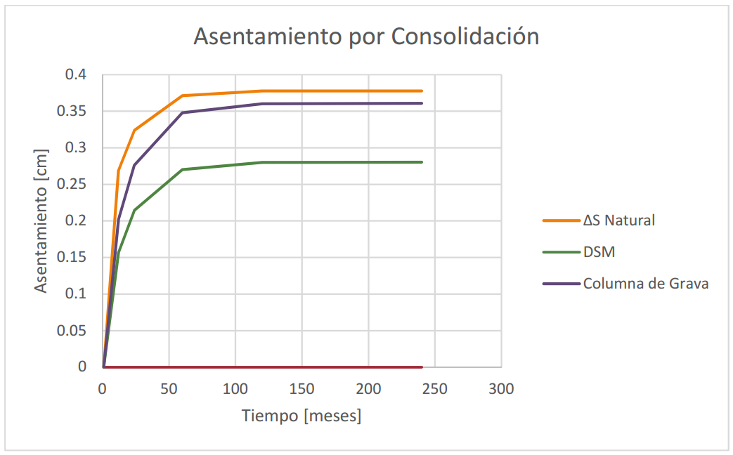

**Figure 5 Settlements for consolidation over time in areas 6 and 10**

21

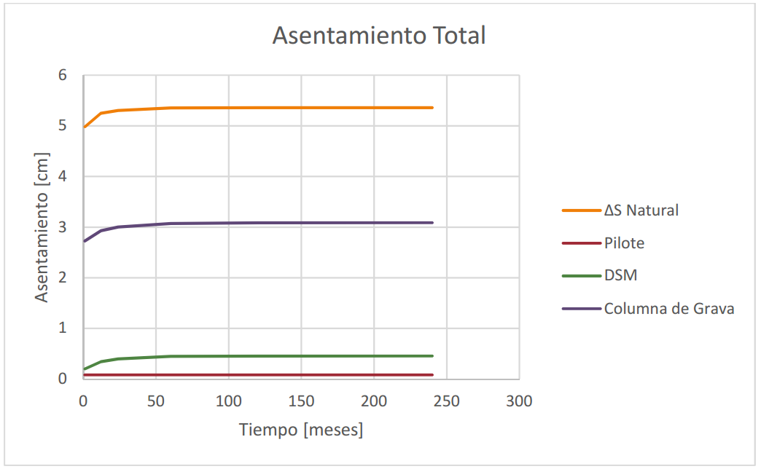

**Figure 6. Total settlements (instantaneous + consolidation) in areas 6 and 10.**

1. **CONCLUSIONS**

The settlements prognosis trough analytical and computational models with boundary conditions based on real data taken in the field are necessary in the in the different stages of the projects. It will improve the construction processes and its maintenance and operational stages in order to have the best decision-making saving time and money.

In this project as the normal thinking a follow-up plan should be prepared for the instrumentation in the yard area to monitor and verify if the behavior of the settlements is within the thresholds defined in the technical specifications and to verify if the model estimates remain realistic, or additional modifications are required. It is necessary to maintain the instrumentation over the years, as well as the topographic records.

Follow up during the operation phase is important as a verification that the settlement thresholds are really accomplished, and even in the case that they greater than expected to apply the countermeasures to avoid damages principally on structures and pavements.

There should be control of the topographic points outside the project, which have been reviewed, as well as the guarantee of the protection of these points for future revisions of settlements. This is because the settlement in the areas is significant, which modifies the levels and possibly positions of the control points.

1. **REFERENCES**

Asaoka, A. (1978). Observational Procedure of Settlement Prediction. Soils and Foundations Vol. 18, No.4.