**HYDROLOGY AND HYDRAULIC ANALYSIS FOR THE DIVERSION OF THE COCOLI RIVER**

Johnny Cuevas M.[[1]](#footnote-1)

Panama Canal Authority, Panama[[2]](#footnote-2)

ABSTRACT:

The excavation and construction of the new locks on the Pacific side for the expansion of the Panama Canal, required before its start, a series of auxiliary works to avoid affecting its development.

One of the immediate problems that was detected and that could negatively affect the development of the expansion works was the course of the Cocoli River that discharged its waters into the Miraflores Lake and that would be intercepted in its course by the projected alignment and construction of the new locks.

The solution to this problem, it was to change the trajectory of the waters of the Cocolí River through the design and construction of a diversion channel, which was part of the Canal Expansion Project (PAC-2). This prevented that the future excavations from coming into conflicts with the schedule of activities that would take place in the area.

The design of the channel of diversion of the Cocolí River considered two stages: the development of the hydrological study and the integral hydraulic analysis of the projected channel and its impact along its trajectory.

In the hydrological study, the design flow rates of the Cocolí River were estimated up to the diversion site and three tributaries that run naturally through the area and that will be affected in their natural course by the projected alignment of the diversion channel. In order to estimate the design flows, preliminary studies were used, but due to the magnitude of the project, they were expanded using hydrological modeling techniques, which were complemented with field inspections.

The hydraulic analysis of the diversion channel contemplated the integral study of all the existing components and structures and those that were design, the alignment of the new channel and the problems that could introduced in the area, due to the build of the new channel, the flood plains and determination of the water profiles along diversion channel, in order to model the whole system to determine all problems and recommend their solutions in the most economical way.

Within the hydraulic design of the diversion channel, it was contemplated to take advantage of part of the existing channels to reduce the work of excavation. Likewise, the construction of a vehicular bridge was analyzed to give access to the west side of the Panama Canal and to the contractors who developed the excavation and construction works of the new locks.

Keyword: River, diversion channel, Hydrology and Hydraulic Modelling, design.

**Presented by:** Cuevas, Johnny

**Topics:** 1.1 - Waterway infrastructures: locks, weirs, river banks

**1. BACKGROUND:**

The Cocolí River Diversion Channel (DCP) Project is proposed to be developed in an area that currently has no permanent human settlements. During the period of permanence of the United States in Panama, it was a military reserve and towards the Nuevo Emperador there was an area of military maneuvers where shooting practices were carried out. After the Canal was transferred to the Panamanian Administration, part of the Cocolí area became the Canal's operating area and was established as Type I Operating Area and Type II Operating Area. The diversion channel will cross these areas, but it will also cross other areas that are not for the exclusive use of the ACP.

The area that will cross the diversion channel, the only economic activity that takes place is associated with the operation of the Panama Canal, mainly the disposal of dredging materials in two deposits that are crossed by the Velázquez River.

**2. LOCALIZATION AND GENERAL DESCRIPTION OF THE COCOLÍ RIVER DIVERSION CHANNEL PROJECT:**

The project of the diversion channel of the Cocolí River, is located in the Corregimiento de Arraiján, District of Arraiján, province of Panama, at the entrance of the Pacific Ocean of the Panama Canal, on the west side, between coordinates 991 800 and 993 050 of North latitude and 652 750 and 655 900 of western longitude.

The population centers closest to the project are the District of Arraiján located to the west and the city of Panama to the southeast. The center of the city of Panama is approximately 7 km in a straight line northeast of the project. In front of the confluence of the Cocolí Canal with the Velázquez River, a high-value residential complex is currently being developed, which includes its own Golf Club, known as El Tucán Country Club.

The project is located within basin 142, between the Caimito and Juan Diaz rivers and has a drainage area of 29.5 km2, up to the diversion site.

Figure No. 1 shows the general location of the diversion channel of the Cocolí River.

**3. SCHEME OF THE PROJECT**

In Figure No. 2, the project outline of the Cocolí River diversion channel is presented and its main components are described below.

The scheme of the Diversion Channel Project (DCP) of the Cocolí River, consists since its inception in Lake Cocolí of the following components.

* A diversion levee dam at least 17.00 meters high with the base located on the fluvial channel of the Cocolí River. Figure 3 shows a picture of Lake Cocolí with the beginning of the diversion channel.
* Diversion channel starting at Lake Cocolí at an elevation of 10.87 m PLD with a length of approximately 3.5 km, trapezoidal section with slopes of 1: 2 and variable hearth width, starting at 15 meters and ending at 30.00 m in the Pacific Ocean.
* The trajectory of the channel will have to cross the existing road that leads to the K9 polygon and the Brujas roadway, where due to the construction of the channel, a concrete drainage system of 3.00 mx 3.00 m should be demolished, to be replaced by a bridge. Figure No 4 shows a photo of the drainage system that will be replaced by a new bridge.
* From station 1 K + 080.00 to 1 K + 440.00, it is necessary to build approximately 360 meters of levees with an average height of 1.80 m on both sides, in order to contain the waters inside the channel, from the station 2 K +60.00 to 2 K + 100.00 (40.00 m in length) and from 2 K + 460.00 to 2 K + 580.00 (120.00 m in length).
* From station 2 K + 040.00, because the channel crosses and affects the flow of three existing streams that are the Victoria Sur, Victoria Norte and the Velázquez River, the DCP must be supplemented with accessory works that includes channeling and coating from the entrances of the tributaries to the diversion channel. Figure 5, 6 and 7 show the photos of the Victoria Norte, Victoria Sur and Velázquez rivers.
* At the confluence of the Velázquez River with the diversion channel, a buffer pond is contemplated to reduce turbulence.

Two critical zones have been identified, which are the area of the levees and the confluence of the Cocolí DCP and the Velázquez River. In this zone, depending on the use given to adjacent lands, dykes can be built or not.

In the recommendations and solutions, a detailed description of the work that must be done along the Cocolí river diversion channel is presented.

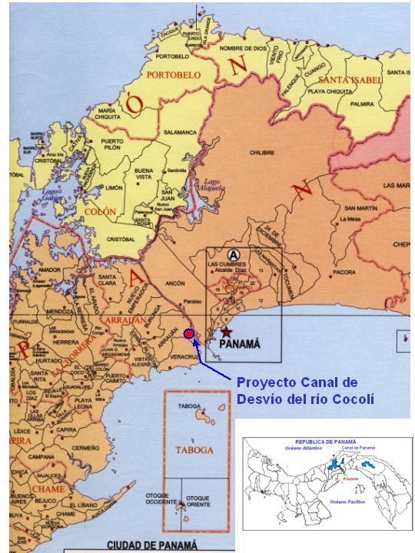

Figure 1. General location of the diversion channel of the Cocolí River.

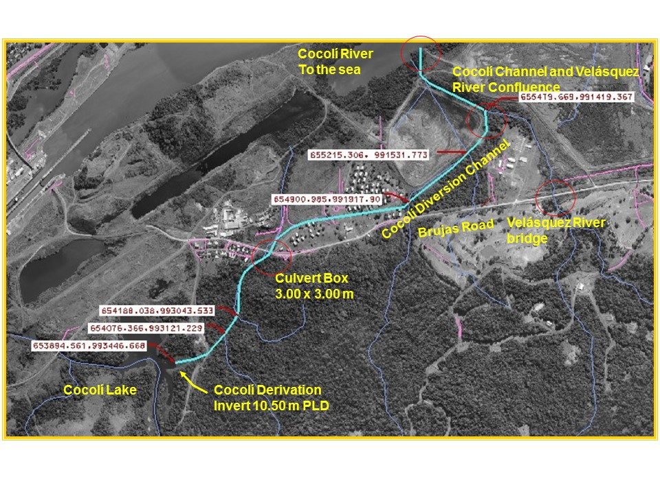

Figure 2. Scheme of the diversion channel of the Cocolí River.

|  |  |
| --- | --- |
|  | Cajon3x3 |
| Figure 3. Confluence of the Cocolí river with the Miraflores lake and outline of the future entrance to the diversion channel. LPalma / June 2007 | Figure 4. Culvert concrete drainage system 3.00 x 3.00 on the road to Brujas, which will have to be removed to run the diversion channel of the Cocolí river. JACM / June 2007 |
| Alcantarilla_3x3 | Alcantarilla_1 |
| Figure 5. Horseshoe culvert in the Victoria Norte creek the Brujas road. View from upstream in the channel of the gulch. Dimensions 3.00 x 3.00 m. JACM / June 2007 | Figure 6. Horseshoe culvert in the Victoria Sur gorge, on the Brujas road. View from downstream in the channel of the gulch. Dimensions 1.80 x 1.80 m. JACM. |

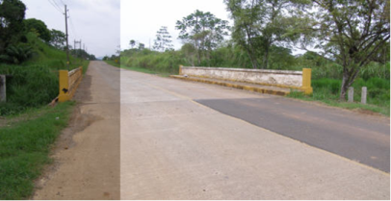

**Figure 7. View of the bridge over the Velázquez River, on the Brujas road looking towards Cocolí. JACM.**

**4. GENERAL DESCRIPTION OF THE WATERSHED 142 THAT COCOLÍ RIVER SUBBASIN IS PART**

According to the Watershed distributions of the Republic of Panama, the sub-basin of the Cocolí River is located within Watershed 142, rivers between the basins of the Caimito River and Juan Díaz River, on the Pacific side of the country, on the west bank of the Panama Canal and its waters pour into Lake Miraflores.

The sub-basin has a circular shape and its topography is quite homogeneous because there are no significant elevation changes from the headwaters of the Cocolí River to its mouth.

The landscape of the sub-basin is dominated in its upper part to the northwest by the highest point which is an unnamed hill with an elevation of 257 meters above sea level. The Cocolí River from its source has an approximate elevation of 220 meters above sea level.

The Cocolí River Diversion Channel Project starts at the end of the Cocolí sub-basin, in the lower part with elevations between 15.00 and 0.00 m PLD.

**5. BASIC INFORMATION**

The basic information for the development of the hydrological and hydraulic study was obtained from three main sources:

* Meteorological and hydrological information
* Existing cartographic information
* Topographic surveys

**6. RAINFALL REGIME OF THE COCOLÍ RIVER SUBBASIN**

The rainfall regime of the Cocolí sub-basin is influenced by the rainy regime of the Pacific side, which is characterized by two well-defined seasons. The dry season that usually goes from mid-December to April and the rainy season from mid-April to December.

Within the rainy season there is a decrease in rainfall between the month of July and August, which is caused by the annual movement of the Inter Tropical Convergence Zone (ITCZ), when it is farthest from the Isthmus of Panama, a phenomenon known as the Veranillo de San Juan or Canícula. The ITCZ is the confluence zone of the trade winds of both hemispheres, North and South. It is an area of light and variable winds, unstable air and strong convective developments, with intense rains. When the Intertropical Convergence Zone moves from North to South, rainfall increases again, with October being the rainiest.

The seasonal distribution of rainfall in the Cocolí sub-basin is controlled by the ITCZ, however, the totals that occur in any point of the country depend on factors such as elevation, relief, distance to the mountain range, exposure to prevailing winds, etc.

In Figures 8 and 9, the rainfall distribution is presented for the rain stations closest to the project, which are Balboa and Pedro Miguel.

|  |  |
| --- | --- |
|  |  |
| **Figure 8. Temporal distribution of rainfall in the Altos de Balboa rainfall station, period 1977-2006**. | **Figure 9. Temporal distribution of rainfall in Pedro Miguel rainfall station, period 1977-2006**. |

**7. HYDROLOGICAL ANALYSIS**

The purpose of the hydrological study was to examine all the components of the surface hydrology of the hydrographic basin that feeds the Cocolí River, with the purpose of estimating primarily their design flows, in addition to analyzing other aspects such as the distribution of monthly average flows.

To complement the analysis, an inspection and field survey was carried out to sites of the Cocolí river basin previously selected, which were selected as preliminary reconnaissance of the topographic mosaics available at a scale of 1: 50000 and 1: 25000. The objective of this inspection and survey was to compare the results obtained through hydrological modeling, with the calculations made as a result of the field surveys.

**7.1. Design Flows:**

As there are no references of measurements or systematic readings in the Cocolí River, we proceeded to estimate the design flows by indirect methods.

For the initial design of the Cocolí DCP, the Geotechnical Section preliminarily used the maximum instantaneous flows that appear in the report "ESTIMATION OF THE MAXIMUM FLOWS OF THE COCOLÍ RIVER", analysis carried out in July 2003 by the Hydrologist Tamara Muñoz, but due To the extent and scope of the Cocolí river diversion channel project, the study was updated and expanded. The tool used for the extension of the study was the HEC-HMS hydrological program developed by the Engineering Corps of the Hydrological Engineering Center of the United States, which is free of charge.

The flows were estimated for return periods of 5, 20, and 50 and 100 years, for the Cocolí River and the Victoria Sur, Victoria Norte, Victoria 3, Victoria 4 and the Velázquez rivers, which will be affected by the deviation channel project when it has been built.

**7.2. Description of the HEC-HMS Model**

The HEC-HMS system was designed to simulate the precipitation runoff processes of a basin and was developed by the Corps of Engineers in the early 60's and its predecessor is known as HEC-1. The HEC-1 or HEC-HMS, is one of the most popular events simulation programs, which can be used for free. The version used for the analysis of the design flows is 3.1.0.

The acronym HEC stands for Hydrologic Engineering Center, which is the research center of the United States military engineering corps, located in Davis, California.

**7.3. Requirements of the HEC-HMS Model**

The requirements of the model depend on what is required to model and on the hydrometeorological information available to feed the model.

For this particular case, what is required to be developed is the design hydrograph of the project, which is why the application of the HEC-HMS model was considered appropriate, since it is an event simulation model. An event model has the capacity to reproduce a single storm, given certain physical parameters of the basin under analysis.

As there are no hydrometric records in the Cocolí basin, we proceeded to estimate the flows using the "Alternate Block Method" and the flood transit for each Subbasin using kinematic wave.

The model requirements for this method are basically physical characteristics such as, drainage surface and time of concentration of the basin and its sub-basins, length and slope of the channel and slope of the landscape and estimation of number of curve.

All this information is determined by means of topographic mosaics, aerial photographs and field inspections. Once these data were obtained, we proceeded to estimate the time of concentration and the design rain for the basin for different return periods.

One of the limitations of this method is that you do not have a station or control point at the exit of the basin to calibrate the model. For this reason, an estimate was made of a flow of the Cocolí River using the traces left by a recent flood (May 2007) and an arm of the Cocolí River, proceeding in both cases to estimate its flow using the area-slope method.

**7.4. Methodology:**

The HEC-HMS model is designed to simulate the surface runoff that results from a rain, through the representation of a basin as a system of interconnected components. Each component can individually simulate an aspect of the rainwater runoff process within an area or sub-basin; the components include the surface runoff of the subarea, the channels and the reservoirs; each component is represented by a set of parameters that specifies the particular characteristics of the component and the mathematical relationships that describe its physical processes. The final results of the modeling process are the output hydrographs or direct surface runoff for each previously specified subarea. Figure 10 shows the HEC-HMS scheme for the Cocolí river basin. The basin was subdivided into 9 small sub-basins.

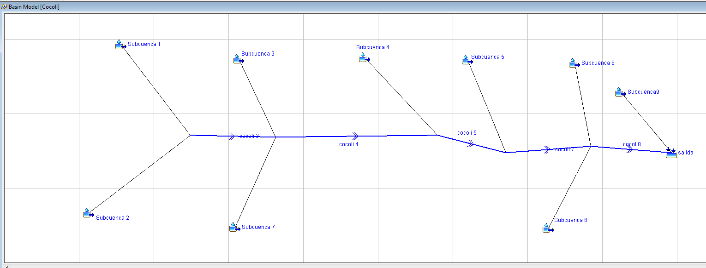

**Figure 10. HEC-HMS scheme for the Cocolí river basin.**

The surface runoff component for a sub-area is used to present the movement of water over the surface of the land to the riverbeds and streams. The input of this component is a precipitation histogram, which was designed by the alternate block method. The excess of rain is calculated by subtracting the infiltration and losses by arrest, and in our case the Soil Conservation Services (SCS) curve number method was selected and alternatively the kinematic wave model was used to calculate the runoff hydrographs in the sub-basins.

The flood routing component represents the movement of flood waves in the channels. The input of this component is the hydrograph obtained upstream that resulted from the individual or combined combinations of the runoff of the subareas, the transit of flows or the derivations. For the flood routing of the Cocolí, the kinematic wave method was used.

**Alternate block method**

The alternate block method is a simple way to develop the design histogram using the Intensity-Duration-Frequency (IDF) curves of the station closest to the project under study. The design histogram generated by this method determines the depth of precipitation that occurs in n intervals of successive times of duration Δt over a duration of Td = nΔt. After selecting the design return period and the time interval t, the intensity is read from the IDF curve or otherwise the equation generated for the curve is applied, for each of the durations for each Δt, 2 Δt, 3Δt ..., and the corresponding depth of precipitation is found by multiplying intensity and duration. Determining the difference between the successive values of depth of rain, is the total amount of precipitation that must be added for each unit of time Δt. These increments or blocks are rearranged in a temporal sequence so that the maximum intensity occurs in the center of the required duration *Td* and the blocks are in descending order alternately to the right and to the left of the central block in order to form the histogram of project design.

We analyzed the IDF curves of the closest rainy seasons, which are considered the most influential in the Cocolí river basin, which are Balboa Heights and Pedro Miguel. The Balboa curves developed for the Ministry of Public Works (MOP) by Federico Guardia and Consultores in 1972 were used as a reference, for a period of 57 years and those of the study "Analysis of Intensity Duration and Frequencies, Maximum Rain Events Annual (1972-1999), Panama Canal Basin - Eastern Region ", developed by Maritza Chandeck Monteza in 2001. Both IDF curves were compared, and it was observed that the ACP curves compared to those of the MOP, they present differences. The main difference is that for the same time interval, the rain intensity is lower in the curves developed by the ACP for the intervals between 1 to 60 minutes. For the 60 to 120 minute intervals, the rainfall intensity of the ACP curves is slightly higher.

One of the theses that is handled is that from rainfall records until 1972, rainfall intensities could be obtained at 5 minute intervals and from 1972 onwards, the minimum registration interval is 15 minutes. At a shorter time interval, rainfall intensities are greater and decreasing with respect to time.

For the analysis of the Cocolí DCP, the IDF curves recommended by the MOP were used, considering that the values of these curves are more critical for the channel design.

In Table 1, the values of the IDF curves of the Balboa station are presented and in Figure No. 11 the Curve Intensity-Duration-Frequency (IDF) is presented.

Table 2 shows the maximum rainfall data obtained through the alternate blocks to develop the design storm's histogram, which was used to estimate the design flood for a return period of 100 years and Figure 12, the graph of the design histogram for a 100-year storm is presented.

Table 1. Summary of intensities to determine the IDF curves for Altos de Balboa rainfall station, period 1921-1986 (57 years).

|  |  |  |  |  |  |  |  |  |
| --- | --- | --- | --- | --- | --- | --- | --- | --- |
| **Tc ( min )** | **Return Periods T (years)** | | | | | | | |
|  | 2 | 5 | 10 | 20 | 25 | 30 | 50 | 100\* |
| 5 | 6.68 | 7.17 | 7.88 | 8.50 | 8.81 | 9.02 | 9.74 | 11.21 |
| 10 | 5.82 | 6.39 | 7.02 | 7.60 | 7.87 | 8.04 | 8.60 | 9.74 |
| 15 | 5.16 | 5.76 | 6.33 | 6.87 | 7.12 | 7.25 | 7.71 | 8.60 |
| 30 | 3.85 | 4.45 | 4.89 | 5.33 | 5.52 | 5.61 | 5.87 | 6.38 |
| 45 | 3.07 | 3.63 | 3.99 | 4.35 | 4.51 | 4.57 | 4.74 | 5.07 |
| 60 | 2.55 | 3.06 | 3.36 | 3.68 | 3.81 | 3.85 | 3.98 | 4.20 |
| 120 | 1.52 | 1.88 | 2.07 | 2.27 | 2.36 | 2.37 | 2.42 | 2.50 |
| \* For the return period of 100 years a formula has been estimated depending on the curves of the other periods of return and their behavior | | | | | | | | |

Figure 11. Intensity Duration Frequency (IDF) curve for Altos de Balboa station.

Table 2. Histogram of the rain developed in 10-minute increments for a 100-year storm and 120-minute duration for the Cocoli river basin using the alternate block method, Altos de Balboa station.

|  |  |  |  |  |  |  |
| --- | --- | --- | --- | --- | --- | --- |
| **Tc ( min )** | **T (hr)** | **Intensity**  **Tr = 100 y** | **Inten.**  **(mm/h)** | **Acum. rain**  **(mm)** | **Rain**  **(mm)** | **Histogram**  **(mm)** |
| 10 | 0.17 | 9.74 | 247.32 | 41.22 | 41.22 | 2.48 |
| 20 | 0.33 | 7.71 | 195.79 | 65.26 | 24.04 | 3.44 |
| 30 | 0.50 | 6.38 | 162.03 | 81.02 | 15.75 | 5.09 |
| 40 | 0.67 | 5.44 | 138.21 | 92.14 | 11.12 | 8.27 |
| 50 | 0.83 | 4.74 | 120.49 | 100.41 | 8.27 | 15.75 |
| 60 | 1.00 | 4.20 | 106.80 | 106.80 | 6.39 | 41.22 |
| 70 | 1.17 | 3.78 | 95.90 | 111.88 | 5.09 | 24.04 |
| 80 | 1.33 | 3.43 | 87.02 | 116.02 | 4.14 | 11.12 |
| 90 | 1.50 | 3.14 | 79.64 | 119.47 | 3.44 | 6.39 |
| 100 | 1.67 | 2.89 | 73.42 | 122.37 | 2.90 | 4.14 |
| 110 | 1.83 | 2.68 | 68.10 | 124.85 | 2.48 | 2.90 |
| 120 | 2.00 | 2.50 | 63.50 | 127.00 | 2.15 | 2.15 |

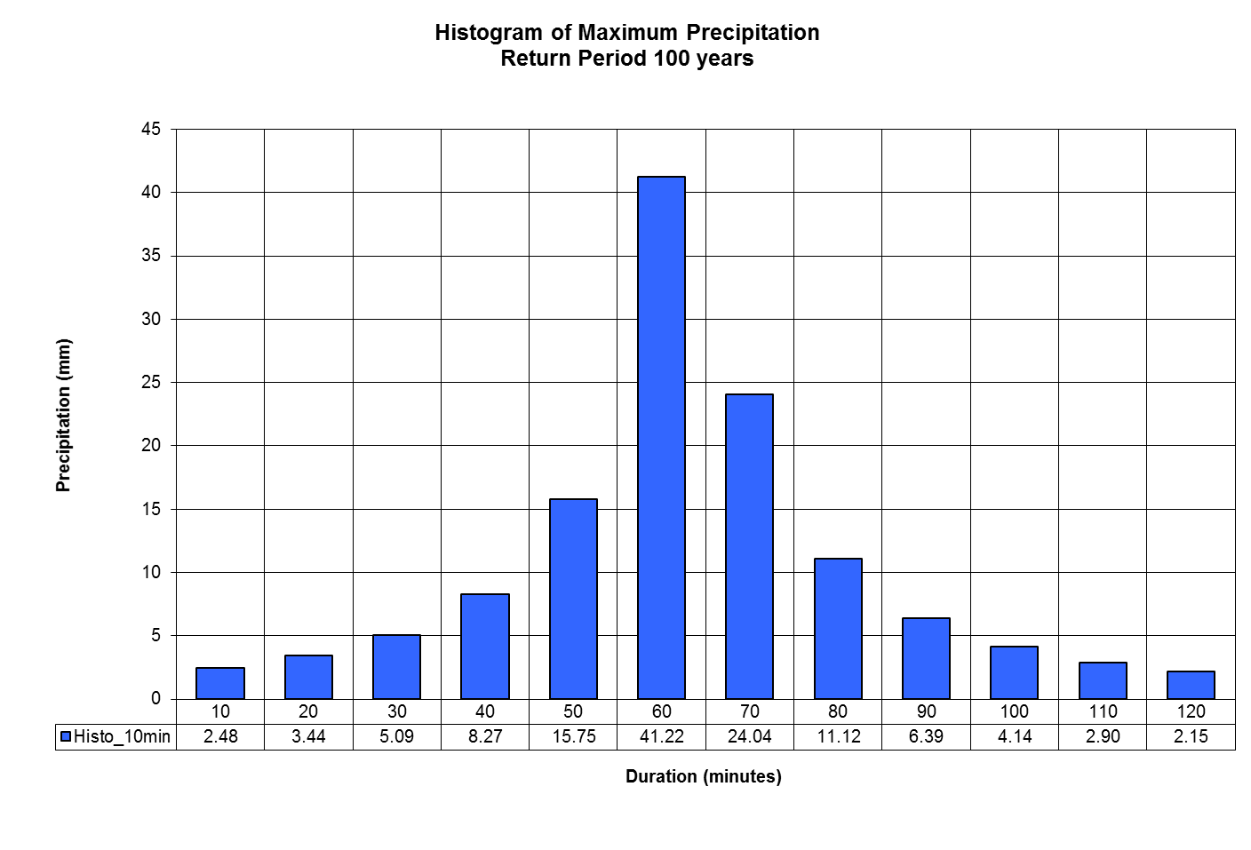

Figure 12. Histogram of maximum precipitation for a return period of 100 years determined using the alternative blocks method.

**7.5. Run of HEC-HMS Model:**

Once all the physical parameters and rainfall histograms required by the HEC-HMS model were obtained, the model was assembled. The Cocolí river basin was subdivided into 9 sub-basins (Figure 10) and 4 stretches of the river were defined to make the routing of the floods. The layout and measurement of all sub-basins of the project was obtained by measuring the mosaics 1: 50000 of the National Geographical Institute Tommy Guardia. From the mosaics, the physical characteristics of the basin were also obtained as the drainage area, the length of the channels, the average slope of the channels and the slopes perpendicular to the river bed for each sub-basin.

With these parameters we proceeded to determine the time of concentration (Tc) for the entire basin and for each sub-basin, adopting the Kirpich method.

The model was assembled as follows:

* The sub-basins were declared and the model was fed with the required parameters.
* It was assumed that the design rain is homogeneous throughout the basin.
* The histogram was introduced for design storms of 20, 50 and 100 years of return period.
* The SCS method was selected to calculate infiltration losses and the kinematic wave method to determine flood hydrographs.
* For the traffic of avenues, the kinematic wave method was also selected.
* Runs were made for the different return periods.

Obtained the results of the runs, it was compared with the preliminary analysis of the study carried out in the meteorology and hydrology section.

**7.6. Results of the Runs of the HEC-HMS Model of the Cocolí River Basin:**

In Table No. 3, the results of the runs carried out for the Cocolí river basin and sub-basins up to the diversion site are presented for return periods of 20, 50 and 100 years of return period.

Design flows to the Cocolí river diversion site were estimated for return periods of 20, 50 and 100 years at 250, 270 and 300 m3/s respectively. It was observed that the flows estimated by the HEC-HMS, exceeds by 11% those obtained by the preliminary analysis, so the estimate is considered acceptable.

Table 4 shows the values of the hydrograph to the site of the diversion of the Cocolí River and in Figure 13 its respective output hydrograph.

Additionally, in order to verify the estimates of the design flows, an inspection and survey of the Cocolí river basin, in the lower part, was carried out in order to try to estimate some flood by means of the slope area. On June 12, 2007, the sections in the main channel of the Cocolí River and another in one of the main tributaries were surveyed in order to estimate a capacity.

The flows of the sub-basins of the small streams that will discharge to the channel of diversion of the Cocolí River, were determined by means of the rational approach method.

Table 3 shows the results of the run with the HEC-HMS for a return period of 100 years. It can be seen that the maximum value is 291 m3/s, but for the run with the HEC-RAS, it was rounded and 300 m3/s was used.

Table 3. Results by Subbasin of the HEC-HMS Model Runs for the Cocolí River for a Period of Return of 100 Years.

|  |  |  |  |  |
| --- | --- | --- | --- | --- |
| **Hydrologic**  **Component** | **Drainage**  **surface**  **(km2)** | **Maximum**  **Discharge**  **(m3/s)** | **Time to[[3]](#footnote-3)**  **Peak**  **(hour)** | **Volumen**  **(mm)** |
| Cocoli 3 | 9.82 | 67.90 | 12Jul2003, 12:20 | 65.63 |
| Cocoli 4 | 16.32 | 136.70 | 12Jul2003, 11:55 | 65.96 |
| Cocoli 5 | 20.34 | 183.90 | 12Jul2003, 11:50 | 65.00 |
| Cocoli 7 | 22.69 | 211.00 | 12Jul2003, 11:45 | 64.60 |
| Cocoli 8 | 27.86 | 271.40 | 12Jul2003, 11:50 | 64.30 |
| Output | 29.51 | 291.40 | 12Jul2003, 11:45 | 64.58 |
| Subcuenca 1 | 6.64 | 39.70 | 12Jul2003, 12:35 | 65.49 |
| Subcuenca 2 | 3.18 | 28.40 | 12Jul2003, 12:10 | 67.13 |
| Subcuenca 3 | 1.85 | 16.00 | 12Jul2003, 12:10 | 61.10 |
| Subcuenca 4 | 4.02 | 62.80 | 12Jul2003, 11:35 | 62.24 |
| Subcuenca 5 | 2.35 | 38.90 | 12Jul2003, 11:30 | 62.33 |
| Subcuenca 6 | 3.11 | 36.60 | 12Jul2003, 11:50 | 61.81 |
| Subcuenca 7 | 4.65 | 62.10 | 12Jul2003, 11:45 | 69.15 |
| Subcuenca 8 | 2.05 | 37.80 | 12Jul2003, 11:25 | 69.36 |
| Subcuenca 9 | 1.65 | 30.8 | 12Jul2003, 11:25 | 69.40 |

Table 4. Maximum Estimated Flows for the Cocolí River to the Derivation Site and for the Affluent that Intercept According to the Period of Return in Years

|  |  |  |  |  |  |  |  |  |  |
| --- | --- | --- | --- | --- | --- | --- | --- | --- | --- |
|  | Subbasin | Área (km2) | | Return Period in years (Tr) | | | | | |
| River/creek | # | Partial | Total | 20 | | 50 | | 100 | |
|  |  |  |  | Q. Parcial | Q. Acum | Q. Parcial | Q. Acum | Q. Parcial | Q. Acum |
| Cocolí | 1 | 6.64 | 6.64 |  |  |  |  |  |  |
| Cocolí | 2 | 3.18 | 9.82 |  |  |  |  |  |  |
| Cocolí | 3 | 1.85 | 11.67 |  |  |  |  |  |  |
| Cocolí | 4 | 4.02 | 15.69 |  |  |  |  |  |  |
| Cocolí | 5 | 2.35 | 18.04 |  |  |  |  |  |  |
| Cocolí | 6 | 3.11 | 21.15 |  |  |  |  |  |  |
| Cocolí | 7 | 4.65 | 25.80 |  |  |  |  |  |  |
| Cocolí | 8 | 2.05 | 27.85 |  |  |  |  |  |  |
| Cocolí | 9 | 1.65 | 29.50 |  |  |  |  |  |  |
|  |  |  |  |  |  |  |  |  |  |
| Cocolí Derivation |  |  | 29.50 | 250 | 250.0 | 270 | 270.0 | 300.0 | 300.0 |
| Victoria 4 |  | 0.65 | 30.2 | 10.0 | 260.0 | 12 | 282.0 | 14.0 | 314.0 |
| Victoria 3 |  | 0.14 | 30.3 | 2.5 | 262.5 | 3 | 285.0 | 3.5 | 317.5 |
| Victoria 2 |  | 1.87 | 32.2 | 24 | 286.5 | 26 | 311.0 | 32.0 | 349.5 |
| Victoria 1 |  | 0.49 | 32.7 | 6 | 292.5 | 7.5 | 318.5 | 9.0 | 358.5 |
| Velásquez |  | 12.90 | 45.6 | 90 | 382.5 | 100 | 418.5 | 110.0 | 468.5 |

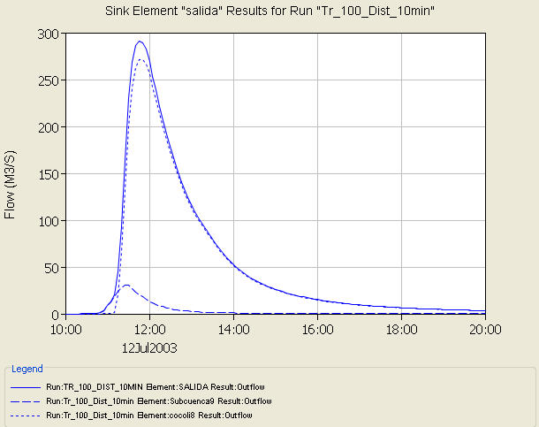

Figure 13. Output hydrograph of the Cocolí River to the derivation site for a return period of 100 years.

**8. HYDRAULIC MODELING TO DETERMINE THE WATER PROFILES OF THE DIVERSION CHANNEL**

To determine the water profiles along the route of the diversion channel of the Cocolí river, for the different selected return periods, the hydraulic modeling program HEC-RAS was used, which has been developed by the Hydrological Engineering Center of the United States Army Corps of Engineers, which has as its predecessor the well-known HEC-2 and has been considerably improved since its appearance in the early 60's.

The current version of the program allows calculations of water profiles for permanent and non-permanent flow in one dimension, sediment transport analysis of the bed and analysis of water temperature.

The HEC-RAS was selected as it is a public domain program, it is widely tested and has literature available for consultation.

The model has among its main features the modeling of water profiles along a channel or channel, modeling and hydraulic calculation of hydraulic structures such as bridges, culverts, etc, in addition to having a module that allows the design Hydraulic channels and calculation of cut and fill.

In the updated version of the HEC-RAS, the HEC-BETA, its applications are only limited by the imagination of the modeler.

**9. MODEL REQUIREMENTS:**

After selecting the model, we proceeded to study its minimum requirements. The information needed for the modeling included the topographic maps of the area, the surveying of the cross sections of the channel alignment and on-site inspections to evaluate all the existing structures. All in order to have a comprehensive representation at the time of the final design of the area that will cross the diversion channel of the Cocolí River.

The cross sections were supplied by the Topography and Topography Section of the Engineering Division, at the request of the Geotechnical Section, which made the preliminary layout of the Cocolí DCP. The sections of the channel were raised following the preliminary stations layout of 20.00 m and width of 50.00 m on each side of the center of the channel proposed.

Once the survey was carried out, the cross sections were sent to the Geotechnical Section for review and conversion of X, Y and Z coordinates, distance in meters. In Figure No. 19, the initial scheme mounted on HEC-RAS of the diversion channel of the Cocolí River is presented.

A total of 186 cross sections were provided for the DCP of the Cocolí River, for the Victoria Sur creek, nineteen cross sections for a length of 473.50 m and the Victoria Norte, five cross sections for a length of 175.00 m. The Velázquez River was used a total of 41 cross sections for a length of 820.00 m.

**10. HEC-RAS MODEL RUNS**

Obtained the design flows of the Cocolí river in the diversion site for periods of return of 5, 20, and 50 and 100 years, we proceeded to assemble the hydraulic model HEC-RAS.

The cross sections for the main channel and tributary streams were loaded, and the design flows for the selected return period were introduced, which in our case is 100 years. To connect the tributaries to the DCP of the Cocolí River, the junction function of the HEC-RAS was used.

Assembled the model, we proceeded to the design of the 3500 meter of the channel and the inflow entrances that will be affected by the future construction of the diversion channel.

In the preliminary runs only the main channel was designed, which was an iterative process. Subsequently, the tributaries were included and the respective runs were made, the outputs were analyzed and if problems such as channel capacity or high speeds arose, they were corrected immediately, and so on until the modeling of the channel was completed.

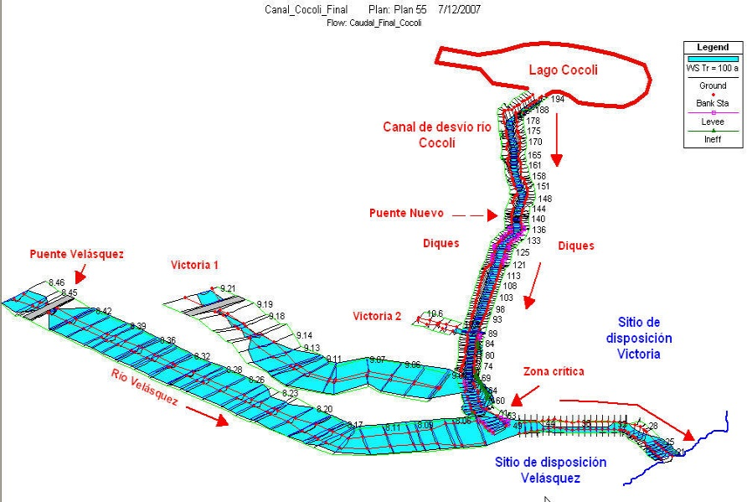

Figure 14. Initial outline of the diversion channel of the Cocolí River mounted on HEC-RAS.

After analyzing the capacity of the channel, the water profiles, the speeds and the slopes, we proceeded to declare the structures, in this case the preliminary design of the new bridge over the diversion channel, the culverts of the Victoria Sur and Norte creeks, Velázquez river bridge, with the purpose of studying its behavior and mainly determining the Extraordinary Maximum Waters Level in the bridge, which is a requirement of the Ministry of Public Works when a plan is going to be submitted for approval.

**10.1. Problems Found:**

The problems that arise from the successive runs of the model and the integration of the components during the design phase, the verification of the hydraulic design of the channel and the different restrictions and objections presented by the different units of the ACP that can be affected in some way or another. Some restrictions included the final alignment of the channel so that it does not affect protected areas, does not affect the slopes of the disposal areas, the channel floor and elevation of the bridge in the designed bridge area, excessive speeds, etc. A brief description of the problems encountered is presented below.

**10.1.1. High speeds:**

In the section between the start of the diversion channel and the projected bridge (station 0K + 00 to 1K + 00) high speeds are presented. This problem is caused because in a stretch of approximately one kilometer where you have to descend 4.75 m which creates high speeds due to the high slope and cause supercritical flow.

**10.1.2. Channel capacity:**

The outflows of water profiles of the preliminary runs, when the design flow was applied for a return period of 100 years, showed that in the section comprised between 1 k + 060 meters (taking as reference the beginning of the detour), water under the proposed bridge, water spills down the plains lateral to the channel. This is a product of the channel crossing a topographic zone of low elevation (flat plains).

**10.1.3. Quebrada Victoria Norte channel not defined:**

The exits indicate that the water spreads through the floodplain adjacent to the channel in that section, which may cause damage to the diversion channel.

**10.1.4. Quebrada Victoria Sur presents backwater effects:**

In this union, the channel of the stream is lower than the channel. This situation causes water from the channel to escape into the creek, flooding the natural floodplains of the creek.

**10.1.5. Río Velázquez effects of backwater at the confluence with the diversion channel:**

Due to the introduction of the diversion channel in the natural channel of the Velázquez river, which alter the natural conditions of the area, which is why this is considered one of the most critical points of the design due to three situations that arise: abrupt of the horizontal alignment (curve), the low slope of the natural course of the river and that the reach of the cross sections was short, because it only covered 20 m from the center of the river to each bank.

These situations cause turbulence and backwater effects at the confluence, which is why the particular situation of this point required a deep analysis. The initial outputs indicate that only by applying the design flow to the diversion channel (not the river), the water traveled upstream of the Velázquez River. The situation became more critical when the design flow was applied to the Velázquez River, since the water by the backwater effect flooded the plains upstream of the bridge.

This situation can cause problems due to the fact that upstream is the bridge over the Velázquez River and the development of the highly valued residential complex, "Tucán Country Club" which includes its own golf club.

**12. RESULTS AND NECESSARY SOLUTIONS AND WORKS:**

Due to the topographic configuration of the area where the diversion channel of the Cocolí River is projected, the following works will have to be carried out.

* At the confluence of the Cocolí River with the lake, it is necessary to contemplate the dredging and formation of a channel to channel the waters of the Cocolí River to the diversion channel.
* The curves should be smoothed, the unusable materials removed from the channel and the obstacles present in the area eliminated.
  + At the mouth of the bypass, the unusable material should be removed and replaced or replaced by a more cohesive material and contemplate the treatment of the bypass mouth by means of rock, riprap, etc., since the turbulence associated with the change of slope and address can cause scouring problems later.
* Dam levee construction at least 17.00 m high in the lake to divert the waters of the Cocolí River to the diversion channel.
* First section of the channel includes from station 0K + 00 to 2K + 030.61. The first section starts at an elevation of 10.87 m PLD and ends before the confluence with the Victoria 2 ravine at 4,343 m PLD. The proposed channel is of trapezoidal section with slopes from 2 to 1 beginning with a width of 15.00 m and ending with 30.00 m.
* The structures of this section are the bypass entrance, four steps of 0.75 m in height to dissipate the energy, a reinforced concrete bridge of 11.00 wide by 36.00 m long and lower beam level of 10.52 m PLD.
* Before the construction of the bridge, it is necessary to demolish the reinforced concrete drainage system of dimensions 3.00 x 3.00 m in station 1 k + 013.89.
* At station 1 K + 017.00, replacement by a bridge with an elevation of the lower beam of the bridge of 1.80 m according to MOP requirements on the Maximum Extra Waters Level (NAME) of 8.72 m PLD.
* From station 1K + 080.00 to 1 K + 440.00, due to the topographic configuration of the land, it is required to build approximately 360 meters of containment dikes on both sides with an average height of 1.80 m, in order to contain the waters inside the channel.
* The second section of the diversion channel includes station 2 K + 060.00 to 2 K + 520.00. Within this stretch are the Victoria Norte and Victoria Sur gulches.
* At the beginning of this section it is necessary to extend the section of the channel from 25.00 m to 30.00 m, along a segment of 20 m to reduce the backwater effect and allow access to the Victoria Norte creek.
* At the end of the section at station 2 K + 520.00, channeling and construction of dams is required to channel the Victoria Norte ravine to the channel. A trapezoidal section with slopes 1: 2 and a length of 86.00 m is required.
* In the Quebrada Victoria Sur it is required to cover the confluence with the diversion channel. Trapezoidal channel 2: 1 and width of the channel of 4.00 m. It should be improved with channeling from 214 m upstream of the junction with the diversion channel. Also in this section the profile with a slope of 0.0036 m / m must be improved.
* In both cases, it is recommended to cover with rock, riprap or another type of coating to avoid the scouring of the entrances of the streams at the confluence with the channel.
* The third section, channeling and expansion of the Velázquez River channel 310.00 m upstream of the confluence with the new channel. Conformation of the entrance to avoid flooding the floodplains of the Velázquez River due to the introduction of the diversion channel of the Cocolí River.

The work of channeling and construction of the Velázquez river dikes will depend on the use given to the adjacent lands. If no significant use is intended, the construction of dams is not necessary.

**13. CONCLUSIONS:**

* Due to the lack of discharge measurements in the Cocolí river basin, indirect methods were used to estimate the design flows up to the diversion site and in the tributaries that will be affected when the diversion channel had built.
* To carry out the estimates of the design flows, the method of rational approximation, the Regional Analysis of Maximum Floods and finally the HEC-HMS were used in a preliminary manner.
* Design flows using the HEC-HMS were estimated using the "Alternate Block Method" and the flood routing for each sub-basin using kinematic wave method.
* The design flows up to the diversion site of the Cocolí River, have been estimated for return periods of 20, 50 and 100 years in, 250, 270 and 300 m3/ s respectively.
* The design flows of the Victoria Sur creek to the confluence with the proposed diversion channel have been estimated for return periods of 20, 50 and 100 years in, 6.00, 7.50 and 9.00 m3/s, respectively
* The design flows up to the Victoria Norte creek to the confluence with the proposed diversion canal have been estimated for return periods of 20, 50 and 100 years in, 24, 26 and 32 m3/s, respectively.
* The design flows of the Victoria 3 creek to the confluence with the proposed diversion channel have been estimated for return periods of 20, 50 and 100 years in, 2.50, 3.00 and 3.50 m3/s, respectively.
* The design flows of the Victoria 4 creek to the confluence with the proposed diversion canal have been estimated for return periods of 20, 50 and 100 years in, 10, 12 and 14.00 m3 / s, respectively.
* The design flows of the Velázquez River to the confluence with the proposed diversion canal have been estimated for return periods of 20, 50 and 100 years at 90, 100 and 110 m3 / s, respectively.
* The design flows of the diversion channel of the Cocolí River until its discharge at the entrance of the Pacific channel, have been estimated for return periods of 20, 50 and 100 years in, 382.5, 418.5 and 468.5 m3/s, respectively.
* For the hydraulic modeling of the water surface of the diversion channel, the HEC-RAS was used, a program developed by the Hydrological Engineering Center of the Engineers Corps of the United States that is free of charge.
* The model was fed with 176 cross sections for the diversion channel of the Cocolí River for a length of 3480.782 m.
* For the Quebrada Victoria Sur, it was fed with 19 cross sections for a length of 473.50 m and the Victoria Norte, 5 cross sections for a length of 175.00 m. The Velázquez River was used a total of 41 cross sections for a length of 820.00 m.
* The level of extraordinary maximum waters at the site of the new bridge for a return period of 20, 50 and 100 years respectively is 8.39, 8.53 and 8.72 m PLD, respectively.
* From station 1 K + 80 to station 1 K + 440.00, due to the existing topographic conformation, dykes are required to contain the water inside the diversion channel.
* At the confluence of the Velázquez River with the new diversion channel of the Cocolí River, accessory works are required (60.00 m wide pond) with the purpose of reducing the turbulence and the backwater effect that occurs when the river joins the river Velázquez with the channel. The Velázquez River must be channeled at the confluence with the new diversion channel.
* It is required to enable the entrances of the Victoria Sur and Victoria Norte creeks.
* Depending on the outputs of the HEC-RAS, it is required to excavate approximately 442 192 m3 of material.
* For the new bridge the Extraordinary Maximum Water Level (EMWL) for a return period of 100 years is 8.72 m PLD, so the lower beam level should be 10.52 m to have a clear distance of 1.80 m to meet the MOP specifications.
* For a return period of 50 years the Extraordinary Maximum Water Level is 8.53 m PLD, so the lower beam level must be 10.33 m to have a clear distance of 1.80 m to comply with the MOP specifications.
* In the section of the new bridge over the diversion channel from station 1K + 006.00 to 1K + 040.00 the slopes will be 1: 1, with a floor of 20.00 m wide and will be covered both in the bottom and in the slopes. This is the product of the 24 inch IDAAN pipeline which is recommended not to move it. From station 1K + 040.00 to station 1K + 050.00 the canal slopes are returned to 2: 1 with a floor of 25.00 wide and must also be coated.
* The average water level expected in the bypass channel for a 5-year return period design is 2.00 m above the channel bottom.
* For a return period of 100 years, the edge condition used at the end of the channel was for a tide of 3.04 m PLD.

**14. RECOMMENDATIONS:**

* It is recommended to validate the estimated data up to the diversion site of the Cocolí river diversion channel project through the installation of a temporary measurement system upstream to confirm the goodness of the estimates.
* Due to the low slopes, once the construction of the Cocolí River diversion Channel has been completed, from the new bridge to the mouth in the sea, it is necessary to give it periodic maintenance to avoid the growth of vegetation in the channel.

**15. BIBLIOGRAPHY**

* Instituto de Recursos Hidráulicos y Electrificación, Panamá, 1993 “CATASTRO DE CAUDALES MENSUALES Y AFOROS ESPORÁDICOS EN RÍOS DE LA REPÚBLICA”.
* Bureau of reclamation, United States Department of Interior, third edition, 1987 “DESIGN OF SMALL DAMS.
* A. Rodríguez M. Marzo 1983 “EVALUACIÓN INDIRECTA DE LOS RECURSOS HÍDRICOS DE UNA CUENCA”. ICE, Costa Rica,
* Dyahouse Gary, Hatchett Jennifer and Benn Jeremy, (2003). Haestad Press, Warerbury, CT USA, “FLOODPLAIN MODELING USING HEC-RAS”. Haestad Methods.
* Germán Monsalve Sáenz (1999), “HIDROLOGÍA EN LA INGENIERIA”. Editorial Alfaomega.
* Linsley Ray, Kohler Max y Paulhus Joseph, (1986). “HIDROLOGÍA PARA INGENIEROS”: Editorial McGraw Hill, segunda edición.
* Chow Ven Te, Maidment David y Mays Larry. “HIDROLOGÍA APLICADA”: Editora McGraw Hill, primera edición 1993.
* Linsley Ray y Franzini Joseph, (1984). “INGENIERIA DE LOS RECURSOS HIDRAULICOS”: Editorial CECSA, tercera edición.
* Chow Ven Te, (1995). “HIDRAULICA DE CANALES ABIERTOS”: Editorial McGraw Hill.
* “MANUAL DE INSTRUCCIONES DE ESTUDIOS HIDROLOGICOS”: Publicación Nº 70, Naciones Unidas, Programa para el desarrollo, Organización Meteorológica Mundial, San José, Costa Rica, Mayo de 1972.
* Ministry of Public Works, second edition (2003). “MANUAL DE REQUISITOS PARA REVISIÓN DE PLANOS”.

**15. HEC-HMS AND HEC-RAS OUTPUTS:**

|  |  |
| --- | --- |
| C:\ING_720-02-02_Informes_Sobre_Control_Inundaciones\Archivos_J_Cuevas_Ejercicios\Practica_Profesional_2007\INFORME_FINAL_RIO_COCOLI\Sub_Cuenca1.jpg | C:\ING_720-02-02_Informes_Sobre_Control_Inundaciones\Archivos_J_Cuevas_Ejercicios\Practica_Profesional_2007\INFORME_FINAL_RIO_COCOLI\Sub_Cuenca2.jpg |
| **Figure 15. Hydrograph subbasin 1.** | **Figure 16. Hydrograph subbasin 2.** |
|  | C:\ING_720-02-02_Informes_Sobre_Control_Inundaciones\Archivos_J_Cuevas_Ejercicios\Practica_Profesional_2007\INFORME_FINAL_RIO_COCOLI\Sub_Cuenca4.jpg |
| **Figure 17. Hydrograph subbasin 3.** | **Figure 18 Hydrograph subbasin 4.** |
| C:\ING_720-02-02_Informes_Sobre_Control_Inundaciones\Archivos_J_Cuevas_Ejercicios\Practica_Profesional_2007\INFORME_FINAL_RIO_COCOLI\Sub_Cuenca5.jpg | C:\ING_720-02-02_Informes_Sobre_Control_Inundaciones\Archivos_J_Cuevas_Ejercicios\Practica_Profesional_2007\INFORME_FINAL_RIO_COCOLI\Sub_Cuenca6.jpg |
| **Figure 19. Hydrograph subbasin 5.** | **Figure 20. Hydrograph subbasin 6.** |

|  |  |
| --- | --- |
| C:\ING_720-02-02_Informes_Sobre_Control_Inundaciones\Archivos_J_Cuevas_Ejercicios\Practica_Profesional_2007\INFORME_FINAL_RIO_COCOLI\Sub_Cuenca7.jpg | C:\ING_720-02-02_Informes_Sobre_Control_Inundaciones\Archivos_J_Cuevas_Ejercicios\Practica_Profesional_2007\INFORME_FINAL_RIO_COCOLI\Sub_Cuenca8.jpg |
| **Figure 21. Hydrograph subbasin 7.** | **Figure 22. Hydrograph subbasin 8.** |
| C:\ING_720-02-02_Informes_Sobre_Control_Inundaciones\Archivos_J_Cuevas_Ejercicios\Practica_Profesional_2007\INFORME_FINAL_RIO_COCOLI\Sub_Cuenca9.jpg | C:\ING_720-02-02_Informes_Sobre_Control_Inundaciones\Archivos_J_Cuevas_Ejercicios\Practica_Profesional_2007\INFORME_FINAL_RIO_COCOLI\Hidrograma_Final_Cocoli.jpg |
| **Figure 23. Hydrograph subbasin 9.** | **Figure 24. Total outflow for 100 years return period.** |

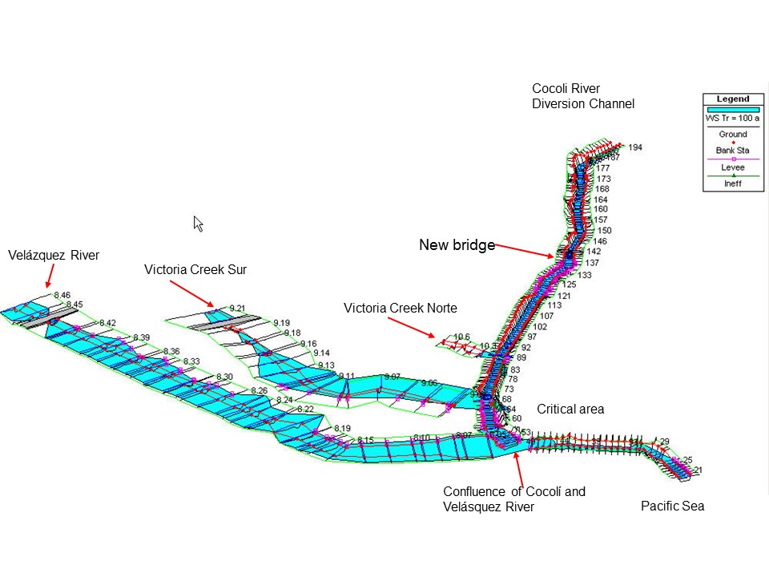

Figure 25. Scheme of the diversion Channel of Cocolí River.

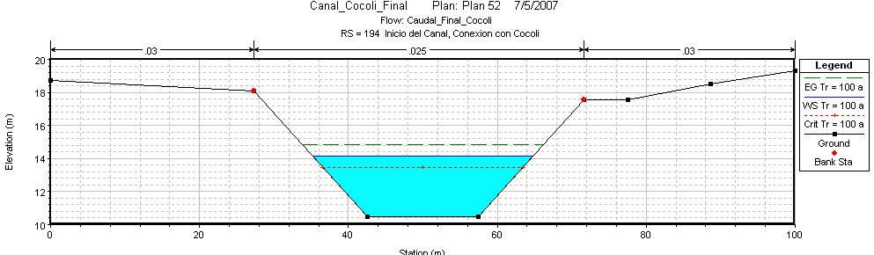

Figure 26. Prismatic section proposed for the diversion Channel.

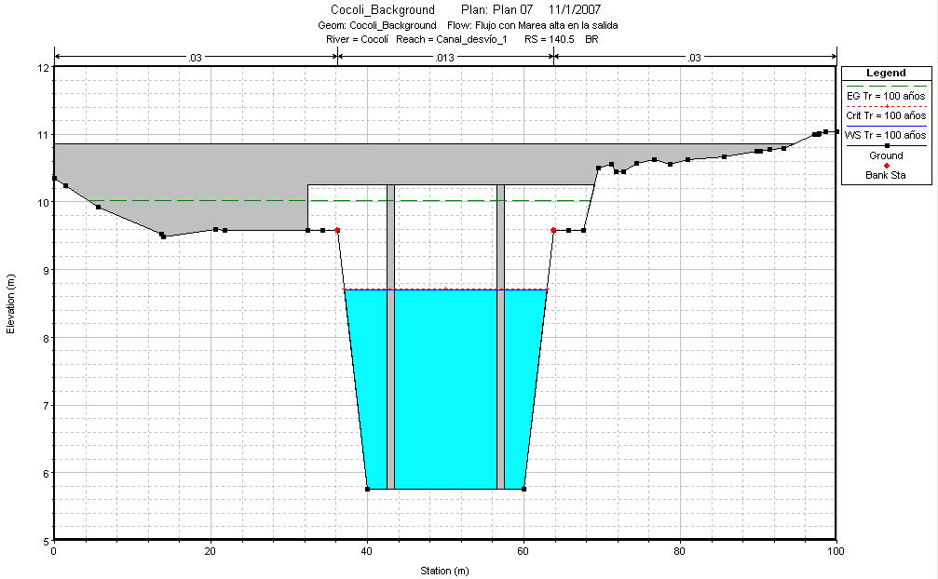

Figure 27. Extraordinary Maximum Water Level for the new bridge.

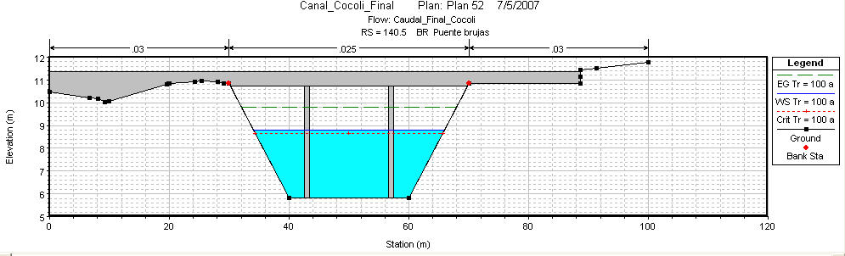

Figure 28. Extraordinary Maximum Water Level for the Brujas Bridge in Velázquez River.

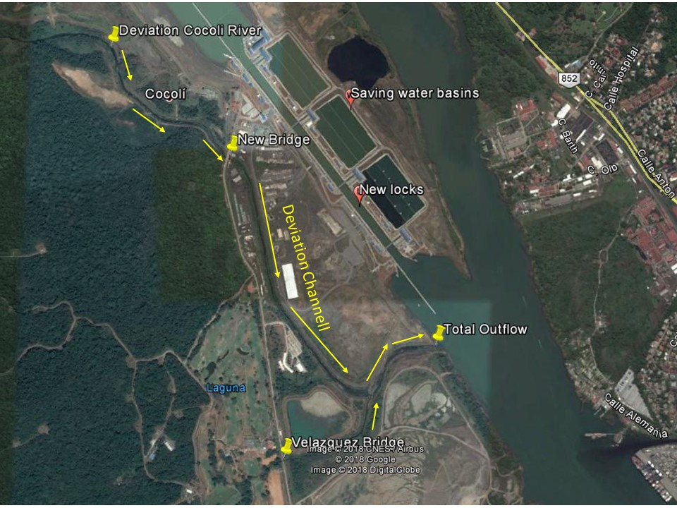

Figure 29. Image of the Cocoli river deviation channel and the new locks of the Pacific side.

1. Manager Water Resources Section [↑](#footnote-ref-1)
2. Email: jcuevas@pancanal.com [↑](#footnote-ref-2)
3. The date was taken arbitrarily, considering as a reference a rain event of the year 2003. [↑](#footnote-ref-3)