ON THE CAPACITY OF ESTUARINE ACCESS CHANNELS:  
A WESTERN SCHELDT CASE STUDY

**by**

*Kevin Delecluyse, Sarah Doorme, Tim Vandenbroucke, Roeland Adams*[1] *and Youri Meersschaut[2]*

**ABSTRACT**

As the demand in maritime traffic increases, so does the need for traffic flow models that can study the nautical accessibility and the capacity of the access channel and port basin to accommodate larger vessels. IMDC has developed such a model for estuarine channels by taking a traffic model for waterway networks and expanding it with a planning module for the destination harbour and including logical rules and maneuvers to translate the typical, complex sailing behaviour of ships on an estuarine channel. The model was then tailored to the case study of the Western Scheldt, an estuarine channel that brings vessels from the North Sea to the port of Antwerp. After calibrating and validating the model to ensure its capabilities of simulating present conditions, the model is being used to investigate the effect of increasing traffic on the channel capacity, and to estimate whether the prognosis for traffic in the year 2030 would lead to congestion issues or capacity problems in the Western Scheldt and/or the port facilities. It can be concluded that with some additional modifications the model can be made fit to simulate traffic flow of ships on estuarine channels.

1. **INTRODUCTION**

The increase in demand in maritime traffic leads to changes in ship size, charge and draft, leading to more challenging operational conditions of maritime ports, particularly more inland situated ports such as Antwerp. Real time nautical models have been developed and used to study the nautical accessibility and to study the conditions for maneuvering to and in the ports (Verwilligen et al., 2008). Such models are limited to the study of the behaviour of one ship and its interaction with other ships and the shallow water conditions in the port basin and the access channel. Useful and necessary information for pilots is deduced from such simulations to improve the safety of the port entry. However, other instruments are required to deduce information on the capacity of the access channel and port basin to accommodate larger vessels in a context of increasing traffic.

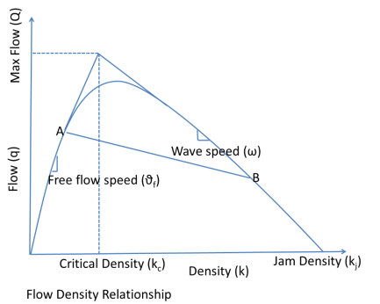

**Figure 1: Relationship between traffic flow and traffic density (source: http://www.lorenzopareschi.com/2010/07/research-activity-kinetic-and-mean.html)**

As in all traffic situations, an continuous increase in traffic density (number of vessels), will at first lead to an increase in traffic flow (cargo), before reaching a maximum value and finally decreasing to zero (standing still). This is illustrated in Figure 1.

Figure 1 does not take into account the complexity of the infrastructure or the multimodality of traffic, yet it does illustrate the basic principle that capacity is equal to the maximum traffic flow. The rounded nature of the tipping point indicates that, prior to reaching the maximum capacity, the traffic flow no longer increases proportional to the traffic intensity. In other words, the transport efficiency decreases. Plans to increase the port capacity related to the expected traffic increase led to a prior demand to investigate traffic flow. IMDC developed a new traffic model capable of investigating the flow and potential saturation point of the access channel and port basin.

1. **THE STUDY AREA**

The Western Scheldt, shown in Figure 2, is the estuary of the Scheldt river that lies completely within Dutch borders. As such, it is an estuarine, intertidal channel that is bordered by the North Sea at its downstream end and the Belgian border (also the location of measuring point CP, used throughout this study) at its upstream end. From there on out, the river is renamed the Lower Sea Scheldt and – even further – the Upper Sea Scheldt.

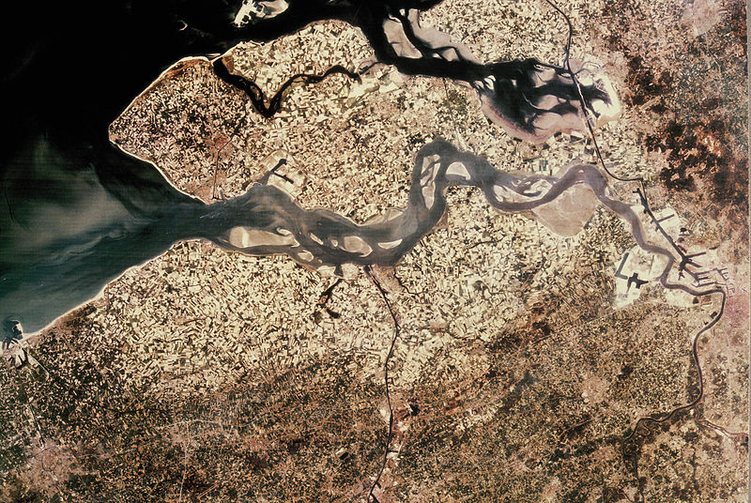

**Figure 2: Aerial view of the Scheldt delta showing the North Sea, the Western Scheldt and the port of Antwerp.**

The port of Antwerp, shown in Figure 3, is located just upstream of the Dutch-Belgian border. It consist of two large harbour areas: Linkeroever (also known as Waaslandhaven) at the left bank of the Scheldt, and Rechteroever at the right bank. The Linkeroever harbour can be reached through two locks: the Kieldrechtsluis and the Kallosluis. Rechteroever has four locks, in two groups of two: the Berendrechtsluis and the Zandvlietsluis at the downstream end, and the Boudewijnsluis and the Van Cauwelaertsluis at the upstream end. Besides the two harbours, the port also consists of three tidal terminals. From downstream to upstream these are the Noorzeeterminal, the Europaterminal and Deurganckdok (separated into Deurganckdok Oost and Deurganckdok West), which is actually a dock leading to and from the Kieldrechtsluis.

1. **THE NAUTICAL MODEL**

IMDC-Waterways (Adams et al., 2014) is a traffic model for waterway networks. It provides insight into the fluidity of traffic as a function of traffic intensity, the bottlenecks in the network and the capacity of the network and its subzones to process current as well as future traffic intensities.

Study areas are divided into a network of homogeneous units or links (e.g. channels, lock complexes) connected by nodes. Fairway properties such as depth, width and angle of curvature can alter between links, but stay the same inside the link. The actions and interactions in the waterways occur on a mesoscopic scale. At the starting node of a link, a prediction is made of the arrival time at the end node of the link, based on the present ship velocity and the path length of the link.

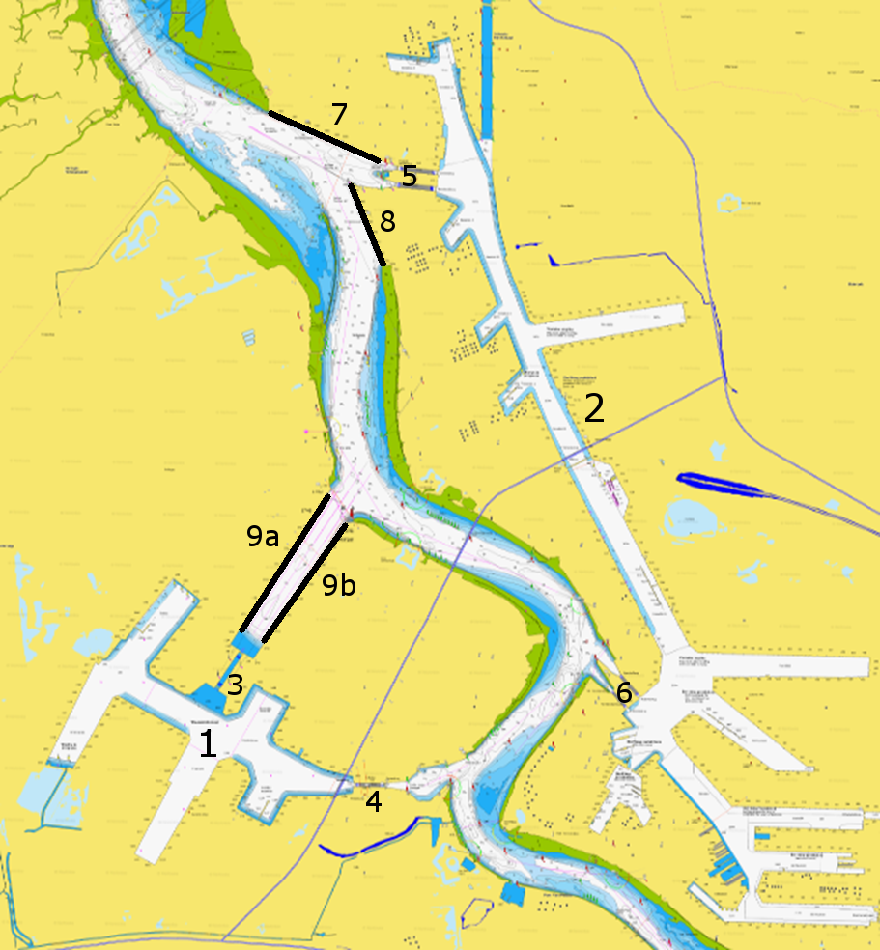

**Figure 3: The port of Antwerp, with Linkeroever (1), Rechteroever (2), Kieldrechtsluis (3), Kallosluis (4), Berendrechtsluis and Zandvlietsluis (5), Boudewijnsluis and Van Cauwelaertsluis (6), Noordzeeterminal (7), Europaterminal (8), Deurganckdok West and Deurganckdok Oost (9a and 9b).**

When the ship arrives in the end node, the maneuvers of the ship in the link are processed and the real arrival time is calculated. The transfer between links is processed on a microscopic scale. Vessels that want to enter a next link are assigned a departure time that depends on the traffic already present in the link and the other vessels that are queueing at the link entrance. This could cause an extra adjustment to the arrival time at the end node of the previous link.

This combination of microscopic treatment with schematization at different abstraction levels allows to shed light on certain aspects without going into detail too much.

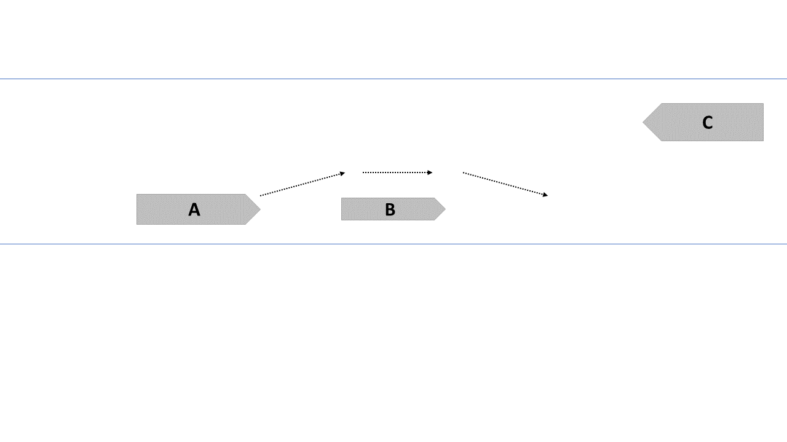

**Figure 4: Schematic representation of an overtake maneuver. Ship A = overtaking ship, ship B = overtaken ship, ship C = oncoming ship.**

The IMDC-Waterways model was expanded in a number of different ways to suit the purposes of the current study. As a precursor to the actual network model, a new planning module is used to simulate the effect of the quay terminals and access locks in and around the two destination harbours. For each vessel type, the tidal windows are calculated based on the water levels registered during the period of interest, the ship draught and the ship sailing speed. These tidal windows are then matched to the generated ship entry times into the network, the sailing time of the ship route and the availability of a lock when the ship arrives at its destination. If the ship has to wait for a lock or quay becomes available, this waiting time is added to the ship entry time into the network. If necessary, the entry time is postponed to a later tidal window and the search continues until the ship is finally planned into a lock or quay. Ultimately, the ship gets assigned an Attributed time Slot (ATS) and an ATS window, i.e. a time window during which the ship may arrive at its destination. This ATS window is determined based on the length of the vessel’s tidal window and the closing of the destination lock.

The time delay a ship might suffer while sailing on the Western Scheldt constitutes a group of changes introduced to the network model. These delays are caused by two kinds of maneuvers the ship could undertake on its route: overtake maneuvers and swing maneuvers.

Overtake maneuvers occur when a vessel encounters another vessel sailing in the same direction at a lower speed, as shown schematically in Figure 4. Only under certain specific circumstances is the faster vessel A allowed to overtake the slower vessel B:

* The vessel velocity difference is larger than 2 knots.
* The available excess channel width– i.e. the part of the channel that isn’t blocked by ship B - is larger than the sum of the width of ship A and the lateral safety distance that needs to be guaranteed between ship A and any vessel it encounters during the maneuver.
* In case the excess channel width does not allow the overtaking of ship B, ship A continues to sail behind ship B and decreases its speed accordingly, until ship A reaches the next network link, thus suffering a delay.
* In case the excess channel width does not allow the oncoming of ship A and an opposing ship C, one of these ships should decrease its speed such that the ship trajectories no longer cross. The selection of the ship that should slow down depends on the time margin the ships have with respect to their respective ATS. In case ship A should slow down, the overtaking maneuver is cancelled and the ship A suffers a delay, similar to the delay discussed above.

Swing maneuvers occur when a ship reaches its destination and needs to turn around before mooring onto a quay or sailing further (as is the case in Deurganckdok). As the swing maneuver takes place, the ship’s turning circle blocks part of the main channel, possibly causing a delay for other ships that need to sail past the swinging ship but cannot due to the excess channel width being too narrow to provide enough lateral safety distance between ships.

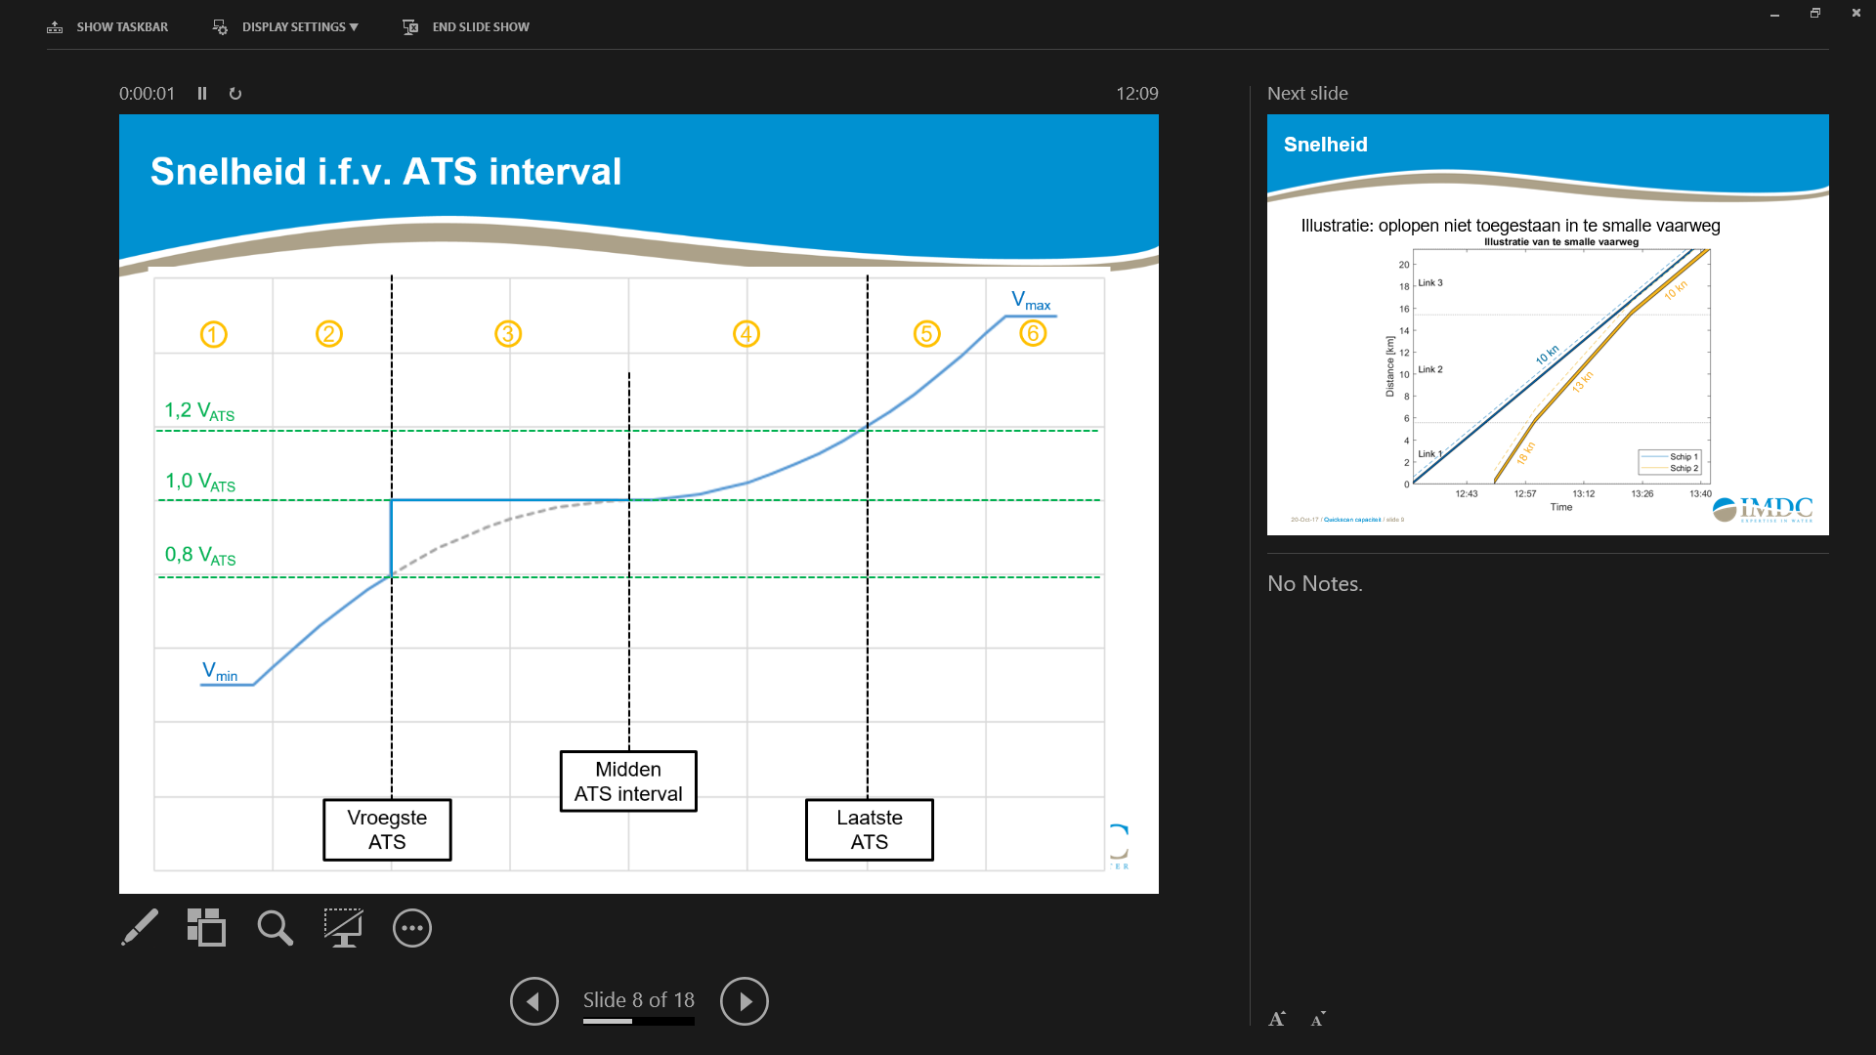

Interme-diate ATS

Latest ATS

Earliest ATS

**Figure 5: Ship speed adjustment mechanism based on the ship ATS window.**

The ATS is one of the key elements in modelling the realistic behaviour of vessels, which want to make up for lost time by increasing their speed if the delay caused by the aforementioned maneuvers become too large, or have to decrease their speed when the destination lock isn’t ready. The governing process behind this automatic self-adjustment of vessel speed during the simulation of a ship trajectory is shown in Figure 5.

When a ship arrives at a node of the network, the projected arrival time at its destination is calculated based on the remaining travelling distance and the ship speed. If the ship would arrive too early, i.e. earlier than the earliest RTA, which is the lower limit of the ATS interval, the ship velocity is multiplied by a factor determined by the blue curve in zone 1 and 2 in Figure 5. Alternatively, should a ship arrive later than the middle of the RTA interval, the multiplication factor is determined by the blue curve in zones 4, 5 and 6. Finally, I the ship would end up somewhere tween the earliest RTA and the middle of the RTA interval, the ship is allowed to keep on sailing at its current speed. At no time can the ship sail at a speed higher than its maximum speed and lower than its minimum speed, as shown in zones 6 and 1, respectively.

1. **TRAFFIC**

In order to investigate the capacity of the study area to process increasing traffic, a traffic generator is required that can generate an artificial series of traffic that acts as a best guess of the expected traffic. To this end, the present traffic needs to be analysed and discretized into a number of ‘type vessels’. This analysis is done on a 2016 extract of the APICS (Antwerp Port Information and Control System) database, an integrated system of part related processes that enables the port authority and its partners to plan and follow up the traffic to, from and inside the harbour. It contains all registered journeys of seaworthy vessels to and from the port of Antwerp, together with some properties of the vessel and the journey itself. For the current model, the vessel types in the APICs dataset are rearranged into a new set of vessel types, namely container vessels, tankers, dry bulk carriers, general cargo and roll-on-roll-offs. The ships are then further categorised based on their origin and destination, retention time in the harbour, sailing velocity, dimensions and draught.

After analysis of the APICS traffic and determination of the vessel types, the artificial traffic series is generated using a stochastic process that is best described by a non homogeneous Poisson process (NHPP). This is carried out while taking into account the following, study area specific conditions:

* Tidebound vessels are stochastically generated, yet can only enter the network during a suitable tidal window
* The lock complexes in the port of Antwerp aren’t accessed freely, yet carefully planned (cf. section 3) and codirect the traffic flow on the river Scheldt.
* As the study area is connected to the Lower Sea Scheldt through a narrow passage, access to the Lower Sea Scheldt isn’t free yet is dependent on traffic conditions. Despite the stochastically generated inter-arrival times, vessels are only allowed entry into the model when this is physically possible.

1. **SENSITIVITY ANALYSIS**

Given the complicated nature of both the planning of quays and locks in the harbour and the sailing behaviour of actual vessels on a river such as the Scheldt, a sensitivity analysis was carried out to get a sense of the variation that can be expected on the results when changing certain parameters. As for the planning module, parameters such as the available percentage of quay length, maximum filling percentage of the locks, the opening and closing times of the lock doors and the availability window of a lock were a wide range of values. The simulations were carried out using the registered traffic and their actual harbour retention times as pulled from the APICS dataset, and feeding this traffic to the planning module. For each simulation, the simulated quay and lock occupancy percentages were compared to the results calculated from the APICS dataset for the same period.

Figure 6 and Figure 7 show the comparison of quay and lock occupancy percentages, respectively, for the best combination of parameters. The figures show that the quay occupancy aligns very well with that drawn from the APICS dataset. The lock occupancy percentage for the harbour of Linkeroever shows a slight discrepancy between the two locks, meaning that more ships are entering the harbour through the Kieldrechtsluis than the Kallosluis. Still, the numbers are within the same order of magnitude as those registered in APICS. Meanwhile, the occupancy percentage of the locks giving access to the Rechteroever harbour show a very good agreement with the APICS data.

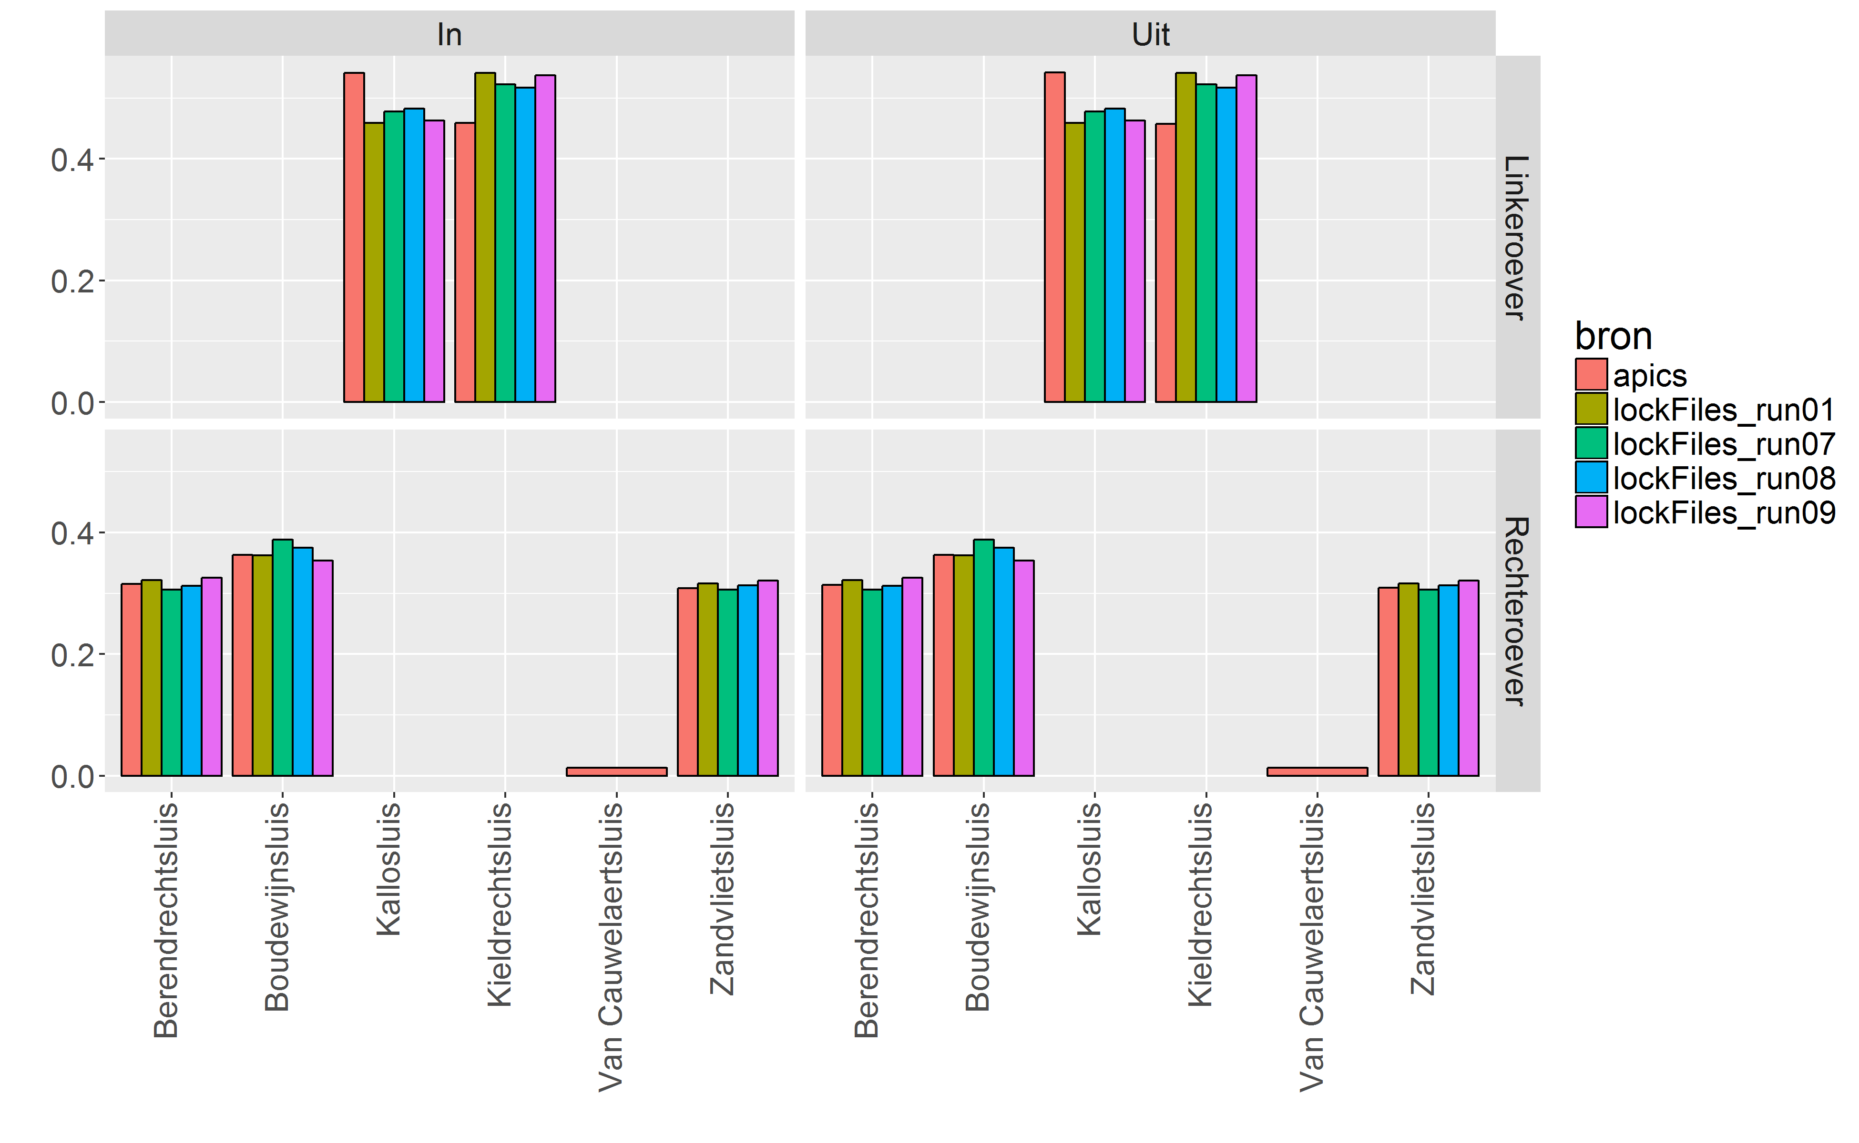

**Figure 6: Lock occupancy percentage for in- and outbound traffic (left and right frames, respectively) and Linkeroever and Rechteroever (top and bottom frame, respectively).**

The main parameter that was changed in the network model is the coefficient used for calculating the lateral safety distance between two ships, typically expressed as C.B, with B the width of the largest of the two ships and C the coefficient in question. The sensitivity analysis was carried out by calculating the excess channel width that remains in all of the network links when two ships of different dimensions meet each other there. This results in passable and non-passable sections of the network for every ship combination, which was then compared to a similar sort of ‘passability chart’ created from the expert knowledge gather during pilot interviews. In the end a coefficient of 1.3 was retained, making the safety distance SD = 1.3 B.

1. **VALIDATION**

The APICS output for a model period of 17/06/2017 – 20/08/2017 was compared to the model output for three different simulations. The final goal of the validation is to determine the ability of the model – i.e. the combination of traffic generator, planning module and network model – to simulate the sailing behaviour and interactions of a real fleet of ships. Only when the agreement is good enough will the model be able to be used with confidence to simulate future traffic flows and do assessments of waterway capacity.

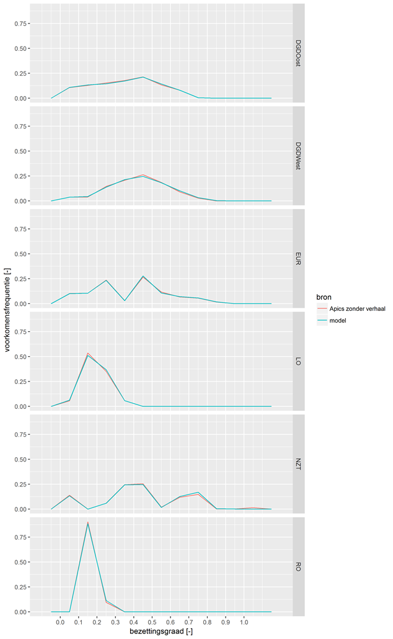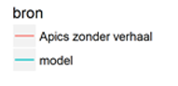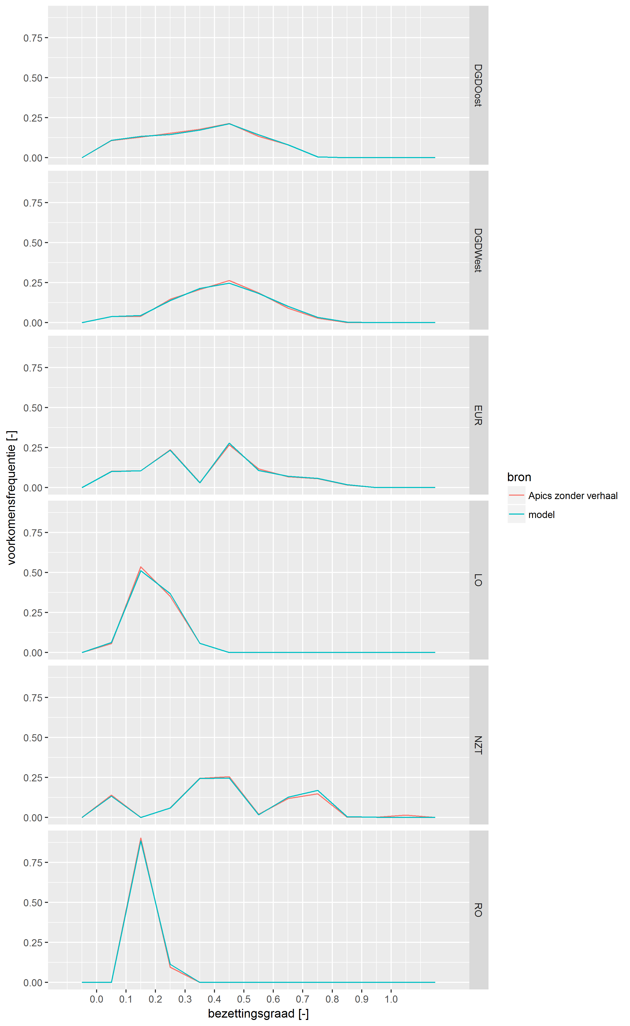

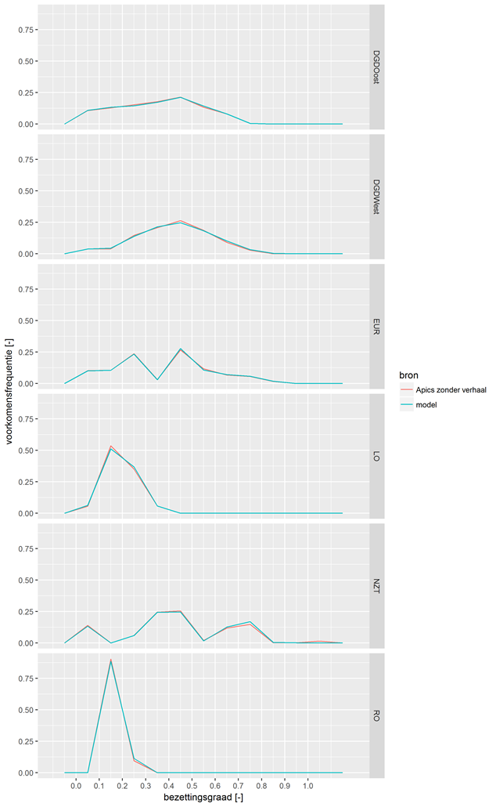

**Figure 7: Quay occupancy percentages (abscissa) and their frequency of occurrence (ordinate) for quays at Deurganckdok Oost (DGDOost), Deurganckdok West (DGDWest), Europaterminal, Linkeroever port (LO), Noordzeeterminal (NZT) and Rechteroever port (RO)**

In a first simulation (denoted ‘registratie enkel’), the APICS traffic is recreated as faithfully as possible by simply having the ships from the APICS dataset enter the model and leave the harbour at their registered times. This simulation circumvents the planning module and focuses on the ability of the network model to recreate realistic ship behaviour.

A second simulation (denoted ‘registration retour’) takes the registration times from APICS and uses them as input for the planning module such that the vessels’ effective departure and arrival times are determined by the availability of the locks and quays and the modelled minimal retention time for each ship type. Finally, a third simulation includes the traffic generator and carries out a simulation (including planning) using an artificial traffic series determined as described in section 0.

Comparison between model and measurements is achieved through two parameters: the vessel velocity and the amount of overtake maneuvers a ship is involved in. The first parameter is displayed in Figure 8 as a velocity per vessel type and per model section (three sections are defined: the coastal region, the river itself and the harbour) for both up and downstream parts of a ship’s journey. The figure shows that a very good agreement is found for all three simulations, across all vessel types and model sections, for both directions of travel. The second parameter can be analysed in two ways, i.e. the number of times a ship is being overtaken by any other ship during its journey, and the number of ships the ship overtakes during its journey.

Figure 9 compares the percentage of occurrence for both numbers for all three simulations with those derived from the measurements. The simulation that is expected to yield the best comparison actually performs the weakest, while the model with biggest uncertainty yields the best agreement. A possible explanation is the uncertainty that is connected to the APICS data and how the sometimes erroneous data is interpreted in the translation to the traffic series for the first simulation.

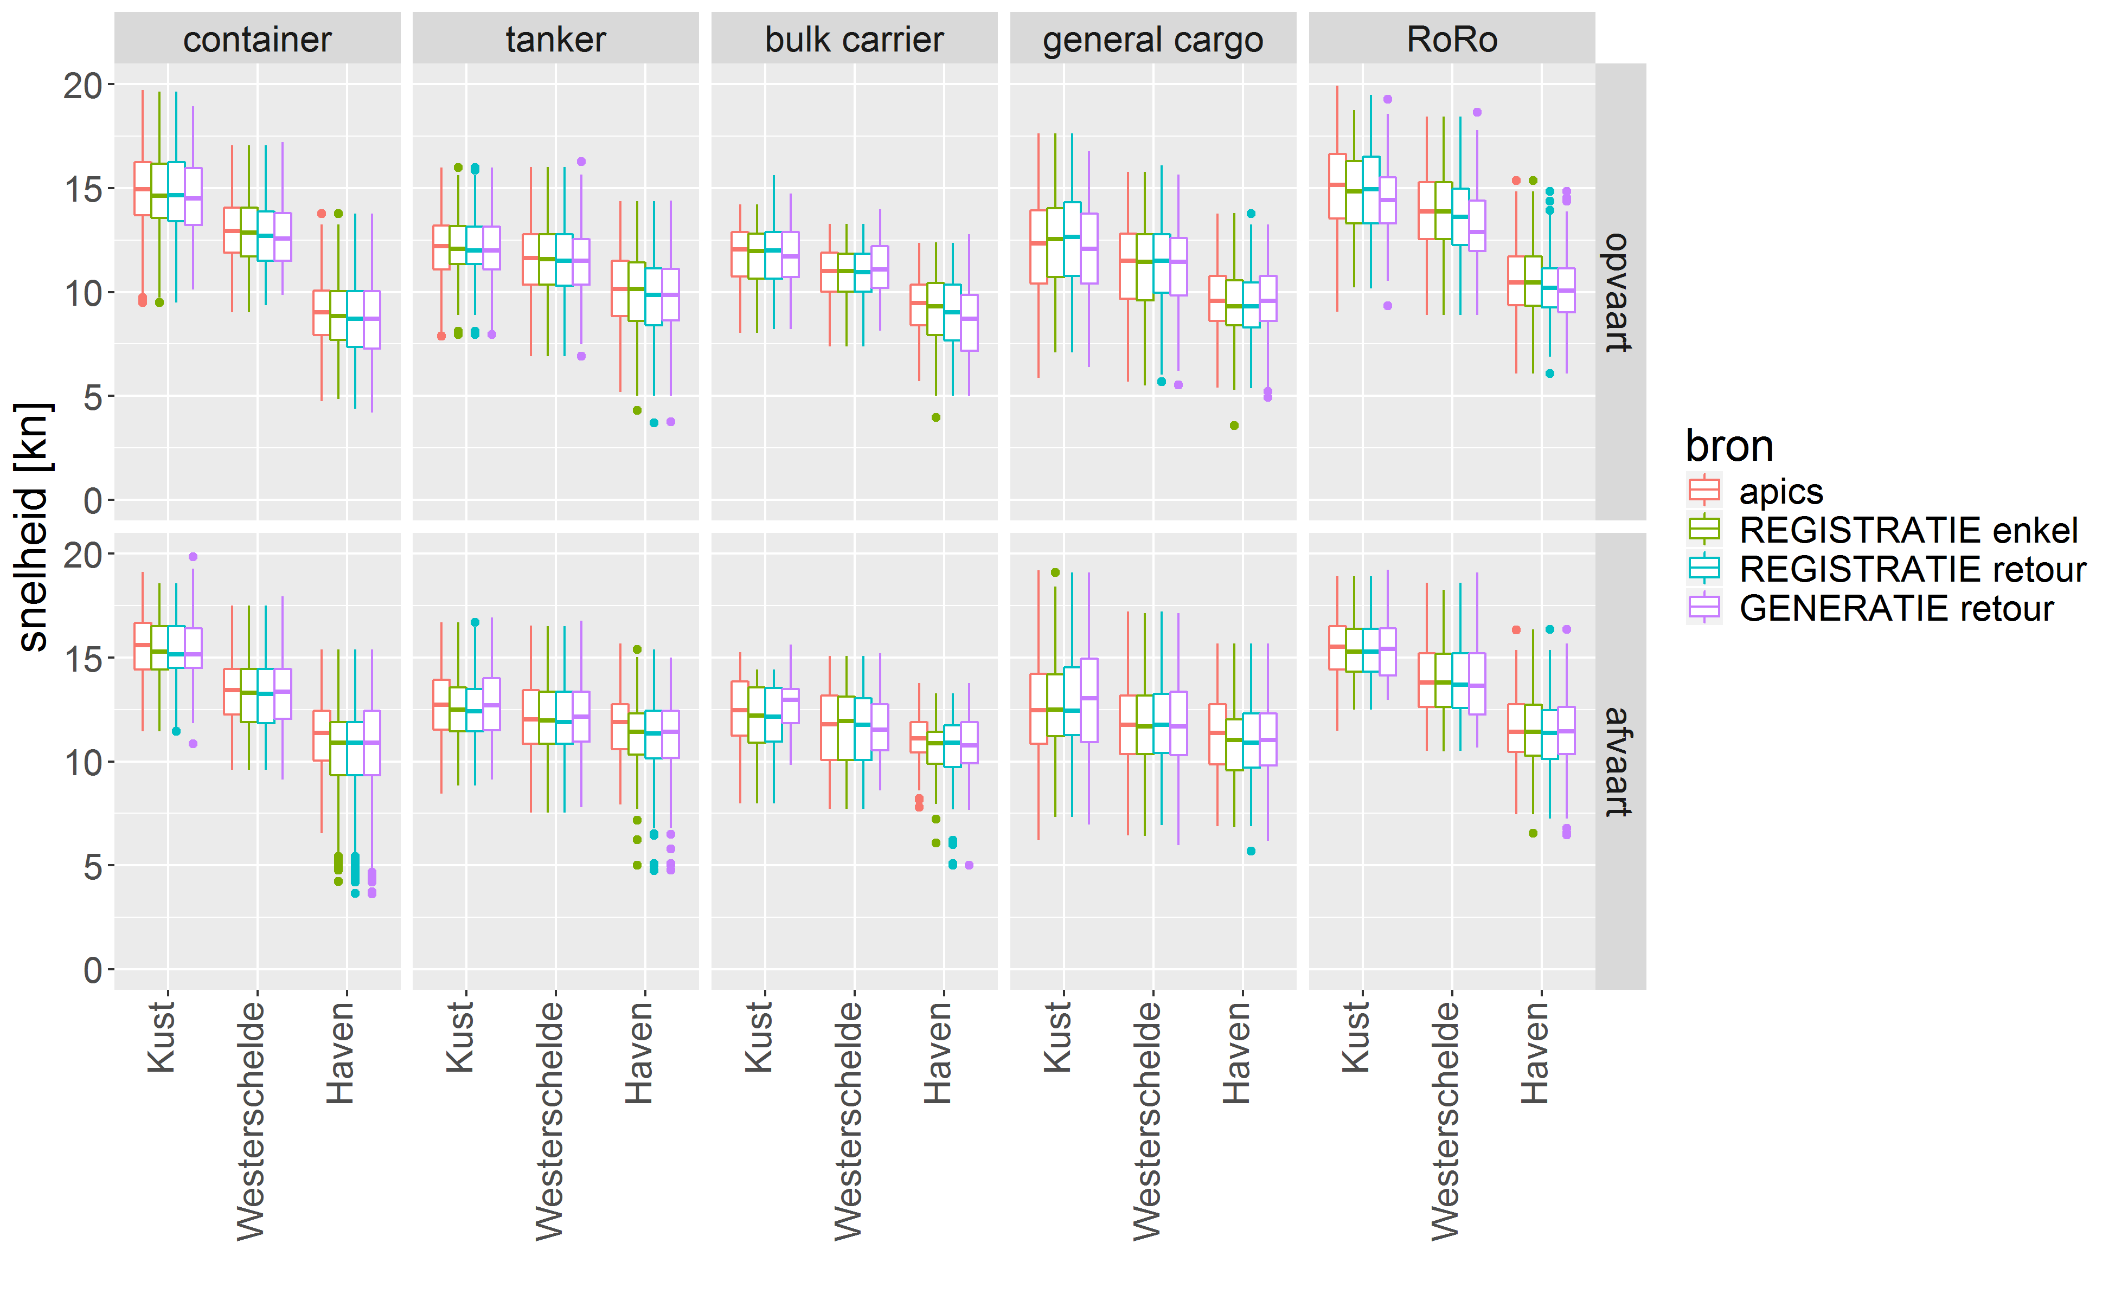

**Figure 8: Comparison of registered ship velocities (APICS) with the velocity output of three simulations, for three sections of the river. Upper frame: portbound traffic, lower frame: seabound traffic.**

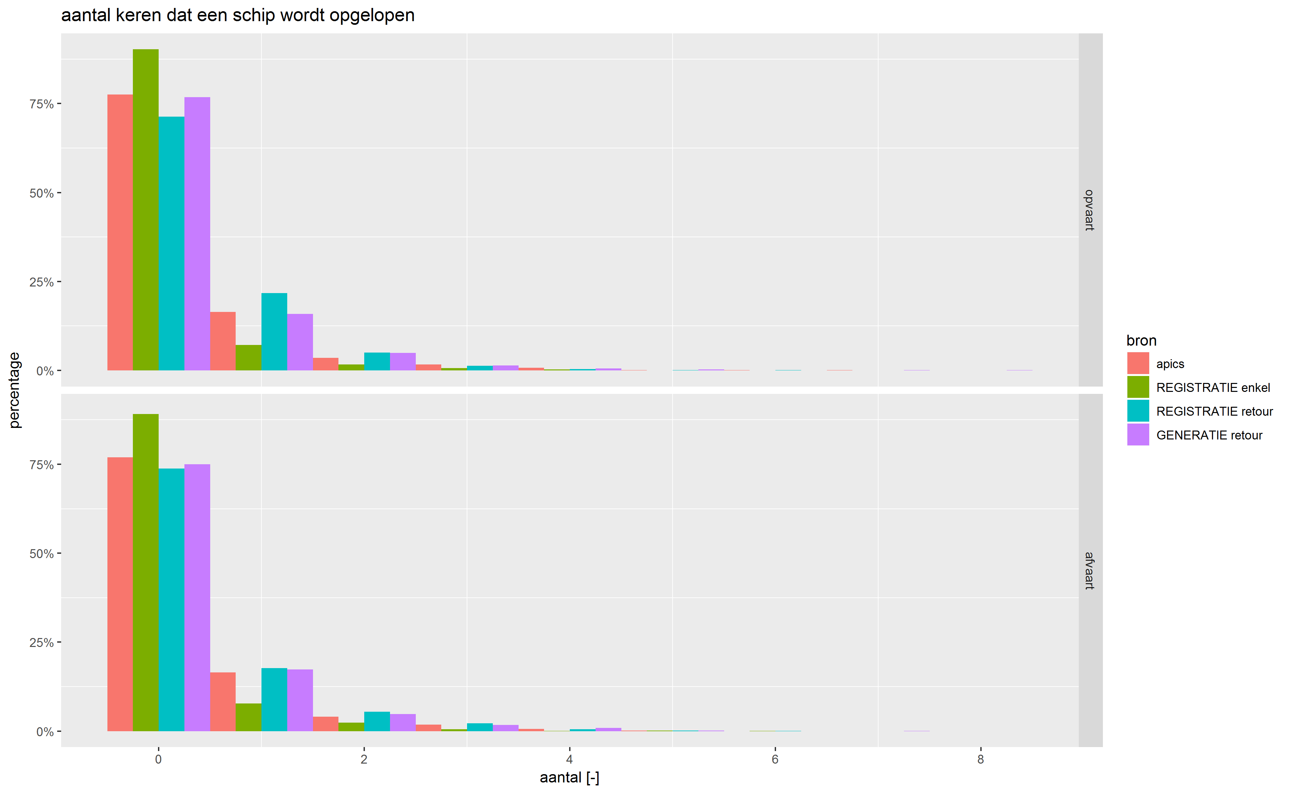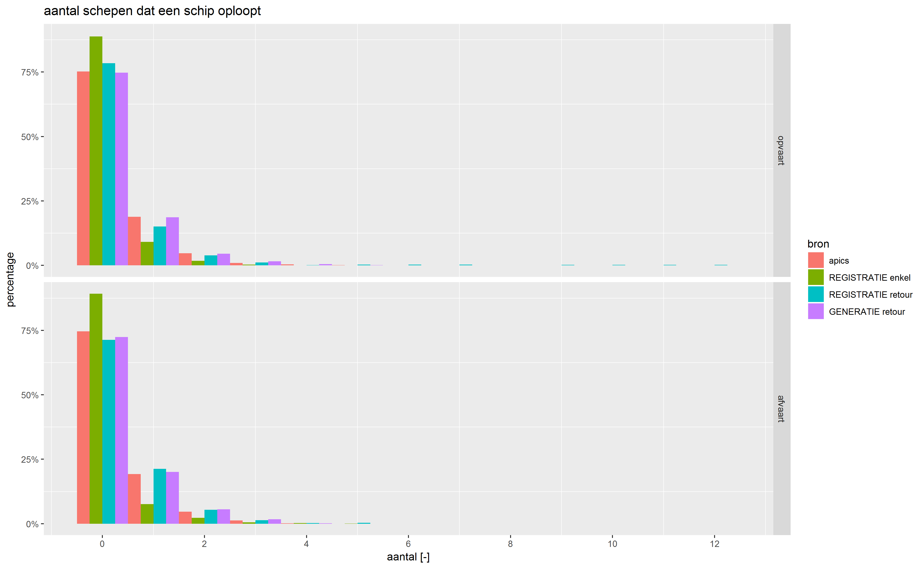

**Figure 9: Number of times a ship is overtaken (left) overtakes another ship (right) in the APICS dataset and the three validation simulations. Upper frame: portbound traffic, lower frame: seabound traffic. Red: APICS data; Green: registry one way; Blue: registry return; Purple; generated traffic.**

In such cases, it is possible that swapping this data uncertainty for a modelled ‘general’ value smoothens out any outliers or ‘bad ships’ that would contaminate the comparison, thereby improving the model agreement with the logged journey data. In any case, the very good agreement of the overtake parameters derived from the third simulation and the APICS data respectively, is a testimony of the apt functioning of the planning module and the traffic generator.

1. **THE CAPACITY OF THE WESTERN SCHELDT**

**7.1 Theoretical capacity analysis**

Simulations were carried out with an increased traffic flow to investigate whether an increase in traffic would saturate the Western Scheldt. The traffic generator was used to generate times series of ships for twice, three and four times the traffic flow, respectively. These times series are generated using the non-homogeneous Poisson process described in section 0. Figure 10 shows the variation of traffic (flow and density) summarized over a tidal cycle as a function of time. The variation is random. Both density and flow show a similar evolution, which indicates that capacity is not yet reached for these traffic multiplication factors.

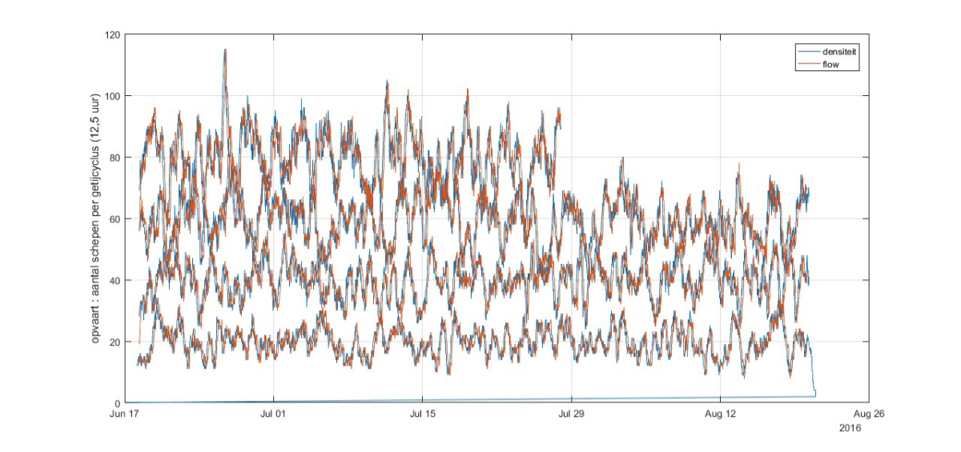

**Figure 10: Traffic (flow = red curve, density = blue curve) expressed as number of ships over a 12.5 hour period of portbound traffic. Seabound traffic shows a similar view.**

Plotting density as a function of flow in Figure 11 still shows a linear relation, which again implies that the capacity of the river system has not yet been reached for the increased traffic.

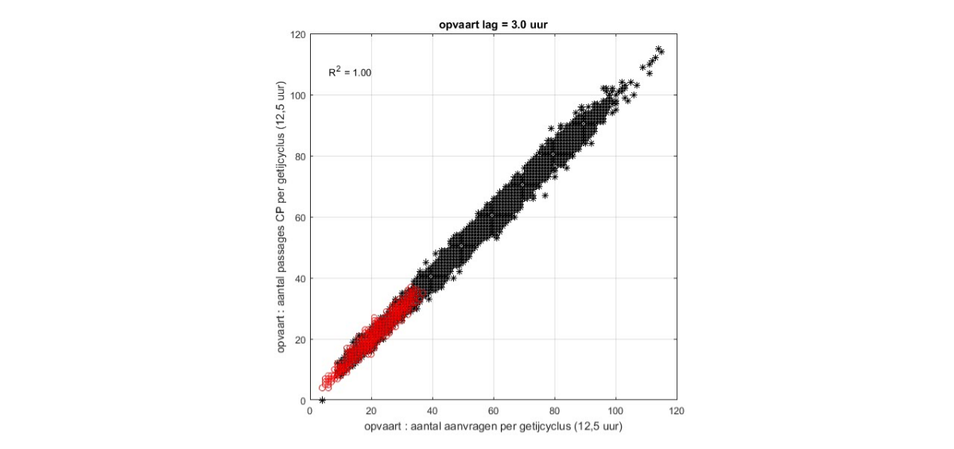

**Figure 11: flow/density chart resp. passages at CP and requests for departure (time difference 3 hours). The figure can be considered as an example of the linearly increasing part of the curve in Figure 1. The red zone indicates the traffic of the prognosis.**

**7.2 Prognosis 2030**

A prognosis for the expected traffic in 2030 was carried out in the frame of the ECA project, in which alternatives for additional container capacity for the Port of Antwerp are being investigate. This was translated by the Port of Antwerp to the total amount of ships that would sail on the Western Scheldt and towards the different port terminals in that year, distributed over the different ship categories.

The main question when simulating with future traffic is if the ability of the fairway to get all of the vessels at their destination without any notable delays and/or problems. In order to answer this question, Figure 12 and Figure 13 again compare ship velocities and overtake maneuvers, respectively, this time comparing the results for the future traffic with the reference case established at the end of the validation exercise (i.e. simulation ‘generate retour’).

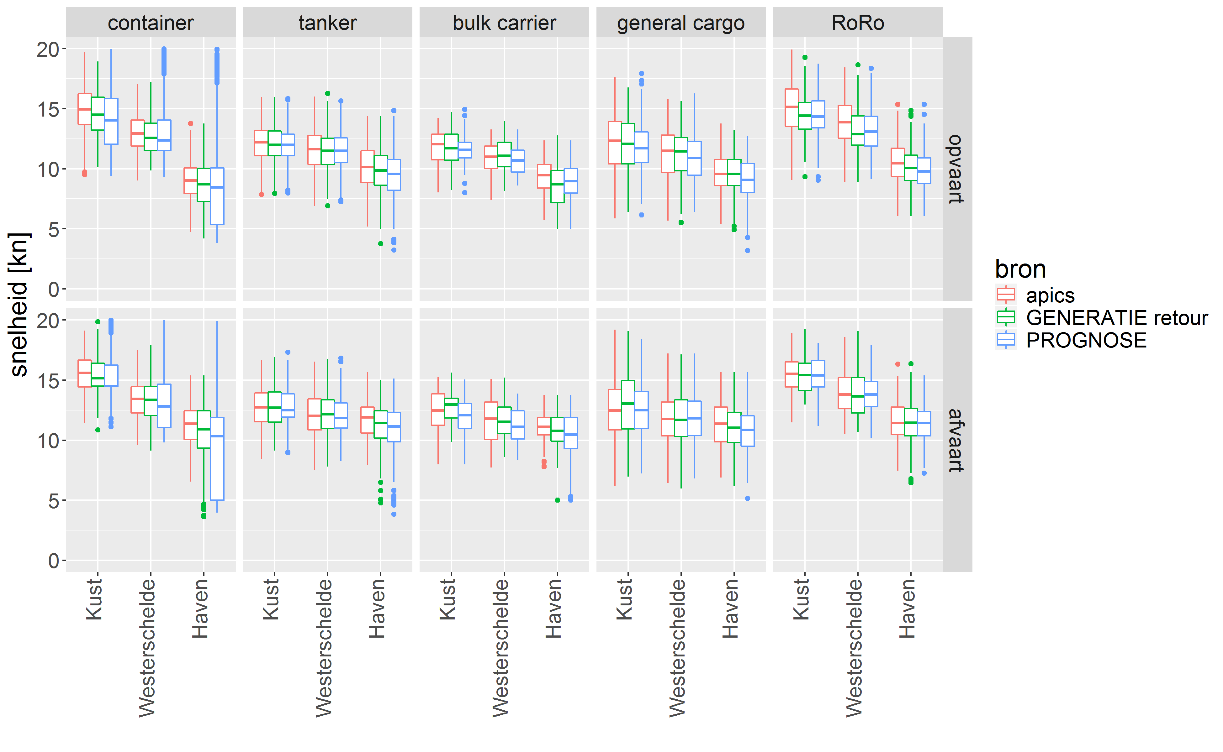

**Figure 12: Comparison of registered ship velocities (APICS, red) with the velocity output of the reference case (green) and the prognosis simulation (blue), for three sections of the river. Upper frame: portbound traffic, lower frame: seabound traffic.**

The figures show that the ship conduct in the prognosis simulation is analogous to that of the reference case.

There is an increase in the number of overtake maneuvers and overtaken ships, which indicates that there is still plenty of room left on the fairway to engage in ship maneuvers and capacity is far from reached. Indeed, as the fairway reaches its capacity, one would expect an increasing difficulty at conducting overtake maneuvers as:

1. the room between ships decreases and the overtaking distance - i.e. the distance a ship must sail next to other ships it is overtaking before it can sail in its ‘proper lane’ – increases and
2. the opposing traffic intensity increases, as do the amount of crossing maneuvers in both directions, which pose an extra threat to the ability to perform an overtake maneuver (cf. section 3). At full capacity, ships would be stuck in an endless ‘traffic jam’, sailing in one single, continuous file in each direction, adapting to the speed of the slowest ship.

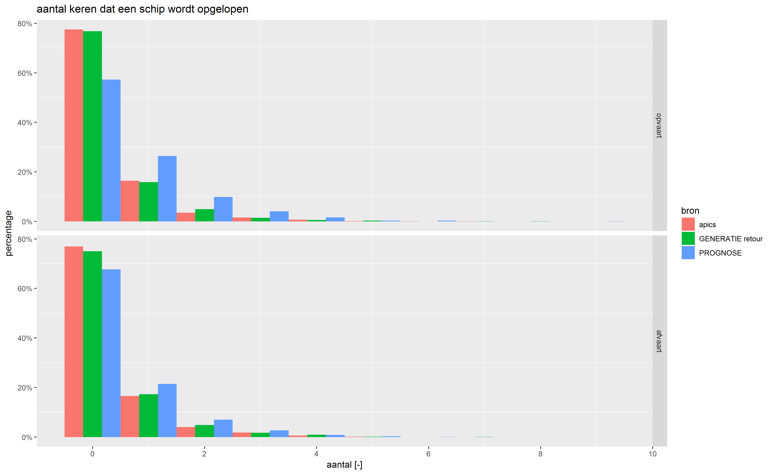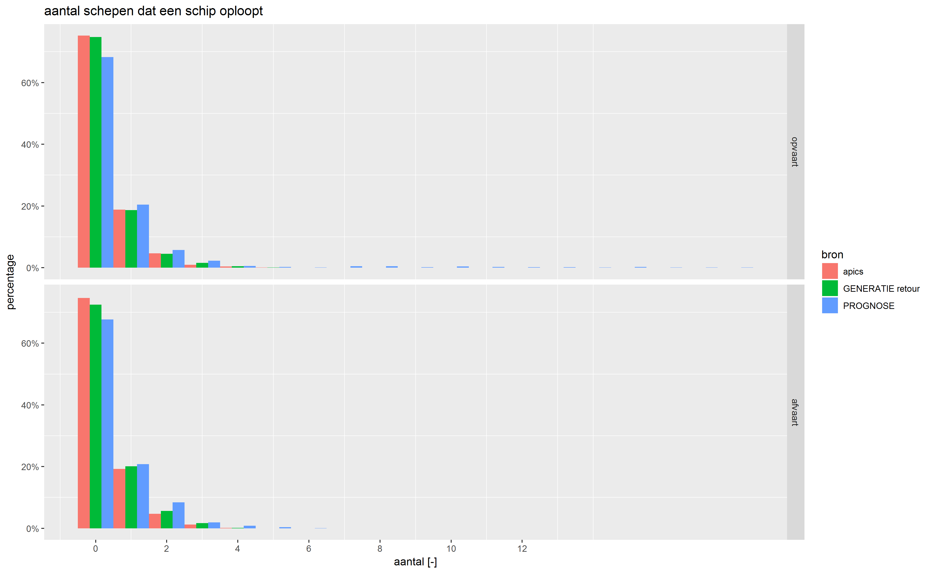

**Figure 13: Number of times a ship is overtaken (left), a ship overtakes another ship (right) in the APICS dataset (red), the reference case (green) and the prognosis simulation (blue).. Upper frame: portbound traffic, lower frame: seabound traffic.**

Overall the ship velocities are in good agreement across all river sections and ship categories, a significant decrease in average velocity is not noticeable, as would be expected in case of saturation. However, some ships appear to sail at higher speed, particularly in the port area, indicating that in order to respect the ATS compensation is required by increased sailing speed. Therefore, at this stage, it must be concluded that the model is not yet decisive. Therefore, modifications are required to effectively limit speed in the port area, and to check whether delays can be compensated earlier.

1. **CONCLUSION**

A traffic model for waterway networks was expanded to investigate the fairway capacity of the Western Scheldt. Main additions are a planning module that regulates when ships start and end their journey, and the inclusion of ship maneuvers that frequently occur.

Validation results indicate that the traffic generator, the planning module and the network module are all capable of adequately simulating the development of traffic in estuarine channels and port basins with complex connections to tidal terminals and dock and port basins connected with locks for the current situation.

Although preliminary results tend to indicate that the fairway has not yet reached capacity for the traffic predicted for 2030, the model needs additional modifications to allow for decisive conclusions in the port area itself.

1. **REFERENCES**

Adams R., Bayart P. & Doorme S. (2014). IMDC WATERWAYS, A design tool tailored to the need of integrated design of waterway infrastructure. 33rd PIANC World Congress, San Fransisco.

Verwilligen, J.; Vantorre M.; Eloot, K.; Mostaert F. (2008). Haven van Antwerpen, Op- en afvaartregeling voor 8000 en meer TEU containerschepen. WL Rapporten, 689_04. Waterbouwkundig Laboratorium & Universiteit Gent.

1. International Marine and Dredging Consultants (IMDC), Van Immerseelstraat 66, BE2018 Antwerp, Belgium
2. Departement Mobiliteit en Openbare Werken, Afdeling Maritieme Toegang