Paper 124 – St-Lawrence Seaway Modernization

NOLET B.; P. Eng.

St-Lawrence Seaway Management Corporation (SLSMC), Canada

Email (1st author): [bnolet@seaway.ca](mailto:bnolet@seaway.ca)

ABSTRACT: The SLSMC is modernizing its current mode of operation through the use of various key technologies: (1) Hands-Free Mooring (“HFM”); (2) Vessel Self-Spotting (“VSS”); (3) Remote Operation and (4) Leveraging AIS. HFM employs vacuum technology to secure a vessel to the lock wall at the touch of a button, instead of the traditional manual tie-up process. The project complements existing technology and enables the SLSMC to continue providing safe and reliable transits while improving its financial position through reduced costs and increased revenues.

# 1 INTRODUCTION

In its effort to tighten its operating costs, the St-Lawrence Seaway Management Corporation (SLSMC) had to look at technology in order to leverage its productivity and efficiency, and ensure its sustainability for the long term. In researching different technologies to achieve this, the SLSMC had to align with the interests of its stakeholders who use the system, to ensure that gains are also realized on their side.

As a result of stakeholder consultations, it was deemed essential that the “modernized” Seaway had to be:

* as safe or safer to transit through,
* as fast or faster to transit through,
* able to reduce the need for manual labor during lockages and improve staff efficiency, and
* able to alleviate some of the requirements for specific seaway fittings in order to potentially allow more vessels access into the Seaway.

# MODERNIZATION

## Hands Free Mooring (HFM)

* + 1. *Holding Capacity*

The process of going through the St-Lawrence Seaway locks can be demanding. The need to deploy mooring wires (28mm diam.) to stabilize vessels during turbulent lockages not only puts a strain on vessel components, equipment and personnel, but can also place both lock and ship personnel in harm’s way. Vessels are traditionally subjected to intense hydraulic forces within a very confined lock, and all involved personnel must apply a high level of awareness to ensure a smooth and safe transit.

There have been cases of mooring wires breaking, which can endanger the safety of all personnel in the vicinity. Mooring wires typically break when attempting to stop vessels, or during an upbound lockage, when the turbulence is at its highest.

One of the main goals of HFM was to reduce or eliminate the need for handling mooring wires, in order to eliminate some of the biggest hazards of vessels transiting the seaway system. As well, the elimination of handling mooring wires would not only eliminate time consuming tasks, but would also translate into personnel no longer having to execute heavy labor, and instead, being available to execute other tasks. The challenge resided in the deployment of a mooring system which would surpass the holding capacity of four mooring wires and hold all vessels almost completely in place throughout all the lockages.

For the large commercial vessels (up to 225.5m in Length) four mooring wires are required to secure the vessel inside the locks during the lockages, two at the bow, and two at the stern.

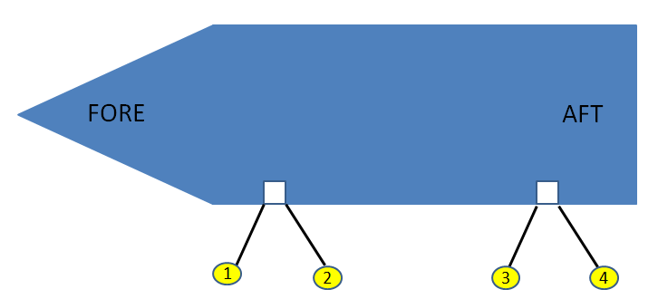

Figure 1: Four Mooring Wires are required for lockages

Mooring wires and associated winches may have a pull capacity of up to 10 Tons each, providing, at best, 20 Tons of holding force in either of the fore-aft direction (assuming wires are parallel to the vessel). Still, it was common to see vessels drifting forward and aft a few meters during a lockage, allowing possible impacts with neighboring structures, causing damage. A typical deep lock in the Seaway has 14metres difference between upper pool and lower pool, and the fill times vary between 8 to 10 minutes. This creates high turbulence around vessels in low pool, with beams sometimes only 600mm less than the width of the lock. The highest forces were measured either at the start of a fill for an upbound vessel, or when the lower mitre gates open prior to releasing a lowered vessel (the lower end mitre gates open swinging towards the vessels).

Any new mooring system not only had to be able to raise and lower with the moored transiting vessels, but also had to be recessed into the existing lock walls when not used. Vessels with beams of 23.77m are common in a lock 24.38m wide leaving no room to accommodate for the equipment, This substantially restricted the allowable fore-aft movement of the new mooring system once moored to the vessels, since vertical slots had to be cut in the existing lock walls to install the new mooring equipment. The need for the HFM equipment to be able to move vertically was emphasized by the high number of vessels who have thick steel rub bars, usually positioned near the waterline. The mooring system had to have the ability to position the different units at a variety of desired heights in order to avoid any rub bars, even if the vessel is in ballast, with a deep draft at the stern and a shallow draft at the bow.

As prototypes were developed and installed, equipped with load cells and strain gauges, along with new water level sensors in strategic locations, data started to be collected for upbound lockages and downbound lockages. Different fill profiles and different locks presented different force patterns over time, which required some HFM equipment adaptation. It was not financially viable to implement a system with sufficient capacity to hold all vessels with zero fore-aft movement allowed. It became evident that a balance between holding capacity and allowable vessel movement had to be achieved. Allowing some vessel movement during lockages drastically reduced the forces on the HFM equipment. Different concepts of energy absorption were explored, ending on the selection of hydraulic cylinders anchored horizontally behind the vacuum pads,

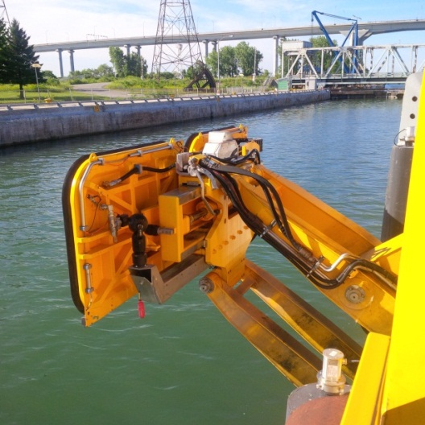

Figure 2: Double Unit extended in to the lock

A standard vacuum pad draws a vacuum of up to -95 KPA, which translates into a coupling force of 20 tons per pad in the pull away direction. The main part of the pad which makes contact with the vessel hull is the neoprene seal on the perimeter of each vacuum pad. The coefficient of friction between the neoprene seal of the vacuum pad and the steel hull is such that the holding force in the vessel’s fore-aft direction is approximately 10 Tons per vacuum pad. Any forces in different directions are to be added when considering the overall holding capacity

. 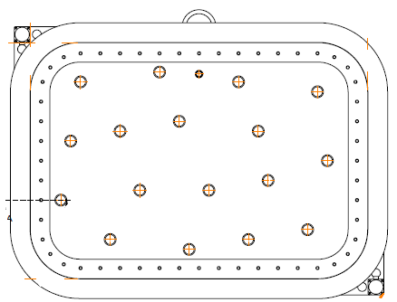

Figure 3: Typical Cavotec MoorMaster tm vacuum pad

The final mooring system being deployed at all deep locks of the St-Lawrence Seaway system is made up of a total of six (6) vacuum pads, providing an overall holding capacity of 120 Tons, or 60 Tons in the fore-aft direction. The layout chosen comprises of three (3) double units, each unit is recessed inside a slot in the lock wall, to minimize civil installation costs. Each pad can move up to 300mm in either direction (downstream or upstream, moored or unmoored).

Allowing a maximum fore-aft movement of 300mm in either direction while moored has been deemed appropriate, keeping the forces within the system capacity for the majority of the vessels. It has also been deemed sufficient to withstand the forces in the reverse direction immediately after mooring upbound vessels in low pool, as a result of the piston effect experienced by large upbound vessels entering the locks with speed.

In some cases, the timing of opening of the intake valves to fill the locks has been adapted to ensure that the main forces on the mooring equipment are vessels pushing into the vacuum pads as opposed to pulling on them, and balancing the fore-aft forces. As well, as a new standard, vessels are now held 300mm away from the lock walls, to preserve the vessel hulls and the lock walls. This change has had an impact of water movements during lock filling, which required some customization of the valve timing opening sequences.

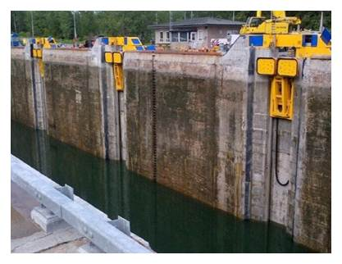

Figure 4: Three double units recessed in a lock wall

* + 1. *Layout of the Mooring system*

When establishing the layout of the equipment, a balance had to be reached between spacing the double units as far as possible to provide them with the best leverage while holding the vessel, and the need to be able to attach to as many vessels as possible using the Seaway system. Commercial vessels as short as 100m in length and as long as 225.5m use the system, and the 6 pads need parallel body to secure the vessels. Based on the profile of the fleet using the Seaway system, it was decided that the optimal layout was to place all three units 25m apart from each other, for an overall footprint of 50m, and centered along the lock wall. Any vessel with approximately 60m of parallel body will be secured with three double units. Shorter vessels may be processed with only two units (4 pads) since the forces on the vessels during the lockages are much less, with the water having more room to move around the vessel.

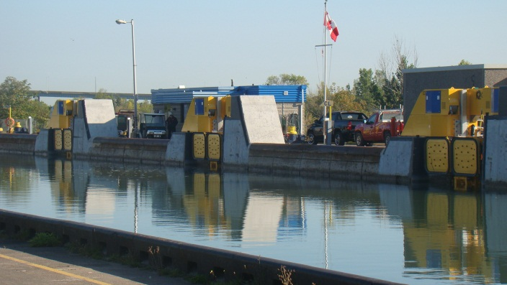

Figure 5: Mooring units centered in the lock wall, 25 m apart from each other

* + 1. *Warping and positioning vessels*

As prototypes were being refined, it also became evident that, for the narrower vessels using the Seaway, the use of wires for positioning close to the lock wall was going to require the provision of an equivalent method, if wires were no longer going to be used. The latest mooring units were designed with the ability to extend close to 2m into the lock, capture the vessel, bring it close to the lock wall and hold it off the concrete face. This added feature has been very well received by the Seaway stakeholders, with the added benefits of safety and time savings.

With the tight tolerances between vessel length and lock dimensions, there was sometimes the need to have vessels move forward 4-5 metres after being stopped, in order to properly fit within the confines of the locks. With the removal of mooring wires, which was the preferred method of finalizing the positioning of vessels, the mooring system had to gain the ability to move vessels a set distance in a set direction (fore or aft). A “Warping” sequence, a Cavotec patented active control technology developed for other installations was modified for this application. It is made up of a series of “attach / move sideways / detach /re-position /re-attach / etc”. The Warping function makes it possible for the Hands Free Mooring system to not only capture the vessels, but also place them in their final position longitudinally in order to proceed with the lockage.

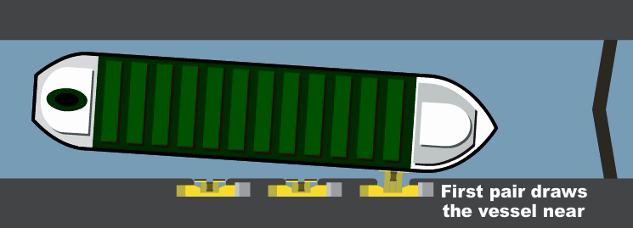

Figure 6: Hands Free Mooring units bring vessels close to the lock wall, and hold them off the concrete wall during the lockage

## Vessel Self-Spotting (VSS)

Vessel clearances at either the stern or the bow can be as short at 3-4 metres. This forces the need for accurate positioning inside the lock before the lockage can proceed.

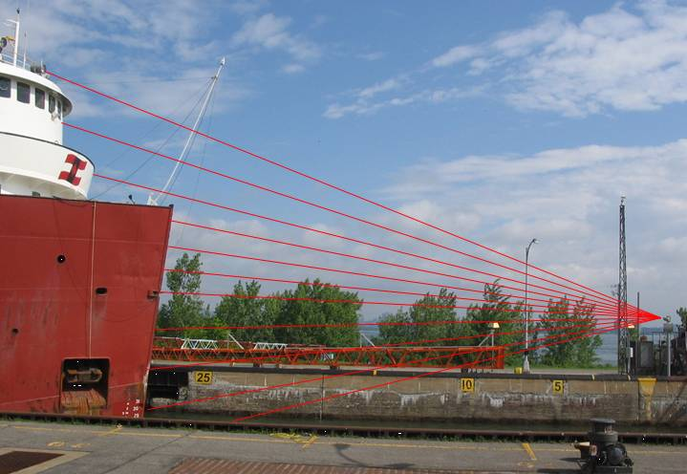

Figure 7: Laser Scanner to spot vessel into lock

VSS uses innovative three-dimensional Class 1, eye-safe laser scanning and image recognition techniques to detect and track the position of the most forward portion of the vessel. It indicates to the vessel the distance it has to go to reach its final mooring position in the lock. The vessel’s position is updated dynamically and displayed to the vessel on LED panels, as it progresses to its final mooring position.

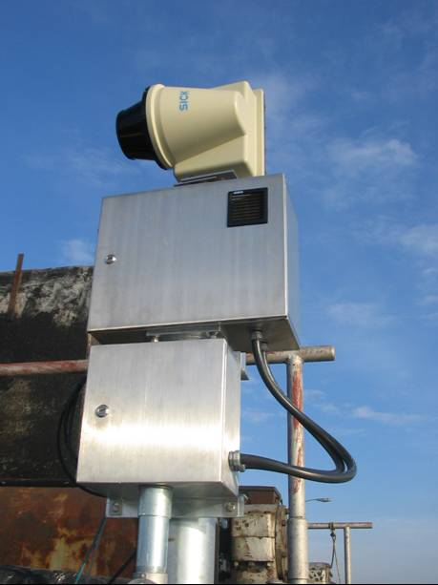 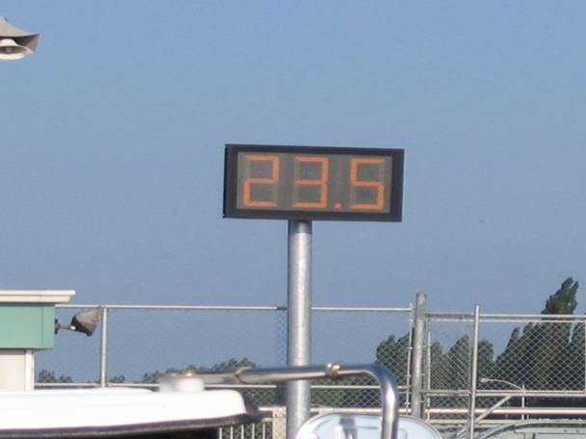

Figure 8: Laser Scanner and Display Panel

VSS is currently implemented and proven operational at all the SLSMC deep locks.

## 2.3 Remote Operation

With the implementation of Hands Free Mooring, the presence of personnel at the lock is no longer required. The operation of the lock can now be done from any site, and are being centralized into the Seaway’s traffic control centres. This allows lock operators to be in charge of different locks at different times, depending on traffic patterns.

The Modernization Project also consists of implementing remote operations for all locks and bridges of the St-Lawrence Seaway Management Corporation. More specifically, the lock operation and associated tasks are being transferred to central control points where operations can be executed and monitored remotely. The ability to touch, hear and see is being replaced by modern cameras, microphones and sensors; in order to ensure smooth transition. The functions being transferred to remote operation will include the following lock equipment:

* VSS;
* gates that allow vessels entry and exit from a lock;
* valves filling and emptying locks;
* ship arrestors, which are used for protection of gates in case vessels do not stop at the appropriate position; and
* the HFM equipment

Remote operation has already been implemented for all movable bridges and has been working successfully for several years.

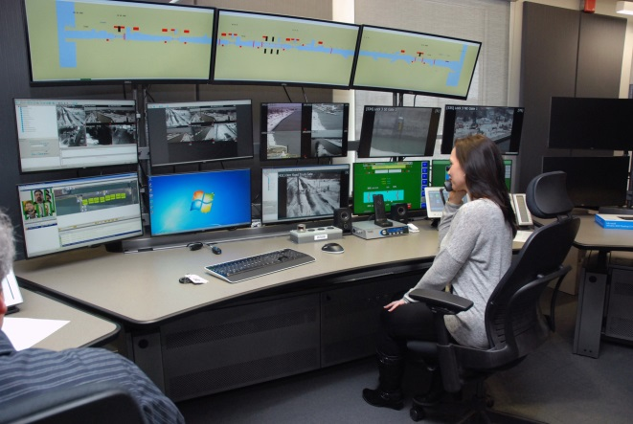

Figure 9: Remote Operations of Locks and Bridges

## 2.4 AIS Leveraging

# In a remote operation environment, ensuring a high level of situational awareness becomes more challenging, as the operator no longer has all the clues he/she is familiar with, from being on site. Therefore better failsafes need to be developed to better safeguard against operational errors.

# It is a Seaway requirement that every commercial vessel entering the Seaway must have a fully functional Automated Identification System (AIS). This allows vessels to broadcast their position and see other vessels’ positions. Geofencing is being created around the vicinity of seaway structures. When vessels approach structures such as bridges or locks, the AIS position is tracked. When the vessel enters the pre-determined geofenced perimeter of the structure, the operator will be prevented from lowering a bridge or closing lock gates just ahead of an oncoming vessel.

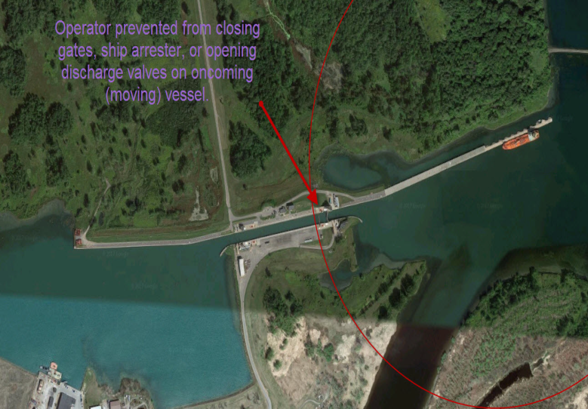

Figure 10: Leveraging AIS to protect Lock Gates

# BENEFITS DELIVERED

## Safety

As more and more compatible vessels are using the HFM system, the use of mooring wires is also disappearing (one of the major injury factors on board a ship). This translates not only into a reduction of frequency of wire breaks and associated hazards, but also a reduction of manual labor which translates in an improvement in the working conditions of all personnel involved.

The process of transiting through the Seaway locks has gone from being very labor intensive to being automated with machinery executing the hard work.

Additional benefits in safety cost savings related to the avoidance of lost time injury are also anticipated over time.

With the addition of AIS failsafes, transiting through the Seaway will remain the safest mode of transportation of goods.

## Staff efficiency

With the HFM equipment securing the vessel safely in position, the tasks of tending to the winches and mooring wires are no longer required, freeing up personnel to execute other tasks.

With increased regulations around work hours and mandatory rest periods, the automation of the mooring has provided some flexibility for vessel crews to facilitate compliance to regulation, by being available during the lock transits, either for other tasks or for resting

.

## Time savings

With the requirement of four mooring wires for each commercial vessel, the tasks of deploying handlines, tying up mooring wires, hoisting up the mooring wires with car haulers and placing them on bollards was time consuming. The mooring and releasing of vessels with the HFM system only takes a few seconds.

## Other benefits

With the requirement to use four (4) mooring wires at each lock, the wear and tear on vessel-mounted equipment such as winches and wires, and its related maintenance and replacement costs, can be substantial. The implementation of HFM at every deep lock completely eliminates that portion, lengthening the equipment life, and spreading the related maintenance.

A review of the current mandatory requirement for vessels to be equipped with mooring wires and roller fairleads will be done, once the system is fully converted. Alleviating this requirement may facilitate Seaway access to some vessels not currently equipped with wires and roller fairleads.

In addition, in the Great Lakes environment, the absence of salt water means that vessels may expect to have a longer service life than salt water vessels. It is common to see vessels with considerable age transit through the Seaway. Sliding on approach walls and lock walls has translated into hulls with poor surface quality on older vessels. With vessels no longer required to tighten their mooring wires to ensure contact with the lock wall during the lockage, the hulls no longer rub the concrete walls with extensive pressure. Not only does this extend the condition and life of both the vessel hulls and the lock walls, but it becomes an important factor, as fleet renewal is currently taking place in the Great Lakes area.

# CONCLUSION

A 2011 study called “The Economic Impacts of the Great Lakes – St-Lawrence Seaway System” revealed the following global contributions of the Seaway system:

* 227,000 jobs
* $34.6Billion (CAD) Economic Contribution
* $14.5Billion (CAD) Personal Income
* $4.7Billion (CAD) in taxes paid to Federal, State,Provincial Governments

These findings emphasized the importance of keeping the vital St-Lawrence Seaway system healthy, competitive and efficient for years to come.

A total of $7.1 Billion (CAD) is currently being invested globally (between 2009 and 2018) in different parts of the Seaway system, of which $1.2Billion (CAD) has been targeted for ships, as part of a global fleet renewal program.

The leveraging of technology to control operating costs allows the St-Lawrence Seaway Management Corporation to remain an efficient and competitive transportation choice.

The recent deployment of technologies such as Hands Free Mooring and Vessel Self Spotting has been very well received by Seaway stakeholders. The improvements in transit times, in safety, the reduction of potential hull damages, the avoidance of extensive maintenance of ship-based equipment, and the flexibility provided in resource allocation has translated into our stakeholders now asking for a faster implementation throughout the Seaway system.

# REFERENCES

“*The Economic Impacts of the Great Lakes – St-Lawrence Seaway System*”, Martin Associates, Lancaster, PA, October 18, 2011