Implementation of the Statistical Territory Register

Keywords: Georeferencing, spatial analysis, concave hull, azimuth, quality indicators

Introduction
The Statistical Institute of (---), is constructing a production system, mainly based on administrative registers[1] made up of three different subsystems: The Statistical Population Register (REP), the Statistical Territory Register (RET) and the Statistical Entity Register (REE).
The REP and REE subsystems manage all the events which affect the microdata studied (population in the case of the REP and companies and entities in the case of the REE). These microdata contain information on postal addresses, owing their geolocation.
The Statistical Territory Register (RET) is a spatial information subsystem whose main purpose is the geolocation and validation of the postal addresses which appear in the other subsystems.
In this paper, we will outline the geocoding and validation processes performed by the RET and describe the methods for the quality control of the basic information permitting the validation of postal addresses.

Methods
Any postal address which appears in the other subsystems (REP and REE) is processed in the RET. If an address does not previously exist on the database, it is assigned a primary key (address code), which will be the foreign key in the REP and REE. It is then geocoded and the coordinates relating to its doorway (horizontal part of the address) are obtained. Finally, the vertical part (i.e. the staircase, floor and door fields) is validated. If the address has been previously processed, its primary key is simply transmitted to the other subsystems.
We will describe the geocoding and validation sources and processes below.

Geocoding
The geocoding processes performed by the RET are performed by means of a web service (REST), provided by the Cartographic and Geological Institute of (---).
This service operates on a database of addresses whose model is the Municipal Address Database of (---). The database covers the whole territory of (---) and the precision of the coordinates returned mainly provides exact positions of doorways or interpolated positions.
This service, intensively used by Idescat for a number of years, permits the mass geocoding of data from the other subsystems and, for the REP, it achieves a percentage of around 96% of records effectively georeferenced.

Validation
A complete postal address actually contains two very different parts: the horizontal part and the vertical part. The horizontal part is generally described by the type of road, the road and the numbering, while the vertical part is described by the staircase, floor and door fields. The geocoding process only deals with information on the horizontal part.
For complete validation of the postal addresses it is necessary to use another administrative register which contains information on the postal addresses. This administrative register is none other than the one related to property in the Cadastre.
The General Directorate of Cadastre manages all the information on plots of land, property and buildings, as a result of which the mechanism for validating a postal address would simply consist of the search for property associated with the vertical address to be validated.
Unfortunately, the set of fields which describes an address in the Cadastre and those in the different subsystems contains a set of totally different codes, and therefore it has been necessary to construct a set of tables with the equivalences between them and perform cascaded searches through the set of equivalence tables: type of road, road, numbering, staircase, floor and door.
While the type of road cardinality in the different sources is relatively small, this is not the case with the roads and the floor and door fields. For the road field (cardinality 100,000), approximately 50% of them have exactly the same literals in the sources in question. For the others, the assignment of the equivalence table has been performed under human supervision, taking into account two criteria:
- Similarity between literals using distances (Jaro-Winkler[2]).
- Percentage of intersection and value of the azimuth between the polygons obtained by means of the concave hull or convex hull operations on the set of points grouped together by roads in the different sources (Cadastre and georeferenced population).
In fact, one road in the General Directorate of Cadastre and that in another source may be described with different codes and have different literals but, if they represent the same road, the polygons representing them should have a large intersection and a single address.
With regard to the staircase, floor and door fields, the casuistry of the type of floor of the property defined as housing has initially been studied and sorting patterns have been defined, taking into account the position of the floor in the possible groups a building may have, in order to find the equivalence between the value of the floors in the Cadastre and the REP. In the case of doubtful types of floors, a descriptive and graphic search of the property has been performed at the Cadastre’s electronic office.
The study has been compared with tables with equivalences of addresses in the Register of Inhabitants and the addresses which appear in the Cadastre for the city of (---), ​​designed by the Municipal Data Office of (---) City Council. As for the non-matching cases, the discrepancies displaying the highest frequencies have been studied.

Quality control
When constructing the concave or convex hull relating to the streets in the Cadastre, we observed the existence of a set of polygons containing points which were abnormally distant from the others, and therefore it was necessary to define a method to locate and estimate the percentage of erroneous polygons. To do so, several indicators were created and those which produced the best classifiers were selected, using comparisons of the area beneath the ROC curve[3].
Finally, the indicator selected, the polygon quality indicator (PQI), combines the maximum difference and the variation coefficient of the lengths of its sides.
It is expressed for each polygon p as follows:
$${\text{PQI}}_{\text{p}}\text{=}{{{\text{CV}}_{\text{p}}}^{\text{2}}\text{·max}\left\{{\text{length}}_{\text{i}}{\text{-length}}_{\text{i+1}}\right\}}_{{\text{i=1…v}}_{\text{p}}\text{-1}}$$
Where “i” follows the sides of the polygon in accordance with its decreasing length, “v_{p}” is its number of vertices and “CV_{p}” is the variation coefficient of the lengths of the sides; both variables refer to the polygon without taking into account the longest side.
The indicator, in addition to classifying and identifying the polygons in accordance with their estimated quality, also enables us to calculate the percentage of polygons liable to be erroneous and the percentage of polygons requiring priority revision.
The causes of the existence of anomalous points include poorly assigned roads, confusion between roads of the same name and type and confusion between roads of the same name but of different types.

Results
The geocoding process achieves 96% of georeferenced doorways and the validation shows that 93% of the complete addresses are valid.
In relation to the quality control, the polygon quality indicator (PQI) creates two groups of interest, determined by two different thresholds:
- Quality Group 1 (QG1) - Erroneous polygons: 90% of sensitivity
- Quality Group 2 (QG2) - Polygons with a very high likelihood of being erroneous: 95% of specificity, QG2 ⊆ QG1
In the following cartogram, we can observe the results obtained by means of the scores of the polygon quality indicator in this classification. The polygons are represented by different-coloured tonalities, depending on their value: the white polygons are those whose likelihood of containing erroneous points is low, while the reddish polygons are those whose likelihood of containing anomalous points is greater; the darker they are, the greater the likelihood. The last group, QG2, the one for priority revision, only affects 2.9% of the polygons of the population.
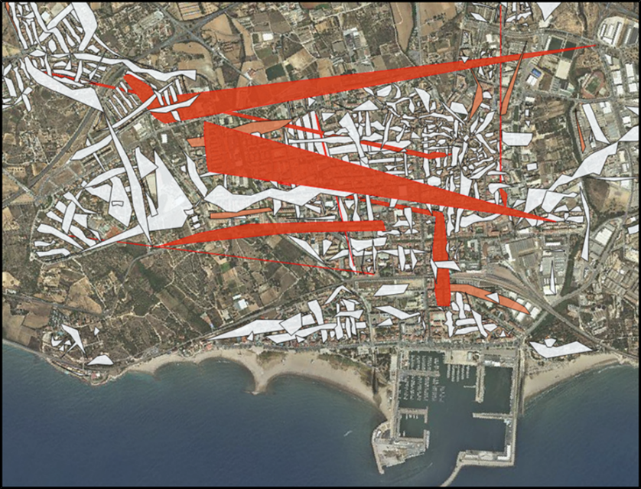
Figure 1. Cartogram. PQI represented in a municipality of (---).

Conclusions
The Statistical Territory Register of (---) incorporates different sources for the purpose of assigning and validating a territorial identifier for each of the statistical units (people, households, companies and entities). The diversity of the descriptions of the postal addresses in the sources used hinders proper spatial identification of the statistical units. The use of spatial and geometrical methods has proved to be a very powerful instrument when it comes to establishing tables of equivalences between the different sources, as well as validating, detecting errors and establishing quality indicators for the georeferenced addresses.
REFERENCES
[1] A. Wallgren, B. Wallgren, Register Based Statistics. Wiley and Sons Ltd. (2007)
[2] W. E. Winkler, “Overview of Record Linkage and Current Research Directions". Research Report series, RRS. (2006).
[3] A. Lalkhen, and A. McCluskey, “Clinical tests: sensitivity and specificity”. Continuing Education in Anaesthesia Critical Care & Pain (2008), 8(6) pp.221-223. (https://doi.org/10.1093/bjaceaccp/mkn041)

