**Title - App for the “Time Budget” Survey**

**Keywords:** Innovation, usability, integration and mobility

# Introduction

The purpose of the proposed paper is to showcase both the design and performance of the app developed at Eustat which was created on 9 April this year for the Survey on “Time Budgets” as a pilot project for the short-term standardization of the new method of survey collection using mobile devices (smartphones, iphone, Ipad and Tablets). This app has been set up to work on both Android and Apple smartphones. Furthermore, the design used in the web surveys and the design used in the app surveys will be compared due to the differences of the electronic devices used in the two mediums.

# Design and performance of the EPT [Time Budget] survey app compared to the questionnaire

Eustat has been using browser-based electronic questionnaires to gather the information for the statistical operation survey on time budgets since 2008, when the questionnaire was primarily used as an IT support for pollsters in management and data collection control tasks.

However, Eustat saw the need to extend the use of these online questionnaires to survey respondents, foreseeing that data collection via the Internet would become the preferred method in the near future. Therefore, in the 2013 campaign, the necessary changes were made to the questionnaire and those being surveyed were offered the opportunity to complete the questionnaire directly on the Internet. This experience was very positive, as analysis of the quality of this data compared to the data gathered through other methods, such as visits and phone calls, revealed that there were no significant differences between the two; the downside was that the percentage of people who had used this method was small, at 5.27%.

During the 2018 campaign, measures to increase the direct completion of questionnaires and to boost the percentage of those using the internet to complete them were reinforced. The main measures included:

* Improving the usability of the Web questionnaire, changing its design completely compared to the previous one, based on past experience and on the new resources that technological developments provide.
* Automation of all the processes that can be automated, to lighten the burden of answering questionnaires.
* The incorporation of multimedia information with explanations of how to fill in online questionnaires.
* Implementation of a single point of access for both survey respondents and pollsters, called SARW, to improve access security and to guarantee data protection.
* Development of a mobile phone app for both Android and IOS platforms, as a new experimental method of collecting data directly from the survey respondent, including interconnection with the web survey, so that both methods can be used interchangeably to complete it.
* Implementation of an app that manages the survey process from beginning to end, including “hot” codification and validation, known as GEDW.

Below, we will describe the solutions put into place for the different parts of the web survey compared to the App survey:

|  |
| --- |
|  |
| Figure 1. Profile of the residents of the dwelling |

|  |
| --- |
|  |

Figure 2. Profile of the reference person of the dwelling

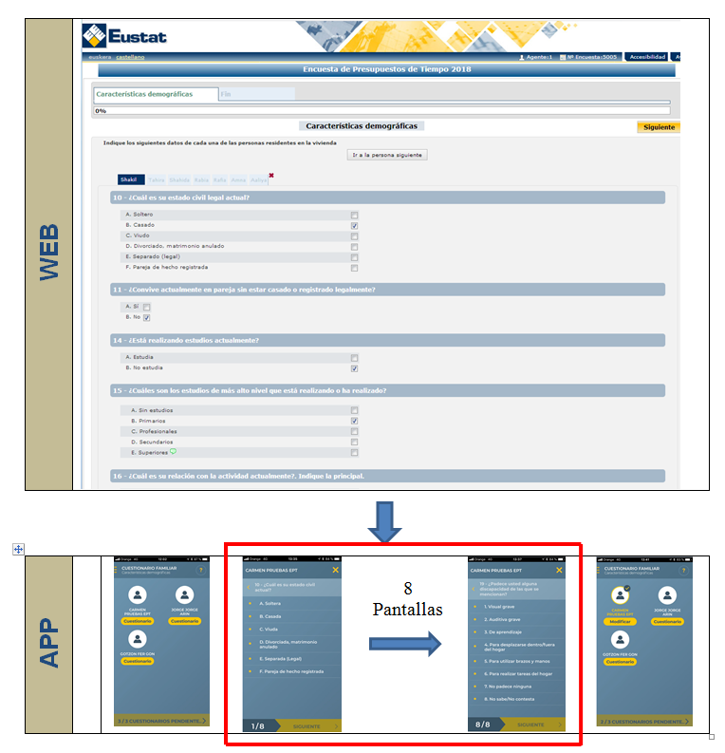

Figure 3. Family Questionnaire

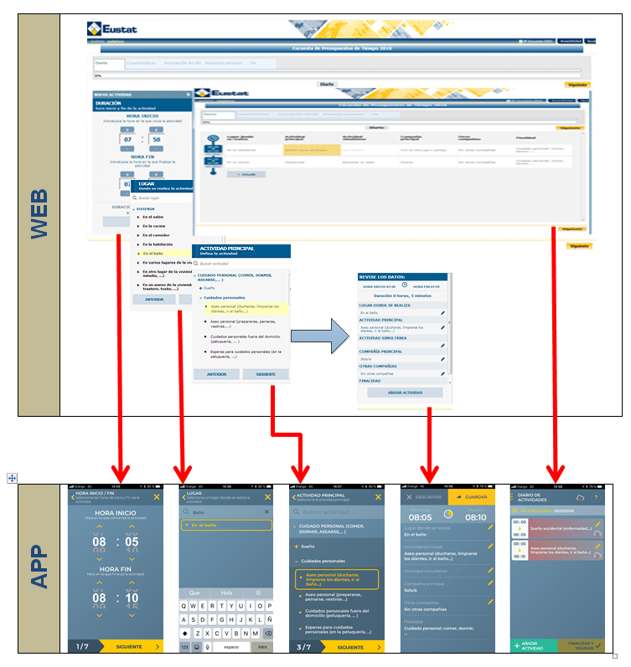

Figure 4. Individual Questionnaire

# Synchronisation of the different methods of online data collection

The system is based on the synchronisation of the data of both methods, that is, being able to start filling in the survey on your work computer, for example, continuing on your mobile on the way home on the underground, and finishing it off on a computer at your friend´s house.

|  |  |  |
| --- | --- | --- |
|  |  |  |

Essentially, the individual sees the same information at all times, regardless of the medium. In addition, when there is no mobile phone signal, the system knows if there are activities that are waiting to be updated in the database and flags up the problem. When an activity with a cloud containing a red arrow appears on the app screen, it means that this activity has not been downloaded from the mobile and therefore, it has not yet updated the database. When you click on the cloud, the phone sends information to the database and it updates immediately.



If there are any inconsistencies in the information we add by mobile or online, the system detects it and a message appears warning of the situation.

# Conclusions

When analysing this data, it should be taken into account that the percentages, apart from the telephone statistics, are not very representative, so the result of the comparison can be very biased. However, we can come to the following conclusions based on previous experience and on the data obtained in the first phase:

**Usability or ergonomics:**

The ease of using the application for users. As with the design of the online questionnaires, when the number of clicks and availability of information must be taken into account, what is most important on the apps is the quality of the questions and answers due to the lack of space not favouring the display of explanatory information or help, and normally scrolling is avoided and the page is designed with one question and its answer per page.

**Versatility**

The ability of systems to adapt to different mediums, in the case of questionnaires this means the different types of browsers and in the case of apps, the different platforms, Android or IOS: In this sense, Eustat has made the effort to ensure both systems are compatible with 97% of the market, to which no noticeable differences are appreciated.

**Speed**

Ease when it comes to filling in information. Online questionnaires use the mouse and mobiles are touchscreen. In principle, one might think that touch screen is quicker than a mouse, but we must remember that on an app, a new page is used for each question/answer and this can be detrimental to speed in not being able to see more than one question at a glance. In fact, as the information set out in the previous section shows, using the app takes around 12% more time than using the browser-based questionnaire.

**Accessibility**

Being able to fill in information anywhere. On this issue, we believe that it is clear that because of two important factors, internet connectivity and almost always having our mobile telephones with us, apps allow broader accessibility than browser-based electronic questionnaires.

In conclusion, we think that apps may be a good alternative to browser-based questionnaires not only because of their user-friendliness but also because of, most importantly, the mobility of these devices. It is clear more experiments and studies will be needed before being able to offer definitive conclusions, although already we are aware of certain aspects of the app that we will have to improve.

.