Targeting a wider public – storytelling with statistical data

Keywords: data visualization, storytelling, software development

Introduction
Reaching a wider public with statistical data is difficult. Smartphones and increasing mobile bandwidth are changing user expectations. Statistical visualizations should meet the standards of current user experience. The Hungarian Central Statistical Office has started to create interactive storytelling infographics and data visualizations to highlight interesting facts, to explain terms, to show results – to improve statistical literacy. Creating customised story visualizations is challenging. It requires cooperation between people from different domains: software development, statistics, communication, management, visualization. It also needs software tools. Publishing to both mobile and desktop environment requires responsive design and cross-browser compatibility. Tools exist, but development is expensive. Is it worth it? Number of visitors should be measured, feedback should be received. This presentation offers insight into the development process of a published interactive storytelling visualization highlighting technical details.

Methods
Statistical literacy is important – we keep saying that. It is our mantra. But how could we reach people who never visit our website and never buy any of our publications? As a minimum we are targeting those who read news sites, assuming statistics could be interesting for them if it is served properly. We need to find a channel where this properly is possible.
More and more users use mobile devices. They have a very short attention span, focusing on something is hard. Just think about constantly beeping notifications, alerts, instant messages! One of the most important word here is: instant. If you are really interested in something, you will probably wait for longer, but – and this is our case – if you are just browsing around you will not.
In the micro-universe of our devices we have a different perception of time.
Reading a book or preparing for an exam could take hours. Reading an article could take minutes. Reading an online article… not too many minutes. Language says it all: we are not readers of a website, we are visitors or users (if interaction is possible). We need to show users something appealing.
Visualization should not be too complex. If our visitors are not familiar with it (like a chord diagram) or it takes too long to get the picture, they might leave.
What is a story? – statisticians may ask. In our case a story is visual representation of data for a phenomenon – built up in a few steps – that makes our visitors feel or think something.
If we want to reach a wider public, our software should work in the main browsers on both desktop and mobile operating systems. One part of this problem is programming, we should use JavaScript libraries and write code that has proper browser support. The other part of the problem is the screen size and orientation. Our chart should have responsive design, so it can adapt to the actual screen.
We are standing on the shoulders of giants. The development of the software would take much longer without existing open source JavaScript libraries. We use D3.js for visualization, and React for controlling the page components and handling events (e.g. buttons).
Even with such good libraries software development is risky. Modern development environments are complex and have a lot of dependencies. Some changes (e.g. an update) work, some do not. Have you ever heard from a developer: ‘What the hell happened? It worked yesterday.’?
Sometimes code decides. If it is easier to code, it is cheaper. We have to define the minimum viable product.
Since our visualization is responsive (adapts to current screen size) it can be easily embedded in other webpages. We published it on our website, of course, but the main purpose of this project was reaching a wider public. The basic idea was that if it is extremely easy to put it into an online article (copy-paste) then journalists get a good looking illustration for free and we get publicity. Win-win.

Results
See Figure for an example: Fruit production in Hungary. A storytelling visualization used in our marketing campaign for Orchard survey in Hungary – 2018.
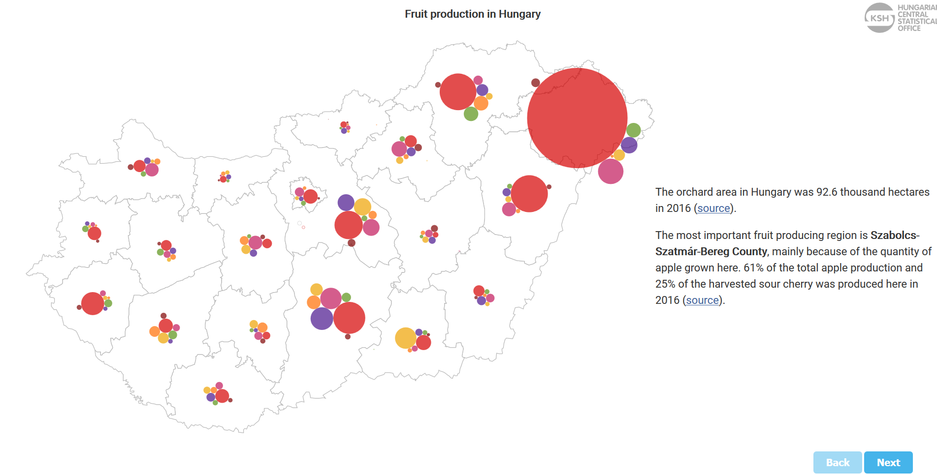  1. | 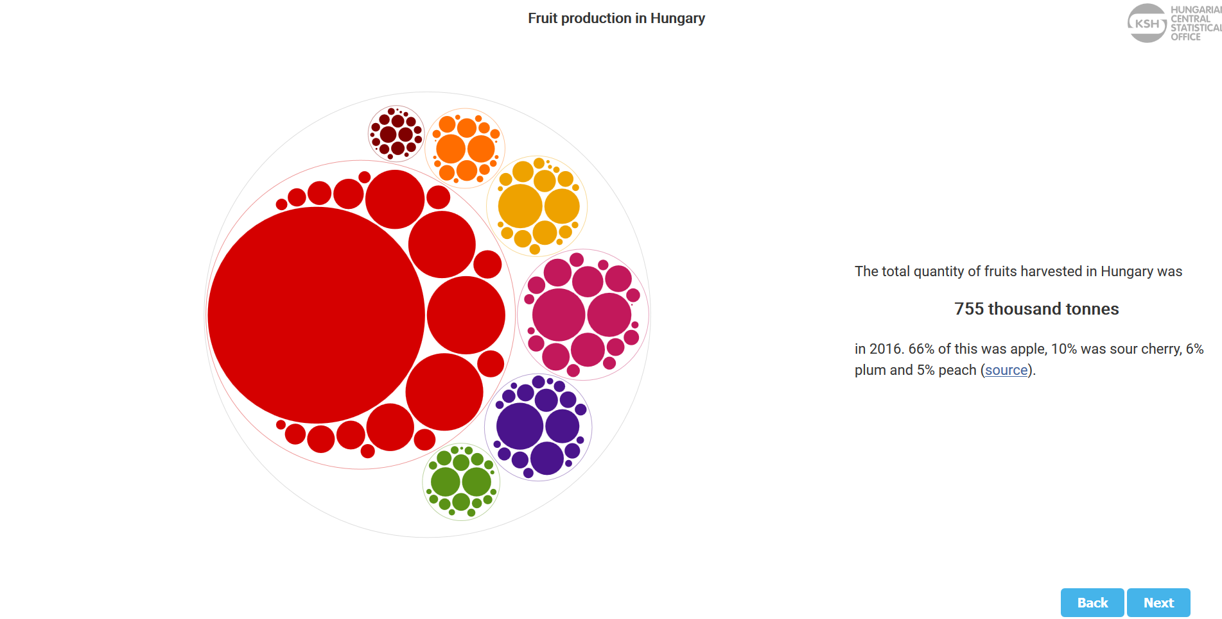  2.
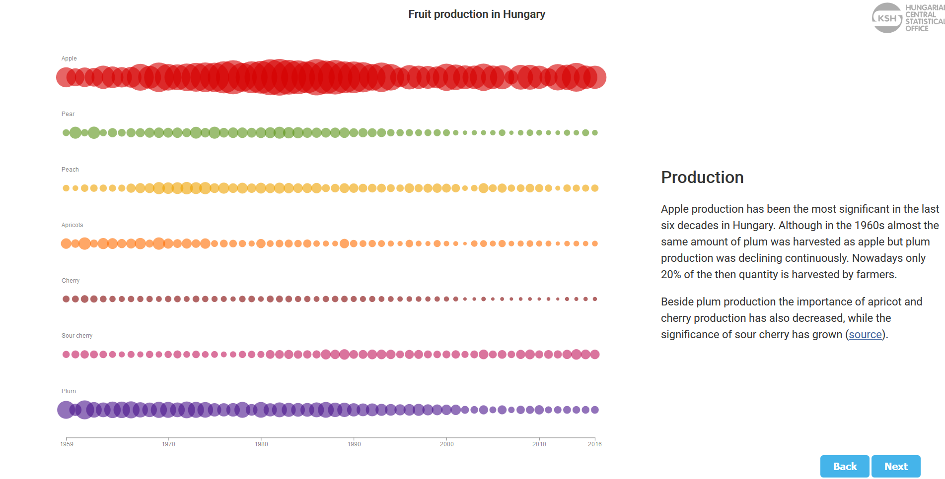  3. | 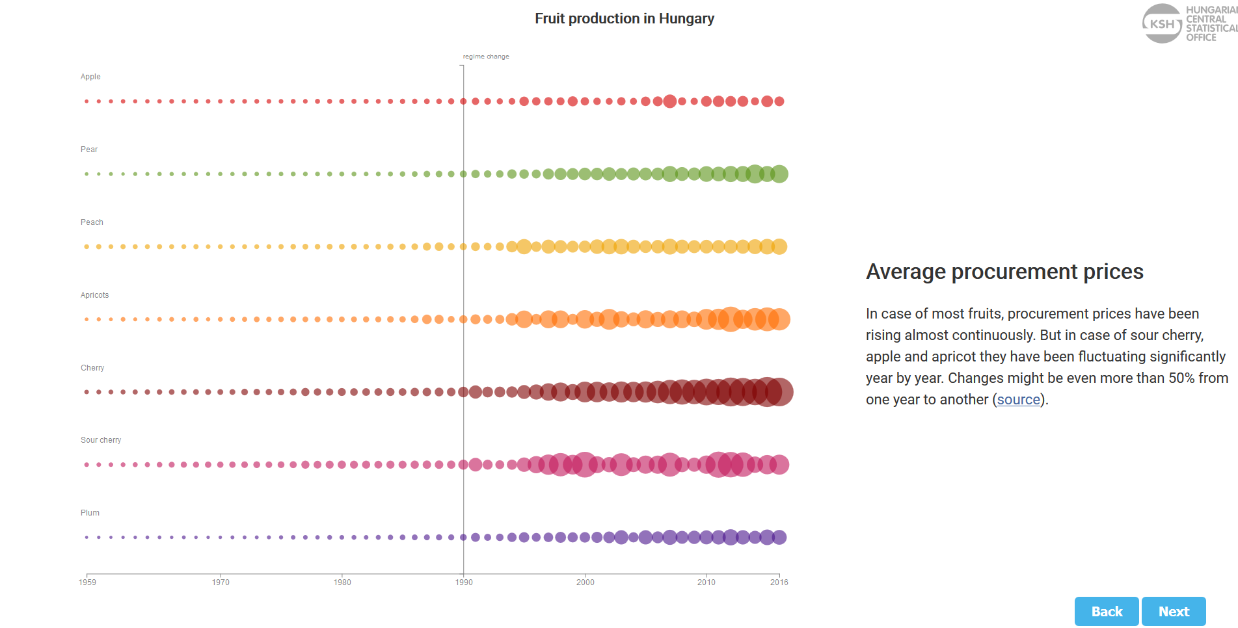  4.
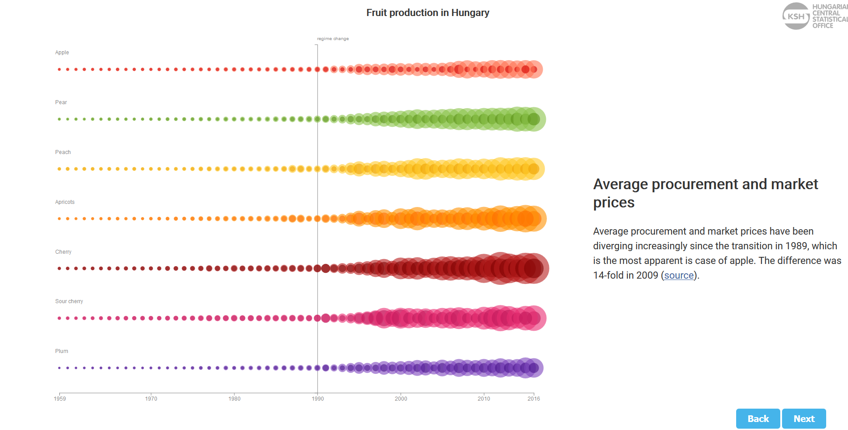  5. | 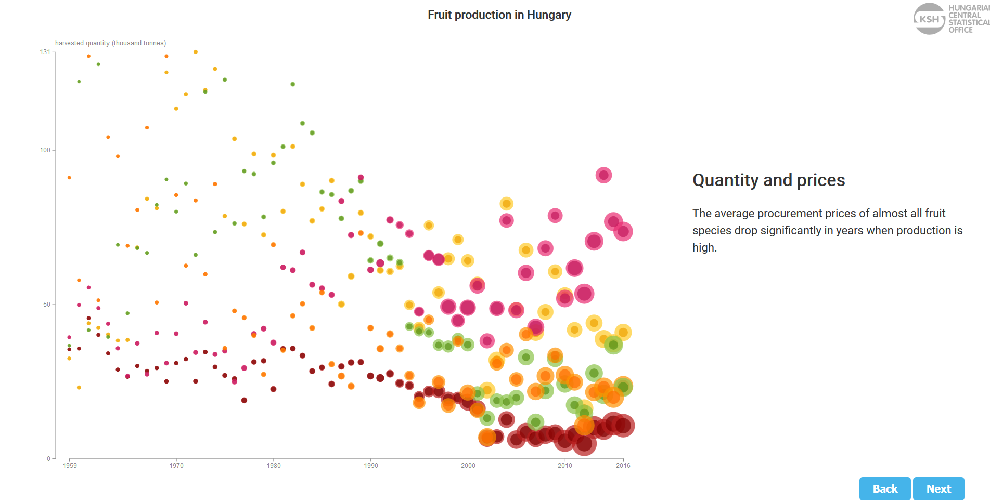  6.
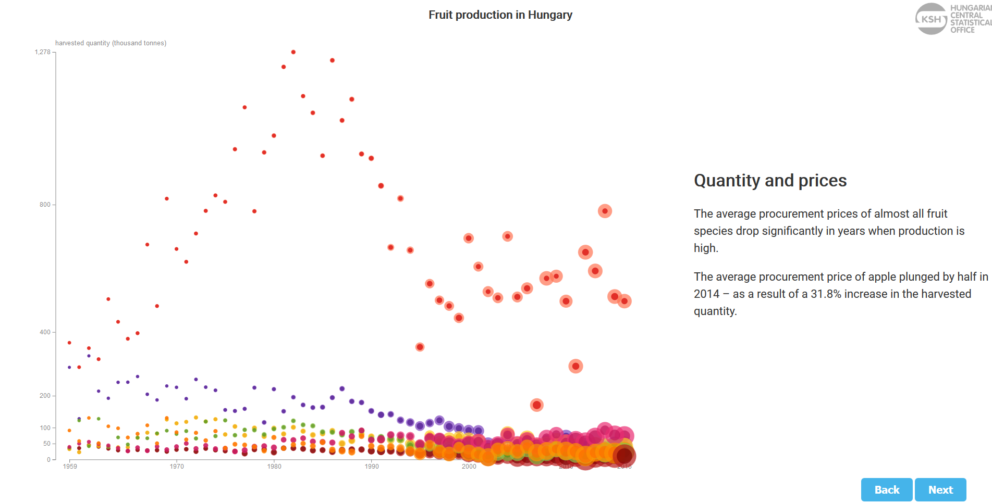  7. | 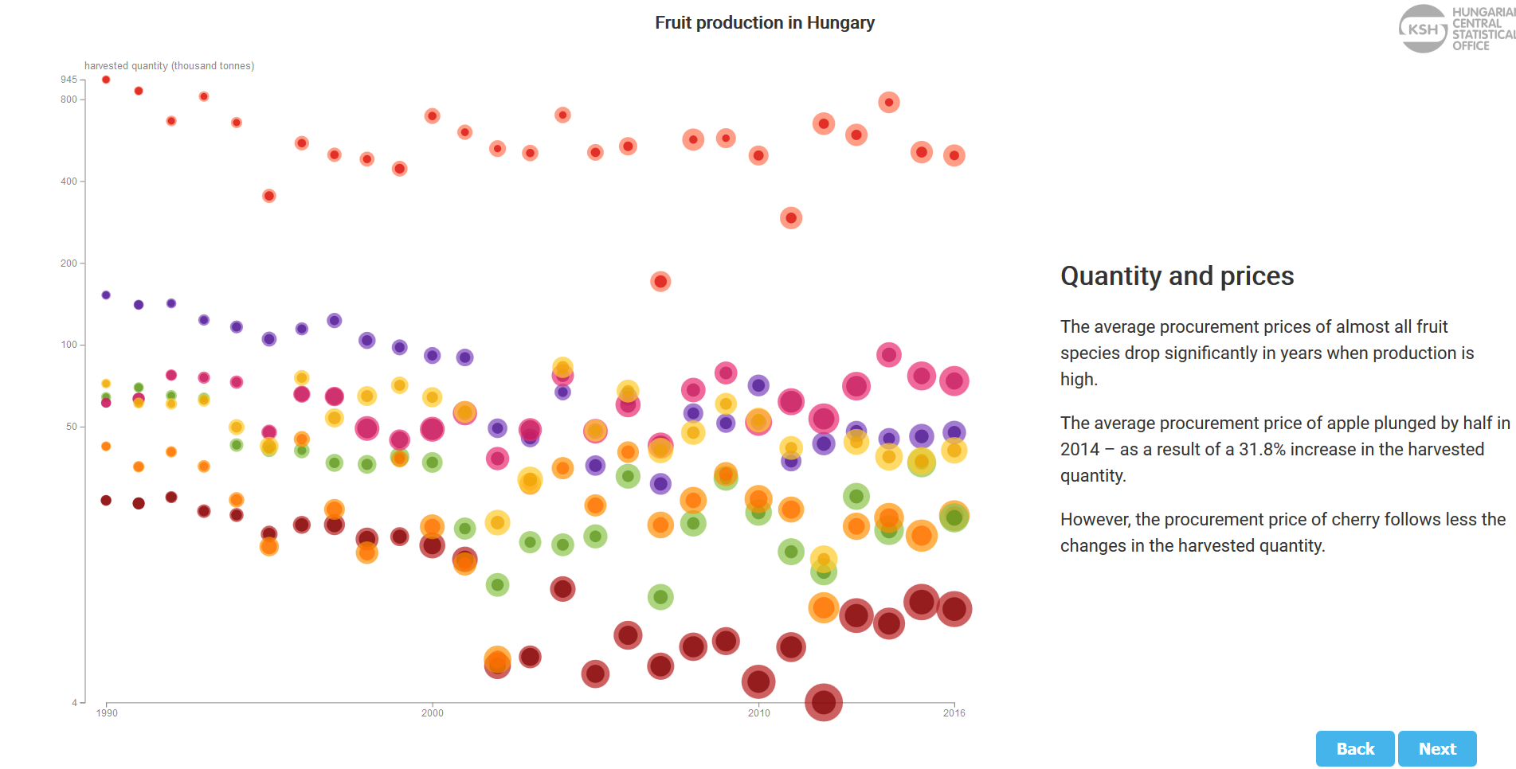  8.
1. Building chart and story step-by-step
https://www.ksh.hu/interaktiv/storytelling/gyumolcs/index.html?lang=en

Conclusions
Is it worth it? Developing custom storytelling visualization takes time and it is expensive (need many resources).
We had a survey and storytelling visualization seems to be popular among students. It is promising. We also have analytics about the page visits which shows that if our storytelling visualization is embedded in a popular news site, then – for a short period of time – we can reach a wider public (10 – 50 thousands page view in a couple of days). A wider public that would never visit our main website.

