IST - Data integration metadata driven concept
Keywords: data integration, metadata driven, data warehouse, GSBPM, innovation

Introduction

High quality statistics output are the biggest challenge for all National Statistical Institutes (NSIs) and it takes tremendous effort to fulfil such high demands. In a country where administrative sources are not the major source of data, employees in NSIs together with IT experts have many difficulties to handle almost every survey on a different way. For every NSIs, and for every company as well, a problem arises, if for every research/project is created a single (special) application. The result can be that applications are developed using different platforms (VB, C++, C#, Java...), and that data is processed and stored in different places, from the server to the local machine, in various formats, from relational database to text ﬁles.

Working in this way, the dependence on various technical platforms and vendors is extremely high and data chaos prevails. Business processes are slow and hard to control, the burden on human resources from redundant processes is increasing and the response to user needs is slowing down. Data processing and process automation, not only in NSIs, but also everywhere, always consist of three main phases: data entry, data editing and ﬁnally data processing with reports generation. Looking at things in this way, we realize that we constantly write the same three programs.

Our idea of new concept and approach was based on the needs of a development environment in which there would be no programming, in which the applications would be uniformed, standardized, easy to create and independent of constant technological changes (new development tools, programming languages, platforms). Further, the need was to have all data on the same platform, on the same type of format or the same type of relation database.

It became clear that only through the full data integration (from IT and statistical point of view) we can achieve all of this, together with maximizing the data usefulness.

Methods
Usually the data is entered into the databases and reports are generated from them. We started the development of the new concept with the question: How about, besides storing data, to store applications in database, as well? Idea was to find a way to describe the application in detail, to keep this description in a metadata database, and to develop a program that will interpret this knowledge base and in real time generate (based on descriptions from that database) and run data entry, data checking, data validation, data editing, advanced search with connecting data from different surveys, reporting and data processing.

In developing new concept, which we called IST, relational databases were chosen to be basis of everything. As the result, the new concept emerged:

- A simple metadata database - IST metadata
- A metadata interpreter - IST interpreter
With data integration, all information is kept in one platform that is easy to use for everyone in the statistical ofﬁce.
The IST.net app is an interpreter. It, literally, reads data from the IST metadata that represents a description of each application, and based on the read data it generates and in real time executes each stage of statistical research or any other project, from data entry to the dissemination of the data. The methodology that is used for developing this new concept is Scrum.
The most important components of the IST.net interpreter are: editing of the IST metadata, data entry, data validation, data edit, data correction, automatic correction, advanced search of individual and aggregated data from the various databases, dynamics reports and the ability to manage procedures in database containing individual and aggregate data.

Components of the IST.net interpreter do not depend on each other very much, i.e. they are loosely coupled. This principle allows easy upgrading of the IST.net program and easy adapting to any new needs.
The scheme below shows in a simplified way the modules of this system. It is not possible to display the flow of data processing because the system is not linear, but modular and flexible.

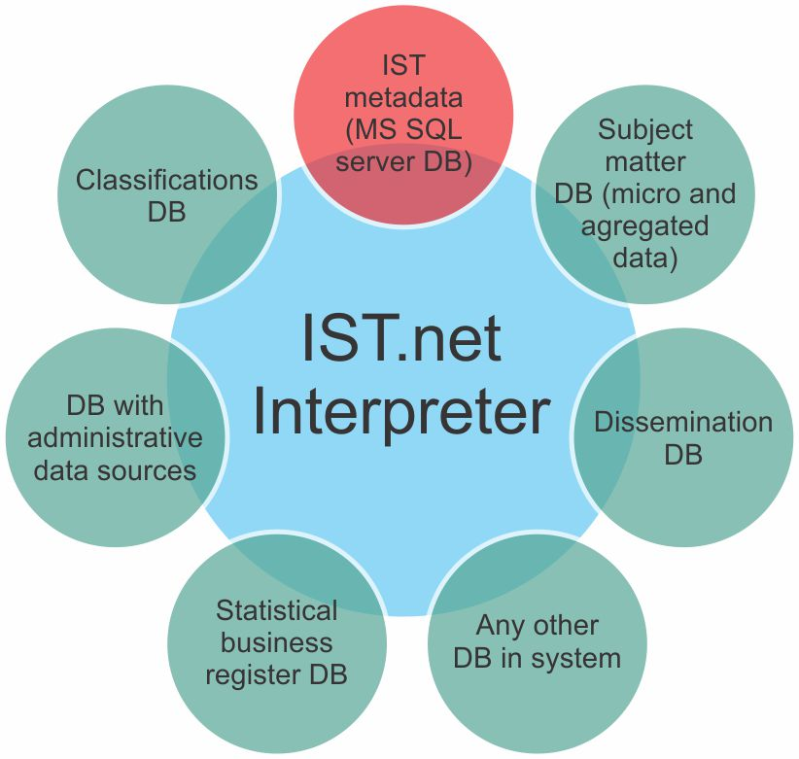
Figure 1. Interpreter model
Reducing the complexity as an ultimate goal lead to that IST is a .net interpreter and a simple metadata database (only 6 tables). These two equally important components, deal with a large number of different databases containing individual and aggregate data.
Table 1. Contents of Metadata database
Metadata database –main elements | Description
Basic | Description of statistical survey and applications connected to it.
Database connection  strings | Contains data related to the micro database that is located in the background of the survey (connection string, alias, etc.)
Tables | Description of relational tables in which the data of statistical survey and the relations between them are located.
Columns of tables | Describing the columns in the table above. This is also where the rules (data checking, data editing, type of controls) are set, which the interpreter program incorporates during the database entry.
Rules for logical  control | Represents a set of logical control and automatic correction rules related to statistical surveys.
Reports procedures | Path to all methods and services for producing dynamic reports (output tables). Path to all procedures for handling

IST.net development has been moved to MS AZURE Cloud platform and also IST.net has been fully developed on Microsoft development tools, on the .net technology and the IST metadata is on the MS SQL server.

Results
- Unified approach to all statistical domains;
- IST is used for about 98% of the statistical surveys in the Statistical Office of the Republic of Serbia (232 desktop + 40 web applications), multi data collection modes (CAPI, CATI, web apps generator);
- IST is not a literally warehouse, but due to the high level of data integration, there is no need to have the platform separately – it would be a duplication of resources;
- Reduced data complexity;
- Increased value of data through uniﬁed system;
- Faster development of IT solutions and IT staff ﬂexibility;
- Improved collaboration among the IT and statistical divisions;
- Standardization of statistical data processing;
- Decrease of cost and time needed while increase of quality;
- From 2014, international implementation and development;
- Tailor made system that can be implemented anywhere.

Conclusions
According to our experience, instead of having different applications it is possible to have just one simple, flexible, upgradable framework solution, very easy to maintain and to further develop. This concept meets the nowadays’ needs of IT developers and statisticians, as well.

This was our way to improve the IT support to statistical production, and also to develop the system that can be adaptable for all potential users. The concept is worth of knowledge sharing, and by sharing, it provides a value user chain.

