Login on Smartphones: A triviality?

Keywords: Smartphone design, online data collection tools, login process, passwords

Introduction
As times have changed and digitalisation has become not only a buzzword but reality, more and more surveys are conducted online as computer assisted web interviews (CAWI), mainly on PCs and laptops. In addition, while online surveys are also increasingly being implemented in official statistics, Internet access is often performed via mobile devices and thus it is a reasonable claim to make data collection via mobile devices feasible.
While general layout and design approaches are frequently discussed, the access to the online questionnaire is often neglected. One reason for this might be that many commercial and scientific surveys are carried out by huge online-panels nowadays. But circumstances for online-panels differ from those in official statistics: Sampling frames and registers lack email addresses so personalised access to the survey via an access-link sent per email is impossible from the beginning. Each time a new survey is introduced, the respondents need to follow login procedures. In Germany, the initial contact to a respondent is via an invitation letter in the post, where instructions are provided how to access the website and login. As this first step seems to be crucial for every participant, we tested the login process on mobile devices.

Methods
The qualitative study involved 27 probands, invited in an iterative setting of four waves to develop and test step by step an appropriate design. These probands came to our pretest laboratory and were asked to complete the survey on their own devices. After a short introduction, probands were left alone in the laboratory to enter data. The process was audio-visually recorded. Afterwards a cognitive interview was carried out.

Results

Access to Website
The first challenge appeared to be for probands to identify the URL in the invitation letter and open the correct website. Some probands did not type in the URL in a browser but started a search and got a hit list. From these observations and feedback from the respondents, we learned that this short procedure which seemed to be rather easy might actually be problematic for a number of persons.

Login Information
The login data consists of two codes: the access number (to call up the specific survey) and an activation code (to obtain individual access). Both codes were provided in the invitation letter.
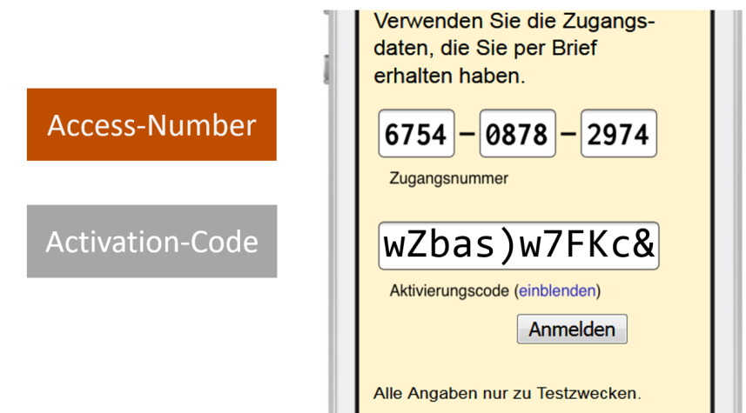
Figure 1. Login Information: Access Number and Activation Code
Due to our findings, there is a risk that the codes will be mixed up, if the design and codes are similar. Consequently, for each code a specific design is recommended (see Figure 1): The access number in numerals and boxes in contrast to the activation code by applying alphanumeric symbols. Moreover, both login keys should be labelled as differently as possible. We recommend to use clearly distinguishable, common names for the login data, in which each word component (e.g. “number”, “code”, “activation”) occurs only once. For the design of the access number, there was a clear opinion in our test: three boxes with four digits each, separated by hyphens. In addition, the cursor automatically moved to the next input field as soon as 4 digits were entered in the first one. Both of these features were positively received by our test persons in the interviews.
Furthermore, the access number and activation code should not only have exactly the same name in the invitation letter and on the website but should also have the same form and be displayed in the same font. Concerning the input of the activation code, a numeric keypad should open to enter the digits. Further challenges on the activation code are presented in the next section.

Design of Activation Code
Another goal was to test the design of the activation code. 13 out of 27 test persons received cryptic activation codes, the remaining 14 persons received “catchy” ones. Basically, catchy codes are alphanumeric combinations by words, syllables and numbers, whereas the cryptic code applies non readable combinations.

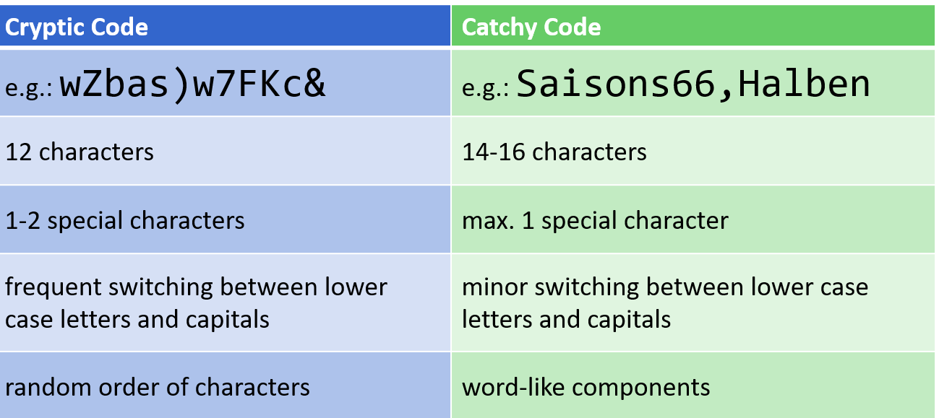
Figure 2. Cryptic and Catchy Activation Codes
In conclusion, objective indicators (number of login problems, login duration) and subjective indicators (self-reported login effort) suggest that catchy codes are preferred. The catchy activation code should consist of a total of 16 characters with memorable syllables or parts of words. It should combine lower and upper case letters together with numbers and two common punctuation marks. It should not start with a special character. Only the first letters of the syllables or parts of words should be capitalized. It should be displayed in a proportional font.
However, data security might make it necessary to rather use cryptic codes. This issue will be checked profoundly again.

Conclusions
As the login process is the first crucial step to a completed questionnaire for every participant this research will help to improve user friendliness and completion rates. Even though these findings are based on low case qualitative testing, the results provided important insights into the world of the respondents. In summary, we identified many different details which can be addressed to simplify login processes systematically. In conclusion, Charles Eames’ word is even true for the design of login processes: “The details are not the details. They make the design.”

