Integration of European data about globalization into the French Statistical Business Register

Keywords: Globalization, business registers, groups, enterprises, legal units, data integration

Introduction
What it is important for Statistical Business Registers (SBRs)? Its main purposes are to provide a solid and reliable infrastructure, genuine basis for business statistics. To improve the quality of business statistics, the European Statistical System (ESS) set up the European System of Interoperable Statistical Business Registers (ESBRs) project, to tackle issues as the inconsistencies in SBR processes due to the absence of common infrastructure for linking and sharing SBRs’ information. ESBRs already provided important outputs, such the upgraded EuroGroups Register (EGR) 2.0 recording the multinational groups implanted in Europe and the setting up of the Interactive Profiling Tool (IPT) prototype, for collaborative European Profiling.
The French SBR consists of a Business Register (BR) network. Actually, the core French SBR called SIRUS is fuelled by 3 so-called “Authentic source BRs” each dealing with one type of statistical unit. Thus, one BR called SIRENE handles the legal units, another called LIFI handles the groups and finally BCE handles the enterprises. Currently, the French SBR provides groups’ data to EGR, according to the EGR production cycle, EGR production is managed by Eurostat team. The French SBR also provides group and enterprise data to the IPT according to Grant Agreement (GA) between the French National Statistical Institute (NSI) and Eurostat.
In light of EGR and IPT progresses, the French NSI intends to integrate into the French SBR, data from the EGR and from the IPT. The aim is to increase the quality of the French SBR. More specifically, integration of data from EGR will provide a better view of the foreign structure and nationality of multinational group implanted in France. Moreover, the IPT will provide valuable information about French enterprises belonging to foreign groups. It will especially allow French NSI to improve the delineation of enterprises within groups that are automatically profiled.
The article will set out in a first part the French SBR network production process, then in a second part, the quality improvement due to the input of EGR and IPT data into the French SBR will be explained.

The French Business Register Network

2.1. Four business registers
This section briefly presents the four French BRs and their links. For details, see [1].
The French system is based on three original source BRs, each dealing with one type of unit, and the French SBR - called SIRUS - gathering all the different information and serving as the sole basis for all statistical operations requiring a reference sampling frame.
The three original source BRs are:
- SIRENE: the administrative register of legal units and local units. Legal units are companies legally speaking and local units the local implantation of the companies. SIRENE contains more than 10 million active legal units and 12 million local units;
- LIFI: the statistical register of groups. Legal units linked by control relationships build groups, also called enterprise groups. LIFI contains about 125,000 groups;
- BCE: the statistical register of enterprises. The BCE contains about 90,000 profiled enterprises (ENT), each of which composed of at least two legal units. Enterprises are statistical units reflecting the economic reality. They are defined according to the Regulation (EC) 696/93. These 90,000 enterprises represent about 310,000 legal units

2.2. French Business Register network
As it shown Figure 1, the key features of the French business register network are:
- SIRUS is the core of the system.
- SIRENE makes the links between the statistical and the administrative worlds
- There is no direct link between the three original business registers (SIRENE, LIFI, BCE). All the data flow from original BRs converge into SIRUS and the data from SIRUS spread to original BRs.
- SIRUS makes the links between the original BRs and the statistical world. For instance, the entire statistical frame is carried out by SIRUS.
- SIRUS is always up to date for the creation of legal units due to a daily updating from SIRENE.
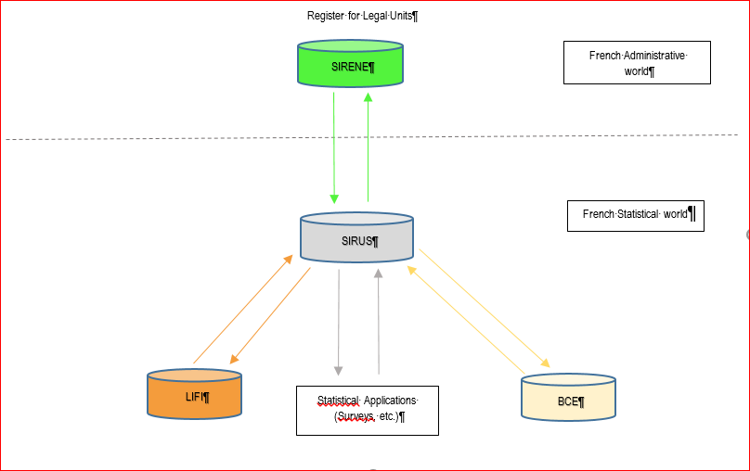
Figure 1 - The French Business Register network

Integration of EGR and IPT data into French SBR

3.1. Brief overview of EGR and IPT
‘The EuroGroups Register (EGR) is the statistical business register of multinational groups in the EU [2]. The EGR runs with the cooperation between Eurostat and the national statistical offices of European Member States and EFTA countries, by pooling together micro data on legal units (LEUs) and their relationships, enterprises (ENTs) and groups (GEGs). EGR provides harmonised information on:
- Groups, enterprises, legal units (identification, demographic and economic characteristics),
- Relationships and control,
- Shareholdings of at least 10%.
Eurostat developed, in the framework of ESBRs, an IT application, the Interactive Profiling Tool (IPT), allowing the NSI to perform European profiling on multinational groups implanted in European countries [3]. IPT provides harmonised information on:
- the worldwide perimeter of Enterprises (GENs, Global Enterprises) - according to the Enterprises (ENTs) definition (cf. Regulation EC 696/93);
- The national footprints of these GENs (called Temporary ENT, TENT). These TENTs can be considered as a starting for the NSI to create their ENTs.

3.2. New data flows from EGR and IPT to be integrated into the French BRs
A couple of new flows will be added to the French BRs network:
- One from the EGR to LIFI to improve the delineation of the multinational groups and their characteristics especially their nationalities;
- One from the IPT to the BCE to improve the delineation of the enterprise, which are often automatically profiled.
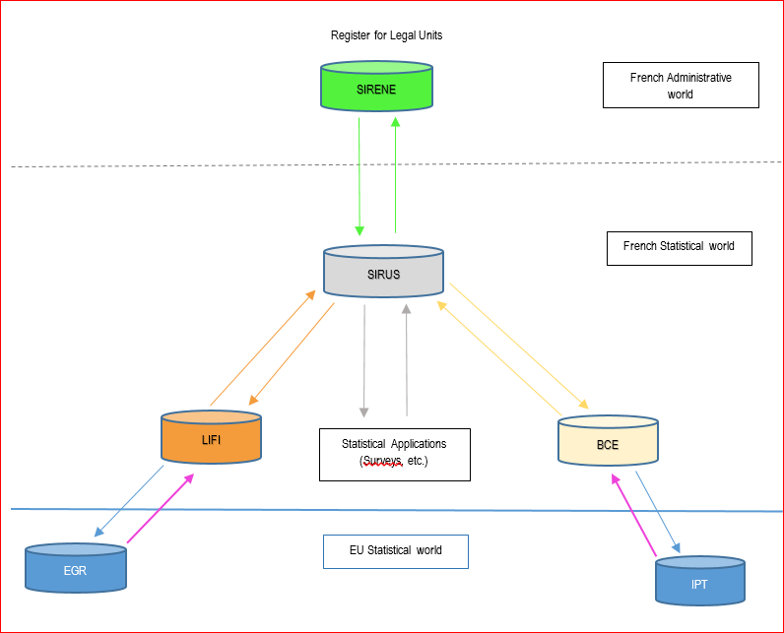
Figure 2 - The French Business Register new network

3.3. The benefits for LIFI
For the group implanted in France the group structure is built up using information from tax return and commercial data processed using LIFI algorithm [4]. However, if the French administrative data are exhaustive for the French part of the group, they are incomplete for the worldwide perimeter. This may explain some mistakes, which can be corrected by the EGR data. Moreover, the EGR could provide the true nationality of the group.
Using this source the French BR may consider for instance an Italian group made of three Legal Units - A, B and C, C is a French LEU belonging to a group and E is consider as an independent LEU by the French BR. The Italian SBR may consider a Dutch group with three LEUs – D, A and B. The Dutch SBR may consider a German group made of two LEUs B and E. Thanks to the EGR, NSI can share their information and got the real structure and nationality of the group. The benefit for the French SBR is especially to consider the French LEUs C and E belonging to the same Dutch group.
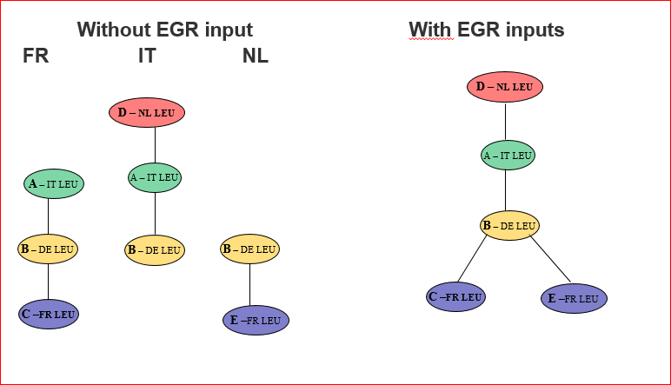
Figure 3 - The benefit of the EGR input to improve the delineation and nationality of the group structure.

3.4. The benefits for BCE
Foreign groups implanted in France are often automatically profiled using an algorithm. That is to say, for these groups the French part of the group is considered as one Enterprise by the algorithm.
However, if a foreign group is profiled using the European profiling methodology and the IPT by the foreign NSI of the Global Decision Center (GDC), the GDC profiler may consider that the group is made of more than one GEN. Actually, the French footprint of the group could consist of more than one TENT. That is to say, more than one potential French ENT.
As it show in the picture below, without the information from the IPT to the BCE, the BCE will create one ENT with 3 French legal units - made of Leu4, 5 and 6 in blue. However, thanks to the new dataflow between IPT and BCE, French SBR will benefit from the European profiling and creates 2 ENTs - one with Leu4 and 5 and one with the sole Leu6.

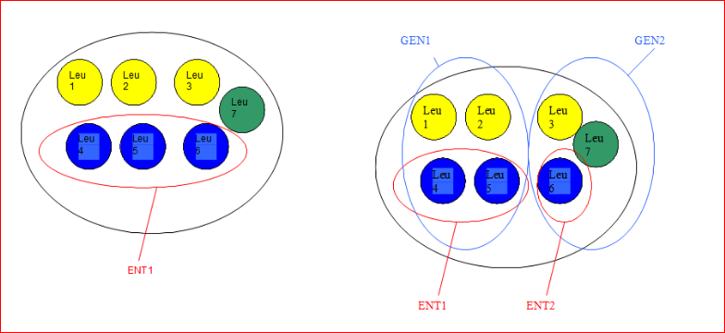
Figure 4 The benefit of the IPT input to improve the delineation of French Enterprises

References
- O. Haag, “Profiling a new and better way to apprehend the globalization” (2016), Madrid
- A. Götzfried, Z. Völfinger and A. Bikauskaite, “The EuroGroups Register”, Conference of IAOS OECD (2018), Paris.
- I. Xirouchakis and V. Hecquet, “Improving the quality of Business Statistics though Profiling”, European Conference on Quality in Official Statistics (2018), Krakow.
- H. Mariotte, “The French enterprise group register”, UNECE : group of expert on business register (2017), Paris

