The EuroGroups Register
Keywords: EuroGroups register (EGR), statistical business register, multinational enterprise group, globalisation

Introduction
Globalisation presents significant statistical challenges, particularly for small and open economies in terms of measuring statistical indicators and communicating the results to users. The European Statistical System allocated high priority to the better measuring of globalisation in the statistical processes and output, in business or macro-economic statistics. Some concrete actions were already undertaken such as setting up of the EuroGroups Register of multinational enterprise groups and the putting in place of a so-called Early-warning System for monitoring restructurings of the groups.
This paper focuses on the EuroGroups Register (EGR), the central statistical business register of Eurostat and the EU and EFTA countries' statistical authorities. The EGR is part of the EU statistical infrastructure and has been built up to better capture globalisation effects as well as for improving the consistency of national data on enterprise groups.
The EGR covers multinational enterprise groups operating in Europe. It provides the statistical authorities of the EU and EFTA countries with yearly population frames of multinational groups. The Register's main function is to provide the statistical authorities with a harmonised picture of multinational groups for their national statistics. The EGR has been growing in terms of quality over years and now covers more than 110 000 multinational enterprise groups in the EU. When at least one legal unit of a multination enterprise group is registered in the EU or EFTA country, the group is in the scope of the EGR.

Scope of the EGR
The fragmented picture that statistical authorities of EU and EFTA countries have of multinational enterprise groups operating on the EU market causes growing harmonisation problems for several types of statistics affected by globalisation.
The EGR is designed to provide a unique survey frame for these and other statistics and therefore to serve as the basic tool for improving them. National statistical institutes (NSIs) and national central banks can use EGR as consolidated and harmonized frame when producing national statistics related to globalization.
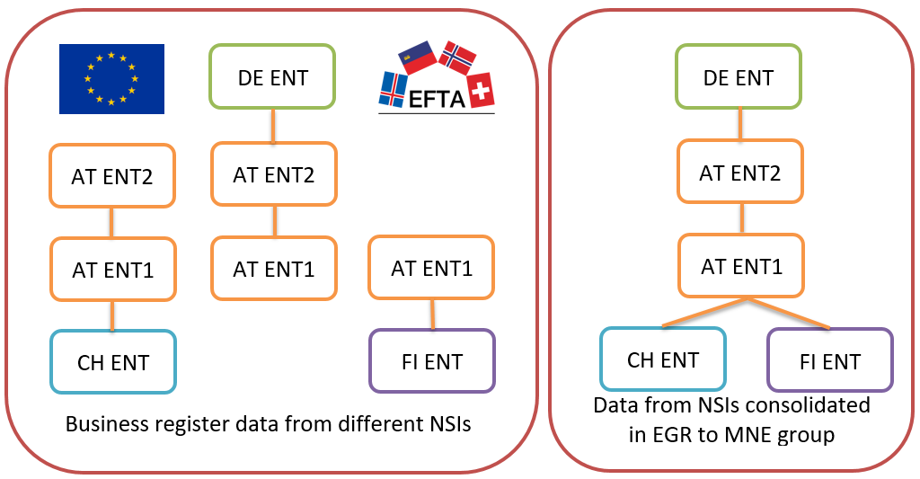
Figure 1: Compilation of the groups in EGR

Process of the EGR
The EGR produces annual data, reflecting the status of the registered groups as of 31st December of the reference year. The collection and validation of the EGR data are complex and long processes. The EGR final data for the reference years are currently available 15 months after the end of each reference year.
To create the EGR frames, Eurostat collects input information on enterprise groups from the national statistical business registers of EU and EFTA countries, and from one commercial data source. National statistical registers deliver micro data on the constituent units of the groups and on their relationships. The EGR also acquires data from one commercial data provider (CDP); this acquisition ensures coverage for units outside the EU and EFTA, and full consistency of the largest enterprise groups.
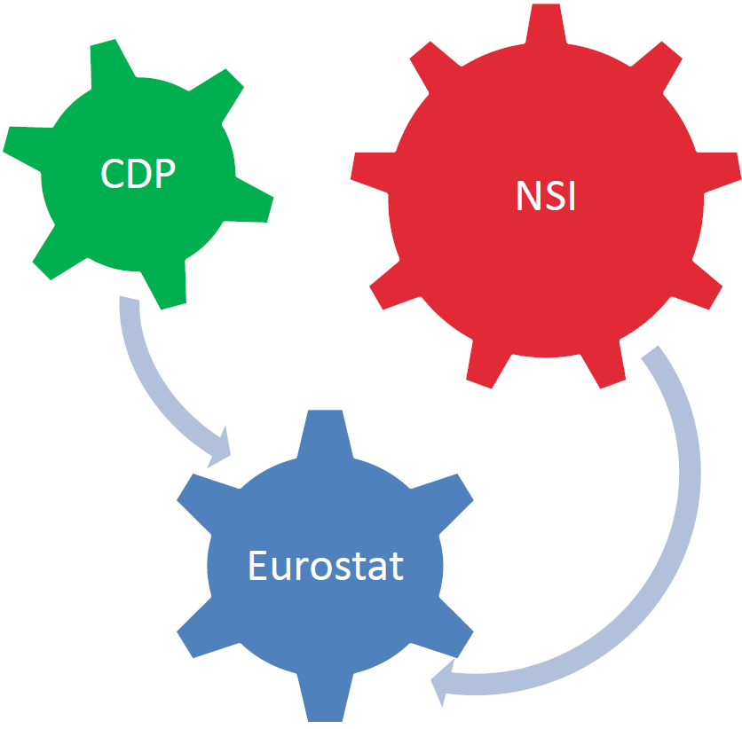
Figure 2: Contributors to the EGR
After validation of input data from the different sources Eurostat via the EGR calculates the consolidated output on the legal units (companies), on their relationships and on their enterprises (the statistical representation of the legal units). Complementary and conflicting information from the sources are treated in the EGR process with predefined priority settings and business rules. In the EGR production the highest priority data are the data from the country of the subsidiaries (bottom-up view), followed by the data from the country of the parent companies (top-down view), followed and complemented by data from commercial data provider.
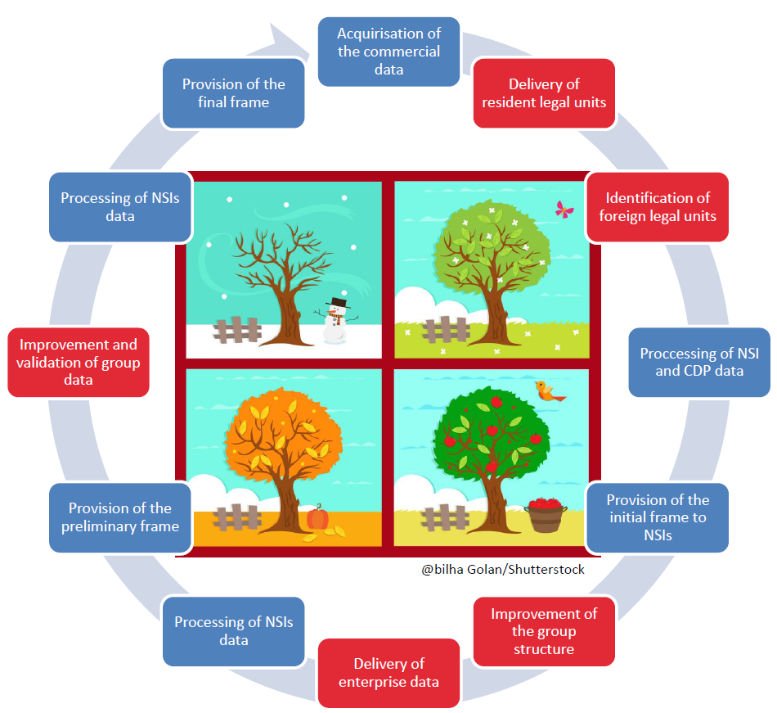
Figure 3: The annual data exchange cycle
Having final information on legal units and relationships for a reference year the EGR compiles the enterprise group structures. The enterprise groups are built on those legal units, which are linked together by control relationships, where the voting rights are above 50 per cent.
The following enterprise group characteristics are calculated in the EGR process for each group: EGR identification number, group main activity code, group employment, group turnover and country of global decision centre (country of the group).
Before publishing the final data on the groups, the calculated group structures and group characteristics are revised and validated by the participating countries and Eurostat.
The EGR process was redesigned to the EGR 2.0 from 2012, the new process was fully implemented in 2015. The switch to the EGR 2.0 improved both the EGR process and the IT system. Data for reference years 2014, 2015 and 2016 were produced completely with the EGR 2.0 system. EGR 2.0 aims to cover all relevant multinational enterprise groups present in the EU.
The EGR data enable information to be produced on the overall structure of multinational enterprise groups in the EU, while preserving the confidentiality of micro-data.

Disseminated statistics
The EGR provides harmonised information on:
- multinational enterprise groups, enterprises and their legal units (identification, demographic and economic characteristics);
- relationships and control of enterprises within the groups;
- shareholdings of at least 10 per cent.
The EGR coverage has increased over the years, due to the launching of EGR 2.0 system in 2015 and the on-going quality improvements. The coverage of the last available EGR 2016 frame enlarged compared to the 2015 reference year, especially for Europe. The coverage of outside Europe entities slightly decreased, as less complete groups were acquired from commercial sources.
The data acquisition policy of EGR targets to collect year by year more data from NSIs and publicly available sources and less data from commercial sources.
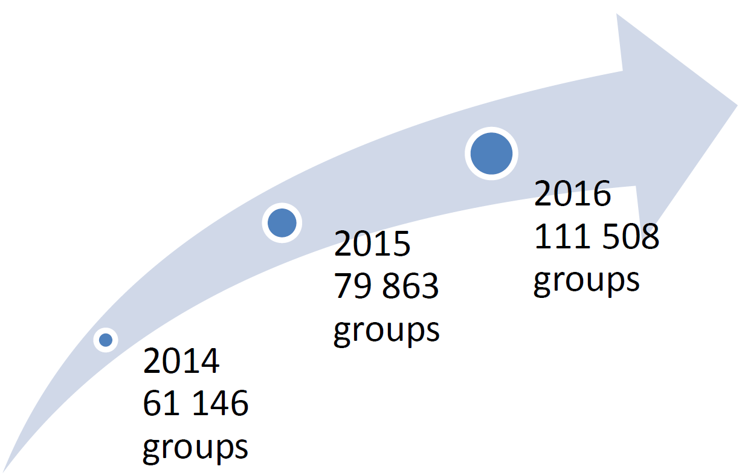
Figure 4: The EGR coverage over the reference years
For reference year 2014 EGR produced data of 61 000 multinational enterprise groups, for 2015 data of 80 000 groups. For the last available reference year, 2016 EGR produced data on 111 000 groups covering 944 000 legal units (companies) and 779 000 enterprises (statistical representation of the companies).
The EGR has very broad coverage of large and medium-sized groups. However small groups and their constituent enterprises are covered to a lower extent. To reach the targeted full coverage, EGR should cover more small multinational groups.

Data sharing and use of the EGR
The EGR is a statistical register with restricted use. The EGR data with the harmonised the multinational groups are only accessible for statisticians producing national statistics in the EU and EFTA NSIs and national central banks.
The EGR provides harmonised information for the users on:
- enterprise groups, enterprises, legal units (identification, demographic and economic characteristics);
- relationships and control;
- shareholdings of at least 10 per cent.
Statistical data producers can use the EGR as:
- coordinated frame population;
- database to derive consistent statistical output;
- auxiliary source to improve quality of statistical output;
- input for measuring global activities;
- database of European enterprises who are part of multinational groups.
The EGR data serve only for statistical purposes, i.e. for the production of the official statistics related to globalisation in the EU Member States and EFTA countries, for example:
- Statistics on foreign affiliates (FATS);
- Foreign direct investment statistics (FDI);
- Statistics on small and medium sized enterprises (SBS);
- Statistics on trade by enterprise characteristics (TEC);
- National accounts – statistics on gross national income (GNI);
- Short term statistics (STS).

The further EGR improvement plans
The EGR 2.0 system has completed successfully two complete cycles of 2015 and 2016 reference years and has reached a good level of maturity. The future developments aim at:
- Improvement of the process and output quality;
- Reduce the efforts required from the users to produce a reference year frame;
- Increase the performance of the IT system.
Additional sources of information such as crowdsourcing platforms, web crawling and different open data projects are seen as further opportunities to increase the quality of the EGR.
Eurostat collaborates with the Global Legal Entity Identifier Foundation (GLEIF), that manages the globally unique legal entity identifiers (LEI) as well as on the GLEIF level-2 data on relationships of legal units, with the aim to record the LEI also in the EGR
We also want to strengthen the user interaction and to monitor the use of the EGR by the user domains (FATS, FDI, GNI, etc.). The EGR should e.g. serve as backbone (= main data source) for FATS statistics production. The collaboration with FDI have been intensified, aiming to further investigate the FDI needs and get the EGR used as much as possible. Also the GNI pilots used the EGR data as basic data source and for quality checking purposes.
Currently the EGR data on MNE groups for the reference year 2017 is being processed. The next EGR frame (including economic variables) for the reference year 2017 is expected to be accessible by end of March 2019.

