Linking Open Data in the European Statistical System

**Keywords:** Linked open data, semantic web, ESSnet, DIGICOM, dissemination, RDF, pilot, publishing, capacity building, innovation

# Introduction

# The aim of this paper is to outline the European Statistical System (ESS) Linked Open Statistical Data (LOSD) project vision, to look at progress in the project to date, to share key insights learned to date and to share the toolkit that has been developed.

# The LOSD project is being delivered in the context of the European Statistical System’s (ESS) DIGICOM project. DIGICOM contributes to two key areas of the ESS vision: (i) focus on users, and (ii) improve dissemination and communication. One of the four DIGICOM work packages is Open Data Dissemination. The ultimate objective of the Open Data Dissemination work package is to facilitate automated access to European aggregate data for heavy users or re disseminators and to improve access to micro data.

# The ESS Network (ESSnet) on LOSD was created to allow the collection of best practices coming both from inside statistical organisations (NSI, Eurostat) and outside (e.g. ISA Framework); and to share these best practices notably through open publication. The LOSD ESSnet consists of four National Statistical Institutes (NSIs) from Bulgaria (Project Coordinator), France, Ireland, Italy. The LOSD ESSnet was launched in November 2017, with initial Linked Open Statistical Data published in September 2018 at the Paris Hackathon, final deliverables are due in April 2019. The objectives of the ESSnet are:

# • To explore NSIs publishing statistical data as LOSD on the semantic web

# • To allow users to engage with statistical data easily as linked open data

# • To prepare NSIs in the wider ESS to publish LOSD

# • To recommend a way forward for the ESS to adopt and exploit LOSD

# To support the delivery of this work, the LOSD ESSnet are subcontracting elements of this work to academic and industry experts from Ireland, namely, (a) the provision of a service to publish and link statistical data on the Semantic Web, and (b) the provision of services, tools and training materials for publishing, using and visualising Linked Open Data.

# This project encompasses these elements of work and will be delivered by the consortium of Derilinx, the ADAPT Centre, and Insight Centre for Data Analytics.

# Methods

The ESSnet LOSD Vision is depicted in the following diagram[1].

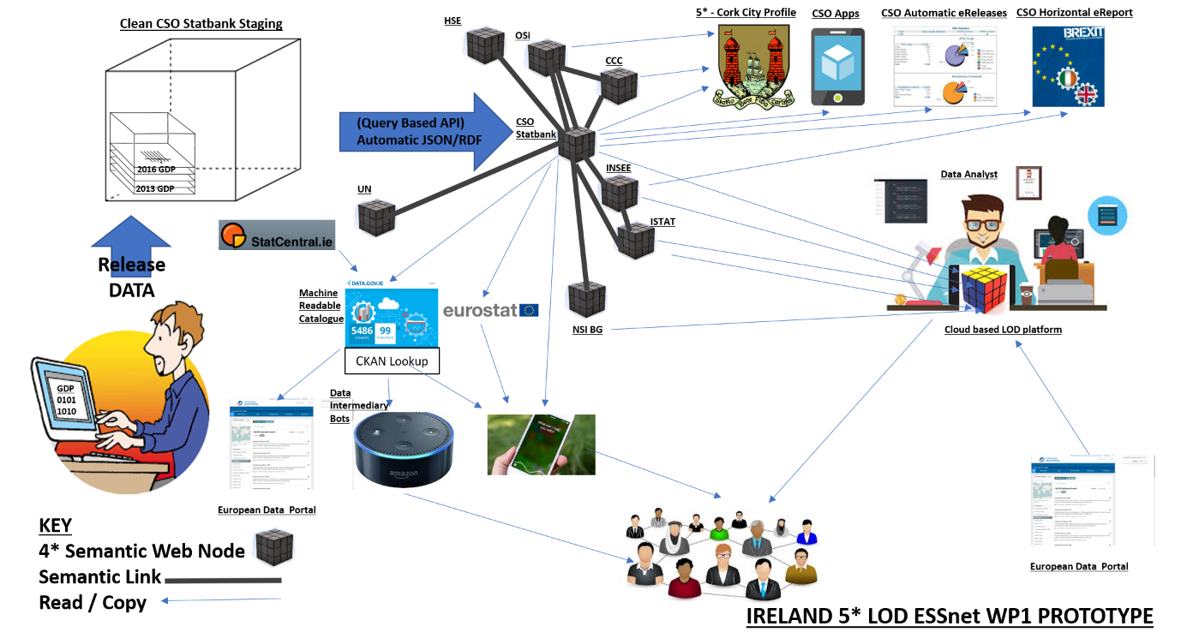

The ESSnet LOSD project will allow NSIs to publish and link statistical data, initially in four pilot NSIs across four specific domains on a centralised linked data service/platform but with the capacity of being expanding across the ESS. Four use cases were adopted by the ESSnet at the Dublin Hackathon in February 2018. The outputs of the ESSnet LOSD project will be:

* Agile - initially linking one Census dataset then expanding to further datasets
* Link data locally, nationally and internationally incorporating non-statistical datasets e.g. spatial, local government
* Each NSI hosts their own single source of RDF data
* NSI links RDF datasets to the European Data Portal (EDP)
* Data analyst accesses LOD through a cloud-based tool pulling from the EDP
* Data analyst has access to LOD Open Cube toolkit
* NSI data analyst can access and create cross domain products and services
* Capacity building once proven model created

# Use Cases

The ESSnet use cases adopted are as follows[2]:

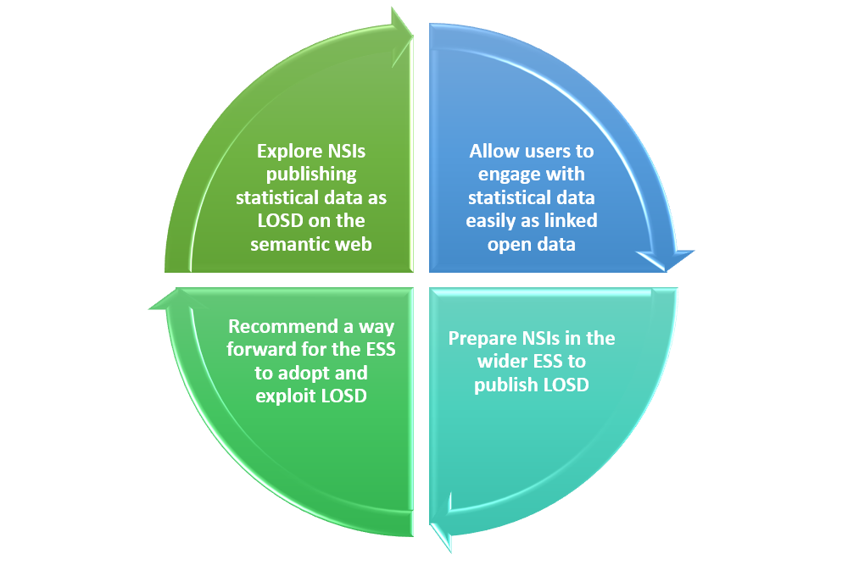

# Conclusions

The paper will outline the steps of the LOSD publishing pipeline build by the ESSnet; data conversions, data publishing, data linking and data visualisation and analysis. The solutions to the use cases will be presented. The toolkit will be explored. A number of data and metadata challenges which have been encountered will be highlighted. What LOSD can achieve will be demonstrated.

# References

1. <https://ec.europa.eu/eurostat/cros/content/essnetlodvision_en>
2. <https://ec.europa.eu/eurostat/cros/content/los-essnet-dublin-hackathon-update_en>

1. <https://ec.europa.eu/eurostat/cros/content/essnetlodvision_en>
2. <https://ec.europa.eu/eurostat/cros/content/los-essnet-dublin-hackathon-update_en>