Mixed mode data collection and adaptive survey design for Structure of Earnings Statistics
Guy Vekeman, Pieter Vermeulen – Statistics Belgium
Keywords: Mixed-mode data collection, adaptive survey design, integrated data collection system

Introduction
The Structure of Earnings Statistics (SES) aims to report on earnings, the occupation and the attained education level of employees [1, 2, 3]. Micro enterprises, employing less than 10 persons, are excluded from the reference frame.
A primary sample includes local units of enterprises whereby a stratified sampling scheme is used. Finally employees are sampled among the selected establishments. The individual inclusion probability for employees is range bound by tuning their required number to the selection probability of the local unit. Very small establishments are drawn with a low probability, yet all employees are selected. An exhaustive survey for large establishments requires a relatively limited sample of employees.
Individual employee remuneration and data on working time will now be retrieved from administrative social security data, recently made available. In this mixed-mode data collection, establishments only need to report on some personal characteristics of their workers, like their occupation and education level attained. This information is available at the human resources unit of the employer and they do not need to source in financial data on remuneration. Since the payroll often is managed by an external social secretariat, the reform implies that the involvement of a third party and the corresponding additional cost for the respondent no longer is required. Both the significantly reduced response burden and the simplified survey questionnaire (from 25 down to 5 variables) should contribute to a much lower non-response.

Methods
Recently we obtained access to delayed individual social security data, broken down by establishment and including information on age and gender of employees. This allows a new employee stratification, which is a considerable improvement over the prior method: establishments were instructed to draw the final sampling of employees determined by a randomly assigned first letter of their surname.
In the new approach, the personnel is stratified according to three age bands, to gender and to the revenue quartile. As such a maximum of 24 occupied strata are possible. The sample drawn aims to include a maximum diversity among the occupied strata. It needs to be considered that individual selection probabilities no longer are equal for all employees of an establishment. Different individual weights will be the result.
The age bands are chosen as to divide the total labour population in approximately equal numbers. Revenue quartiles are determined by NACE division (the 2 digit level). In this way an important wage disparity among different economic activities is accounted for, thereby allowing a representative sample for all establishments selected.

Adapting the survey design according to the staff renewal rate
Since the individual social security data are delayed, some employees selected may have left the establishment while new recruits may not yet show up in administrative data when drawing the sample. If staff renewal is limited, this only is a minor nuisance. Oversampling may take care of missing out some employees having left the enterprise. However, when staff renewal is extremely high - exceeding 30% - it is considered necessary to trade off the benefits of employee stratification to the freshness of the secondary sample. The new approach then needs to be abandoned and establishments are required to draw a sample among employees by the randomly assigned first letter of their surname or an alphabetic sequence of possible letters.
Using prior dated (T-2 year) social security data, NACE divisions with very high staff renewal rate -hence a failing personnel retention policy- have been identified. These economic activities include the ‘usual suspects’ such as ‘interim agencies’ and ‘hotels, restaurants and pubs’. Yet also for retail trade a disturbingly high staff renewal rate was observed.
Nevertheless the full coverage of social security data allows checking how well the simple random sample of the respondent distributes among the micro-strata. Post-stratification may allow optimizing individual weights.

Results

Primary selection of establishments
Stratification criteria for establishments are economic activity (NACE-3 groups) crossed by employment size band and by region (NUTS-2). However only the employment size band sets the primary inclusion probability according to following table:
Table 1: Establishment sampling rate as a function of employment Size class.
Size class | Boundaries | Min | Rate
1 | 1-4 | 1 | 0.012
2 | 5-9 | 1 | 0.028
3 | 10-19 | 1 | 0.063
4 | 20-49 | 2 | 0.125
5 | 50-99 | 2 | 0.25
6 | 100-249 | 3 | 0.5
7 | 250-499 | 3 | 1
8 | 500-999 | 3 | 1
9 | 1000+ | 3 | 1
Both a minimum target size and a sampling rate are applied. All establishments with more than 250 employees are drawn exhaustively. However the minimum sample size often imposes a higher effective sampling rate than the one shown. Unfortunately the observed population of establishments is extremely scarce in many strata of micro-establishments or small enterprises. It was deemed necessary to pool some strata of NACE-3 groups of the same NACE-2 division in order to avoid very small establishments and enterprises drawn in every survey. Pooling strata is frequent in manufacturing, where employment is geared towards large production units, leaving only a limited population of small establishments.

Secondary sample size
In the second phase a number of employees to be drawn in every establishment is determined. This number depends on the inclusion probability of the establishment. Small establishments with up to 19 employees are drawn with a low probability, hence all employees are selected. The a priori individual employee selection probability is shown in the below graph:
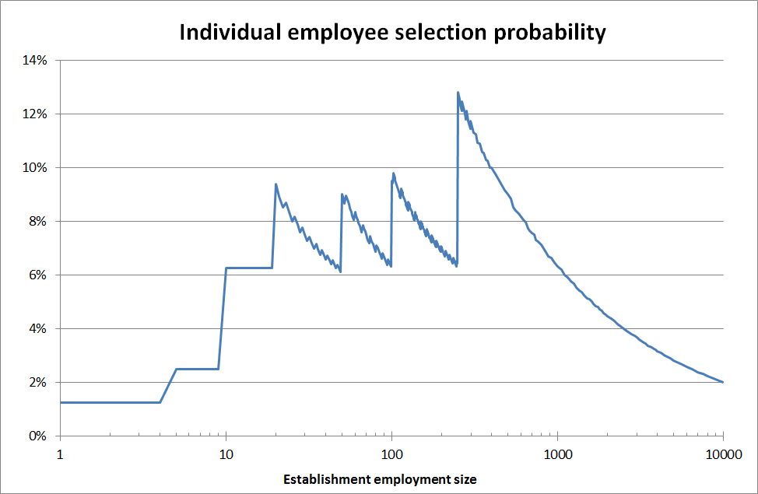
Figure 1. Individual employee selection probability as a function of the establishment employment size.
From size band 3 to 9, selection probability is range bound. The small inclusion probability of micro establishments lowers their employee selection probability. In large establishments the sample size has a square root proportionality to employment size hence also reducing the individual employee selection probability.

Second stage stratification and allocation
Using the delayed personnel data for the establishment, a micro-stratification is made according to gender, age category and wage quartile. The latter is determined across the economic activity on NACE division base.
A population count of the micro-strata is calculated and the secondary sample size may be tweaked to accommodate for a moderate staff renewal rate. A relatively high (20%) yearly staff renewal rate (as measured between T-2y and T-1y on a NACE-2 division level) requires an extra 25% employees to be drawn whenever feasible.
There are a few mutually exclusive cases:
- All eligible persons need to be drawn, since the desired sample size is not smaller than their number. This full-coverage trivial first case refers to about 11% of the micro-strata.
- The number of micro-strata is larger than the sample size. The second case is relatively rare with only 5% of the micro-strata. Even though only one single person will be selected in a micro-stratum, there cannot be a full coverage of the micro-strata: some ‘singleton strata’ will remain uncovered.
- There is a high stratum coverage: the number of micro-strata in the sample is equal to or less than half the sample size and the number of eligible persons exceeds the sample size. This mostly occurs for large enterprises or for SME’s with above average uniformity in the micro-strata breakdown. A low wage-dispersion is, relative to that of the NACE-division, or a more narrow age dispersion is low favour high stratum coverage. This case occurs for 14% of the micro-strata.
- There is a low stratum coverage: the number of micro-strata in the sample exceeds half the sample size and the number of eligible persons exceeds the sample size. Last case ‘low coverage’ is the more common with 70% of the micro-strata.
Both in the third and fourth case, one person will be selected in all of the micro-strata. The rest of the sample will be assigned proportionally among the more populated strata. In the more common fourth case, this concerns less than half the number of persons sampled.

Response rate
The new survey design has first been applied to the 2017 SES for national needs. Preliminary results look promising. As anticipated, most larger respondents have flagged several employees drawn as having left the enterprise. Nearly always replacements are added for some or all of the number of those having quit. So far a recommended employee replacement policy has not been conceived.
The new design will also be applied for the EU-wide SES for 2018.

Conclusions
The mixed mode data collection and the adaptive survey design are not the first attempt to gear the SES towards relying heavily on administrative data [4]. But the approach chosen warrants coherent and representative data on the labour population.

References
- Council Regulation (EC) No 2744/95 of 27 November 1995 on statistics on the structure and distribution of earnings
- Commission Regulation (EC) No 1916/2000 of 8 September 2000 on implementing Council Regulation (EC) No 530/1999 concerning structural statistics on earnings and on labour costs as regards the definition and transmission of information on structure of earnings (Text with EEA relevance)
- Commission Regulation (EC) No 1738/2005 of 21 October 2005 amending Regulation (EC) No 1916/2000 as regards the definition and transmission of information on the structure of earnings (Text with EEA relevance)
- Kevin McCormack and Mary Smyth, CSO Ireland, Constructing Structural Earnings Statistics from Administrative Datasets, NTTS-2015 Proceedings, 216-219

