Data(trans)forming

**Keywords: data, information, knowledge, data ecosystem**

# Introduction

*The ability to manage data is critical to the success of organisations*

In the modern fast-paced society, public administrations need data for informed/evidence-based decision making, for policy monitoring and reporting, for enhancing their functioning and for monitoring societal phenomena. Therefore, public administrations need to develop the ability to extract insights from data to support their activities and to be responsive to a rapidly-changing environment. To this aim, data must be relevant, trusted, timely and of good quality.

Improving the way a public administration exploits and exposes data is critical to achieve its policy targets in policy-making, optimise its internal functioning, be transparent and provide services to European citizens.

The European Commission has a central role in unlocking the potential of data across the EU, to help citizens, businesses and public administrations in reaping the benefits of the data revolution, and improve the way data-services are delivered and consumed.

Internally, the Commission recognised the data challenge and the need to act in this field with particular focus on "Improving information retrieval and delivery" and "Maximising use of data for better policy-making".

The fast evolving technological landscape comes in support of the above mentioned objectives: increasing availability of computing power, dropping costs of storage and hardware, better use of resources through distributed data processing, modern data analytics and data science, business intelligence, artificial intelligence are only a few of the driving capabilities offered by technology in this field.

For the reasons mentioned above, it is crucial for the European Commission to become a data-driven organisation – data(trans)forming.

Being a data-driven organisation is not only a technological challenge. Technology acquisition, talent hiring and training, launching of projects/programmes, consolidation of data and data policy, organisational structures, communication campaigns, stakeholders’ engagement processes, project management need all to be aligned to achieve the high-level strategic objectives and uplift the maturity of the organisation in generating and exploiting insights coming from internal and external data. Moreover, given the speed at which new data projects need to be developed, new stakeholders become relevant (including, for example, new internal and external data providers), new technology becomes available and new business cases are developed. This entails that a new approach to strategy definition and implementation needs to be adopted.

This paper illustrates how the European Commission will be transformed in a data driven organisation.

# Methods

*The DataStrategy@EC is the comprehensive vision and the foundations to transform the Commission into a data driven organisation*

Table 1. Transforming the European Commission in a data driven organisation

The Challenge Transform the Commission in a data-driven organisation

The Solution Set-up a Commission data ecosystem, i.e. a system of interconnected resources and services for capturing, curating, storing, protecting, elaborating, accessing, using, re-using, consuming, analysing, disseminating and sharing data

The Execution Building upon the current data assets and strengths, by 2020 gradually build the Commission data ecosystem and the EU data framework through well focused dedicated thematic area initiatives coordinated at corporate level.

The Action Plan Implement the strategy through a set of actions supporting the achievement of the strategic goals according to five dimensions – data, technology, people, policy and guidelines, organisation – focusing on enabling the data ecosystem and the data maturity required to become a data driven organisation.

## Strands and value

*Data is a strategic asset*

Data (in its broader definition encompassing data-information-knowledge) is a strategic asset for the European Commission and has to be managed as such. Data is expected to underlie informed decision making, to underpin the practical functioning of the Commission and to monitor societal phenomena and, where appropriate, the impact of EU on them.

Therefore, the DataStrategy@EC is more than the mere handling of data and the related technical solutions and it calls for an ecosystem, i.e. a system of interconnected and interacting elements for and around data.

The DataStrategy@EC covers five strands:

* Data: internal and external data sources need to be exploited as much as possible to generate evidence supporting decisions
* Technology: improving the technological landscape is essential to generate insights rapidly and effectively
* People: the right people with the right skills need to be made available to the organisation
* Policy and Guidelines: policies need to be defined and enforced to ensure security and quality of data, and to promote and control its flow within and outside the organisation
* Organisation: roles and responsibilities need to be clearly defined within the organisation

## How to build a Data Ecosystem

To implement the DataStrategy@EC, an action plan has been set up covering the actions that need to be carried out by the European Commission to establish a functioning Data Ecosystem.

The Action Plan identifies 10 strategic objectives whose achievement will transform the Commission into a data driven organisation. Operationally it is implemented through 8 concrete actions. Parts of these actions have already started and others will start before the end of 2018.

Table 1. Transforming the European Commission in a data driven organisation

|  |  |  |
| --- | --- | --- |
| **N.** | **Short Name** | **Strategic Objective** |
| 1 | Data Identification | Identify and classify data relevant for decision-making processes across the organisation and for the functioning of the organisation itself |
| 2 | Data Access | Guarantee access to data relevant for decision-making and functioning across the organisation, respecting the necessary confidentiality and security restrictions |
| 3 | Data Analytics | Enable and foster the use of modern data analytics technologies to achieve a rapid and effective generation of insights |
| 4 | Data Infrastructure | Put in place a sound infrastructure to support experimentation with data technologies and high-performing data produce |
| 5 | Data Roles & Responsibilities | Define, assign and enforce at corporate and local level proper data governance roles and responsibilities |
| 6 | Data Labs | Design and apply new collaborative organisational models to maximise innovation and experimentation in the data field |
| 7 | Data Skills Acquisition | Acquire new data skills for the organisation to support the development of a corporate data capability. |
| 8 | Data Literacy | Improve data literacy across the organisation. |
| 9 | Internal Data Management Policies | Establish, enforce and constantly update internal corporate policies and guidelines on data management, data governance and data security. |
| 10 | Compliance with EU Data Policies | Ensure within the Commission the compliance with existing EU data policies on data sharing, re-use or security needs to be |

# Results

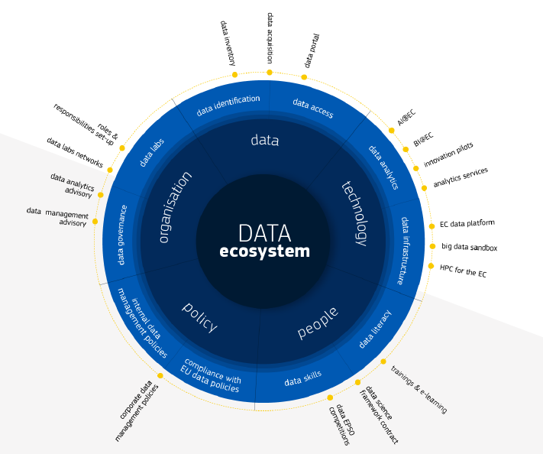

Figure 1. DataStrategy@EC – Action Plan – Dimensions, Actions and Enablers

# Conclusions

Transforming the European Commission in a data driven organisation is a necessary challenge that can be successful only if it relies on a mix of elements: alignment to the strategic targets; cultural change; build on the current status to evolve to the target status; exploit data technologies; leadership; strategic effort; digital transformation strategy.

# References

1. Communication to the Commission, Data, Information and Knowledge Management at the European Commission, C(2016) 6626.