GDP Flash Estimates for Germany

**Keywords:** Gross domestic product (GDP), economic growth, flash estimates, monitoring economic growth and business cycle

# Introduction – GDP flash estimates

Gross domestic product (GDP) – or more specifically its (positive or negative) rate of change or growth rate – is generally considered to be one of the main indicators for the performance of a country’s economy. As policymakers and other users rely on both accurate and timely data on economic growth, it is important to regard both aspects when discussing flash estimations. GDP flash estimates give an earlier picture of the economic situation than regular GDP estimates. They are produced as soon as possible after the end of the quarter in accordance with the same concepts as regular national accounts estimates. Flash estimates therefore differ from forecasts, nowcasts or leading indicators, as they give a coherent picture of the growth of the whole economy, respect the accounting rules and focus on actual data for the past. They are based on a less complete set of source data than regular estimates, though, due to the more timely calculation. It is therefore crucial to check the reliability of the flash estimates, as there is a trade-off between timeliness and accuracy.

# GDP release policy in Germany and Europe

Germany began publishing first quarterly GDP flash estimates in 2003. Since then, these estimates have been released every quarter, 45 days after the end of the quarter. Around the same time as the first quarterly GDP flash estimate publication at t+45 days, the Federal Statistical Office also performed several feasibility studies on a quarterly GDP flash estimate at t+30 days. The aim of these feasibility studies was to provide users with reliable early estimates already within 30 days after the end of a quarter. As the results were ambiguous, especially with a focus on the reliability of the estimates, it was decided not to publish the results at the time. German national accounts, however, continued to compile an internal GDP flash estimate until today, using the results to support and ensure the quality of the regular calculations with the additional benchmark. The release policy did not change, though; the first quarterly GDP estimate for Germany is still published around 45 days after the end of the quarter.

The economic, financial and technological developments in recent years have led to an increasing demand for more timely results, especially from European policymakers like the European Commission and the European Central Bank. Eurostat therefore began publishing quarterly preliminary GDP flash estimates 30 days after the end of the quarter (t+30) for the European Union and the Euro Area in 2016. The majority of Member States contributed to this European GDP flash by providing the national estimates to Eurostat, in the case of Germany under embargo. Even though German national accounts had 15 years of experience on GDP flash estimation after t+30 days at the time, the results were still not published, as the reliability of the results was still considered to be too low. This was also the case according to the quality criteria developed by the Eurostat Task Force on Flash Estimates, which were used as benchmark for the decision to publish the European flash estimate. The GDP growth rate is typically somewhat less volatile the larger the area it is calculated for. Therefore, it is easier to prepare and publish reliable early estimates for a larger economic area (like the European Union or the Euro Area) than for an individual country, and revisions are usually smaller, as the experience with the t+45 flash has also shown.

# The three pillars of the German GDP flash estimate at t+30 days

When estimating GDP, three levels of aggregation can be used: the GDP itself, a level according to the published quarterly data at t+55 days (branches of production side and/or components of demand side of GDP), or any other level of disaggregation.

At the beginning of the German GDP flash estimations at t+30 days, the different approaches were tested. An early outcome was that a direct estimate of the quarterly GDP and its growth rate would lead to high forecasting errors. Furthermore, it could be shown that a breakdown of branches of the production side and of the components of the demand side is useful for the estimates.

The German GDP flash estimate at t+30 days can be characterized as a three-pillar-approach that consists of an expert approach, an econometric approach and the reconciliation.

## Expert Approach

The expert approach is the first pillar of the German GDP and consists of the estimates of the units within the national accounts divisions, which are responsible for the calculations of GDP at t+45 days and t+55 days as well as annual GDP results. However, the situation at t+30 differs from the situation at t+45/55 because of the lack of the availability of both – monthly and quarterly data. Thus, the experts have to estimate the missing data.

## Econometric Approach

The second pillar of the German GDP flash model provides estimates by using solely econometric time series forecasts, respectively. This econometric modeling and forecasting have to be done for both calculation methods of GDP in Germany – Production and Expenditure side.

This approach is calculated independently from the expert approach. Main data sources of this approach are statistics of the Federal Statistical Office, which are complemented by data from external data producers.

## Reconciliation

Reconciliation is the third pillar of the German flash estimate of GDP which brings together the results of expert and econometric approaches. In an internal conference at t+29 days, representatives of the both approaches present and justify their estimates. At the end different results are balanced to one quarterly GDP. The main highlights of the conference are four deviating results of the GDP: Production and Expenditure sides of both pillars.

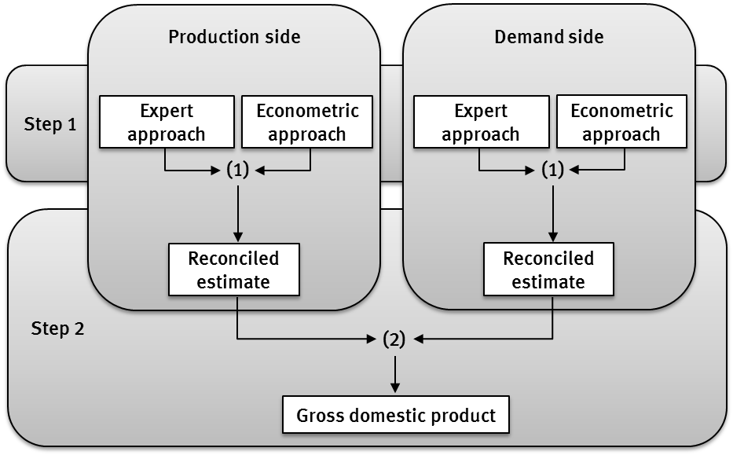

Figure 1: Reconciliation of the GDP for the German flash estimate

Flash estimates usually have to be revised more than later estimates as less basic data is available at the time of the estimation. These revisions can be used as a quality indicator to assess the accuracy of the flash estimate, the significance of the data used, and the adequacy of the models in use.

# Quality of the German GDP flash estimate

The quality of official statistics is one of the main factors which should be considered more precisely during the development of statistics for publication. The accuracy of results is probably the most important quality indicator of GDP estimates. Therewith, there are some quality requirements for GDP flash estimates developed by Eurostat, which are also suitable for usage as a benchmark for the accuracy of national flash estimates:

1. t+30 should be an unbiased estimate of GDP growth at t+45, with an average revision between –0.05 and +0.05 percentage points (ppt), and no more than 66.7% of revisions in the same direction
2. The average absolute revision for GDP growth at t+30 should be within 0.10 ppt compared with t+45 GDP growth estimate, and within 0.13 ppt compared with t+65 GDP growth estimate.

The quality assessment of the German GDP flash estimate at t+30 days was carried out for different time spans including different phases of the economic cycle. The longest observation period comprises more than 50 observation points.

In the quality assessment of the German GDP flash estimate the first quality acceptance criterion, the mean revision, is fulfilled in almost all test calculations. The second quality acceptance criterion, the mean absolute revision, is not fulfilled for any time span. The analysis of the different time spans, however, shows that the quality of the German flash estimates increased slightly over time.

# Outlook for GDP flash estimates in Germany

As the estimation of GDP flash estimates at t+30 days is continuously developed further in Germany, the quality of the flash estimates is also improving. This is among others due to the fact that more and more basic data is available earlier. This implies on the one hand that the compliance of the quality criteria should be reviewed from time to time, as new data on revisions becomes available. On the other hand, it could be worth looking at the possibility of flash estimations performed at an even earlier point of time. Therefore, Germany is about to launch a new feasibility study on GDP flash estimates to be compiled within ten days after the end of the reference quarter. At this time, two months of the quarter are already available for some indicators, and the data base is close to the one at t+30 days. The results of the study are expected in 2020.

The paper is going to explain in detail the German approach of how GDP flash estimates are produced at t+30 and how this early estimation differs from the traditional flash estimation at t+45. It will also give an outlook on the data availability and models used at t+10 as well as on newly available indicators (e.g. MAUT statistics) and their feasibility for GDP flash estimates. It will further discuss different quality criteria in order to assess the accuracy of the results. Finally, it will briefly look ahead at possible future work and developments regarding the flash estimations in German national accounts.