Mixed mode data collection and adaptive survey design for Structure of Earnings Statistics
Guy Vekeman, Pieter Vermeulen – Statistics Belgium
Keywords: Mixed-mode data collection, adaptive survey design, integrated data collection system
The Structure of Earnings Statistics (SES) aims to report on earnings, the occupation and the attained education level of employees.
Individual employee remuneration and data on working time will now be retrieved from administrative social security data, recently made available.
- Mixed-mode data collection,
- Establishments need to report on some personal characteristics of employees (E.g. occupation and education level attained)
- All information available at the HRM
- Financial data on remuneration not needed.
- No involvement of third party and no additional cost for the respondent (Payroll often is managed by an external social secretariat.)
- Much lower non-response due to 1) reduced response burden and 2) simplified survey questionnaire (from 25 down to 5 variables).

Method: Adapting survey design to staff renewal rate
Individual social security data delayed by one year (T-1) and broken down by establishment and including information on age and gender of employees => new employee stratification.
Three age bands x gender x revenue quartile => (maximum) 24 occupied micro-strata.
Sampling policy: maximum diversity among the occupied strata => individual selection probabilities no longer equal for employees => different individual weights.
The age bands are chosen as to divide the total labour population in approximately equal numbers. Revenue quartiles are determined by NACE subsection (the 2 digit level) => wage disparity among economic activities accounted for => representative sample.
- Data freshness issue (T-1) => while sampling some employees have left & new recruits don’t show up
- Limited staff renewal => oversampling
- High staff renewal => establishments draw a sample among employees (randomly assigned first letter of surname) ‘= prior art’
NACE subsections with very high staff renewal rate some ‘usual suspects’ (‘interim agencies’, ‘hotels, restaurants and pubs’) but also retail.
Full coverage of social security data: checking on simple random sample by the respondent distributes among micro-strata. Optimizing individual weights (post-stratification)

Primary selection of establishments
Stratification criteria for establishments: economic activity (NACE-3 division) x employment size band x by region (NUTS-2).
Table 1: Establishment sampling rate as a function of employment Size class.
Size class | Boundaries | Min | Rate
1 | 1-4 | 1 | 0.012
2 | 5-9 | 1 | 0.028
3 | 10-19 | 1 | 0.063
4 | 20-49 | 2 | 0.125
5 | 50-99 | 2 | 0.25
6 | 100-249 | 3 | 0.5
7 | 250-499 | 3 | 1
8 | 500-999 | 3 | 1
9 | 1000+ | 3 | 1
Observed population of establishments is scarce in many strata of micro-establishments or small enterprises => pooling strata of NACE-3 divisions of the same NACE-2 subsection (occurs often in manufacturing).

Secondary sampling of employees
- Second sampling phase: number of employees/establishment
- Employment size band sets rule for calculating the secondary sample size
Table 2: How the employment size band determines the secondary sample size
Employment size band |  | Secondary sample size
Number of employees |  | (nearest integer rounding)
1 | 1-4 | TE
2 | 5-9 | TE
3 | 10-19 | TE
4 | 20-49
5 | 50-99
6 | 100-249
7 | 250-499 | 2*
8 | 500-999 | 2*
9 | 1000+ | 2*
(TE=total establishment employment)
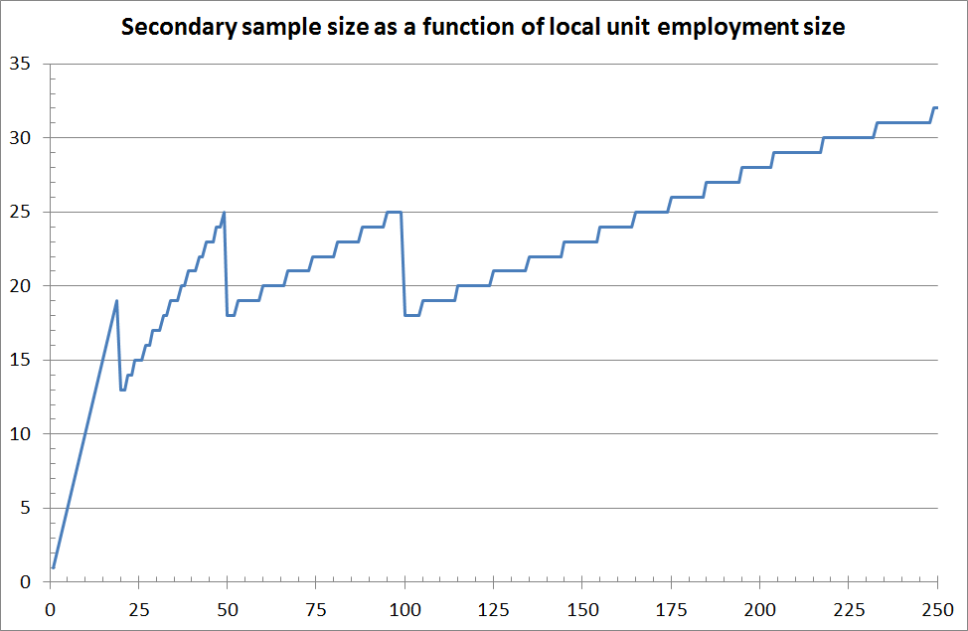
Figure 1: Secondary sample size as a function of employment in the establishment
Secondary sample size increases stepwise: higher inclusion probability for larger establishments (first stage) offset by lower employee sample size (second stage) => a priori individual employee selection probability is range bound for SME’s
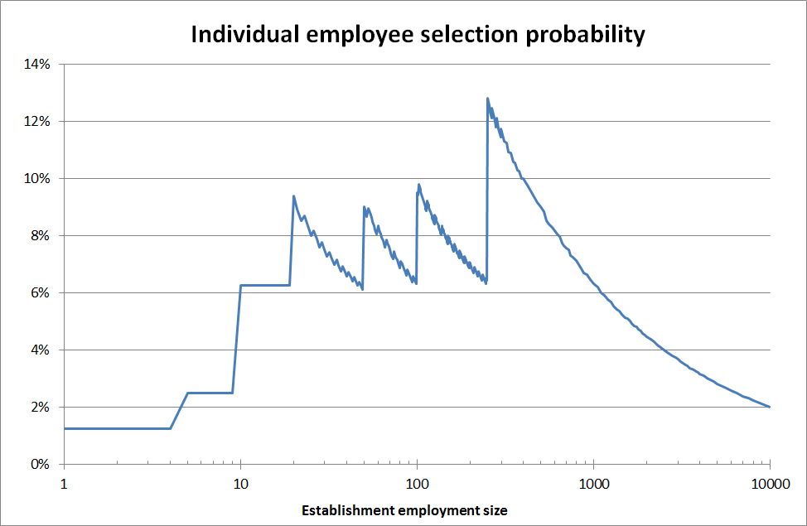
Figure 2. Individual employee selection probability as a function of the establishment employment

Second stage stratification
Individual data by establishment => micro-stratification (gender, age category and remuneration quartile)
Remuneration quartiles are determined across the economic activities on NACE Rev 2 subsection ‘2-digit’ base. Those may differ quite a lot across the overall economy.
Table 2: Extreme values of monthly gross remuneration across economic activities
 |  |  | Monthly gross remuneration (€)
Nace Rev2 |  | Descriptif |  | Q1 | Median | Q3
81 |  | Cleaning |  | 1629 | 1831 | 2050
19 |  | Oil refining |  | 5166 | 6517 | 8140
Remuneration dispersion (Variation coefficient on monthly remunerations and interquartile range) also very different between NACE Rev2 subsections.
Age categories are determined as to equally divide the labour population of employees of the economic activities covered. They divide the 2017 labour population (across economic activities) as follows:
- Employees born between 1953 and 1968 (aged 49 to 64) - 32% of population
- Employees born between 1969 and 1981 (aged 36 to 48) - 37% of population
- Employees born after 1982 (aged 35 or below) - 31% of population
Younger age category: grown by the time of the 2017 survey; older age category: suffered outflow. Middle aged workers (aged 36 to 48) continue to outnumber.
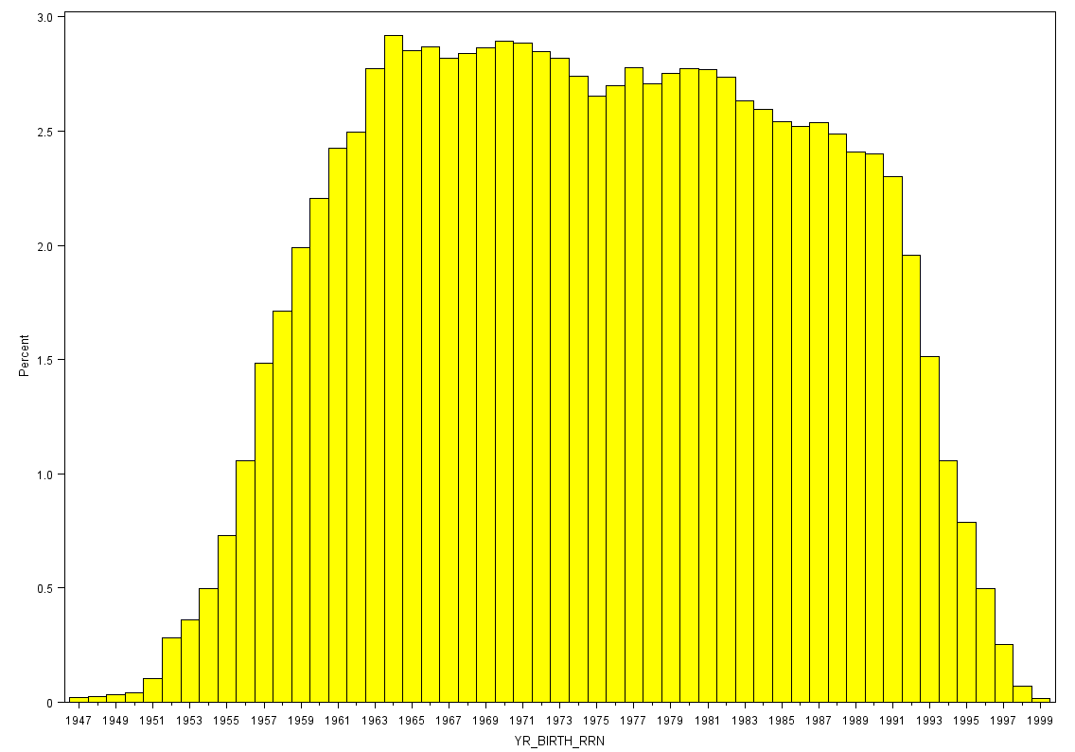
Figure 3: Labour population breakdown by birth year
Second stage sample allocation
Number of micro-strata versus secondary sample => mutually exclusive cases:
- All eligible persons need to be drawn (trivial): (11%);
- More micro-strata than sample size: (5%). No full coverage: missing out ‘singletons’;
- A high stratum coverage: Sample > 2 * number of micro-strata (14%);
- Low stratum coverage: Sample > number of micro-strata (70%).
Case 3 & 4: selected 1 employee in all micro-strata. Then assign rest of sample will proportionally to micro stratum size.

Response rate
New survey design applied to 2017 SES (for national needs) => improved response rate.
=> many larger respondents have flagged employees who left
=> Mostly they were replaced by other employees (not anticipated)
=> No recommended employee replacement policy
=> Lack of freshness of admin source : newly recruited employees for replacements is good idea
=> Applying new design for the EU-wide SES for 2018 (imminent).

Open for discussion:
- Determining individual weights; 2) Sample coordination; 3) GDPR and anonymization

