**Perception of individual taxpayers regarding the   
e-invoice portal in tax compliance**

Alexandre Silva ([asilva@iscac.pt](mailto:asilva@iscac.pt))[1], Joana Leite1, Daniela Costa1 and Cidália Lopes1

**Keywords:** tax, e-invoice portal, compliance, SEM

# Introduction

The present paper intends to assess and analyse the perception of individual taxpayers regarding the fulfilment of their tax obligations. In particular, to analyse the impact of the introduction of the e-invoice portal in tax compliance, and in this way adding value to official statistics, where the focus is restricted to the satisfaction assessment and the identification of flaws.

The theme is justified for several reasons. First, the tax compliance paradigm followed the evolution of the digital economy, and today it is only possible to file the tax returns online. Secondly, in 2015 the e-invoice portal was linked to the individual taxpayer's tax returns allowing them to manage their taxation, through the validation of their expenses, that will be deducted on the tax amount.

This study intends to check how taxpayers evaluate the e-invoice portal in their relationship with tax obligations. It is our intention to see if it is seen as a useful tool to support tax compliance or, instead, as an "obligation" to the taxpayer which leads to an increase of compliance costs.

## e-invoice portal

As from 1 January 2013, "individuals, whether natural or legal persons, who have a registered office, permanent establishment or fiscal domicile in Portugal and are engaged in transactions subject to VAT, are obliged to notify the Tax and Customs Authority (TA) by electronic transmission of data, the invoice elements issued under the VAT Code through the e-invoice portal" (article 3 of law no. 198/2012, of 24 August).

Initially aimed at combating tax evasion and avoidance, the Portuguese State assigned to taxpayers a 15% deduction of income tax with expenses in sectors like aesthetics. This benefit was limited to invoices issued with the taxpayer's identification number (NIF) and communicated to TA by the companies, and its main objective was to minimize the number of transactions that were not invoiced and therefore not taxed.

Through the unpaid work of the taxpayer, who acted as an inspector of TA ensuring that the sales and services of these sectors were properly billed, the Portuguese Government was able to reduce the amount of undeclared income, estimated at around 17.82% of GDP [1], while Europe and the OECD average 20.20% and 15.28%, respectively, in the years 2010-2015.

The e-invoice portal (figure 1) was developed since 2013 and any tax payer can access checking the expenses and benefits.

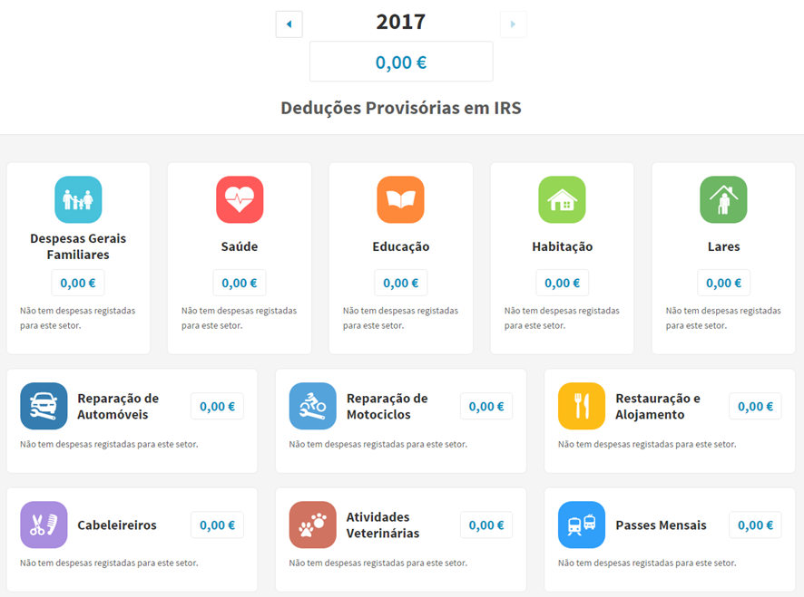

Figure 1. e-invoice portal

In order to allow a greater number of interactions between the taxpayer and the TA in an increasingly faster, easier and safer way, the e-invoice portal appeared. It has now become important to analyse the individual taxpayer's perception of all these changes and functionalities in the fulfilment of their tax obligations.

Our study evaluates the perception of individual taxpayers in relation to the use of the e-invoice portal in the tax compliance process in Portugal.

# Methods

A 31 questions questionnaire was made available, in April and May of 2017, to individual taxpayers from the region of Leiria and Coimbra through the Google Forms platform, using social networks and the teaching and non-teaching population of Coimbra Business School and Portuguese Chartered Accountants Association.

It was measured the (perceived) subjective norm, usefulness, reliability, compatibility, ease of use and attitude [2,3,4]. A structural equation model (SEM) analysis was performed with AMOS [5].

# Results

A total of 118 responses were obtained.

# 

Figure 2. SEM regression weights

The subjective norm is significantly related to usefulness. The more taxpayers take into account the opinions of those around them regarding the e-invoice portal, the more useful they think this is.

The usefulness variable takes into account whether taxpayers consider that the portal, with all its functions, is important for a correct fulfilment of the tax obligation that it proposes to help. As has been seen previously, it is important that such a portal be considered useful by taxpayers as a way of encouraging tax compliance.

It is in this follow-up that we can also conclude, by the model of the figure 2, that the ease of use variable - which aims to measure whether the portal is simple and intuitive - is significant and positively related to usefulness. The more useful the portal becomes, the more taxpayers think it is easy to interact with it.

The variable ease of use is still positively related to the variables compatibility - which aims to measure how compatible the e-invoice portal is with taxpayers' fiscal life - and reliability - that seeks to assess the level of trust that taxpayers attribute to the portal - yet than in a moderate way.

As one would expect, after concluding that the relationships between the variables are positive and significant, it is expected that all these variables will result in a good attitude of the taxpayer before the portal e-invoice, as we have come to conclude.

# Conclusions

# After analysing the perception of individual taxpayers regarding tax compliance and the use of the e-invoice portal we can, in summary, conclude the following.

# In the international literature, several authors have studied the relationship between the use of online portals and the level of compliance of individual taxpayers with tax obligations.

# Some concluded that the quality of services provided by the tax administration is positively related to the use of online portals, and, as might be expected, perceived ease of use also positively influences the use of online portals [6].

# In a similar study in Sweden [7], concludes that online delivery of income tax returns has been significantly adopted by taxpayers over the years as it is seen as a faster and more convenient way to meet tax obligations.

# Taxpayers considered the e-invoice portal an intuitive, practical and quite useful platform. It enables any taxpayer, with a lower knowledge of the tax, a slightly more enlightening and detailed view of the tax calculation. It also helps with tax planning, since it allows the taxpayer to consult, throughout the year, their expenses and their repercussion on the tax.

# According to the results obtained, we found that taxpayers who did not make mistakes in completing their declaration demonstrate a better attitude towards the portal. The type of income earned is related to the usefulness attributed to the portal, which makes sense since, for example, Category B income requires greater care in validating the invoices on the platform. We also verified that the number of dependents influences the ease of interaction with the portal. The fact that there are dependents requires consulting the personal page of each one, which makes the validation process of expenses more time consuming.

# We conclude that the variables subjective, compatibility, reliability, usefulness and ease are positively related to each other, and that, together, result in a good attitude of the taxpayer towards the portal.

# References

1. L. Medina and F. Schneider, Shadow Economies Around The World: What Did We Learn Over The Last 20 Years?, International Monetary Fund Working Papers (2018).
2. F. D. Davis, Perceived Usefulness, Perceived Ease of Use, and User Acceptance of Information Technology, MIS Quarterly 13(3) (1989), 319-340.
3. M. Fishbein and I. Ajzen, Belief, Attitude, Intention and Behaviour: An Introduction to Theory and Research, Reading, MA, Addison-Wesley (1975).
4. J. Rose and G. Fogarty, Determinants of Perceived Usefulness and Perceived Ease of Use in the Technology Acceptance Model: Senior Consumers’ Adoption of Self-service Banking Technologies, in: Academy of World Business, Marketing & Management Development Conference Proceedings Volume 2 (2006) No 10.
5. B. M. Byrne, Structural equation modeling with AMOS: basic concepts, applications, and programming, Mahwah, New Jersey: Lawrence Erlbaum Associates (2001).
6. B. Mustapha and S. Obid, Tax Service Quality: The Mediating Effect Of Perceive Ease of Use of the Online Tax System, Procedia – Social and Behavioral Sciences, 172 (2015) 2-9.
7. R. Egowan, Assessing e-services from a user perspective: A study of the Swedish electronic tax declaration, Master’s thesis in E-government by the Swedish Business School at Örebro University (2011).

1. Coimbra Business School| Coimbra Polytechnic Institute