Urban Statistics 2020: A Growing Demand for Geospatial Urban Statistics from the Perspective of the City of Helsinki

Ari Jaakola (ari.jaakola@hel.fi)[1]

**Keywords:** Urban statistics, Small area statistics, Geospatial information

# Introduction

The City Council of Helsinki approved the Helsinki City Strategy in September 2017 [1]. It sets the outlines city development in the years 2017-2021. The Strategy’s vision is ambitious: Helsinki wants to be “the most functional city in the world”.

The content of the vision is comprehensive. It includes themes such as securing sustainable growth, developing services, responsible management of finances as well as a faster and more agile organisational culture with continuous development of the city’s own operations and practices. All these objectives request a solid base of statistical information but at the same time they challenge the existing statistics and information base of the city.

In this abstract I will discuss the growing demand for urban statistics, and especially versatile urban statistics for facilitating well informed decision making of the city authorities. I will study these issues from the perspective of the city of Helsinki. The key questions are what kind of statistical information the city needs to reach the objectives set out in the City Strategy, what kind of challenges the new needs will bring to the current statistical information base and how to develop the existing statistics in order to meet the challenges.

# What kind of statistical information does the city of Helsinki need?

First of all, the city needs a solid statistical base to understand it’s present operating environment and future development. This covers basic statistics on the residents, their living conditions and well-being, economic activities and development, and the state of the environment. Statistical time series are highly important for detecting changes and assessing possible future developments. Statistical monitoring is needed to assess whether the targets are met. In order to anticipate future developments (e.g. the population projections) it is necessary to have adequate information available for planning and designing different public services. [2] [3]

Another need for statistics stems from the aim of curbing the differentiation between population groups and neighbourhoods of Helsinki. In order to maintain social cohesion and to prevent the growth of disparities between individuals and neighbourhoods there is a need for statistics that describe the differences between people from various age groups and backgrounds. Monitoring the developments on the neighbourhood level equally important for preventing the unwanted development of segregation.

Thirdly, the Helsinki City Strategy emphasizes functionality. The basic task of the city is to provide high-quality public services and to create the conditions for a stimulating and enjoyable life. A functional city means that concrete actions and choices must be taken in order to make everyday life smoother for residents. This means that we must measure and monitor the functionality with the help of statistics. Accessibility of places and services by different modes of 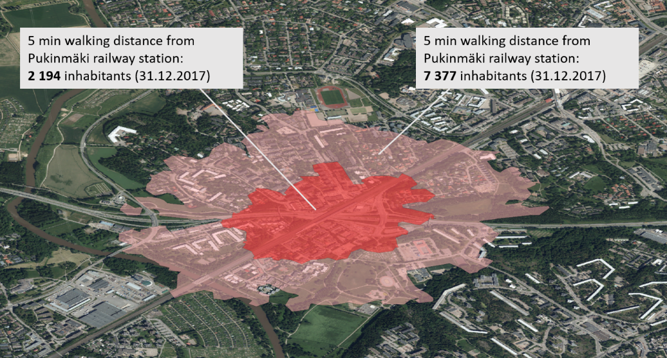transportation is a good example of that (Figure 1.).

Figure 1. Example of an analysis on accessibility: number of inhabitants within certain (5 min and 10 min) walking distance from local train stations.

In addition to the themes mentioned above, there are two other important aspects to be considered. One is that the city needs comparative statistics from other cities in Finland but especially in the case of Helsinki, from other countries, too. The other is that the city must have information on its own services and operations, especially from the perspective of residents, enterprises and third sector organizations. [4]

# The challenges of producing the necessary statistical information base

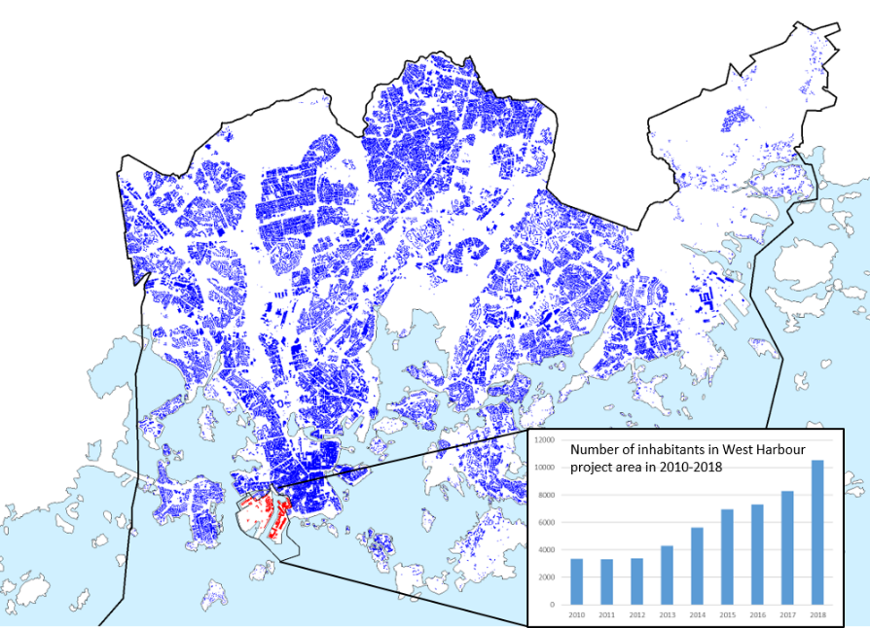As stated in section 2 the city’s information needs are wide-ranging. There is a need for increasingly detailed information on various urban phenomena. Detailed information is needed, for example, on residents with different backgrounds including the second- generation immigrants (i.e. residents who are born in Finland and are Finnish citizens but whose parents were born in other countries). Another aspect is the need for small area statistics and of areal statistics that differs from the traditional statistical areal units (see for example figure 1). Large project areas and development zones are examples of areal units whose development needs to be monitored (Figure 2).

Figure 2. Example of project area whose development needs to be monitored.

In addition, there is a set of new kind of urban phenomena that should be subject to better statistical monitoring and analysis. Immigration and the integration of immigrants, labour migration, the lifestyles of different population groups, the functionality of the urban structure, the development of digital services and their use (different potentials related to digitalization) and the participation of residents and other actors are examples of the wide-ranging areas of information that must be developed.

As the biggest city and city region in Finland, Helsinki needs comparative statistics also from cities in other countries. In addition to the city-level data, more accurate and detailed comparable data of neighbourhoods is needed in order to better understand different urban phenomena such as segregation. Only this will help us to evaluate the situation in one city compared to others. As to the particular data needs of Helsinki, developing comparable small area statistics is one of the most important tasks for data providers.

Last but not least, we need to consider the usability of the data. A special challenge is that the data needed for statistical monitoring is scattered across different organizations maintaining the data, and the data is offered in many different formats. That makes it difficult to combine different data sets. Sometimes it is difficult to get the data out of the databases because of the lack of good user interfaces or use it because of incomplete documentation. Sometimes the bottleneck is the data delivery process itself, including the organization’s ability to handle the requests for data or to organize the data delivery.

# How to move on?

The key question for a city’s statisticians and researchers is how to meet these challenges and the growing demand for urban and regional data. In Finland, we have a functioning registry system with state-wide and up-to-date basic registers on population, housing, property and planning. These registers are connected to each other, and they can be connected to other data bases that are maintained for other purposes, like education, health care and social services. This constitutes an excellent basis for producing various statistics.

Despite a good point of departure there is still a lot of work to do. The interoperability, comparability, availability and usability of the data are still crucial fields of work. Developing the regulation and common practices of the use of data is highly important, too. All of these need a lot of close and intensive cooperation between the data providers and users. Helsinki Region Infoshare open data service [5] is a good example of that.

One important aspect of developing the interoperability and usability of data is that the statistical data should be connected to geographical information. The geospatial statistical data enables us to combine different data sets with no common identification fields by using location. It also enables much more choices for data processing and analysis (based on location and geographical links; see figures 1 and 2). Finally, it enables more choices for presenting the data, for example different kinds of maps. Georeferencing the statistical data makes the data more versatile and usable.

# Conclusions

From the perspective of the City of Helsinki, there is a growing demand for geospatial urban statistics that should be versatile enough for different purposes and should cover a wide range of different aspects of urban life and city services. Statistics should be modelled as geographic information and presented at the most detailed spatial and attribute levels possible. This enables the data users to better enrich data it with data from other sources, to (re-)form relevant areal units and to do more accurate spatial analyses. It also offers more options to visualize data. Thus, it increases the possibilities of utilizing statistical data for different purposes.

In order to produce such data, a close co-operation between the producers and users of data is needed. Data producers should work together for better interoperability, comparability, usability and availability of geospatial statistical data. This also requires a better understanding of potential new data sources, different use cases and the user’s needs. The user’s views should be taken into account when developing data and data delivery services, like web services, interfaces and APIs (application programming interfaces). This would increase the use of data, and by that token, also the value of the data.

# References

1. The City of Helsinki, The Most Functional City in the World. Helsinki City Strategy 2107-2021. <https://www.hel.fi/static/helsinki/kaupunkistrategia/strategia-en-2017-2021.pdf> (14.6.2018)
2. The City of Helsinki Statistics and Research Programme 2016-2018 (Tietoa Stadista – Helsingin kaupungin tilasto- ja tutkimusohjelma 2016-2018, Muistioita 2016:2). <https://www.hel.fi/hel2/Tietokeskus/julkaisut/pdf/16_06_20_Tietoa_Stadista_2016_2018.pdf> (Only in Finnish; 14.6.2018)
3. Jaakola, Ari & Vilkama, Katja (2016): Helsinki’s present state and development 2016, Summary of key findings. Quarterly 1/2017 (pages 8-25). <https://www.kvartti.fi/sites/default/files/files/issue/helsinkiouarterly2017_screen.pdf> (14.6.2018)
4. Teemu Vass (2015): The digitized city is a goldmine of data and information. Quarterly 3/2015 (pages 5-9). <https://www.kvartti.fi/sites/default/files/files/issue/quarterly3_2015_screen.pdf> (14.6.2018)
5. Helsinki Region Infoshare Open Data Service (https://hri.fi/en_gb/)

1. Statistics and Information Services Manager, City of Helsinki