**Preparing for 2021 Census: Use of the individual administrative data for profiling of the Latvian emigrants**

Sigita Šulca, MSc

sigita.sulca@gmail.com

University of Latvia Faculty of Geography and Earth Sciences

**Abstract**

The research aims to construct a demographic and socio-economic profile of the modern Latvian emigrant using administrative data at the individual level. The obtained emigrant profiles will help predict the probability of emigration from the geographic, demographic and socio-economic perspective. Furthermore, it will allow to prepare for the 2021 Census, which will be organized only from administrative data sources.

**Keywords:** Migration, Geographical mobility, Migrant profile, Administrative data

1. **Introduction**

Research topicality is related to the decline in population and its impact on the future development of countries. In parallel, mobility of citizens is seen as an essential economic and personal benefit. The marked rise in migratory flows is a result of economic crisis, lower welfare support, and different levels of income between countries, progressive climate change and unrest from military conflicts. Predictions have pointed to the marked increase in mobility “…people will be on the move in numbers and ways we have not seen before.” (Clemens et al. 2008).

Changing migration patterns in the context of the increase in migration flows necessitates the preparation of statistics, which provides the forecasting of migration processes, the planning of logistics and integration measures for migrants and the development of policies for the reduction of migration.

Using the administrative data on the individual level from various registers, it is possible to construct a more objective geographic, demographic and socio-economic profile of the emigrant. This paper will shed light on the demographics and geographic profile as well as socio-economic (education level) aspects.

1. **Data and methods**

This study analyses the data of the administrative registers at the individual level using the IBM SPSS program and combines different variables for each person. The study uses administrative data at the individual level for the 2014-2016 emigrants-recognized persons (Emigration data, 2014-2016). Data has been sourced from the Population Register of the Office of Citizenship and Migration Affairs, the Ministry of Education and Science and 32 higher education institutions of Latvia. The processing of data was performed according to the Confidentiality rules of the Central Statistical Bureau of Latvia and the Law on the Protection of Personal Data.

The typical data collected for each Latvian emigrant includes age, gender, estimated place of residence (according to the method of the Central Statistical Bureau (Method, 2012)), marital status, nationality. From the socio-economic indicators, the level of education was divided according to ISCED 2011[1]. Every year, emigrants are evaluated as a separate data set without considering the returnees.

1. Results

The results show that administrative data provided a reliable tool for preparing the profile of the Latvian emigrants. Qualitative demographic indicators and education levels could be assessed.

Emigration from Latvia has not notably increased in the last years. Outmigration reached a peak in 2009-2010, at the time of global economic crisis and first post-crisis, when about 35,000 people emigrated from Latvia each year. Emigration has now dropped to about 20 000 a year. 85% of emigrants are 18 years or older in 2014 to 2016.

* 1. **Emigrants by regions**

Looking at the emigration data by region, it appears that the largest proportion of the emigrants in the regions was from the Kurzeme region - more than 1.2% of the population has emigrated, but the largest number of residents emigrated from Latgale (see 1. Figure).

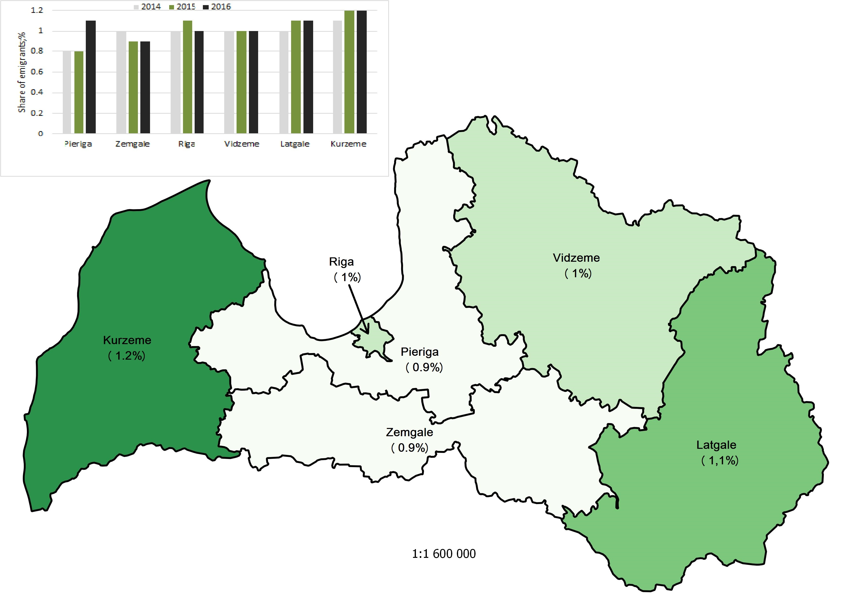

1. Figure. **The share of emigrants in usual residents 2014 – 2016 %**

*Source: author’s projection based on the CSB data (2018)*

The analysis of the data by 5-year age groups observed difference between the population emigrated from the regions of Riga and Pieriga and the other regions that are located farther away from the capital city of Latvia.

* 1. **Emigrants by citizenship**

The proportion of non-citizens emigrants has remained stable over the past three years compared to those of the same groups in the usual population. The emigrants with Latvian citizenship do not exceed 1%, but non-citizens 0.4%. The proportion of emigrants with a nationality of another country, as compared to the proportion of such persons among usual residents, increased from 2.5% in 2014 to 5.4% in 2016. The increase in 2016 can be explained by the fact that the method of estimation of the usual population of Latvia was specified. Several counties in Latvia found a large number of people with the citizenship of non-European country who declared their place of residence at the address of employer[2].

* 1. **Emigrants marital status and the family composition**

About 30% of the emigrants were married, and 50% were registered as not married. The number of the divorced emigrants decreased from 22% in 2014 to 17% in 2016. The divorce rates of people older than 40 were two times higher for emigrants than for the usual residents.

Data was compiled on underage children of all parents who had emigrated from 2014 to 2016. If a mother had emigrated, in more than half of the cases, minors had emigrated with mother, while 47.6% remain in Latvia. If only father had emigrated, in most cases the children stayed in Latvia - 83,1%. In cases where both parents had emigrated, 31.6% of children had stayed in Latvia.

* 1. **Emigrants education**

To find an answer on the education of the emigrants was concluded that most of the emigrants have been obtained elementary or secondary education, ISCED 1-3 (ISCED 2011). Comparing the distribution of education levels among emigrants and the distribution of education levels among the usual residents of Latvia, the share of the persons with basic education among emigrants is by 4.3 percentage points higher (21.6%) than among usual residents. In turn, the proportion of persons with secondary education among emigrants is by 6.6 percentage points higher (48%) than among usual residents. The share of emigrants with higher education is 7.2 percentage points lower than that of usual population.

The analysis of data on age groups shows that the most significant departure of the educated people is more representative among the 25-29 and 45+ age groups. When evaluated in terms of gender, this tendency is more characteristic for women. Young men mostly have left Latvia with basic and secondary education (~90%), however tendency of emigration of persons with higher education level were observed and data shows that more than 20% emigrant women have high education and less than 10% of men.

1. **Conclusions**

According to administrative data, the **most typical contemporary Latvian emigrant is "a young (25-29 years old), unmarried Latvian man from Kurzeme or Latgale region who has at least secondary education.**"

Some aspects can be compared with the results of survey conducted in Latvia. For instance, in a study on the population's intention to emigrate where sample size was 8005 respondents, ascertained that the intention to work abroad was expressed mostly by men under the age of 24 from Latgale or Zemgale region who acquired basic or secondary education (Krišjāne et al., 2007).

In 2015, the book "The Latvian Emigrant Communities: A Hope for the Diaspora" was published. It contains several analytical articles written by sociologists, economists and communication researchers from Latvia. In the article "Emigration from Latvia in the 21st Century in the regions, cities and districts" research was conducted using three data sources: the data of the Central Statistical Bureau on emigration, the Labour Force Survey data, as well as the data gained from the 2014 and 2015 internet survey of the emigrants who had left country from 2000-2014. It seems that the results are in line with the findings of migration theories that more intensive emigration is expected from places with higher unemployment and lower levels of material security (Mieriņa et al., 2015).

The most important conclusion is that most of the emigrants are those who are the most mobile. These young people have completed their studies, started working, have not established a family, and want to earn more and travel. Upon reaching the age of 30, other priorities arise, for instance, internal migration flows (to Pieriga) suggest that people have achieved stability both materially and socially. A returnee’s study should be conducted to determine remigration flows for persons aged above 30.

Further research will be carried out in three directions - identification and application of main theories and methods for profiling migrants, the use of additional administrative data for profiling, as well as an assessment of the quality of available data. It would be necessary to provide more in-depth analysis to individual demographic indicators (for instance, does the emigrant has a child, where the children live – with parents or not, the number of children) and socio-economic (employment, occupation, health status, availability of services in the place of residence, material security, dependents) and their impact on the probability of emigration. This data can be used for the government to think of new support mechanisms for residents from Latgale and Kurzeme, to retain the stability in these regions, while giving rise to new forms or employment and industry.

**Sources**

[1] Clemens, M. A., Claudio M., and Lant P. 2008. “The Place Premium: Wage Differences for Identical Workers across the U.S. Border. “ CGD Working Paper 148. Washington, D.C.: Centre for Global Development.)

[2] Emigration data 2014 – 2016, <http://data.csb.gov.lv/sq/17984>

[3] ISCED 2011 http://ec.europa.eu/eurostat/ramon/other_documents/isced_2011/index.cfm?TargetUrl=DSP_ISCED_2011

[4] Krišjāne, Z. et al., (2007) Geographic mobility of the labour force, 2007 University of Latvia. - p. 164.

[5] Method of preparing population statistics, 2012 http://www.csb.gov.lv/sites/default/files/dati/demstat_metodologija_eng.pdf

[6] Mieriņa I. et al., 2015 The Latvian Emigrant Communities: A Hope for the Diaspora, 2015 Agency Radar. - p. 25

1. <http://ec.europa.eu/eurostat/ramon/other_documents/isced_2011/index.cfm?TargetUrl=DSP_ISCED_2011>
2. These persons were employees of enterprises (for example, long-distance drivers) who had declared the place of residence at the address of the company. These persons were immediately excluded from the usual population of Latvia and included in the number of emigrants after the detection of fact that they had not lived permanently in Latvia.