The harmonised Labour Market Areas – the European value added

Valeriya ANGELOVA-TOSHEVA (Valeriya.ANGELOVA-TOSHEVA@ec.europa.eu)[1], Dario BUONO (Dario.BUONO@ec.europa.eu), Teodora BRANDMUELLER (Teodora.BRANDMUELLER@ec.europa.eu)

**Keywords:** Functional geographies, LMAs, harmonisation, cross-border commuting, industrial districts

# Introduction

The European Union has defined far-reaching policy development objectives in the context of the Cohesion Policy, the ten Commission priorities and more recently within the context of the Sustainable Development Goals and the Urban Agenda. These political initiatives share the challenge to provide adequate, statistical information on which to base the necessary policy actions. In order to implement the policy initiatives in the European context, there is a growing need for not only higher geographical detail and references related to administrative units, but also for information, that reflects the inherent structure of the social and economic reality at which European decisions and projects need to be targeted. As such, the structuring of information according to functional areas is complementary to the established administrative areas and regions.

With concepts such as the Labour Market Areas (LMAs), the established system of the territorial classification of NUTS based on the national administrative structures of Member States should be supplemented by the concept of “functional geographies”. The concepts of the LMAs attempt to reflect the phenomenon that with increasing mobility, administrative regions coincide to a lesser degree with the places where people live and work. Administrative regions cannot always address European and national policy needs as regional administrative boundaries are often the result of historical circumstances; they do not necessarily mirror the present day's social and economic reality; commuting might distort important regional data on NUTS such as GDP, employment/unemployment rates, consumption and environmental statistics.

LMAs can be defined as a geographic area designed for the purposes of compiling, reporting, and evaluating employment, unemployment, workforce availability and related topics. It is a statistically defined, economically integrated territory, where the majority of people live and work.

This article aims to present the main principles of the method for delineation of LMAs and based on some interesting results to demonstrate the European value added of this functional geography.

# The method

For the last ten years, Eurostat has intensively worked on the EU-wide harmonisation of the LMAs concept starting with a study together with the research community to investigate the value added, feasibility and best practices in the EU. The subject has been intensively studied in the Working Group on Regional, Urban and Rural Development Statistics, both in a specific Task Force and in a range of EU grants. The approach for delineation of LMAs proposed to the Member States is a simple, transparent, reproducible, consistent, and policy independent bottom-up method that needs only commuting flows as input. Furthermore, a script based on open-source software (R package) supported the IT implementation of the method. The method is designed to aggregate neighbouring Local Administrative Units (LAUs) to LMAs, satisfying a particular validity condition (internal cohesion and external separation principles), based on functional relationships, namely the commuting flows.

The algorithm operates with set of four parameters (minimum and target size of the employment (minSZ and tarSZ) and minimum and target self-containment of the LMA (minSC and tarSC)).

$$\frac{minSC}{tarSC}≤\left(1-\left(1-\frac{minSC}{tarSC}\right)∙MAX\left(\frac{tarSZ - SZ}{tarSZ - minSZ},0\right)\right)∙\left(\frac{MIN(SC, tarSC)}{tarSC}\right)$$

The algorithm stops when all clusters of LAUs fulfil the validity condition.

# Results

The results presented below are only few examples for the achievements of the European LMAs' network. All results are available on the website for Collaboration in Research and Methodology for Official Statistics[2].

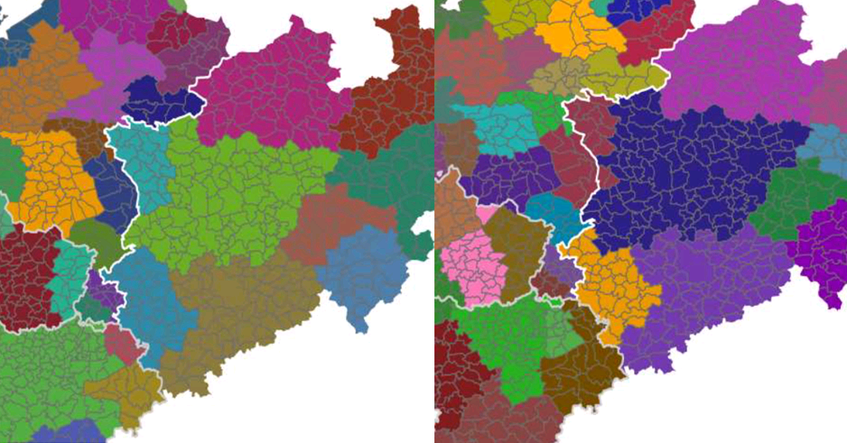

Figure 1. LMAs in the Dutch-German border region produced without and with cross-border commuting data

Statistics Netherlands used the proposed method to produce LMAs in the Dutch-German border region without and with cross-border commuting data. We observe large effects on the construction of the LMAs inside the countries, especially in Netherlands. The inclusion of cross-border information results in clusters that are more logical.

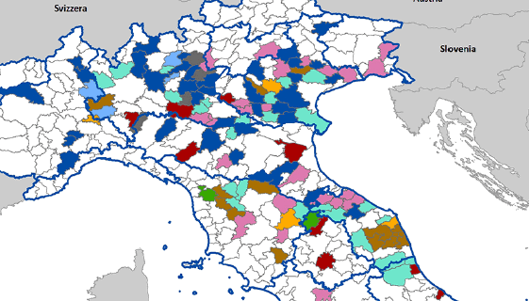

**Figure 2. Industrial districts based on LMAs in Italy**

ISTAT used the harmonised LMAs to produce a customised functional geography, namely the industrial districts. According to the 2011 business census data, the coloured LMAs show the presence of a dominant industry in the medium, small to medium size enterprises measured in employment by different NACE activities. It was found out that there is no dominant industry in the majority of the LMAs in southern Italy.

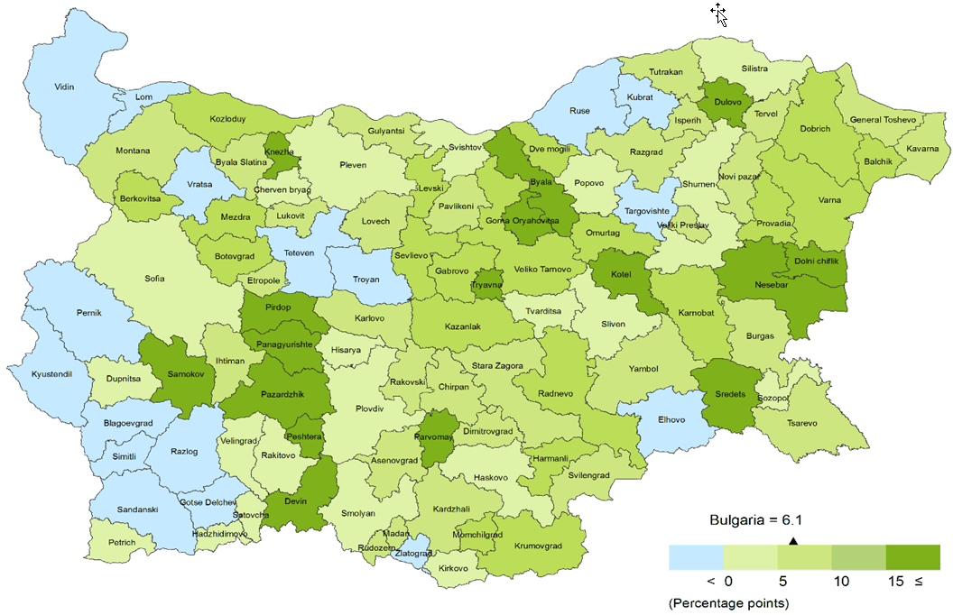

**Figure 3. Gender gap for the employment rate (15-64) by LMAs in Bulgaria**

Bulgaria has demonstrated that the delineation of the harmonised LMAs is not an end in itself. Various socio-economic data on LMAs could be produced using simpler method such as direct estimates or more sophisticated approaches such as Small Area Estimations.

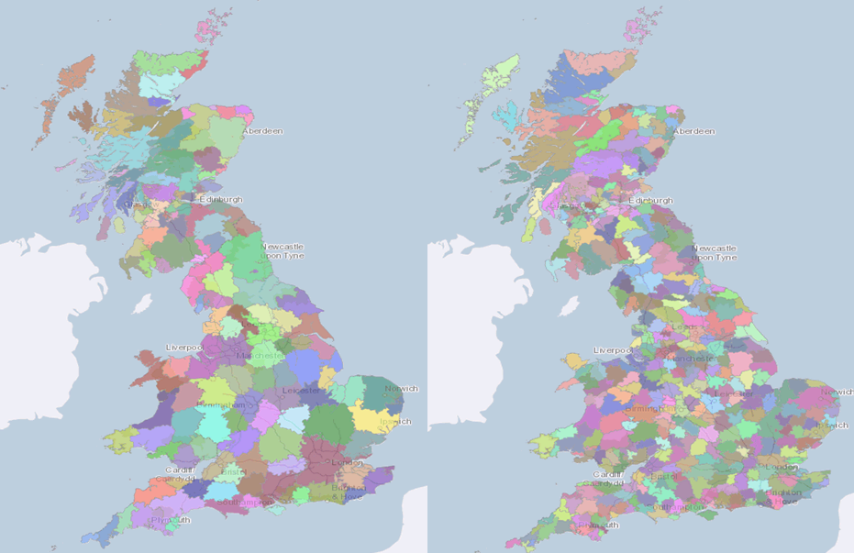

**Figure 4. Alternative LMAs by high and low qualifications of the employed persons in UK**

We observe that hypothetical LMAs for workers with low qualifications only, compared to those for workers with high qualifications, are considerably smaller. Alternative LMAs have been produced by several European countries by specifying the gender, the age, the mode of transport used by the commuters etc.

# Conclusions

Functional geographies such as the LMAs overcome some limitations of the NUTS. The use of harmonised definition of LMAs for Europe could support sector policies, urban and transport planning. The concept of the LMAs, when interpreted in a European context, is necessary to better address various employment and social policy issues. Combined with other data sources, the LMAs could be a powerful analytical tool.

# References

[1] M., Coombes, J.M., Casado-Diaz, L., Martinez-Bernabeu, F., Carausu, (2012). Study on comparable Labour Market Areas, Final research report, Luxembourg. Available at: https://ec.europa.eu/eurostat/cros/content/study-comparable-labour-market-areas_en

[2] ISTAT (2015), La nuova geografia dei sistemi locali, Roma. Available at: https://ec.europa.eu/eurostat/cros/content/new-geography-local-systems_en

1. Eurostat
2. https://ec.europa.eu/eurostat/cros/content/labour-market-areas_en