The circular market flow as an approach to explain the value of official statistics to users

Margarita Rohr ([margarita.rohr@uv.es](mailto:margarita.rohr@uv.es))[1], Florabela Carausu[2]

**Keywords:** value of official statistics, circular market flow, statistical literacy

Starting from the idea that official statistics are a public good, the authors argue that ensuring the value of official statistics can tackle positively the challenges that official statistical producers are currently facing. From the legal point of view a public good belongs to or is provided by the State at any level through all bodies being part of the public sector. From the economic standpoint, it is a good that is available to all population and its use by one person does not reduce its use by another. In this sense, official statistics are very important for the economic and social development of a country and its significance can be explained by the circular market flow.

The main objective of this paper is to offer a new way of understanding the importance of the statistical system for the economic and social development of societies, but as well to promote the continuous and systematic dialogue between statistics producers and users, focused towards communicating the value of official statistics to the society in general.

The circular market flow is proposed as a basis for showing the relations that exist within an economic system, and as well the important role that official statistics play within the society. Statistical literacy, the communication of the value of official statistics to stakeholders, and a closed feedback loop are capable to engage all actors with the process of producing official statistics, ensuring its sustainability.

# Introduction

Statistical offices are currently facing several challenges:

* methodological (how to deal with multiple data sources, and BigData and their quality);
* challenges related to their communication role (how NSIs could explain the role and objective of the statistical office, their ‘product’ and the ‘value added’ of the statistical products);
* challenges that deal with the responsiveness of the statistical office to user needs;

Addressing statistics user needs is an increasing challenge for NSIs. The question on the relevance of official statistics to make sense of the evolving nature of today’s world is popular. Contrasted to the data or statistical products coming from producers outside the official statistics sphere, official statistics are judged for coming in too late for decision making or not be granular enough, among others.

The understanding and mutual trust of stakeholders towards official statistics is essential for closing data gaps and information needs.

The credibility of (some) official statistics is questioned. GDP, poverty, employment rates, migration flows figures are frequently questioned, because people in their day-to-day life do not identify with “averages”. Therefore, trust is an essential factor in the relation between official statistics producers and their users.

Furthermore, whenever official statistics producers are capable of closing data gaps, new ones appear, or the existing ones need further interpretation in correlated contexts. Statistical offices are making efforts to put in place processes to consult users and monitor their satisfaction. But, these actions require rather a continued dialogue between producers and users, than an action with a certain frequency.

# Methods

The objective of this paper is to raise awareness and to offer a new approach for understanding the importance of the statistical system for the economic and social development of societies, but as well to support the continuous and systematic dialogue between official statistics producers and users, focused towards communicating the value of official statistics to the society in general.

To reach the planned objective, we propose to use the circular market flow as a basis for showing the relations that exist within an economic system, and as well the important role that official statistics play within the society.

The intervention of the state/governmentin the market flow, initially considering only two actors (i.e. the households and the enterprises) is tow folded:

* On one side, the government acts both:
  + as an enterprise, because it demands productive factors from households, offering them in change goods and services;
  + as a household, buying goods and services from enterprises, offering them in change a price.
* On the other side:
  + the government develops its tax function, receiving income through charging taxes. The income obtained this way is used to finance the public goods and services, and to social transfers to households.

We assume that an NSI, as part of the government, has the same functions, and intervenes in a similar way in the economic system.

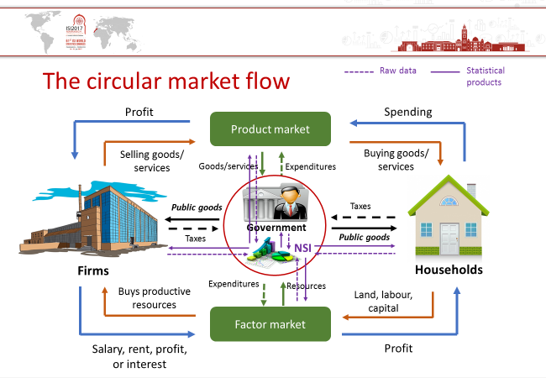In detail, the statistical office collects data from the actors in the market and uses them to develop statistical products; for example,

* + in the case of households, the data collected through household surveys are used for developing social statistics and indicators, which further on serve for policy making in the social sphere for the benefit of the society as a whole;
  + in the case of business and industry surveys, the data collected serves for producing indicators for developing economic policies in the different business sectors;
  + the product market and the factor market provide information about the prices of consumer goods and services and factors.

Dropping out the monetary flows and good and services from the circular market flow, the main actors of the statistical system and the exchange of statistical information within a national statistical system are represented.

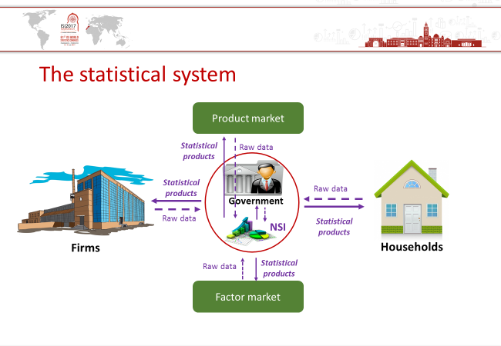

By definition – and in line with our approach, and the economic theory – the statistical system should be balanced as well. In other words, the demand coming from users should adjust the offer of statistical products. And the statistical products placed on the product market should be consumed.

In line with the assumption, the circular market flow allows us to see that a national statistical office, as part of the government, produces public goods.

Given that the national statistical office is the main provider of official statistics, we understand official statistics as a public good.

The definition of official statistics as a public good it’s not new at all; several statistical offices already include this definition in the legal acts regulating the statistical system, for example:

* Statistics Norway defines official statistics as a public good that everyone shall have equal access to;
* ONS UK considers the statistics produced by them are designed to meet the wider public good as well as the needs of the government;
* Eurostat promotes the definition of official statistics as a public good providing a basis for the smooth functioning of governments.

Taking forward this definition of Eurostat, allows us to consider that official statistics support the regulatory function of the government in the circular market flow.

# Conclusions

We have seen that the official statistics public good definition is well rooted in the discourse of statistics producers. However, this understanding should be shared by the other actors in the circular market flow (i.e. enterprises, households, and the government). Albeit, this implies a set of actions expected from the users, namely:

* Awareness of the importance of official statistics for efficient decision-making;
* Contribution to the process of producing official statistics;
* Cooperation between all actors involved;
* Making use of official statistics products.

These are all ingredients of what would happen if the definition of official statistics as a public good would be rooted in the understanding of other actors, as well.

In order to support the understanding of official statistics as a public good by all actors, there actions are proposed:

* Statistical literacy could help official statistics to be valued and engaged with;
* Communicating the value of official statistics to the actors could ensure the closed feedback loop;
* Strengthening the dialogue between statistics producers and user could ensure the sustainability of the process.

# References

Asle, R. (2016). The concept and commodity of official statistics, Statistical Journal of the IAOS-1 (2016) 1-13.

Bumpstead, R. and Alldritt, R. (2011). Statistics for the people? The role of official statistics in the democratic debate. 58th World Congress of the International Statistical Institute, Dublin, Ireland 21-26 August 2011.

ECE/CES/2016/11. Value of Official Statistics – Interim Report, Note by the Task Force on the Value of Official Statistics.

European Statistics Code of Practice (2011).

Laux, R. (2016). Trustworthiness, Quality, Value: What assurance do independent assessments of code-compliance give? European Conference on Quality in Official Statistics (Q2016), Madrid, Spain 31 May – 3 June 2016.

Laux, R. and Alldritt, R. (2008). Trends in User Needs. IAOS/Scorus Conference on “Smart Data, Innovative Uses – Reshaping Official Statistics”, Shanghai, China 14-16 October 2008.

MEDSTAT III Project (EU financed): “Supporting the dialogue between the users and producers of statistics”.

1. University of Valencia
2. DevStat