Exchange Rate Effects in the International Investment Position -   
Methods, Tools and Applications for Germany

Stephanus Arz, Stefan Hopp, Ulf von Kalckreuth[1] (ulf.von-kalckreuth@bundesbank.de)

**Keywords:** **IIP, external position, currency composition, exchange rate sensitivity.**

# Introduction

Exchange rate movements play an important role in explaining the development und fluctuation in national and sectoral gross and net wealth and the rate of return on foreign investments. The German international investment position (IIP) statistics has for a long time provided and published data on assets and liabilities with foreign counterparties by sector and by financial instruments. For the time since 2012, all items can additionally be broken down according to seven currencies: Euro and six non-Euro denominations. Ex post, this allows calculating the effect of exchange rate changes on the Euro value of assets and liabilities, enabling a wide range of analytical work. These exchange rate changes are now collected in an index of exchange rate effects in the IIP, which depicts the influence of individual exchange rate movements on all non-derivative assets and liabilities in the external position on an aggregated level as well as on various disaggregated levels. Ex ante, it is possible to conduct partial sensitivity-analyses of exchange rate shocks. Furthermore, the extended IIP approach can under certain qualifying assumptions be used to indicate currency mismatches and potential imbalances and as a basis for delving deeper into sectoral currency risk exposure and potential vulnerabilities on the aggregate level.

International spillovers of financial shocks can be transmitted by a variety of channels, among them direct financial interlinkages and demand effects. The exchange rate is a summary relative price for traded goods and services as well as for real and financial assets. Thus it will steer trade and financial flows and determine the relative wealth of people, sectors and nations, including their state of solvency. The Asian crisis started out as a series of currency devaluations that triggered stock market declines and made foreign debt positions of a number of countries unsustainable.

The IIP is to national wealth what the current account is to GNP: national wealth is the sum of real capital plus the net foreign position of a country. Thus, in order to categorize and analyse wealth effects of exchange rate fluctuations, the IIP is the point of departure. Obviously, wealth effects of exchange rate movements on countries, sectors and individuals depend to a large extend not only on their overall gross and net financial positions but also on the currency denomination of their portfolio.

Our paper gives a methodological exposition on analysing the instantaneous valuation effects, with a focus on the German IIP. As the statistical data compilation in Germany is methodologically guided by the IMF BPM6 directives which apply world-wide, it can be expected that this type of analysis is feasible in many other countries.

# Methods

## Basic concepts

Consider any vector  of *K* different IIP stocks at the end of period *t* on any level of aggregation – different instruments in the balance sheet of a sector, or aggregates over multiple classes of instruments. There is an associated composition matrix . For each entry  of the stocks vector, line *k* of the composition matrix gives the currency composition. Let *N* be the number of currency denominations, with 1 indicating the home currency. We obtain:

 and .

All elements in  and  are denominated in units of home currency. Let  be the vector of relative exchange rate changes for the *N* currencies with respect to period t, the first element being an entry for the home currency which is identically equal to zero. To facilitate interpretation, the exchange rates indices are given in price notation, ie in units of home currency per unit of foreign currency. In order to indicate the exchange rate effect in the changes of positions from *t-1* to *t*, we condition on the asset structure in *t-1*. Then the *vector of exchange rate effects* for all positions in is given by the matrix product

 .

It is useful to rephrase this in terms of rates of change, using weights. Define a weighting matrix for the currency composition of assets, where the elements in each line add up to one:

 (1)

and accordingly an *vector of IIP weighted exchange rate changes:*



The term  is a vector of growth rates. One can look at it in two ways. First, by weighting the exchange rate changes on the basis of IIP positions, it "translates" these changes into effects on wealth stocks. Second, from the perspective of these stocks, the elements of  denote the relative change in the positions of  induced by exchange rate variations. The absolute value of effects can be recovered by simply multiplying the weighted changes  back into the stocks . By suitably choosing components of interest in , one can compute exchange rate effects by instrument, by sector or by any combination of these two. And obviously, the same set of computations is possible for a matrix  of liability positions according to currency denominations, leading to corresponding weighted exchange rate changes  for liabilities. It is important to understand that these exchange-rate induced valuation effects are not identical to economic gains and losses in the affected sectors, as economic agents may partly or fully protect themselves by hedging activities. The counterparties of these hedging activities, on the other hand, may assume additional risk not captured by the IIP currency breakdown.

## An Index of IIP weighted exchange rate effects

Given a time series of  for any asset or liability position, it is straightforward to construct Laspeyres-type indices of exchange rate effects, upon which analytical work can be based. Chain-linking the growth factors associated with  while setting some base period equal to 100 yields an index for the capital gains and losses due to exchange rate changes in the respective IIP positions. For any asset or liability position *k*, we obtain , the **I**ndex of **I**IP-weighted **E**xchange rate effects:



At the Bundesbank, as a service to analysts, the  are being computed and stored for the baseline combinations of sectors, instruments and currency denominations, as well as for many meaningful aggregates, ready for analytical use.

## Sensitivity analysis

For purposes of forward looking financial stability analysis, it may be interesting to study the volatility of *IIP*, given the current structure of assets and liabilities. Consider any asset or liability position . Let the row vector  be the currency weights for this position -- row *k* in the general weighting matrix in equation (1) -- and  be the associated weighted exchange rate change. Let  be the variance-covariance matrix of exchange rate changes. The elements of  can be estimated on the basis of historic time series observation. Then

.

is the standard deviation of IIE for  on the basis of current exchange rate composition and the correlation structure for exchange rates. Taking also into account the absolute value of the position, which may be changing quite strongly over time, we may consider instead the exchange rate induced standard deviation of position:



# Results

As an example for the analytical value of IIE, we may consider exchange rate effects for common stocks in portfolio investment. Graph 1 illustrates the development of the index of IIP weighted exchange rate effects on the value of foreign shares holdings, both in the aggregate and disaggregated by sectors. The top panel shows the IIE for aggregate holdings, the panel below shows the associated quarter-on-quarter changes by sector. One can readily observe the depressing effects of the Euro appreciation in 2013 and the strong positive effect that the depreciation in 2014 had on the Euro value of foreign share holdings, and the deflating effect of the re-appreciation in 2017. The panel below shows that the brunt of the effects is borne not by MFIs but by other financial institutions, to a lesser degree also by private households. This sort of information may be of high analytical value for financial stability analysis.

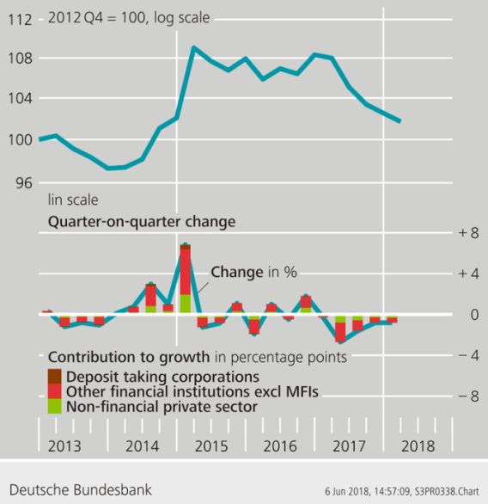

Graph 1: IIE for shares in portfolio investment (asset side)

As an example for sensitivity analysis, consider the development of the standard deviation for total assets and total liabilities in Germany in Graph 2.



Graph 2: Exchange rate related standard deviations for total assets and total liabilities

For the overall exchange rate induced variance in the German IIP, the massive increase of assets and – to a lesser degree – of liabilities denominated in foreign currencies is an important driver. Although these numbers are large in absolute values, they are a more or less mechanical result of tight integration of a large economy into the world financial system, both on the asset and on the liability side. Of course, the standard deviation of Germany's net position (not shown) is much lower.

# Outlook

As yet, we are not in a position to trace the important consequences of hedging activities. This remains an important task for future work.

1. All authors are at Deutsche Bundesbank, DG Statistics. The paper reflects the authors' personal opinion and does not necessarily reflect the views of the Deutsche Bundesbank or the Eurosystem.