Title – Inequality and well-being in Europe: from a transnational to a place-based analysis

**Keywords:** Inequality, well-being, Europe, multi-scaling analysis, monitoring indicators, Horizon Europe, public policies.

# Introduction

Inequality and well-being are central concerns in today’s world. Inequalities are growing and their consequences are visible in the economic, social, cultural and political structures of contemporary societies. The most advanced theories of inequality emphasize that social inequalities are multidimensional, very often intersect with each other and are systemic and cumulative [1, 2, 3 and 4]. Recent studies emphasize that inequality constrains well-being [5 and 6], but the findings are mostly supported by analysis between countries, that do not take into consideration inequalities within countries and their specific transnational scope. The adoption of a multi-scaling perspective – transnationally, nationally and place-based – that would reveal how social inequalities have consequences on well-being of citizens, allows overcoming strict visions of European integration, convergence and social cohesion. Having Portugal as a national case study, this presentation is part of an ongoing project (TIWELL – Territories of Inequality and Well-Being) that intends to replicate the research strategy to others European countries, namely by applying to the next framework of the Horizon Europe (2021-2027). We propose to operationalise a set of inequality and well-being monitoring indicators which make it possible to enhance public policies, supported on a European well-being agenda, that could impact in localities, regions, cities and countries of Europe.

# Methods

The presentation will discuss some data results about social inequality and well-being in Europe, transnationally, inside and between countries. We have developed multivariate analysis and articulate several statistical methods, namely multiple correspondence analysis (MCA), categorical principal components analysis (CatPCA), and clusters analysis, based on updated micro-data from the European Social Survey (ESS) (year 2016) and aggregate local indicators for the case of Portugal. The overall TIWELL project is also using data from EU-SILC, and other statistical methods such as principal component analysis and regressions, namely multilevel regressions. Inequality indicators are based on European Social Survey and local aggregate indicators from Portugal. Well-being indicators are based on the OECD Better Life Index [7] applied to the European Social Survey, and also local aggregate indicators, a first case experimentation.

# Results

These partial results have the purpose of showing some of the statistical possibilities in the development of a multi-scaling analysis of inequality and well-being in Europe, specifically by pointing to the multidimensionality and intersections on social inequalities and well-being at the transnational and national scales of Europe, but the place-based scale will also be object of data analysis in our presentation.

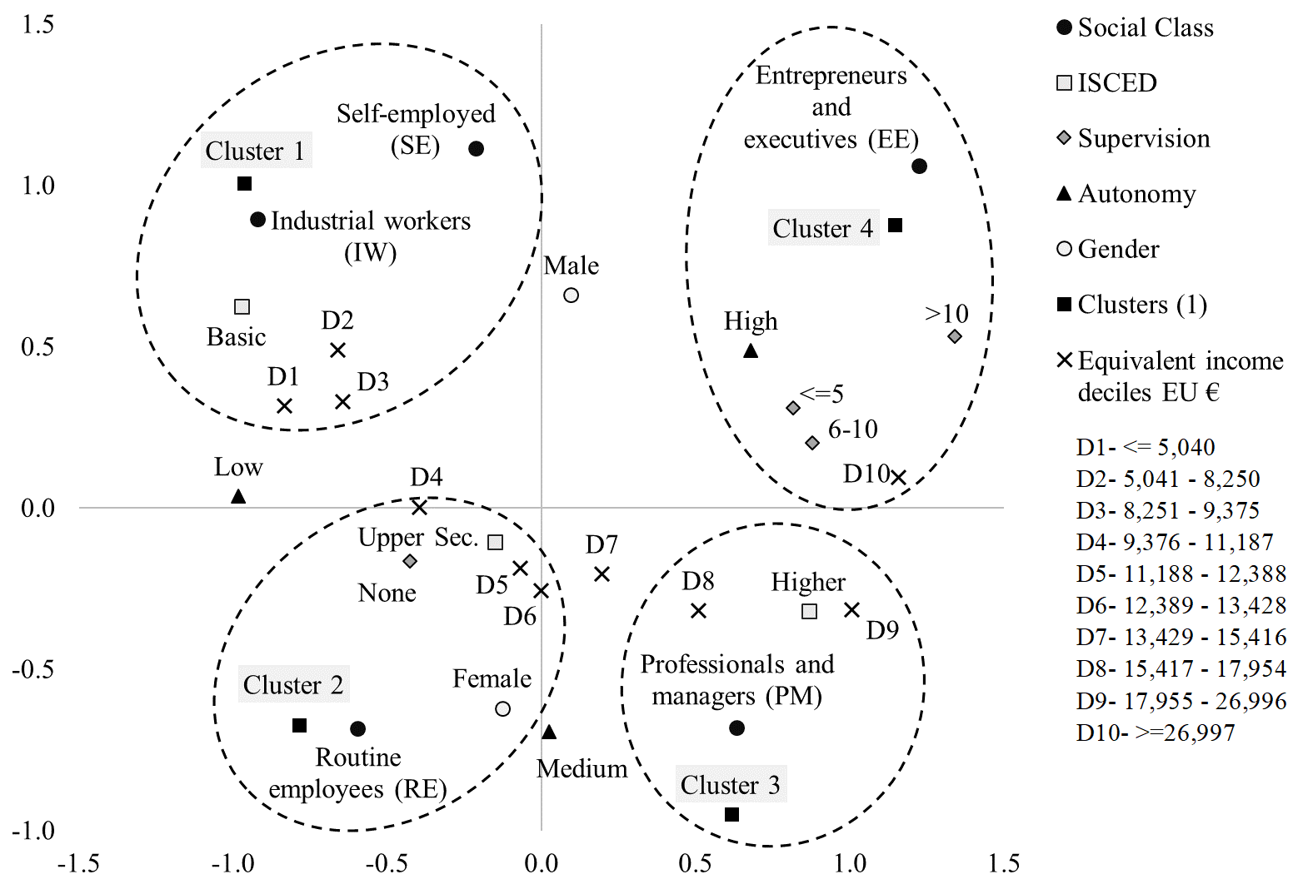

Figure 1. The transnational social space of Europe

Based on (ESS) micro-data, transnationally is it possible to observe a European social space of inequalities, built on significative differences of class, gender, education, income and supervision and autonomy at work. These transnational social space of Europe reveals how social inequalities are multidimensional, intersect with each other and bring advantages/accumulation and dispossession/deprivation to European citizens (Figure 1).

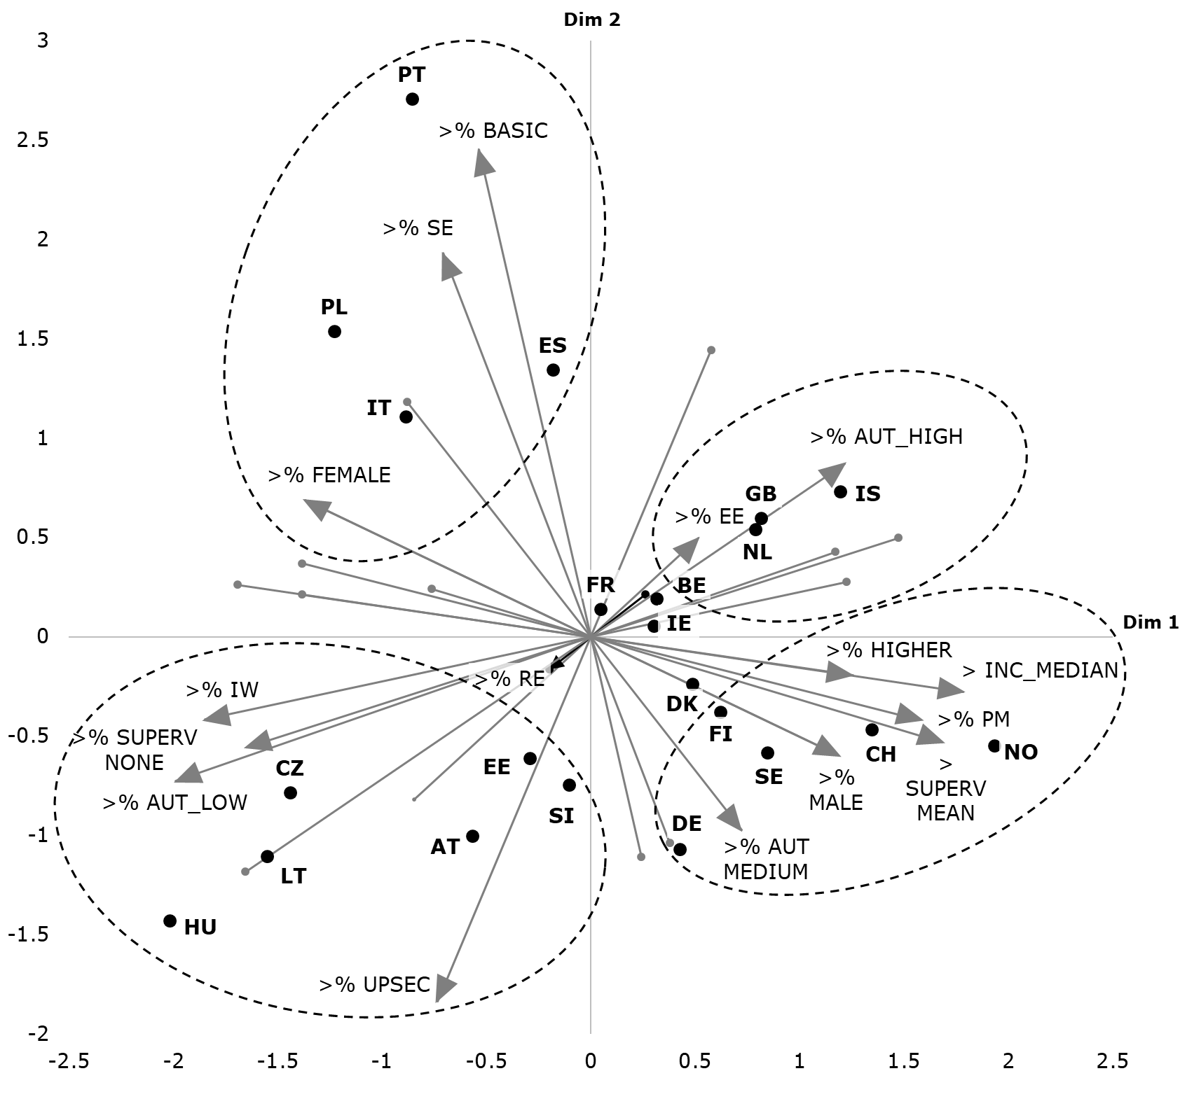

Figure 2. Inequality configurations in Europe

The national configurations observed in Figure 2 accentuate the importance of countries for a fuller understanding of social inequalities in Europe. The contexts of the countries allow inequalities to be better located and expose a Europe far from the convergence and social cohesion sought by the institutions of the European Union.

|  |  |
| --- | --- |
| Nordic high-rank wellbeing profile  (WBGV=6.9)  IS, NO,SE | |
|  | |
| Central Europe medium-rank well-being profile (WBGV=6.4)  AT, BE, CH, DE, FI, GB, NL | Southern Europe medium-rank well-being profile (WBGV=6.2)  FR, PT, ES |
|  |  |
| Eastern Europe low-rank well-being profile (WBGV=5.8)  EE, HU, IE, PL, SI | Social disengagement low rank well-being profile (WBGV=5.5)  CZ, IT, LT |
|  |  |

Figure 3. Well-being profiles of European countries

Relying in the average country scores (min-max) in the nine dimensions of well-being of the OECD Better Life Index, what we called the Well-Being Global Volume (WBGV), five country profiles were identified (Figure 3). Well-being profiles differ more in terms of well-being volume that in terms of well-being structure. Among the five groups of countries with different well-being profiles, one presents the highest volume of wellbeing (the Nordic countries), two profiles present a medium-rank wellbeing volume (the Central and Southern Europe), with scores either more penalized by lower material conditions (income and job earnings), or either by lower work-life balance; and two low-rank well-being profiles (Eastern Europe and regional mixed-countries), one more penalized by lower scores in work-life balance, and the another more penalized by low scores concerning social engagement (low personal security and low social connections).

# Conclusions

The European social space is currently very unequal. Higher education, higher income, and belonging to a more privileged social class positively influence well-being and men tend to present higher well-being than women. The five well-being profiles identified among Europe are clearly structured by social inequalities, opposing higher- and lower- qualified socio-occupations, and males and females' life circumstances. Profiles are mostly defined in terms of volume of well-being, mainly expressing European regional affiliations and asymmetries of class, income and education. The analysis developed confirms the existence of multidimensional intersections between social inequalities and well-being.

Place also counts to understand the relations between inequality and well-being. The place-based analysis conducted in Portugal, which first have identified five national clusters of inequalities - constructed with some of the main indicators that are also significant at the transnational and national levels – that were then compared mobilising local well-being data from 74 indicators, have shown us that science and the European Union institutions, to a more fully understanding of the relations between inequality and well-being, needs to consider altogether the transnational, national and placed-based levels of Europe. This interlinked perspective has the value to clearly define what should be the scope and the design of specific well-being public policies throughout European Union.

# References

[1] G. Therborn (2013), *The Killing Fields of Inequality*, Cambridge, UK, Polity Press.

[2] A.B. Atkinson (2015), *Inequality: What Can Be Done?*, Cambridge (Mass.), Harvard University Press.

[3] B. Milanovic (2016), *Global Inequality. A New Approach for the Age of Globalization*, Cambridge, Harvard University Press.

[4] T. Piketty (2020), *Capital and Ideology,* Cambridge/Massachusetts and London, The Belknap Press of Harvard University Press.

[5] R. Wilkinson and K. Pickett (2018), *The Inner Level. How More Equal Societies Reduce Stress, Restore Sanity and Improve Everyone’s Well-being*, London, Allen Lane.

[6] J.E Stiglitz, J. Fitoussi and M. Durand (2019), *Measuring What Counts: The Global Movement for Well-Being*, New York, The New Press.

[7] OECD (2020), *How's Life? 2020: Measuring Well-being*, Paris, OECD Publishing.