**National Data Management –  
Implementation of the Once Only Principle in Switzerland**

**Keywords:** Once Only Principle, National Data Management, Metadata, Data Harmonization, Data Stewardship

# Introduction

In the past, the public administration of otherwise highly modernized countries have tended to a certain degree towards the establishment of technological silo structures – sometimes for good or at least understandable reasons (e.g. the nature of fragmented authority, bureaucratic institutions tend toward specialization etc.) [1]. The most obvious consequence for a citizen is the occasional need to provide the same information to two different institutions.

[National Data Management (NaDB)](https://www.bfs.admin.ch/bfs/en/home/nadb/nadb.html) is a program launched by the Swiss Federal Council to create the foundation for the implementation of the Once Only Principle. The long-term goal is to align the federal data landscape in such a way that persons and businesses will no longer have to report any information more than once. Nowadays many countries (including even the European Union as a supranational organization [2]) make efforts to establish the Once Only Principle. This is our approach, the Swiss way.

# Interoperability Platform

The Swiss Federal Statistical Office (FSO) will be in charge of developing and maintaining an Interoperability Platform (IOP), which will maintain records of the data administered by various public institutions. Although the platform will provide in-depth descriptions (including information regarding data quality), the actual data itself will be hosted by the data owning institutions.

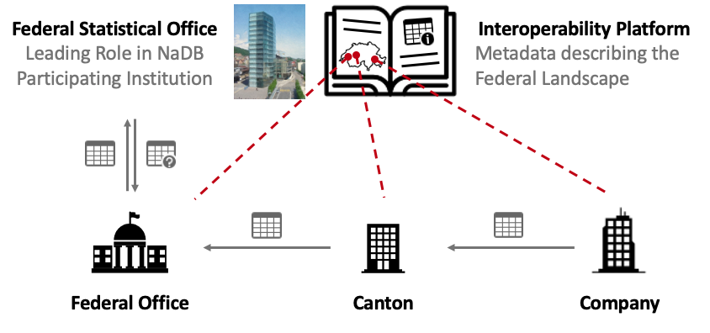  
**Figure 1. Interoperability Platform in NaDB**

From a technical viewpoint, IOP will be a central (federal) metadata platform, administered by the participating institutions. The data exchange will take place directly between the involved parties and is not part of the new system. Because the comprehensive description of an institution's data treasury takes a certain amount of effort, we will be examining data profiling techniques to speed up the process and we are planning to generate some metadata automatically based on the existing data tables.

# Preparation work

To be able to lead the NaDB project successfully on a federal level, the FSO needed to implement it within its own walls first. In the summer of 2019, we launched an internal project, which was aimed specifically at centralizing and harmonizing all statistical data. One key concept of the project is the idea of “used variables” and “defined variables”: When we introduce a new data set, we first describe the required “defined variables”, e.g. “location”, and then reference it by creating a “used variable”, like “place of residence” or “place of work”.

This simple and easy to grasp harmonization strategy is supported by “Data Stewards”. The Data Steward is a quite well established role (occasionally under slightly different names) within the domain of data quality (see for example [3] or [4]). At FSO, Data Stewards have the task to approve the defined variables proposed by domain experts as well as the final data tables comprised out of used variables. This approval process is supported by our custom-built intranet portal, which staff members use to examine metadata and analyse the data they are allowed to access.

# Data Harmonization

Data Stewards will also play a vital role on a federal level within NaDB. They will have different scopes (like Swiss Data Steward, Data Steward Statistics, Local Data Stewards, etc.) on different levels of the program. On top of ensuring a high level of data quality, we also expect them to push forward our data harmonization agenda: no longer should federal institutions have a different understanding about the same variable or concept.

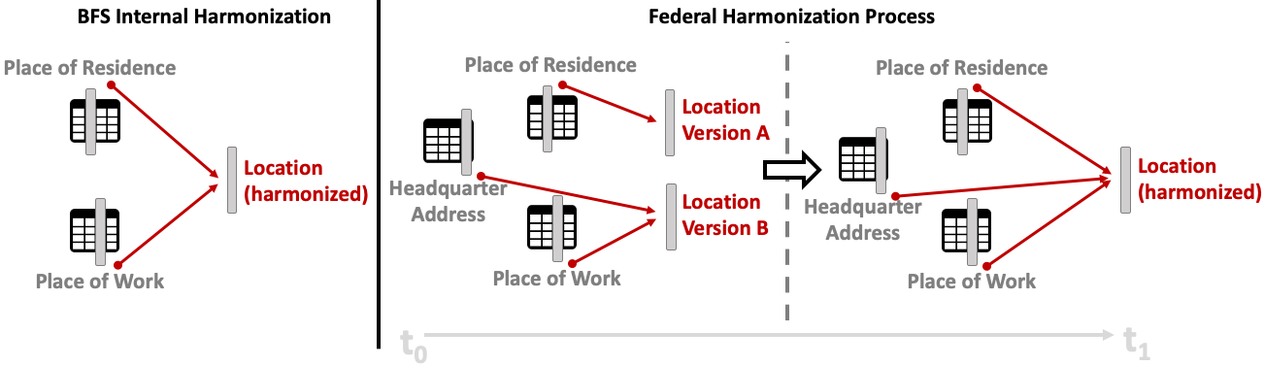  
**Figure 2. Data Harmonization as a Convergent Process on Federal Level**

In Figure 2, we depict the harmonization process. On the left side, the BFS-internal process is more directive and the data needs to be harmonized upfront, since the data owner has to reference an already existing and approved defined variable to finalize a statistical output. On the right side, we see the harmonization of federal data which is a longer and less directive process. We will be designing the organizational and technical setup of the NaDB in such a way that the landscape converges over time into a distributed but harmonized federal data repository. In concrete terms, while we will accept the existence of more than one definition (and encoding) of the concept “occupation” in the beginning, we will make a joint effort to lower the number of conflicting definitions gradually. Ideally, we end up with just a single definition through the course of this federal program.

# Data Quality

Data harmonization is one aspect of data quality. However, in our context we need to address a very specific need: There must be a way to judge the quality and applicability of a foreign-hosted dataset without accessing the data itself, only based on metadata. That is why we plan to develop a set of data quality metrics, which will be made available together with the detailed technical description in the metadata hosted by the IOP. From our present point of view, these metrics will be a mix of qualified and quantified information about the actual data.

# Outlook

As we laid out our broad plan, it should have become evident that we are just at the beginning of a longer journey in which many federal and cantonal institutions of Switzerland will be actively involved. FSO will apply all its learnings from the past to design and establish a slim but well-suited federal data infrastructure. This solution will be the foundation for a more comprehensive exchange of data and should eventually lead to the full implementation of the Once Only Principle.

# References

[1] C. Reddick: Public Administration and Information Technology, Jones & Bartlett Publ., 2011, p. 117 - 121

[2] European Commission: EU eGovernment Action Plan 2016-2020, Brussels 19. 4. 2016, <https://eur-lex.europa.eu/legal-content/EN/ALL/?uri=CELEX:52016DC0179>

[3] B. Kight and D. Smith: The Strength is in the Governance. In: Teradata Magazine, June 2007, p. 77–79.

[4] D. Marco and A. Smith: Metadata Management & Enterprise Architecture: Understanding Data Governance and Stewardship. In: DM Review, 2006.