ADELE: Overview of a deep learning application for land use and land cover change detection and classification in Switzerland

Keywords: Deep Learning, Random Forest, Change Detection, Classification, Land Use and Land Cover.

Introduction
During the past decades, the Swiss Federal Statistical Office (SFSO) has elaborated highly accurate land use (LU) and land cover (LC) classification surveys covering the Swiss territory. These surveys are an invaluable tool for long-term spatial observation with a repetition cycle that has been gradually reduced from 12 years (in 1979) to 6 years today. Until now, the classification of the 4 million sample points covering Switzerland into 73 categories (27 for LU and 46 for LC) was elaborated by visual interpretation of aerial images.
In the framework of SFSO’s experimental statistics, the project “Arealstatistik Deep Learning” (ADELE) aims to speed up the process of classification by using deep learning algorithms and keeping a high level of accuracy. The results and knowledge obtained so far demonstrated the innovation potential for the SFSO in using artificial intelligence to process images.

Data
Several kinds of data are collected and combined in order to build the model. The main data are aerial images (SWISSIMAGE, 50cm RGB 3 x 8-bit), which are the basis of the classification for both the visual interpretation and the deep learning module of ADELE. Then auxiliary data are added such as imagery from the Landsat satellite constellation, Digital Elevation Model (DEM), Canopy Height Model (CHM), and Registers (land, agriculture, etc.). These additional data are used in a second step in the model in order to improve the result of the deep learning module.
The preparation of the data takes place through different modules in a workflow. They link the corresponding initial main and auxiliary data with the area statistics database, for the previous and current survey period. Then specific pre-processing steps are executed in order to generate the final data for the subsequent classification step. All modules are implemented in the programming language Python.

Methods
Among the learning methods that have emerged from artificial intelligence (AI) for image recognition, Convolutional Neural Network (CNN) are particularly adapted to statistics on land use and land cover for which data are available in very large quantities. For this reason, our first module of the main classification method is composed of a pre-trained model of Xception, which takes as input the three channels of the SWISSIMAGE. This model has the advantage to be freely available and pre-trained on ImageNet. Moreover, it has trainable convolutional blocks, which allow a fine-tuning of the model to our image patterns.
In order to include auxiliary data to the model, a second module composed of a Random Forest (RF) algorithm merges auxiliary data with the post-classification vector (the last deep features) of the CNN module (Figure 1). This approach helps substantially in improving the prediction accuracy.
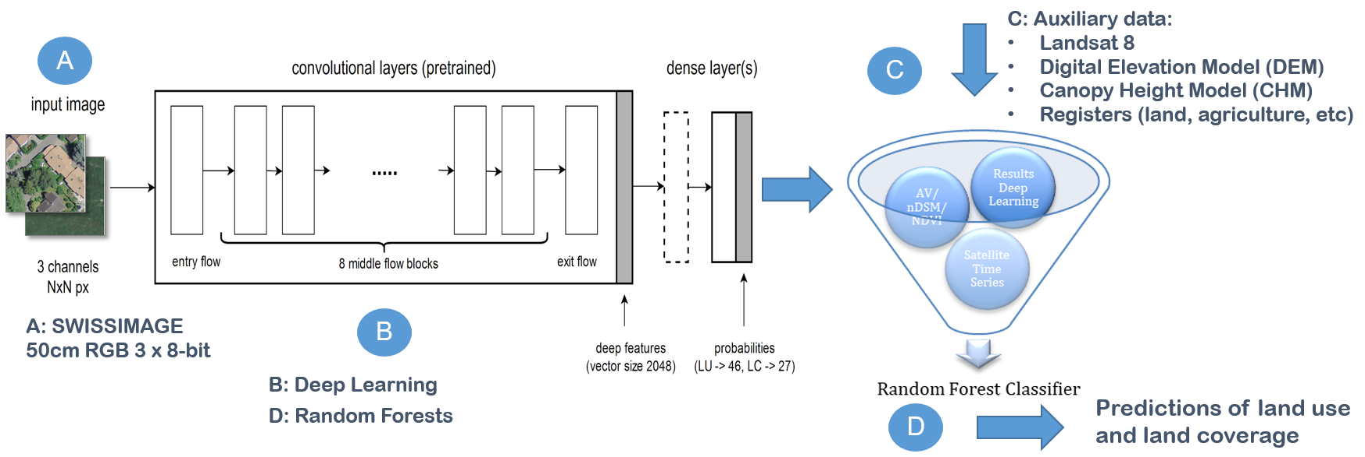
Figure 1. Workflow of the main classification module with Convolutional Neural Network and Random Forest
This main procedure is applied in the first place for the classification of new images at time T for both land use and land cover.
An adaptation of this method is also proposed for change detection purpose. When considering two images at the same geographical location but at two different times T-1 and T, we can run in parallel two CNN algorithms, and then use the difference of the post-classification probability vectors of each CNN for the two images in the subsequent random forest model. This last random forest model will classify the corresponding point to change/no-change.
By taking into account the results of the classification and the change detection all together allows us to improve the general accuracy of the classification.

Validation
Validation of the predictions accuracies requires the characterization of thresholds on prediction probabilities. An example of threshold analysis is presented in Figure 2 for a small trial dataset, for which ground truth is available due to the standard visual interpretation process. Based on the analysis of these 5’000 survey points, if the prediction probability threshold is set to 0.65 (axis “b”), meaning that a classification prediction with a self-estimated probability equal or above 0.65 would be accepted in production, one would expect that 1’500/5’000 (see “d”) of the sample points would not require visual interpretation, resulting in a considerable reduction in cost/time. At the same time one would accept that approximately 3% (100% - 97%, see “c”) of the sample points could be classified inaccurately and that a limited number of classes are included (see “e”).
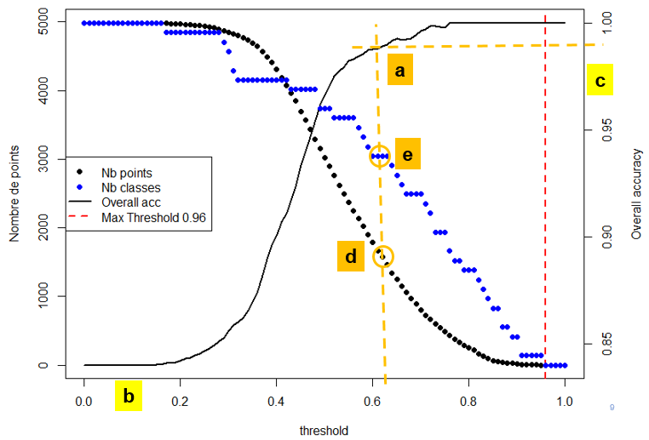
Figure 2. Example of threshold analysis for a reduced dataset

Results
As the finalised model is still under development, results based on a prototype over 200’000 sample points are summarized as follows:
- Land cover (LC): for 5 classes out of 27, we reach a precision greater or equal to 90%. Among these 5 classes are bodies of water, herbaceous vegetation, trees and glaciers, representing 81% of all sample points.
- Land use (LU): for 10 classes out of 46, we reach a precision greater or equal to 90%. Among these 10 classes are viticulture, arable land, mountain pastures, forests, and lakes, representing 44% of all sample points.
An illustration of early results, where only the top levels of the classification nomenclature is shown, is given in figure 3, for an area unknown to the algorithm.
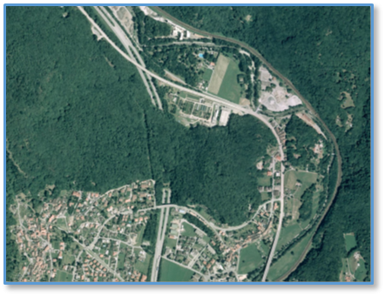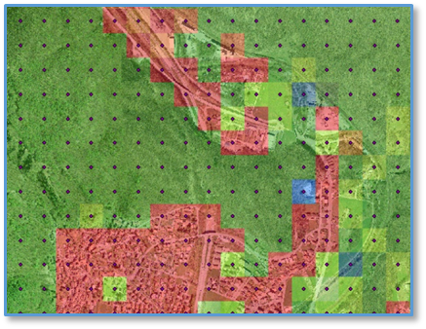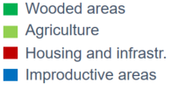
Figure 3. Left: Aerial image of Toricella-Taverne (Tessin, Switzerland); Right: classified area points

Conclusions
The main objective of the proposed approaches is to shorten the production time for the classification of LU and LC by keeping a high level of accuracy. To this regard, we are currently focusing on the validation of the predictions accuracies and the characterization of thresholds on prediction probabilities (i.e. the result reliability self-estimated by the algorithm). These thresholds will determine to which degree the ADELE module can be used to produce reliable publication results.
The model has to be finalized for production, but preliminary results based on a prototype (proof-of-concept) show promising results. This will help us to move forward with a concept integrating visual interpretation (by experts) supported by automatic classification and change detection. Further potential improvements could be realized in the following areas: statistical validation of reliability and reproducibility of the predictions; time adjustment between data; validation of the benefit of other data sources.

