Official statistical estimation of the effect of the online cash register to the shadow economy in Hungary
Keywords: Value Added Tax, Tax Evasion, Shadow Economy

Introduction
In order to reduce the shadow economy, a lot of countries tax administration everywhere around the word, introduce different kind of Electronic Fiscal Devices [1]. A wide variety of these technological devices can help the tax authorities to monitor business transactions. Although these techniques are used since the beginning of nineties not so much is known about their real effect.
In 2014 the Hungarian government introduced mandatory online cash registers (OCR), which are special Electronic Fiscal Devices, in some sectors. As a result, almost 200,000 OCRs have been installed by 100,000 enterprises. In the paper we use micro data to estimate the effect of OCR introduction on reported turnover in the most affected sectors: retail, and accommodation and food services (AFS). We assume that OCR installation does not change a company’s operating model, so the increase in reported turnover around the installation date reflects a reduction in the shadow economy.

Methods
To identify the effect of the introduction of online cash registers we exploiting the heterogeneity in installation dates, and estimate the following panel econometric model with company and time fixed effects:
$$y_{i,t}=β_{0}+β_{1}o_{i,t}+β_{2}w_{i,t}+γ_{t}+δ_{i}+ε_{i,t}$$
where
$y_{i,t}$ is the log reported turnover of the $i$th company at quarter $t$;
$o_{i,t}$ is the OCR dummy, 1 if the company i has at least one operating OCR in quarter t and 0 otherwise;
$w_{i,t}$ is the log reported total wage cost for company i in quarter t. This variable is taken from the yearly CIT return, so its value is fixed in all four quarters of the year;
$γ_{t}$ time fixed effect at quarter $t$;
$δ_{i}$ company fixed effect for the $i$th company;
$ε_{i,t}$ residual of the $i$th company at quarter $t$.
Our parameter of interest is $β_{1}$, which shows the relative change in reported turnover (measured in log points) after the introduction of the first OCR.
We estimated the above regression on the effects of OCR introduction separately for the two sectors and also for different firm sizes. Firm size is measured by yearly average turnover (from VAT returns) prior to OCR introduction.
When deciding about the number of size categories for firms, we face the following tradeoff: with more size categories we can better observe the size-specific heterogeneity, but the estimated coefficients have larger standard errors as the number of observations decreases. We tested whether the estimated OCR effects in different size categories were significantly different from each other and used this information to construct our baseline size categories. Specifically, we ran regressions for 20 different size categories, within each possible sector (accommodation, food services, and different industries within the retail sector). In our final specification companies are categorised into two main sectors:
- retail sector as a whole,
- accommodation and food services (AFS) sector.
In terms of size categories, we divided both sectors into three categories: small, medium and large firms. This means that we estimated the model for 6 different subsamples. Small companies were in the lowest size quintile, medium companies in the second quintile, and large companies were in the third, fourth and fifth quintiles (meaning that more than half of the companies were categorised as large). The decision to merge three quintiles into one single size category was based on estimated size-specific OCR coefficients, which were not significantly different from each other within the three largest quintiles. As the division into size quintiles was conducted separately in the two sectors, the size limits (that separate the different size categories) were somewhat different in the two sectors.

Results
Our results show an increase in turnover after OCR introduction in all sectors and all size categories. However, the sector- and size-specific OCR effects are significantly different from each other. In general, OCR effects are larger for smaller companies and in the AFS sector. In the retail sector the estimated OCR effect is not significant for large companies, but the effect is 5.4 percent and 23.0 percent for medium and small companies, respectively. In the AFS sector, the effects for small, medium and large companies were 35.1 percent, 13.2 percent and 6.7 percent, respectively (Figure 1).
Figure 1
Summary of main results: estimated $β_{1}$ coefficients and their 95% confidence intervals
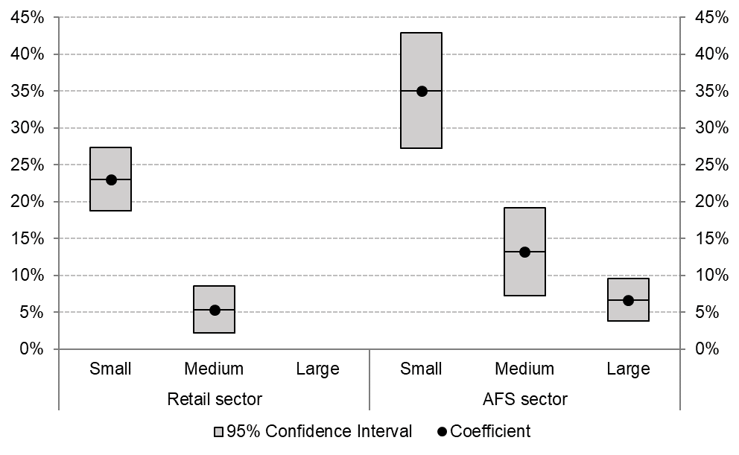
These findings on significantly positive turnover effects are similar to the results of other papers in the literature [2,3] that use micro data to analyse the effect of EFD introduction in other countries. Some of these papers have also shown that the effect depends strongly on the size of the company, which coincides with our intuition. However, these previous calculations were not as detailed as ours.
The positive but nonsignificant coefficient for the large companies in retail sector makes hard to give and overall effect of the introduction. We also take into account the fact that not all the companies from the sectors was needed to introduce the OPGs. Keeping in mind these limitations, we present our best estimates for the magnitude of the total OCR effect. In order to assess the overall aggregate effect of OCR introduction on growth in turnover, we extrapolated the results we received for the estimation sample to all enterprises in the two sectors. The size categories were the same as above, for all the companies which had installed at least one OCR, and where the VAT/OCR turnover was less than 1.5. We found that the introduction of OCRs contributed to annual growth in the whole retail sector by 0.4 percentage points.
In the AFS sector, we find that the introduction of OCRs contributed to the annual growth of the sector by 4.3 percentage points. This number is also somewhat smaller than the effect in the three size categories, mainly because one third of the companies did not have to install OCRs (similarly to the retail sector).

Conclusions
We identify a remarkable effect of OCR introduction on reported turnover in both sectors. For small enterprises, reported turnover increased by 23 percent and 35.1 percent in the retail and AFS sector, respectively. We also find significant but smaller effects (5.4 and 13.2 percent) for medium-sized enterprises in both sectors. For large companies, we only observe a significant impact in the AFS sector 6.7 percent. We also made a lot of different tests, which shows that our results are quite robust.
We not only measure the effect of the introduction, but also show, that these effects hardly dependent on the sector and size of the company. Our most important message is the fact that the smaller the company, the bigger the relative effect caused by the OCR on the reported turnover. These experiences can be very useful for the countries, which just planning to introduce the Electronic Fiscal Device.

References
[1] OECD, 2013. “Electronic Sales Suppression: A threat to tax revenues.” Available online: https://www.oecd.org/ctp/crime/ElectronicSalesSupression.pdf
[2] Fan Haichao and Liu Yu and Qian Nancy and Wen Jaya, 2018. “The Dynamic Effects of Computerized VAT Invoices on Chinese Manufacturing Firms.” NBER Working Paper No. 24414
[3] Awasthi Rajul and Engelschalk Michael, 2018. “Taxation and the Shadow Economy. Policy” Research Working Paper No. 8391, World Bank, Washington, DC

