An application of BREAL to sensor data

**Keywords:** BREAL (Big Data Reference Architecture and Layers), sensor data, smart meter, electricity consumption.

# Introduction

BREAL (Big Data REference Architecture and Layers) [1] is reference architecture for Big Data developed within ESSnet Big Data 2. BREAL serves the purpose of guiding Big Data project by NSIs and helping the development of standardized solutions and services that NSIs within the ESS and beyond can share. Specifically, BREAL is a set of artefacts organized according to three layers, namely a business layer, an application layer, and an information layer.

In order to test the applicability of yet another standard, the reference architecture was adopted by other work packages within the ESSnet. One of the work packages adopting BREAL worked with high frequency readings of electricity consumption by virtue of smart meters. This presentation highlights lessons learnt from applying a reference architecture conceived mainly as an academic exercise to a real case with emphasis to the information layer.

# Methods

The general information architecture for smart meters is described using BREAL GIAB (Generic Information Architecture for Big Data) [2] and three layers: A raw data layer, a convergence layer, and a statistical layer as shown in Figure 1. Obviously, a lot of analyses and compromises are hidden behind these seemingly simple representations, and various business functions (also defined within BREAL) are applied within the different layers.

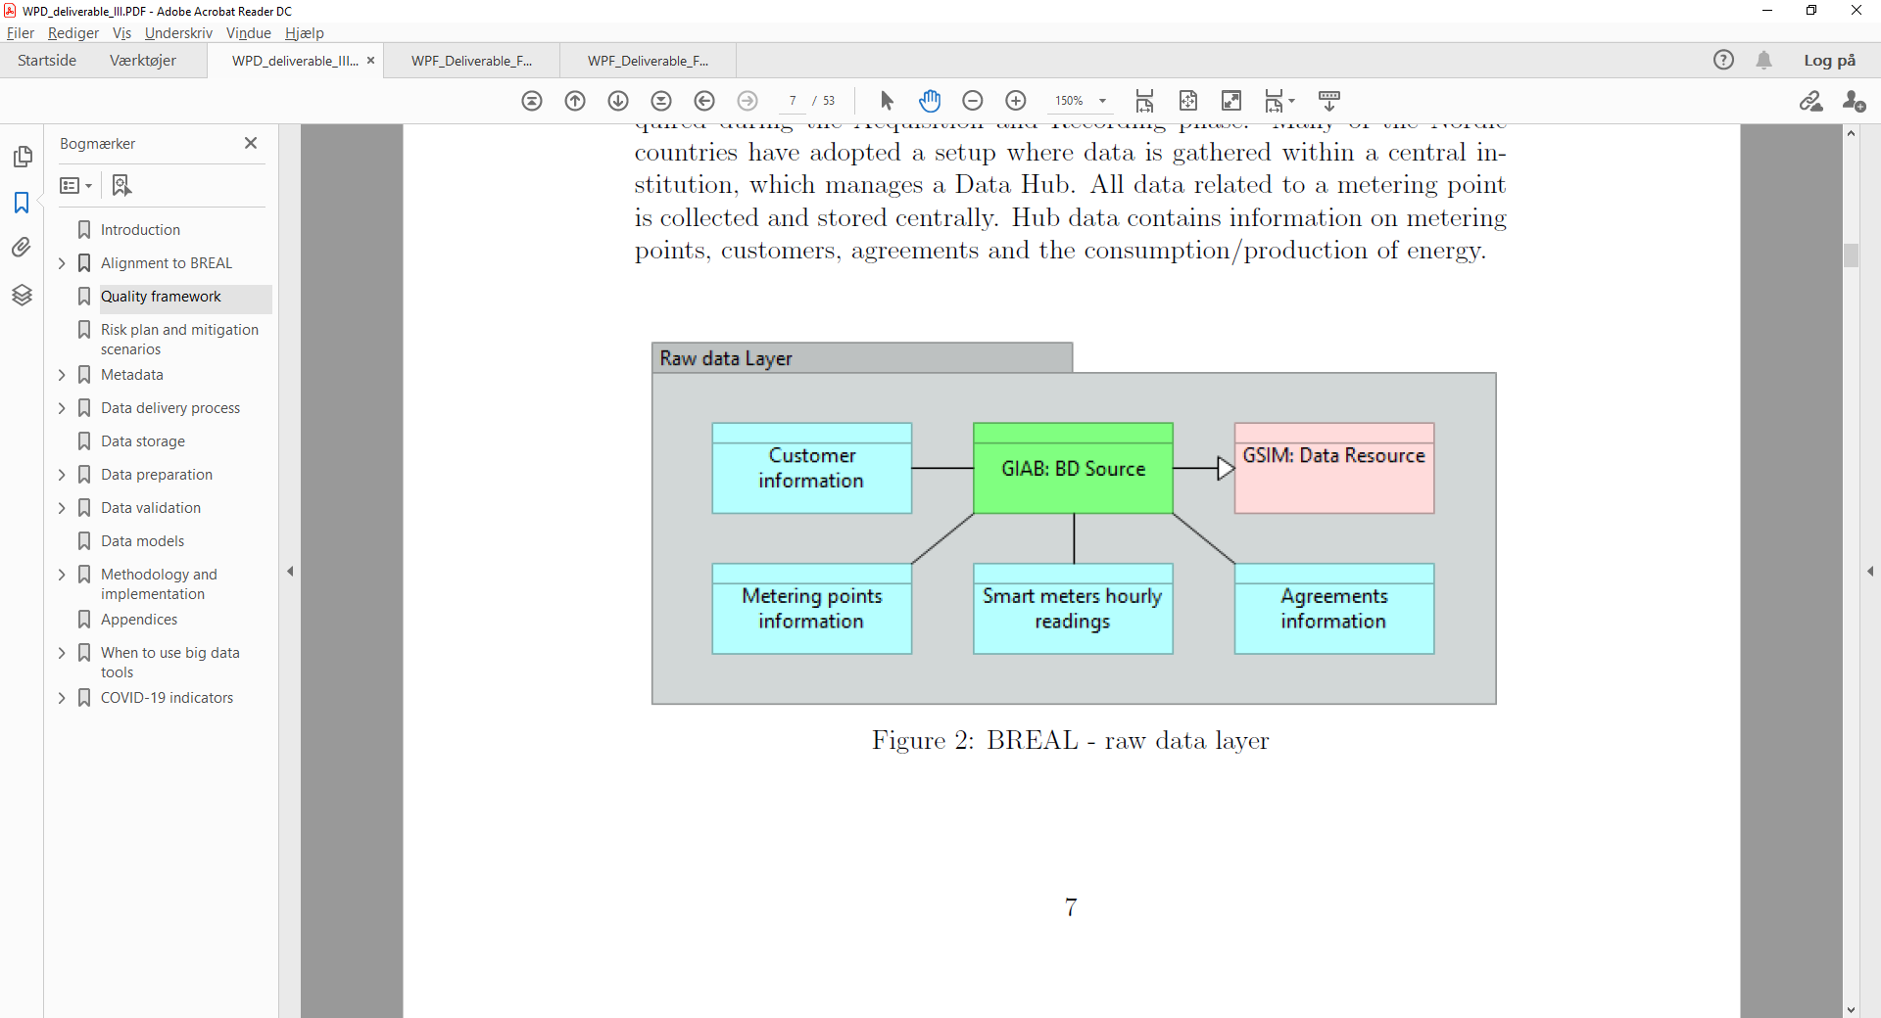

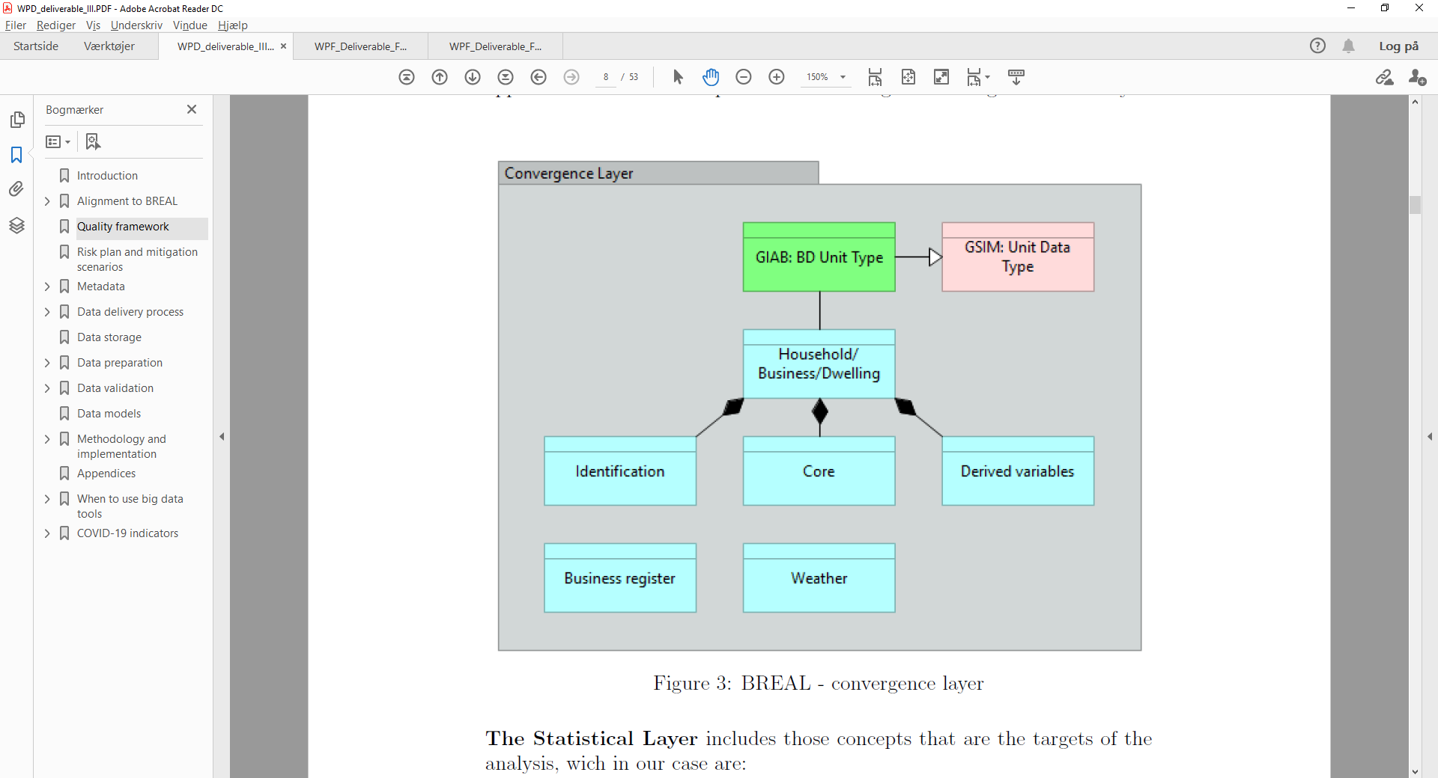

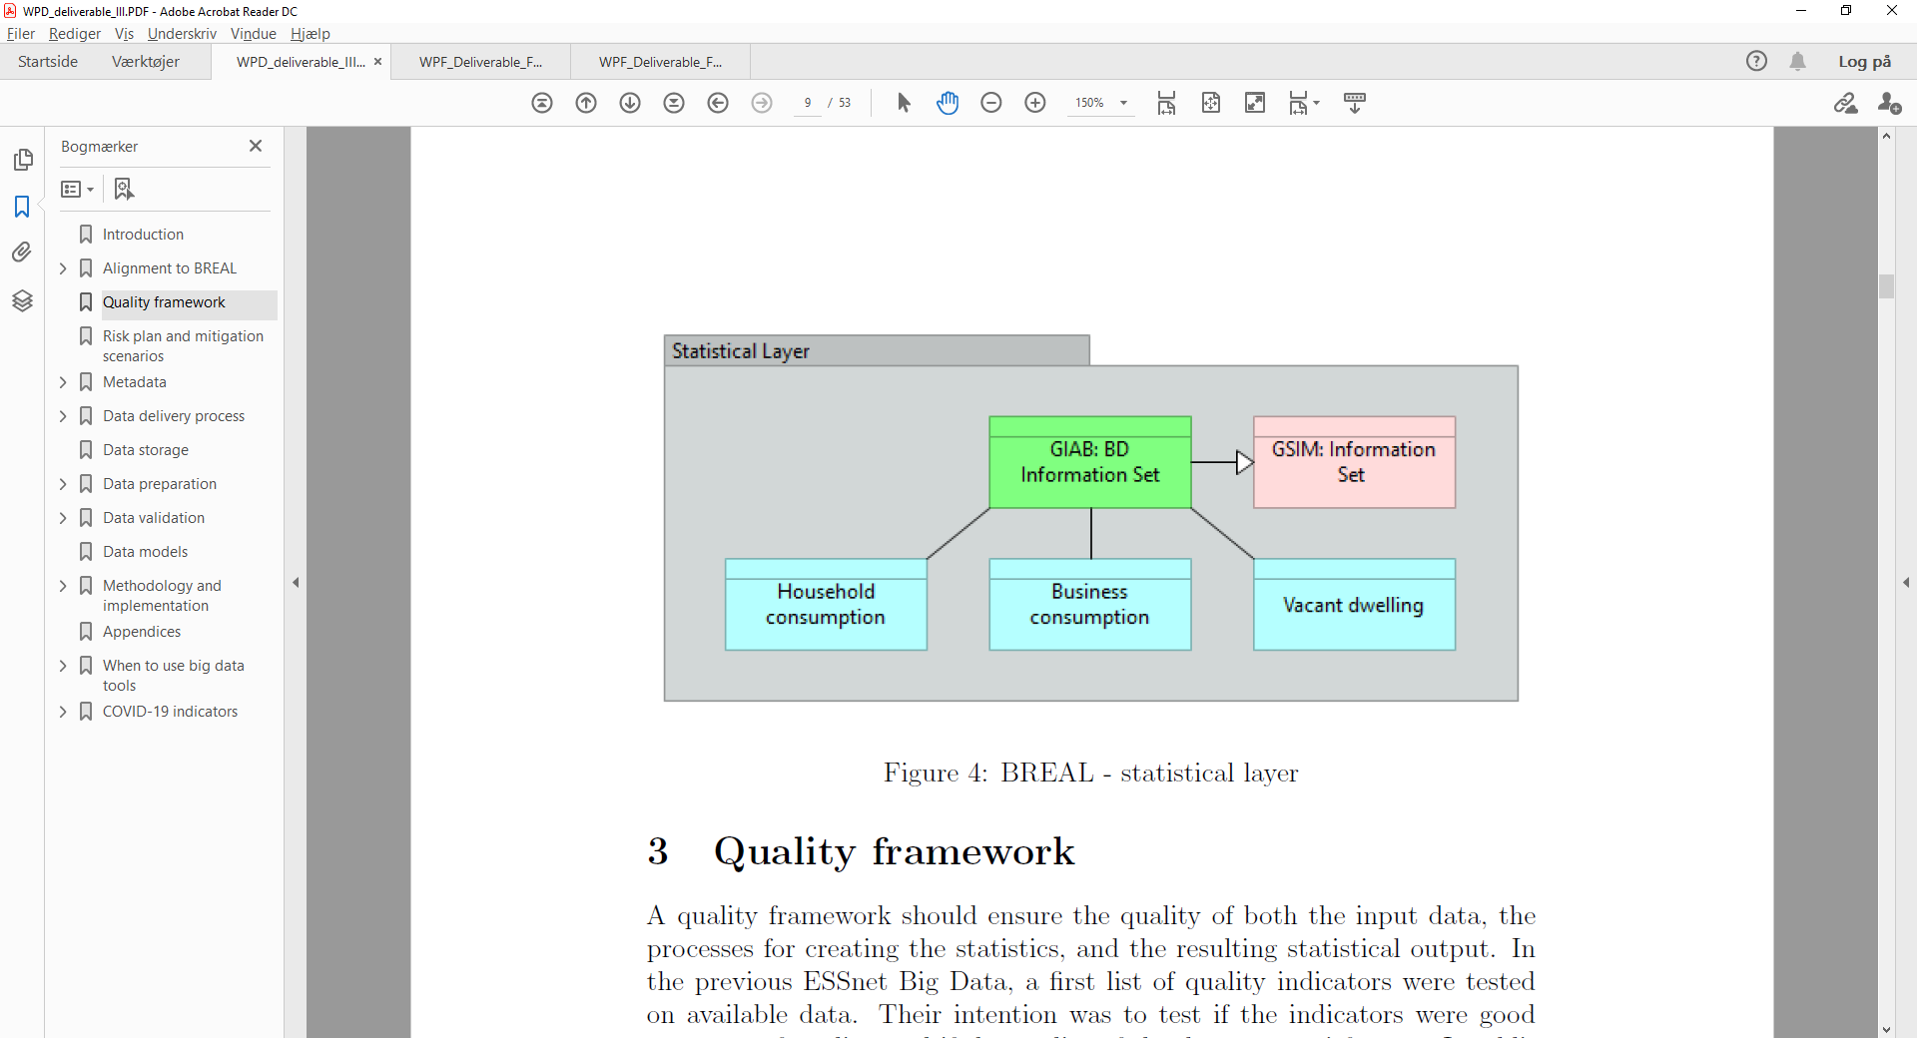

Figure 1. Raw data layer, Convergence layer, and Statistical layer.

# Results

Various results are shown in [3]. As these are not yet final, these are not shown in this abstract.

# Conclusions

The BREAL has been shown to be of great value in order to organize and conceptualize data and metadata in projects where masses of information must be internalised within NSIs, i.e. where the original data gathering is not done by an NSI. Also, the application of BREAL aids in communicating the content of the data and helps sharing tools and solutions between NSIs.

# References

1. BREAL: Big Data REference Architecture and Layers. Business Layer. Deliverable F1. Frederik Bogdanovits (Statistics Estonia), Arnaud Degorre, Frederic Gallois (INSEE), Bernhard Fischer (DESTATIS), Kostadin Georgiev (BNSI), Remco Paulussen (CBS), Sónia Quaresma (INE), Monica Scannapieco, Donato Summa (ISTAT), Peter Stoltze (Statistics Denmark). 35 pp. [Link](https://webgate.ec.europa.eu/fpfis/mwikis/essnetbigdata/images/6/65/WPF_Deliverable_F1_BREAL_Big_Data_REference_Architecture_and_Layers_v.03012020.pdf).
2. Data and application architecture in BREAL: GIAB (Generic Information Architecture for Big Data). *DRAFT*
3. Implementation of smart meter data in the production of official statistics. Deliverable D3. Arko Kesküla, Tõnu Raitviir (Estonian Statistics), Ingegerd Jansson (Statistics Sweden), Johan Fosen, Tatsiana Pekarskaya (Statistics Norway), Maria Rønde Holm (Statistics Denmark). 53 pp. *DRAFT*