SORS - Rapid Survey System

**Keywords:** statistical production, survey, decision-making

# Introduction

The goal of this paper is to present the way how SORS has adapted the statistical production to the new occurrences caused by the COVID19 outbreak. New situation imposes many difficulties in regular data collection. These difficulties are considered as a significant challenge and the serious test for the current SORS organization. At the same time, decision-makers put additional pressure to get data that will support the economy forecasting to better anticipate economic trends.

# Methods

New occurrences showed us that we need to maintain a different communication channel with reporting units as a valuable source of data. At the same time, official statistics must be able to quickly respond to unforeseen circumstances and the best way for that is to add new and rapid statistics surveys which can help us to better anticipate and react in these situations. For the same reasons, SORS has immediately introduced several new and online monthly surveys under the joined name “Assessment of economic indicators“ in the domain of industry, construction, retail trade and tourism. To achieve mentioned activities SORS developed a new automated tool under the name Fast Survey System which covers multiple phases in statistical production from survey designing, monitoring, analysing and managing feedbacks to the users and the policymakers.

# Results

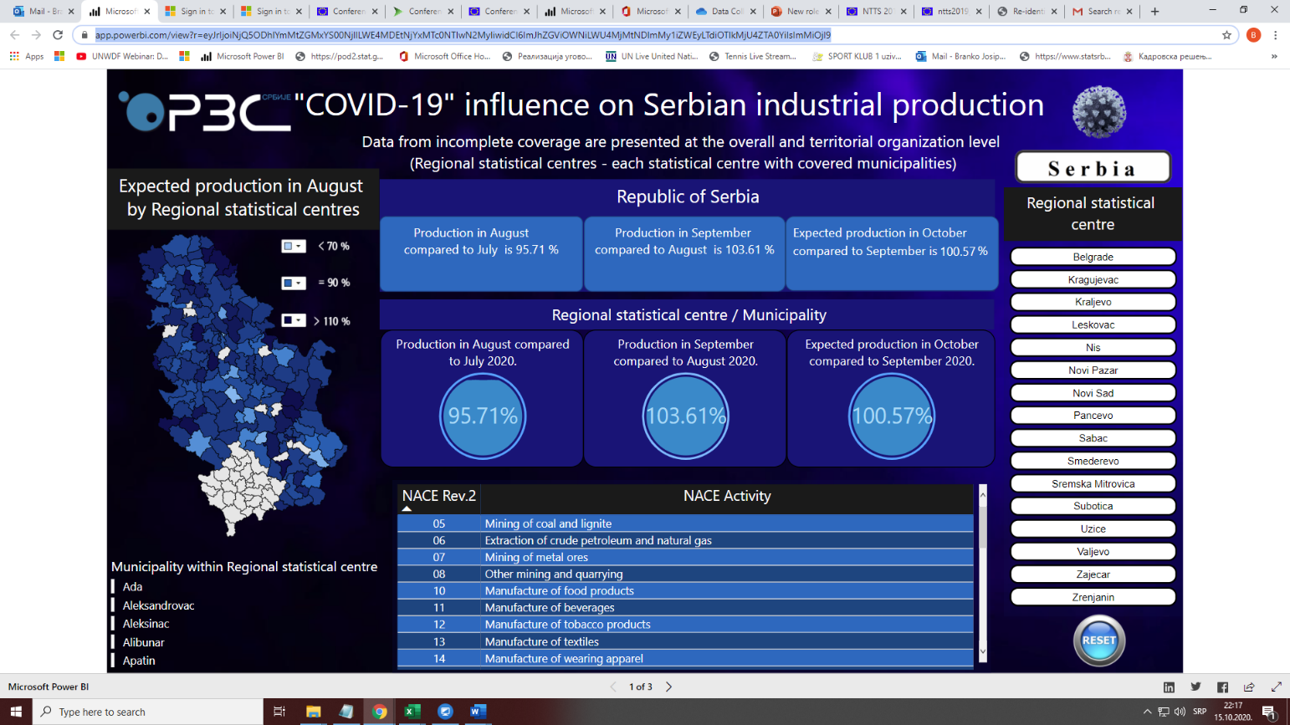

Figure 1. Interactive report on industry assessment survey

As the result of every survey, an interactive report has been created with available data on the lowest possible territory lever which demonstrated the way to help not only to government stakeholders but to the local decision-makers as well.

# Conclusions

This paper will present the new and innovative strategic approach of the SORS in dealing with the COVID19 issues, and the new role of the NSI as not just to provide data for economic forecasting, but to forecast future stakeholder’s demands.