Advanced Estimates 2020: The impact of COVID-19 on Income inequality and poverty indicators

**Keywords:** income distribution, microsimulation, flash estimates, Covid effects

# Introduction

EUROSTAT is already producing flash estimates on income and poverty, but the 2020 release refers to income year 2019. In the current crisis related to COVID-19, it becomes essential to provide earlier information to enable policy makers to assess the extent to which the labour market shock and policies put in place in different Member States affect the income distribution in 2020.

Eurostat will release advanced estimates 2020 already this year. This will depart from the standard methodology as it will include further modelling strategies to account for the COVID specific impacting factors and incomplete data. Estimates will be based on both 1) **the effects on the labour market** due to the covid19 economic shutdown and 2) **temporary policy measures** put in place in 2020 in order to support households’ income and workers affected by the crisis. The former is based on labour market data from LFS as well as administrative data collected by Eurostat on the number of beneficiaries of short-term wage schemes. The actual policies and benefits concerning these support measures are simulated via EUROMOD[1].

# Methods

## Labour updates

Changes in employment are modelled by explicitly simulating transitions between labour market states (Figari et al., 2011[1]; Avram et al., 2011[2]).

For the analysis of the COVID effects in 2020 this methodology was modified in order to take into account specific factors to the current crisis. The changes on the labour market in 2020 considered more relevant for the purpose of our analysis are the increase in the number of recent job leavers and the sharp drop in working hours due to the lockdown[2]. These overall trends are translated in distributional information by assessing the risk of individuals either to lose their job (1) or to have reduced working time/be on temporary layoffs at the pick of the COVID crisis in quarter 2 (2). We model via a logistic regression at individual level for all countries these probabilities. The main impacting factors used in the model are age groups, sex, economic sector, occupation and type of contract (temporary vs permanent). Probabilities are finally imputed in the baseline SILC file using the common labour and demographics characteristics. The baseline SILC file used for this risk analysis has income and labour variables updated to 2019 (the same microdata file used for the flash estimates 2019). The labour information is then updated from 2019 to 2020 based on the aforementioned probabilities. This allows “to distribute” the labour risks for workers and households at different parts of the income distribution.

The final number of individual undergoing transitions to unemployment are calculated on the most recent data available, extrapolated to the full year 2020 via modelling. The forecast of the employment rate for 2020 is done via a vector autoregressive moving-average processes with exogenous regressors (VARMAX) model, taking into account 2 breakdowns (gender and age groups). The VARMAX method enables to model the dynamic relationship both between the dependent variables and also between the dependent and independent variables. As first step 3 regressors with a lower frequency (month) and with more recent data availability have been selected: The unemployment by sex and age ([une_rt_m](https://appsso.eurostat.ec.europa.eu/nui/show.do?query=BOOKMARK_DS-055624_QID_74AE00B8_UID_-3F171EB0&layout=TIME,C,X,0;GEO,L,Y,0;S_ADJ,L,Z,0;AGE,L,Z,1;UNIT,L,Z,2;SEX,L,Z,3;INDICATORS,C,Z,4;&zSelection=DS-055624UNIT,PC_ACT;DS-055624S_ADJ,NSA;DS-055624SEX,F;DS-055624AGE,Y25-74;DS-055624INDICATORS,OBS_FLAG;&rankName1=UNIT_1_2_-1_2&rankName2=AGE_1_2_-1_2&rankName3=INDICATORS_1_2_-1_2&rankName4=SEX_1_2_-1_2&rankName5=S-ADJ_1_2_-1_2&rankName6=TIME_1_0_0_0&rankName7=GEO_1_2_0_1&sortC=ASC_-1_FIRST&rStp=&cStp=&rDCh=&cDCh=&rDM=true&cDM=true&footnes=false&empty=false&wai=false&time_mode=NONE&time_most_recent=false&lang=EN&cfo=%23%23%23%2C%23%23%23.%23%23%23)); Short-term business statistics / [Production in industry](https://appsso.eurostat.ec.europa.eu/nui/show.do?query=BOOKMARK_DS-069583_QID_-5318B5EE_UID_-3F171EB0&layout=TIME,C,X,0;GEO,L,Y,0;INDIC_BT,L,Z,0;NACE_R2,L,Z,1;S_ADJ,L,Z,2;UNIT,L,Z,3;INDICATORS,C,Z,4;&zSelection=DS-069583UNIT,I15;DS-069583S_ADJ,SCA;DS-069583INDICATORS,OBS_FLAG;DS-069583INDIC_BT,PROD;DS-069583NACE_R2,B-D;&rankName1=UNIT_1_2_-1_2&rankName2=INDIC-BT_1_2_-1_2&rankName3=INDICATORS_1_2_-1_2&rankName4=S-ADJ_1_2_-1_2&rankName5=NACE-R2_1_2_-1_2&rankName6=TIME_1_0_0_0&rankName7=GEO_1_2_0_1&sortC=ASC_-1_FIRST&rStp=&cStp=&rDCh=&cDCh=&rDM=true&cDM=true&footnes=false&empty=false&wai=false&time_mode=NONE&time_most_recent=false&lang=EN&cfo=%23%23%23%2C%23%23%23.%23%23%23); Harmonised index of consumer prices ([HICP](https://appsso.eurostat.ec.europa.eu/nui/show.do?query=BOOKMARK_DS-055110_QID_-387D5641_UID_-3F171EB0&layout=TIME,C,X,0;GEO,L,Y,0;UNIT,L,Z,0;COICOP,L,Z,1;INDICATORS,C,Z,2;&zSelection=DS-055110UNIT,RCH_M;DS-055110INDICATORS,OBS_FLAG;DS-055110COICOP,CP00;&rankName1=TIME_1_0_0_0&rankName2=UNIT_1_2_-1_2&rankName3=GEO_1_2_0_1&rankName4=INDICATORS_1_2_-1_2&rankName5=COICOP_1_2_-1_2&sortC=ASC_-1_FIRST&rStp=&cStp=&rDCh=&cDCh=&rDM=true&cDM=true&footnes=false&empty=false&wai=false&time_mode=NONE&time_most_recent=false&lang=EN&cfo=%23%23%23%2C%23%23%23.%23%23%23)). These 3 regressors have been extended via ARIMA models until December 2020, then grouped by quarters and finally used as covariates in the VARMAX model.

For the total number of employees on temporary layoffs we use monthly administrative data on the total number of jobs supported by governmental measures. These are jobs in public and private sectors for which employees are either on short time work (and assimilated schemes) or on temporary lay-offs that are financially compensated, at least partially, by government funds that may transit or not through the employer. The data refers to stocks and the reference period is the end of the month. This data comes from a new data collection by Eurostat to address the need for timelier data on this high policy relevant subject. The Directors of Social Statistics (DSS) gave their support on May 2020.

For the update of self-employment income, we adopt a two-steps approach: the temporal disaggregation of EU-SILC data followed by a vector autoregressive model (VAR). The purpose of this procedure is to produce an estimation of 2020 self-employment income, from partially observed data. Research has been conducted at Eurostat on the comparability between National Accounts and SILC data (Eurostat 2018), showing good results for some countries and income components. For the estimation of self-employment income in SILC we draw from National Accounts mixed-income data, which at present are available for the first two quarters of 2020, showing a significant impact of the crisis related to the pandemic. At first, SILC time-series is temporally disaggregated into quarterly observations (Sax and Steiner 2013), we then proceed with the vector autoregressive model to complete the 2020 series.

## Policies via Euromod

The update of policies is done via EUROMOD, the European Union tax-benefit microsimulation model, maintained, developed and managed by the Institute for Social and Economic Research (ISER) at the University of Essex and the Joint Research Centre (JRC) in the European Commission, in collaboration with national teams from the EU Member States.

EUROMOD is used to simulate changes in the income distribution within the period of analysis. Income elements simulated by the model include universal and targeted cash benefits, social insurance contributions and personal direct taxes. Income elements that cannot be simulated mostly concern benefits for which entitlement is based on previous contribution history (e.g. pensions) or unobserved characteristics (e.g. disability benefits). These are read from the data and updated according to statutory rules (such as indexation rules) or changes in their average levels over time. Both contributory and non-contributory unemployment benefits are simulated in the model. In some countries, an effort has been made to address issues such as tax evasion and benefit non-take-up. Detailed information on EUROMOD and its applications can be found in [4].

All simulations are carried out on the basis of the tax-benefit rules in place on the 30th June of the given policy year. It also includes the discretionary policy measures exceptionally introduced or activated by national government to address the covid-19 economic challenges, in particular, policies to preserve jobs (wage compensation schemes) and the income support to self-employed.

# Results

The first results currently available refer to the labour part. Throughout this section results for EU refer to 26 countries, DE excluded due to lack of data. In general the “risk” to face a loss of income and deeper poverty has different patterns across the two dimensions analysed (layoffs versus lose job) and varies substantially across age categories, economic sectors and countries. The COVID crisis and the temporary lay-offs have a strong sectorial dimension. The highest risk to be on temporary layoff in the EU is linked to the accommodation and food sector. While in general the risk of losing job is at a lower level, we can note strong disparities between categories of workers. The risk to lose job was higher for temporary workers, young employed (aged 16-24) and low skilled occupations).

Both labour risks are highly unequal across the income distribution with vulnerable individuals (lower income from work) more likely to experience further income losses. We assess the risks linked to the lockdown measures across three main income groups: Low-income earners comprise individuals in deciles 1, 2 and3; the middle group comprises deciles 4, 5, 6, 7; deciles 8, 9 and 10 define the high-income category.

We can note a clear tendency to have a higher percentage of workers at risk in the low earners group at EU level.

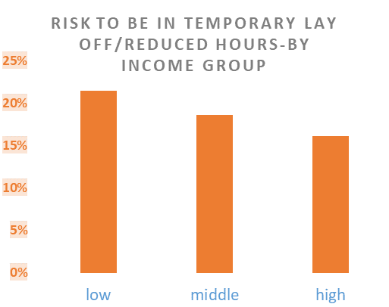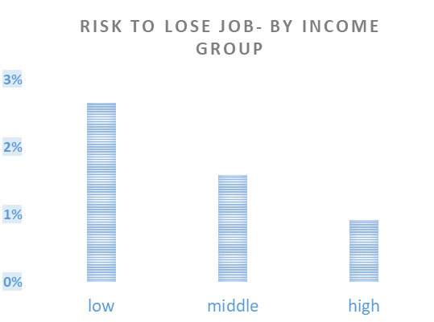

Finally, a country comparison brings the evidence of a differentiated geography of the labour risks in the EU. In the chart below they are ranked according to the largest difference in the probability to have reduced working time, between the high work income group and the low work income group. In almost all the countries, the red marker is above the green one, indicating that low-income earners face higher probabilities of reducing working time. Furthermore, the most affected countries are the ones showing the largest gap between the two groups.

#### Average risk of reduced working time (temporary layoffs or reduced working hours) by income (from work) group

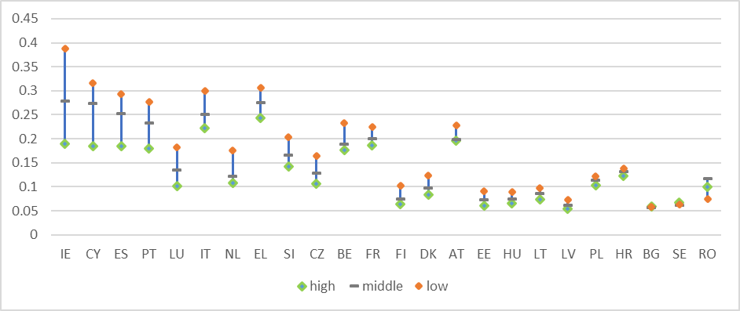

# Conclusions

As this analysis highlighted the inequality of labours risks is very high across the income distribution with a likely worsening of the situation for vulnerable categories. In tehh next stage for quantifying the effects on the main income indicators the analysis needs to integrate the impact of temporary policy measures introduced in different countries in order to support households’ income and workers affected by the covid-19 economic shutdown.

# References

1. Figari, F., Salvatori, A. and Sutherland, H. (2011) Economic downturn and stress testing European welfare systems, Research in Labor Economics, 32: 257-286.
2. Avram, S., Sutherland, H., Tasseva, I. and Tumino, A. (2011) Income protection and poverty risk for the unemployed in Europe, Research Note 1/2011 of the European Observatory on the Social Situation and Demography, European Commission.
3. Eurostat (2018), Methodological note.

<https://ec.europa.eu/eurostat/documents/7894008/9077550/Methodological_note.pdf>

1. Sax, C., and Steiner, P., (2013), *Temporal Disaggregation of Time Series*, The R Journal Vol. 5/2: 80-87
2. H. Sutherland and F. Figari, EUROMOD: the European Union tax-benefit microsimulation model. International Journal of Microsimulation, (2013), 6(1), 4-26

1. For more information on Euromod and the standard nowcasting methodology please see Eurostat methodological note on flash estimates
2. <https://ec.europa.eu/eurostat/documents/2995521/11410470/3-08102020-AP-EN.pdf>