Notice the noise: detecting misclassifications in register data

Vera Oosterveen, Arnout van Delden, Sander Scholtus

Introduction
National Statistical Institutes (NSIs) provide official statistics that contribute to the public debate and policy development. NSIs aim to develop these statistics efficiently and cost-effectively. NSIs do this, among others, by making use of already available administrative data. These data, such as registers, are collected for non-statistical purposes and are adopted for producing statistics.
There is, for example, the statistical business register (SBR) which is a population frame for enterprises, that contains economic activity codes (NACE). Economic activity codes are used to classify business statistics by economic sector. Therefore, errors in the SBR have consequences for many business statistics. In The Netherlands an incorrect code can occur during the registration of a business at the chamber of commerce, or due to real activity changes which are not reported to the chamber of commerce. Such changes are rarely reported [1, 2] since this is not obligatory.
Manual NACE code checks are costly and time-consuming. Other ways to improve the quality of NACE codes are therefore very welcome. Several studies aimed to predict economic activity with text classification approaches [3-5]. One potentially attractive source is texts from dedicated business websites. However, classification based on website texts is complicated since they are not necessarily created to describe economic activity. Often, websites focus on branding and selling products or services. If a website text is uninformative for economic activity, a text classifier will not be able to correctly classify the corresponding enterprise. Moreover, in the SBR we classify enterprises by their main economic activity which is not necessarily the activity found on a website.
The current study proposes a method where auxiliary information is used to identify whether units in a large noisy data set are misclassified or not, rather than to predict the exact correct class. We apply the method to the detection of NACE misclassifications in the SBR, using enterprises' website texts as auxiliary information. The proposed method serves two purposes. First, if the method accurately predicts which instances in a register are likely to be misclassified, these instances can subsequently be corrected by manual editors. Second, the outcomes give insights into the fraction of errors in different economic sectors. In the current study, we conduct experiments to investigate under which conditions the proposed method is (not) able to correctly identify the misclassified instances.

Methods

Methodology
We estimate the probability that a unit is misclassified using a mixture model. Let $z_{i}$ denote whether unit $i$ is misclassified ($z_{i}=1$) or not ($z_{i}=0$). Further, let ${\hat{y}}_{i}$ be the observed class, $ξ_{i}$ the vector with auxiliary textual information of unit $i$, $u_{i}$ the vector with background characteristics and $θ$ the vector with the model parameters. Additionally, let $π_{i}$ be the (prior) probability that unit $i$ is misclassified given only its background variables $u_{i}$ which is estimated by logistic regressions with parameters $θ_{R}$. We are interested in the posterior probability $P\left(z_{i}=1 | {{\hat{y}}_{i}=h, ξ}_{i}, u_{i},θ\right)$that unit $i$ is misclassified given the observed code $h$ and $ξ_{i}$, $u_{i}$ and $θ$, which is given by:
$$τ_{i}= P\left(z_{i}=1 | {{\hat{y}}_{i}=h, ξ}_{i}, u_{i},θ\right)= \\ =\frac{π_{i}\left(u_{i};θ_{R}\right)Ψ\left({\hat{y}}_{i}=h;ξ_{i},u_{i},ϵ,θ_{M}\right)}{\left[1-π_{i}\left(u_{i};θ_{R}\right)\right]P\left({\hat{y}}_{i}^{*}=h|ξ_{i},u_{i};θ_{M}\right)+π_{i}\left(u_{i};θ_{R}\right)Ψ\left({\hat{y}}_{i}=h;ξ_{i},u_{i},ϵ,θ_{M}\right)}$$
where $P\left({\hat{y}}_{i}^{*}=h | ξ_{i}, u_{i};θ_{M}\right)$ is the probability to predict class $h$ by a machine learning model with parameters $θ_{M}$ given the textual information and the model parameters. The term $Ψ$ is the probability for unit $i$ to be observed as $h$ when its true code is unequal to $h$, which depends on the probability to predict $P\left({\hat{y}}_{i}^{*}=g | ξ_{i}, u_{i};θ_{M}\right)$ ($g≠ h$) and on the transition probabilities of a unit to be observed as $h$ while its true code is $g$. These transition probabilities are assumed to be known (fixed). We assume that for a given $h$ some codes $g$ have high transition probabilities and all others together have a low probability ($ϵ$).
Variable $z_{i}$ is an unobserved, latent, variable. The probabilities $τ_{i}$ and the parameters $θ$ are estimated in an (approximate) EM algorithm. The methodology is generic and can be combined with any machine learning algorithm from which a probability can be obtained. We used a Naïve Bayes algorithm, because it is estimated very fast.

Creating a synthetic data set
We evaluated the proposed method using empirical data from the SBR where we artificially introduced misclassifications. We selected 25 industries for the experiments, some of which are combinations of different NACE codes.
First, the main page was scraped from 76 270 enterprise websites, within the 25 industries. The corresponding observed NACE codes were obtained from the SBR. Next, we applied a filtering step with the aim to obtain an error-free data set. We used an ensemble filter based on three different learning algorithms. An instance was considered to be correctly classified when 1) the predictions of all three classifiers agreed with the observed NACE class in the SBR, or, 2) when the predictions of at least two classifiers agreed with the observed class and the average of the classification's probability estimates fell above the 50th percentile. After the filtering step, the data set contained 45 965 enterprises.

Experimental settings
To initiate the EM algorithm, we used a small portion of the population for which the true label is known: further referred to as labelled set. In the experiments, this set was sampled randomly from the data set. We tested the effect of the size of the labelled set on the outcomes, using 20, 50, or 100 instances per industry.
We purposely generated NACE errors. The error proportions varied with enterprise size class (SC) groups (in number of employees) and number of legal units (LU) resulting in eight different error probability classes, see Table 1. This way non-random errors were appointed. For each industry, averaged over the units in the population, four (average) error proportions were applied: 6, 12, 24, or 43% errors. Also, we distinguished among subtle errors, obvious errors, both subtle and obvious errors and realistic errors. With subtle errors the erroneous code is easily interchanged with the true code, such as ‘garden centre’ and ‘gardener’. With obvious errors the erroneous code clearly differs from the true code such as ‘photography’ and ‘restaurant’. For the realistic errors, the error sizes were estimated in an audit sample while the relative transition rates between industries were derived from yearly transitions in the SBR.
Furthermore, we tested four settings concerning the mixture component $π_{i}$, referred to as audit sample settings$.$ Setting 1 and 2 were without audit sample for $π_{i}$. In setting 1 we took $π_{i}=π$, in setting 2 $π_{i}$ is a function of the eight probability classes. For setting 3 and 4 we took an audit sample of 50 units for an initial estimate of $π_{i}$. In setting 3, the sample was stratified and $π_{i}$was estimated by the four SC groups. In setting 4, the sample was stratified and $π_{i}$was estimated by the eight probability classes.
Table 1. Proportion of errors per probability class, shown for average error proportion 12% (the numbers scale with average error proportion)
 | SC 0–30 | SC 40 | SC 50 | SC 60+
1-2 LU | 0.103 | 0.136 | 0.202 | 0.015
3+ LU | 0.139 | 0.176 | 0.226 | 0.024

Performance measures
We evaluated our method by computing the true positive rate (TPR, also Sensitivity) and true negative rate (TNR, also Specificity), where a true error ($z_{i}=1$) which is predicted as an error is considered to be a true positive. Furthermore, the correspondence between the class labels and the probability for that label is expressed in the Entropy R² [6], which is 0 when the predictions are unrelated to the true labels and 1 when the class labels are predicted correctly with probability 1. We repeated the whole procedure to generate errors and compute model performance five times and averaged the results.
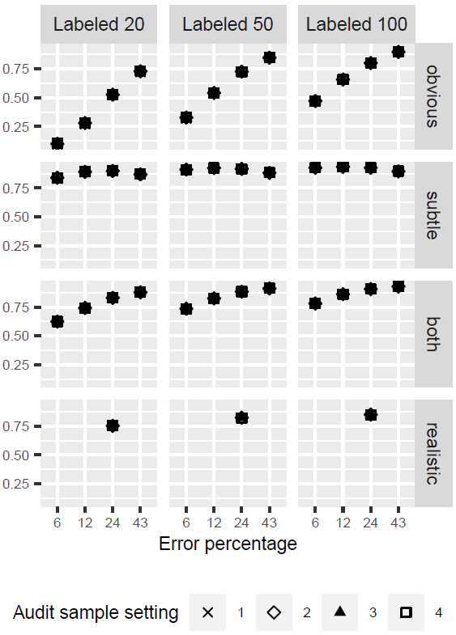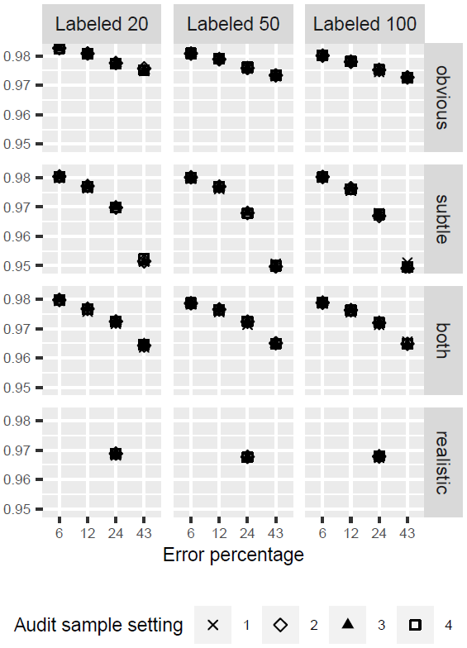
Figure 1. True positive rate (left panel) and true negative rate (right panel).

Results
The performance for finding classification errors, the TPR, was least for the ‘obvious errors’, very good for the ‘subtle errors’ and in between for ‘both’. These counter-intuitive results can be explained as follows. The value of $τ_{i}$ depends on $Ψ$ which in turn depends on the transition probabilities which were assumed throughout to be high for subtle errors and low for obvious errors. So for the situation that only obvious errors were generated, the actual occurring transition probabilities did not correspond with the assumed ones.
Furthermore, we found that the TPR increased with the size of the labelled set. The TNR varied between 0.96 and 0.98. It decreased with the proportion of errors but was hardly affected by the size of the labelled set. The entropy R² ranged from approximately 0.9 (6% subtle errors) to 0.5 (43% subtle errors) (not shown). For all error types, entropy R² decreased with the error proportion and slightly increased with size of the labelled set.
The audit sample settings did not affect the TPR and TNR – as averaged over all units (Figure 1), but they did affect the TPR and TNR when they were stratified by probability class (not shown). We found that $π_{i}$ and TPR were estimated most accurately for settings 2 and 4 and least accurately for setting 1, except for two groups. For very large units (SC 60+) results were erratic because the error probabilities were very small and we repeated the procedure only 5 times. For small, simple, units (SC 0-30, 1-2 LU) there were no differences between the settings and results were similar to the results averaged over all units. The reason is that those small simple units were by far the largest group (88%): their actual $π_{i}$ value was close to the overall mean $π_{i}$ in the population. So estimating a $π_{i}$ per probability class (setting 4) does not improve over the average $π_{i}$ (setting 1) for this group.

Conclusions
In the current study, we introduced a method to detect non-random misclassifications in register data. Detecting the misclassifications is important because classification errors can influence the accuracy of statistical output [2]. When misclassifications can be found with an automated method, time and costs for manual editing are saved. The experiments in this simulation study showed that the overall performance of the method is satisfactory as long as the transition probabilities that are input to the model are close to the true transition probabilities. It would be interesting to study whether it is possible to estimate those transition probabilities as part of the EM procedure. It is also useful to test and evaluate the method on real data of the business register. Finally it would be interesting to apply the method to other kinds of administrative data such as highest attained education.

References
- Christensen, J. (2008). Questioning the precision of statistical classifications of industries. DRUID Conference on Entrepreneurship and Innovation, 17–20.
- Van Delden, A., Scholtus, S., & Burger, J. (2016). Accuracy of mixed-source statistics as affected by classification errors. Journal of official statistics, 32, 619–642. doi: 10.1515/ jos-2016-0032
- Du, M., Han, Y., & Zhao, L. (2018). A heuristic approach for website classification with mixed feature extractors. In 2018 ieee 24th international conference on parallel and distributed systems (icpads) (pp. 134–141).
- Kühnemann, H., van Delden, A., & Windmeijer, D.(2020). Exploring a knowledge-based approach to predict NACE codes of enterprises based on web page texts. Statistical Journal of the IAOS 36, 807–821.
- Berardi, G., Esuli, A., Fagni, T., & Sebastiani, F. (2015). Classifying websites by industry sector: A study in feature design. In Proceedings of the 30th annual acm symposium on applied computing (pp. 1053–1059). New York, NY, USA: ACM. doi: 10.1145/2695664.2695722
- Boeschoten, L., Oberski, D., & De Waal, T. (2017). Estimating Classification Errors under Edit Restrictions in Composite Survey-Register Data Using Multiple Imputation Latent Class Modelling (MILC). Journal of Official Statistics, 33 (4), 921–962. doi: 10.1515/jos-2017-0044

