Nonresponse in the Icelandic Labour Force Survey during Covid-19

**Keywords:** Iceland, Labour Force Survey, nonresponse, types of nonresponse.

# Introduction

The unpredictable nature of the covid-19 pandemic and the fast-changing societal reactions to it, makes it hard to predict how the pandemic may influence response rates in social surveys. Meanwhile, sudden declines in response rates may have particularly unfortunate consequences for surveys such as the European Labour Force Survey (EU-LFS), which is used to track important social and economic indicators in order to estimate the societal impact of the pandemic.

While the EU-LFS has generally enjoyed a high response rate compared to other social surveys, its response rate has decreased since 1980 1,2. During the time period 2014 to 2018, 25 out of 35 countries participating in the EU-LFS observed an increase in nonresponse, with the largest overall decline in response rate found in the Icelandic Labour Force survey (IS-LFS) 3. Thus, it imperative for Statistics Iceland to monitor, explain and understand the nature of nonresponse in the IS-LFS, particularly in times of societal disruption, such as during the covid-19 pandemic.

In this paper, we aim to report, if and how different types of nonresponse change in the IS-LFS during the Covid-19 pandemic. We will present to date results which will be updated in the final version of the paper.

# Methods

## The IS-LFS

From 2003, the IS-LFS is a continuous survey conducted via a computer assisted telephone interview (CATI). Respondents in the IS-LFS constitute a simple random sample of about 5000 individuals from the National Registry, sampled quarterly and attempts at contact are made in random order over the weeks of the quarter. This allows for monthly estimates of different types of nonresponse.

We report descriptive statistics for respondent nonresponse, according to foreign/Icelandic citizenship and age groups, at the time of the attempted contact, - that is, for the actual timing of respondent behaviour, and not the reference time-period, as is customary when reporting results from the labour force survey. This allows for a quite sensitive tracking of nonresponse during times of swift societal changes.

# Results

## The general trend in response rates

Since 2003, the overall response rate in the IS-LFS was relatively high, or about 80 %. However, in 2011 response rates started to decrease. From 2011 to 2020 response rates decreased from 84.7% to 64.7%, a decrease partly driven by the lowering response rate of people with foreign background (see Figure 1).

In the third quarter of 2020, the response rate for people with foreign background was about 20%, while for people with Icelandic background it remained relatively high, or about 72%.

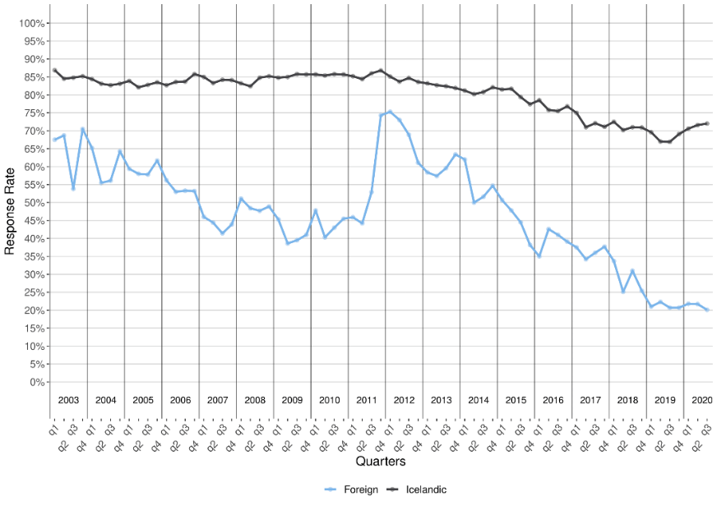

Figure 1. IS-LFS response rates 2003-2020 by background.

At the same time, a divergence in response rate across age groups increased (Figure 2), with people between 65 and 74 having consistently the highest response rate and declining far less than that of younger people.

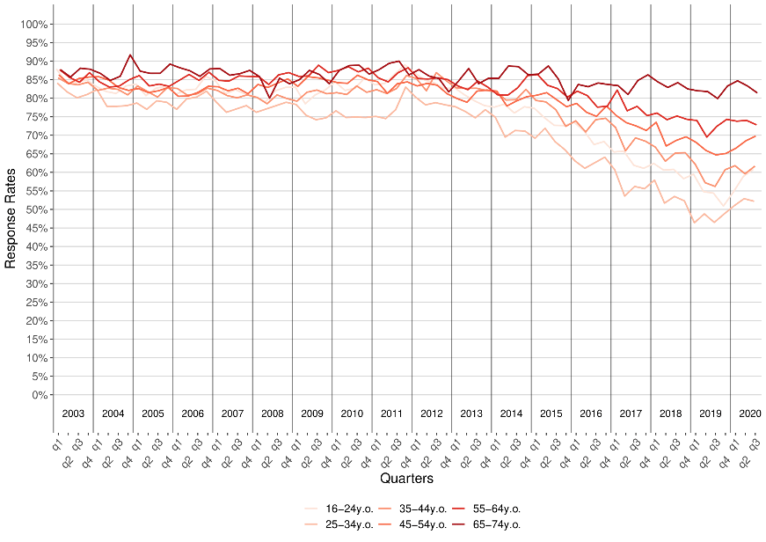

Figure 2. IS-LFS response rates 2003-2020 by age groups.

## Development of nonresponse during Covid-19

Figure 3 and 4 shows how levels of different nonresponse type develop from month to month for the covid-19 period March to September 2020, by background and age groups, respectively. Measures are shown from January 2019 for comparison. Non-contact was much higher in March among people with foreign background (70%) than Icelandic background (15%), but a clear effect of covid-19 is hard to discern. The same can be said with regards to age groups. Age groups differ considerably in levels of non-contact. People aged 25-34 have consistently the highest overall nonresponse rates (47% in March), due to non-contact , while the oldest age group has consistently the lowest nonresponse rate (16% in March). However, no clear effect of covid-19 can be seen on nonresponse between age groups.

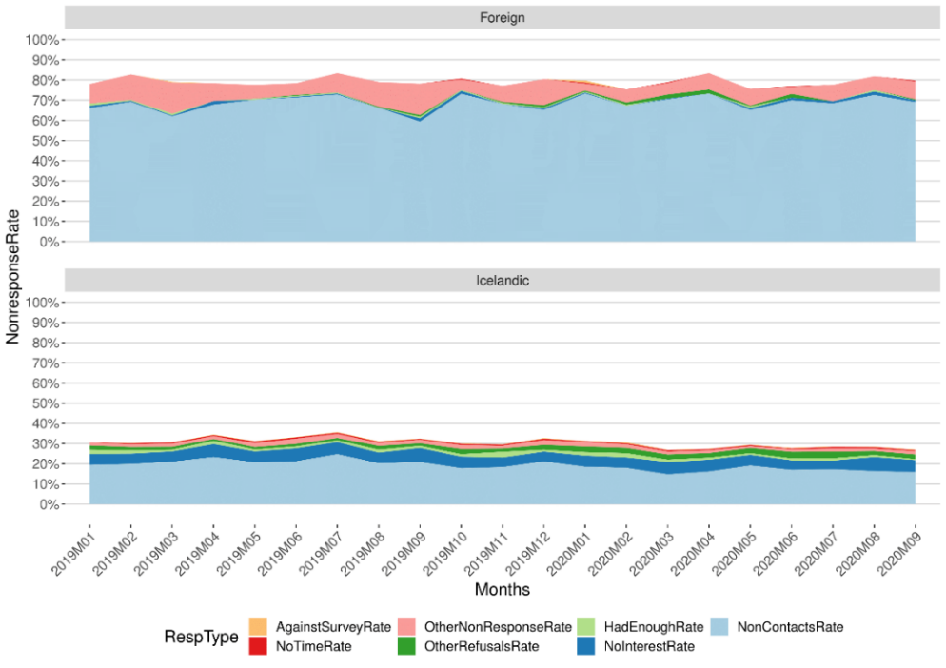

Figure 3. IS-LFS nonresponse types during Covid-19 by background.

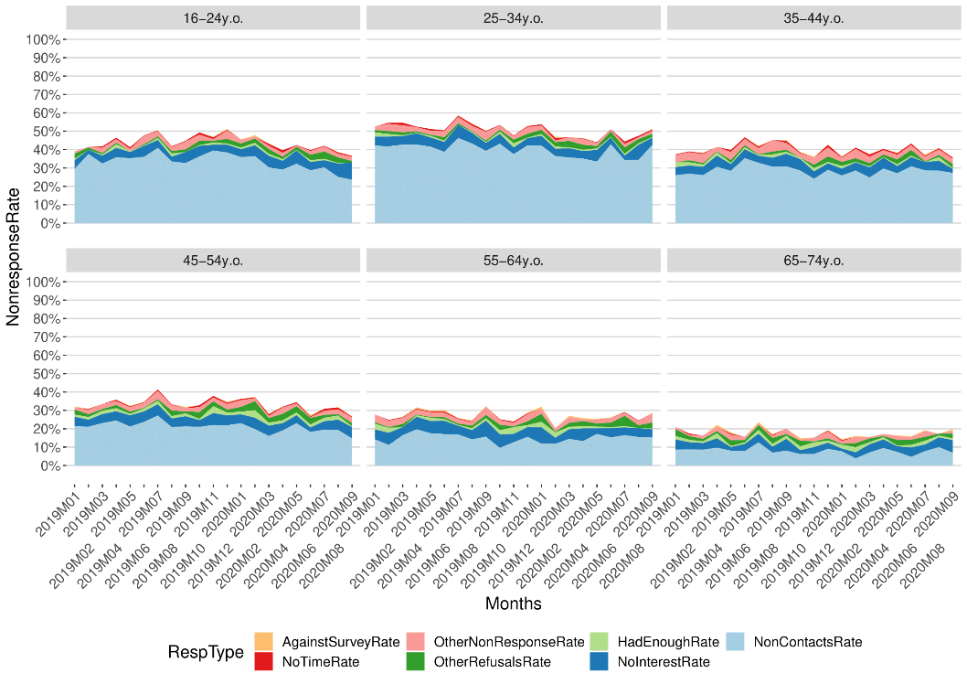

Figure 4. IS-LFS nonresponse types during Covid-19 by age groups.

# Conclusions

The results show, that to date, the Covid-19, has not affected nonresponse in the IS-LFS in a clear way. In fact, nonresponse rates have slightly decreased among people with Icelandic background since the third quarter of 2019. Because no clear effect of covid-19 on nonresponse, Statistics Iceland has not implemented changes to IS-LFS data collection, and made no adjustments to data processing in order to deal with nonresponse in the survey.

Yet, the general downward trend in the IS-LFS response rate since 2011 warrants scrutiny. It is clear that the overall response rates in the IS-LFS depend, at least partly on changes in demographic composition in Iceland, which changed drastically in 2006 (see <https://statice.is/statistics/population/inhabitants/background/>).

While the decline in response rate is in line with global trends survey response, few studies have focused on the *reasons* for this trend2,4. Countries differ considerably not only in demographic composition and development, but also with regards to type of nonresponse. For example, while the proportion of non-contacts and refusals in LU- LFS was 33.9 and 2.9, respectively, these proportions were 8.7 and 42.4 in the UK-LFS in 2018 3. This suggest that the surveycontext4–6 may be important. For example, in countries where people primarily use their mobile phone for telecommunication they may be harder to reach for telephone based interviews, than in countries were landline is the primary telecommunication tool, resulting in non-contacts.

We suggest that in order to understand, explain and hopefully hamper nonresponse more attentions should be given to the reasons for nonresponse. Our results show that the main reason for nonresponse in the IS-LFS is non-contact, which is likely to be shaped by the drastic technological change inherent in the massive mobilisation of telecommunication in Iceland7. This may explain why non-contacts among people with foreign background and younger people is high, as we find likely that these groups use mobiles as their primary telecommunication tool. It stands to reason that although this means that people are less bound to participation in CATI surveys in the privacy of their homes, they may also find it uncomfortable to answer burdensome surveys,- or even answering telephone calls from unknown numbers, in public or at work.

In conclusion, although Covid-19 has, as of yet, not affected nonresponse in the IS-LFS in a clear way, it does not mean that it could not in the months ahead. Thus, we will update our result for the final version of this paper, which will be presented in March 2021. Regardless, we believe that exploring the general reasons for the global downward trend in survey response rates becomes a vital task for NSIs, - if they are to continue assessing important economic and social trends in the years to come using social surveys.

# References

1. de Leeuw, E. & de Heer, W. Trends in household survey nonresponse: a longitudinal and international comparison. in *Survey Nonresponse* (eds. Groves, R. M., Dillman, D. A. & Little, R. J. A.) 41 (Wiley, 2002).

2. Luiten, A., Hox, J. & de Leeuw, E. Survey nonresponse trends and fieldwork effort in the 21st century: Results of an international study across countries and surveys. *J. Off. Stat.* **36**, 469–487 (2020).

3. European Union. *Quality report of the European Union Labour Force Survey 2018*. (Publications Office of the European Union, 2020).

4. de Leeuw, E., Hox, J. J. & Luiten, A. International Nonresponse Trends across Countries and Years: An analysis of 36 years of Labour Force Survey data. *Surv. Methods Insights from F.* 1–11 (2018). doi:10.11587/IZNRQ5

5. de Leeuw, E., Hox, J., Silber, H., Struminskaya, B. & Vis, C. Development of an international survey attitude scale: measurement equivalence, reliability, and predictive validity. *Meas. Instruments Soc. Sci.* **1**, 1–10 (2019).

6. Leeper, T. J. Where Have the Respondents Gone? Perhaps We Ate Them All. *Public Opin. Q.* **83**, 280–288 (2019).

7. *Statistics on the Icelandic Telecommunication Market*. (2019).