Bee swarms, barcodes and bubbles – what do they have in common? Visual data narratives on regional development

**Keywords:** data visualisation, data storytelling, interactive statistical maps

# Introduction

The COVID-19 pandemic has already had an enormous impact on socio-economic developments. An ever-increasing number of data and statistics are needed to plan the recovery measures. Ofﬁcial statistics at all territorial levels - national and regional - will become even more important for monitoring the social, economic and environmental impact, helping policy makers to decide on the best policies to fight recession.

Having a trustworthy point of reference for statistics and data on Europe is fundamental for better decisions, policies and for informing the public at large. In order to fulfil this task, products that help to fight disinformation in a post-trust world are essential. Communicating regional and local data to wide audiences helps to increase the understanding of the diversity that exists between regions; it sheds light on territorial disparities and creates trust by bringing statistical information closer to citizens.

The digital transformation has changed the world in the past couple of decades. This change provides both an opportunity and a challenge at the same time. On the one hand, it offers the potential to reach a wider public with statistical information. On the other hand, it has increased user expectations: statistics should be easy to access and understand, be relevant and concise, and be presented in an attractive format.

This paper offers insights into how Eurostat addressed this challenge and opportunity through the example of the “digital transformation” of the *Eurostat regional yearbook.*

# Methods

The *Eurostat regional yearbook* is a very popular Eurostat publication with a long-standing tradition. This publication was started in the 1970’s and since 2000, has been published on an annual basis. It has been one of the most downloaded Eurostat flagship publications in recent years. Nevertheless, we believed that an interactive digital version of the yearbook could reach an even wider audience.

To kick off the project we organised a simplified version of the Design Sprint developed at Google Ventures as described below. [1] The Design Sprint is a process for answering critical questions through design, prototyping, and testing ideas with customers. We went through the following steps in two phases:

Phase 1

* understanding the problem and the context
* setting a target
* review of existing ideas to remix and improve
* sketch solutions
* choose the most promising solutions and integrate them into a storyboard

Phase 2

* build a prototype
* test and collect feedback

Phase 1 was completed within one week. As a result of Phase 1, we then agreed on how and what we wanted to prioritise.

How? - Focus on enhanced user experience

* “Scrolly-telling”
* Concentrate on explore and explain
* Easy navigation
* Responsive design – mobile friendly
* Reusable and adaptable

What? – Focus on visuals

* Six new data visualisations
* Three main sections (People and society; Economic activities and Environment and natural recourses) showcasing 30 indicators

When developing the individual story-telling data visualisations, we followed these steps, inspired by data visualisation guidebooks [2][3]:

* Understand the context
* Decide what we would like to show (correlation, geographical patterns, distribution, trends, etc.) and create a storyline
* Choose the appropriate visual
* Add interactivity
* Eliminate clutter: “Grey is your best friend”
* Think about design
* Tell the story

To satisfy the requirement of reusability we made all visualisations embeddable as stand-alone visuals. The coding for [the](https://github.com/eurostat/regl-map-animation) [Dorling cartogram](https://github.com/eurostat/NutsDorlingCartogram), the [Bee swarm](https://github.com/eurostat/beeswarm) graph and the [Barcode generator](https://github.com/eurostat/barcode-generator) is also available on Eurostat GitHub. [4]

# Results

The figures below show two examples of how a “sketch” from the concept phase was turned into an interactive storytelling data visualisation in the final publication.

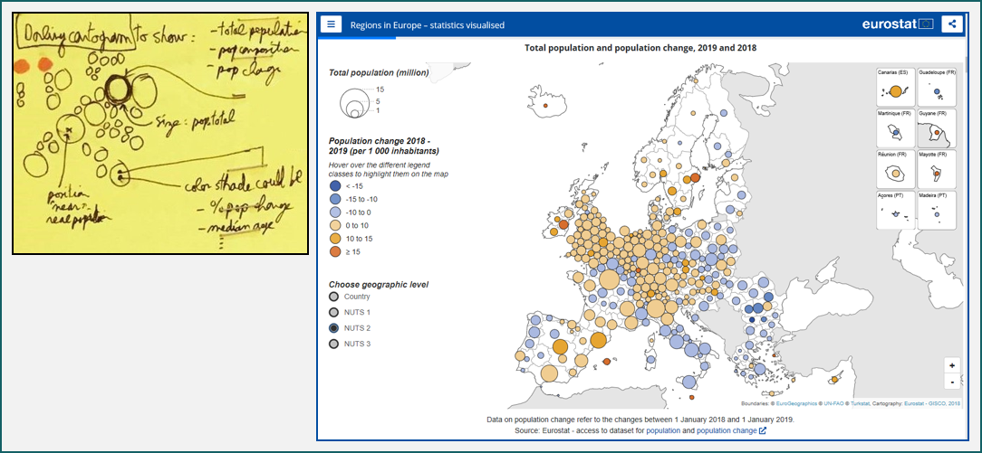

Figure . From sketch to publication – the example of the Dorling cartogram

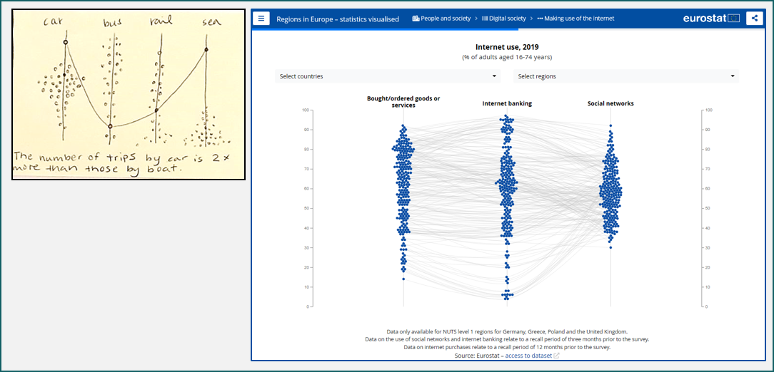

Figure . From sketch to publication – the example of the Bee swarm graph

These are just a few examples of the many interactive visualisations available in the new digital publication [*Regions in Europe — statistics visualised*](https://ec.europa.eu/eurostat/cache/digpub/regions/) [5], which was released on 12 October 2020. All of its visualisations are accompanied by short texts explaining the main findings.

The digital version is complemented by a longer version – similar to the previous editions - available as a downloadable document (PDF) [6] and Statistics Explained articles [7] (Statistics Explained is a wiki-based Eurostat website). These longer articles provide a more detailed picture where the descriptive analysis is accompanied by pre-defined maps, figures and infographics.

The results of the small-scale, pre-release, user testing were very promising. We will closely monitor the uptake of the complete communication package after the release. Whether or not we manage to reach a wider public is yet to be seen.

# Conclusions

We believe that with the new, interactive digital publication we can meet the increased user expectations: regional statistics is presented in a playful, easily understandable way in a concise and attractive format. The key to accomplish this was a motivated, highly skilled, well-managed, multi-disciplinary team containing: web developers, communication experts, data visualisation experts, graphic designers, GIS experts and statisticians. The support and commitment given by the hierarchy was also essential.

# References

1. Knapp, J., Zeratsky, J., & Kowitz, B. (2016). *Sprint: How to solve big problems and test new ideas in just five days*. London: Bantam Press.
2. Nussbaumer Knaflic, C. (2015). *Storytelling with data: A data visualization guide for business professionals*. Hoboken, NJ: Wiley.
3. Kirk, A. (2019). *Data visualisation. A handbook for data driven design*. London:
4. <https://github.com/eurostat/>

1. <https://ec.europa.eu/eurostat/cache/digpub/regions/>
2. <https://ec.europa.eu/eurostat/publications/statistical-books/regional-yearbook>
3. <https://ec.europa.eu/eurostat/statistics-explained/index.php/Eurostat_regional_yearbook>