The Eurostat business cycle clock: aim, scope and main characteristics

**Keywords:** Business cycle analysis, Markov switching models, PEEIs, turning points detection.

Using scoreboards of indicators to monitor the different aspects of a phenomenon is rather common, in particular in relation to policy decision making. The Principal European Economic Indicators (PEEIs) is an example of a scoreboard aiming to describe the economic and labour market situation as well as price developments, which are of particularly high importance for economic and monetary policy. In order to give a clear and concise message to the user, there is a need for summarising information from multiple indicators to capture and highlight key signals behind a scoreboard of statistical indicators.

We will present the [Business Cycle Clock](https://ec.europa.eu/eurostat/cache/bcc/bcc.html) (BCC), which is Eurostat’s online tool focusing on representing the recent state of the economy. Fluctuations of the economy between periods of expansion and contraction have been subject to business cycle analysis for many years; however, representing the evolution of the economy, when we can consider it to be in a recession phase, or when the growth is accelerating or decelerating, does not correspond to unanimous and measurable concepts. We will introduce three different cycles: business, growth and acceleration cycles and a synthetic message derived from a simultaneous analysis.

We will first introduce the methodological framework underlying the BCC tool, including the statistical detection of turning points, empirical dating and assessment; then some results on the recent output of the tool during the COVID-19 crisis will be presented.

# Introduction

The economy is subject to cycles with expansion and contraction phases, and understanding in which phase we are, and if there are signs of a change of phase, or being close to a turning point, is one of the main issues tackled by econometric researchers.

Eurostat has a long experience in the construction of turning point coincident indicators based on multivariate Markov Switching models [1]. The Eurostat BCC is able to represent several aspects of cycles in a unique, visual context.

The idea at the base of the BCC is looking at the business, growth and acceleration cycles and represent the six possible states obtained by combining those three cycles in a unique image, a clock, which is at the same time familiar to the reader and conveying an intuition of cycles.

# Methods

The BCC tool is based on probabilistic coincident indicators obtained by Markow-Switching models; more precisely on a coincident indicator for each of the three cycles: the Business Cycle Coincident Indicator (BCCI), the Growth Cycle Coincident Indicator (GCCI) and the Acceleration Cycle Coincident Indicator (ACCI).

Markov Switching (MS) models were introduced in business cycle literature by Hamilton in 1989 [2]; they give output transition probabilities measuring the probability of either staying in the same regime or switching to another regime. Those indicators provide information about the occurrence of a turning point, or change in phase, in the respective cycle.

The models used in the BCC will be denoted as MSIH(M)-VAR(N), Markov switching models with (or without) intercept (I) and heteroscedasticity (H), and with M regimes, with N indicating the order of the lag polynomial in the autoregressive part.

A multivariate model for the BCCI and the GCCI has been developed, complemented by a univariate model for the ACCI; the sequence of obtained turning points matches the so-called αABβCD sequence, see [1], with the different letters corresponding to peaks and troughs of the three cycles. More precisely: starting with the business cycle, we can call C a trough in the business cycle, and B a peak; we will call A a peak in the growth cycle, and D a trough; finally α and ß are the peak and the trough of the acceleration cycle. The described approach is not based on a unified theory that applies to different cycles, but it has more of an empirical, data-driven nature. It is particularly interesting that turning points follow the specific time sequence.

Once a sequence of a turning point is obtained, it is also necessary to assess the results, which represent the evolution of a latent (not directly measurable) variable. What is feasible is to compare the obtained sequence with another sequence obtained by a different dating approach. A simple, non-parametric dating methodology complements the MS probabilistic indicators. These two methodological blocks are both essential and complementary for a cycle analysis.

# Results

The tool interface consist of two parts: the graph in the upper part shows the result of a detrending procedure applied to GDP, showing the GDP growth cycle as a percentage deviation from the trend, together with bars related to peaks and troughs of the cycles based on the data obtained by historical dating.

The main part of the tool is the (one or more) clocks displayed with the related hand showing the phase at a given time.

We will present the indications of the Eurostat BCC tool during the COVID period; for example, the tool signals in September a probable recession phase for the euro area. The most significant results in the period close to the presentation will be shown.

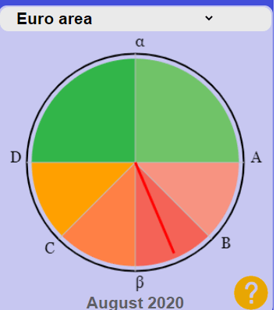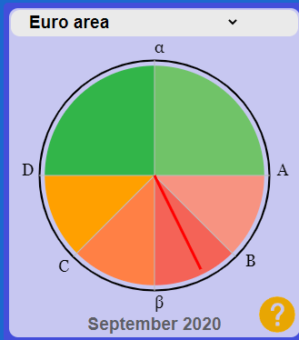

Figure . BCC tool for euro area – August and September 2020

# Conclusions

Understanding large sets of macroeconomic indicators is not always straightforward; the Eurostat business cycle clock is a tool based on a robust and transparent methodology, giving synthetic signals on the state of the economy. It also enables to go deeper into the details of all phases of the cycles due to the joint analysis based on acceleration, growth and business cycles. Although the tool is of an experimental and empirical nature, it can be seen as fully complementary to official statistics, to give users a timely and visually appealing representation of the economic situation.

# References

1. Anas J, Carati L, Billio M, Ferrara L, Mazzi GL. Composite cyclical indicators detecting turning points within the ABCD framework. In: Handbook on Cyclical Composite indicators, Eurostat and United Nations, editors; 2017. p. 357-398
2. Hamilton, JD. A new approach to the economic analysis of nonstationary time series and the business cycle. Econometrica; 1989 (57):357-384.